3-Tier Architecture application deployment on EKS

3-Tier arcitecture means application written using three different layers are called 3 tier architecture,
*frontend layer
*backend layer
*database layer

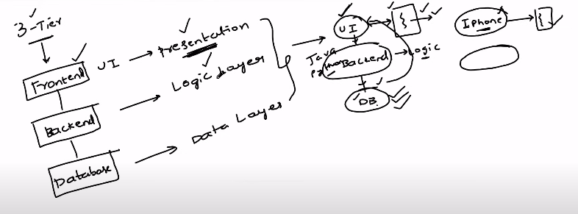
All real time applications are 3tier application.
Ex: flipkart,intagram, facebook etc,

workflow of frontend,backend and database:

*The UI which you will see that is served from frontend layer,
*when your perform any action on UI, respons data to that action is served from database but interfact with UI action and fetch details from batabase backend is required.backend have logic to understand the request and fetch required details from database.

Ex: you visited fliplkart website, it will load dafult UI page,
when you search any specific model mobile, request will go to backend and backend understand request ,fetch the details from database and give to frontend to serve details.

High Level design understanding of Robot shop application:

workflow of user in any E-commers application.

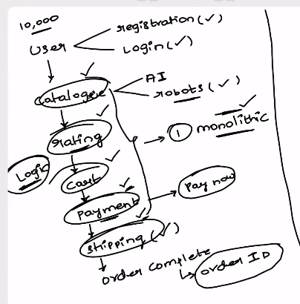

User --> visit website ---> login or Register then login
catalogs -->(seleting diffrent products section) AI and robots
rating -->
add to cart -->
payment -->
shipping details -->
order completed --> get order id

catalogs,ratting,add to cart,payment,shipping details are have its own different logics. If we written code to handle logics of all modules which are required to application and give it as single binary to deploy then this application is called as monolithic application.

Monolithic application or Monolithic architecture: application is collecttion of modules,each module have it’s own logic to contribute to application.
If code of one module have dependency on other module code and have single deployable binary for all module are called monolithic architecture or monolithic application

Microservice Application or Microservice architecture: Application is a collection of modules,
each module will work independently,have api end point to connect to other module to check full functionality of application and have seperate binary file to deploy for each module is called microservice architecture or microservice application.

There are total 9 microservices.

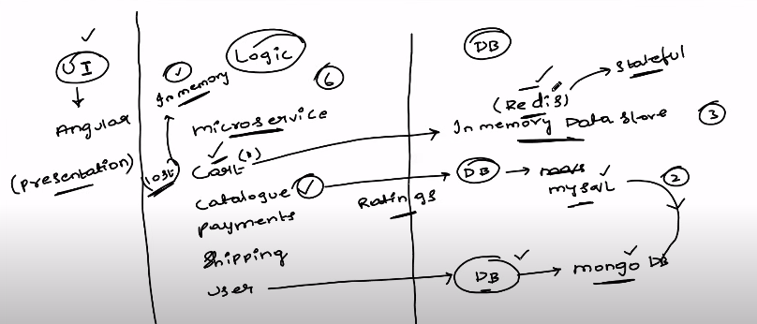

Redis--> is used to store the items which is saved from user because once user login back after some time, it has to show the added items list in card and is called in memory.
Mysql --> store the component details
MongoDB --> user to store the user details
cards --> logic to communicate to database
catalog --> logic to communicate to database
ratings --> logic to communicate to database
payments --> logic to communicate to database
shipping --> logic to communicate to database
user --> logic to communicate to database

configure IAM OIDC provider means Service account with IAM policies:

why we require to attatch policies?

When we deploy the application in EKS cluster, we will create service account to communicate within components, but any component need to communicate with aws service to get data or provide data, service account must have the policies attached to it.

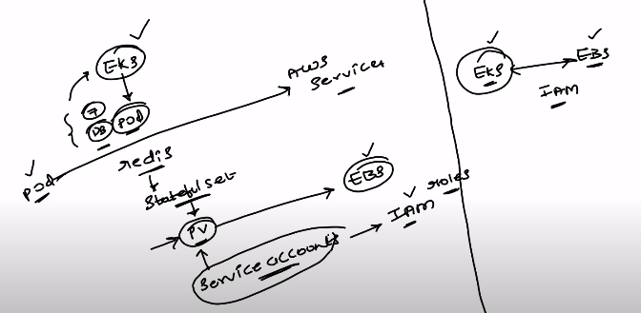

To deploy the robot shop application,follow the files present in EKS folder of below repo and once all files commands done, using helm folder,deploy the robot application.

PV and PVC concepts:
Storage class will check the pvc and create pv.
There will be many stage classes,In EKS we are using the EBS CSI plugin to create the PV in EBS volume.
Storage class must be installed in cluster to use and create pv.

https://github.com/Raghumnstudent/three-tier-architecture-demo/tree/master/EKS

Installed the eksctl -->

https://eksctl.io/installation/#for-unix

awscli is installed and configured the account earlier only and kubectl also installed.

Creation of EKS cluster:

$ eksctl create cluster --name demo-cluster-three-tier-app1 --region ap-south-1

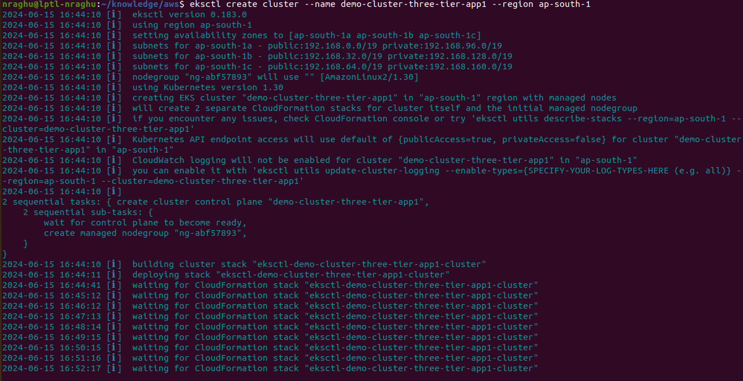

it took 30 minutes to create, i was using my mobile hotspot

commands to configure IAM OIDC provider:

$ export cluster_name=demo-cluster-three-tier-app1

$ oidc_id=$(aws eks describe-cluster --name $cluster_name --query "cluster.identity.oidc.issuer" --output text | cut -d '/' -f 5)

$ aws iam list-open-id-connect-providers | grep $oidc_id | cut -d "/" -f4

$ eksctl utils associate-iam-oidc-provider --cluster $cluster_name --approve

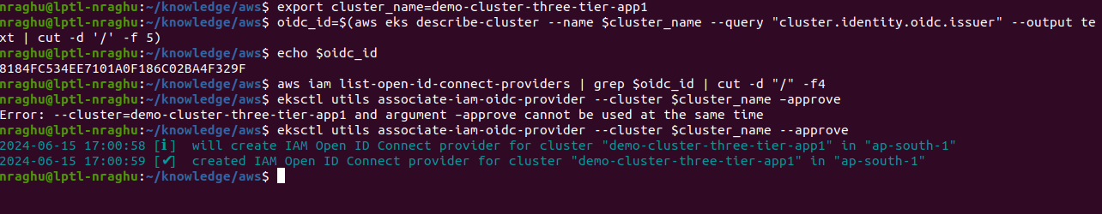

How to setup alb add on:

Download IAM policy:
$ curl -O https://raw.githubusercontent.com/kubernetes-sigs/aws-load-balancer-controller/v2.5.4/docs/install/iam_policy.json

Create IAM Policy
$ aws iam create-policy \
--policy-name AWSLoadBalancerControllerIAMPolicy \
--policy-document file://iam_policy.json
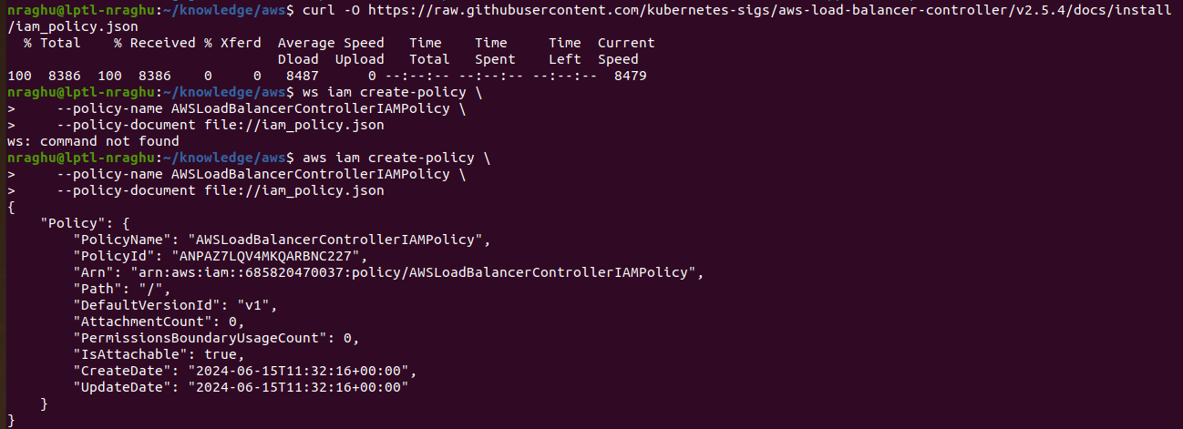

$ eksctl create iamserviceaccount \
--cluster=demo-cluster-three-tier-app1 \
--namespace=kube-system \
--name=aws-load-balancer-controller \
--role-name AmazonEKSLoadBalancerControllerRole \
--attach-policy-arn=arn:aws:iam::685820470037:policy/AWSLoadBalancerControllerIAMPolicy \
--approve

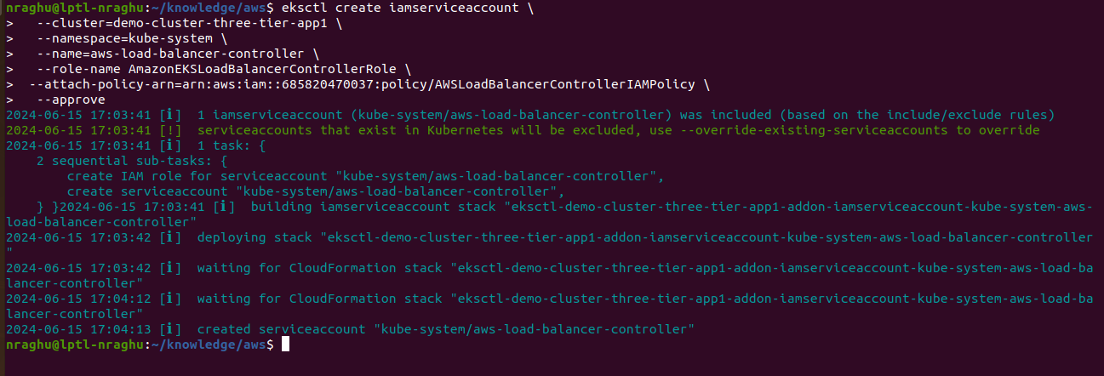
Belo command will update the config file of cluster to communicate.
$ aws eks update-kubeconfig --region ap-south-1 --name demo-cluster-three-tier-app1

Deploy ALB controller:

$ helm repo add eks https://aws.github.io/eks-charts

$ helm repo update eks

$ helm install aws-load-balancer-controller eks/aws-load-balancer-controller -n kube-system --set clusterName=demo-cluster-three-tier-app1 --set serviceAccount.create=false --set serviceAccount.name=aws-load-balancer-controller --set region=ap-south-1 --set vpcId=vpc-03af21395a2c232f2

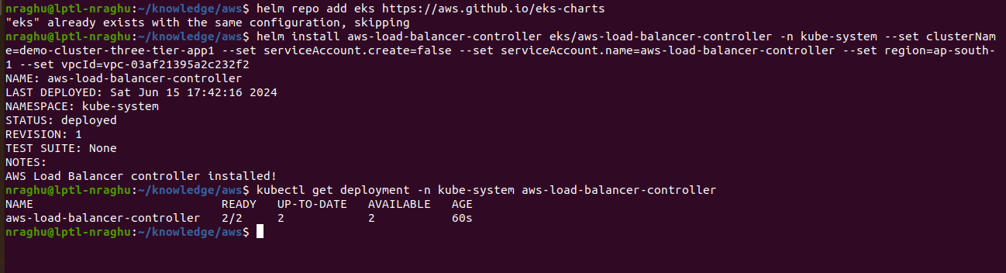

$ kubectl get deployment -n kube-system aws-load-balancer-controller

Installation of Robot shop app using helm chart:
*go to inside of helm folder
$ kubectl create ns robot-shop
$ helm install robot-shop --namespace robot-shop .
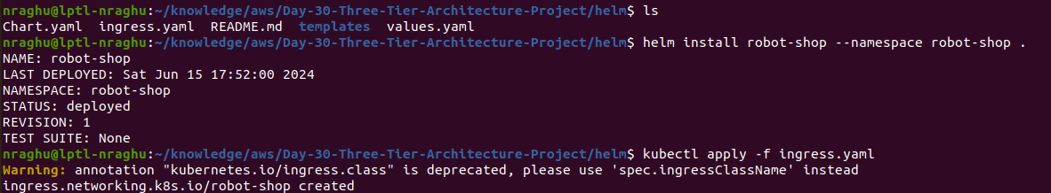
$ kubectl apply -f ingress.yaml

$ kubectl get pods -n kube-system

$ kubectl get ingress -n kube-system
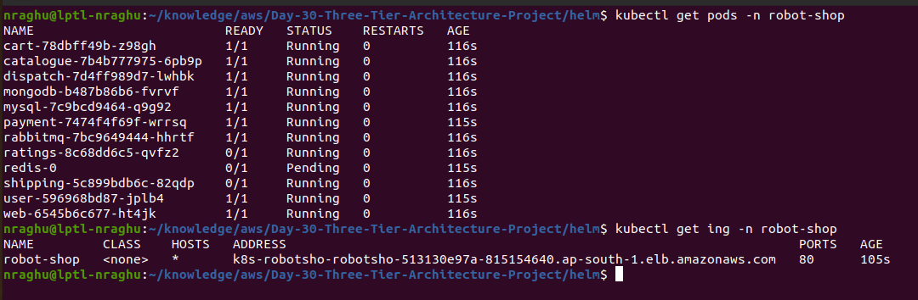
Access the application using addess provided from ingress resource.
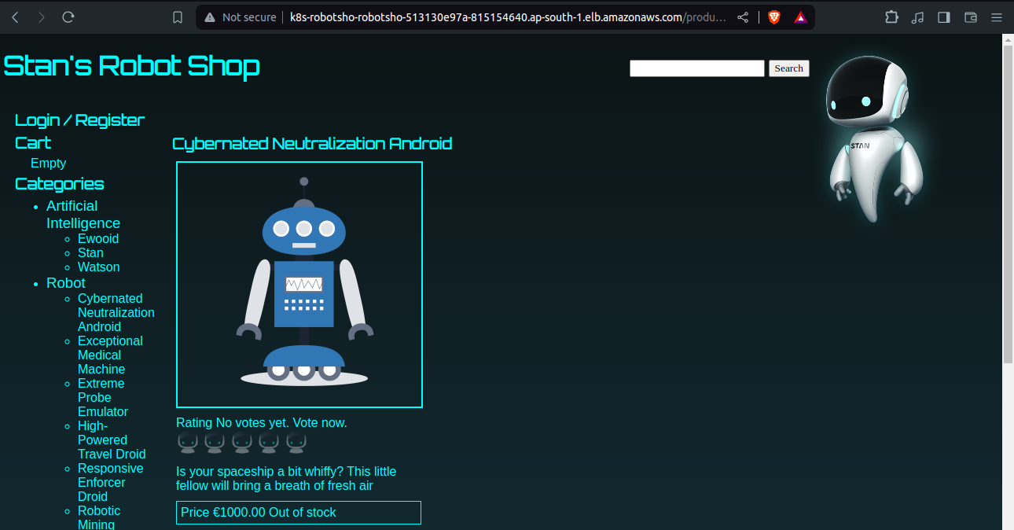
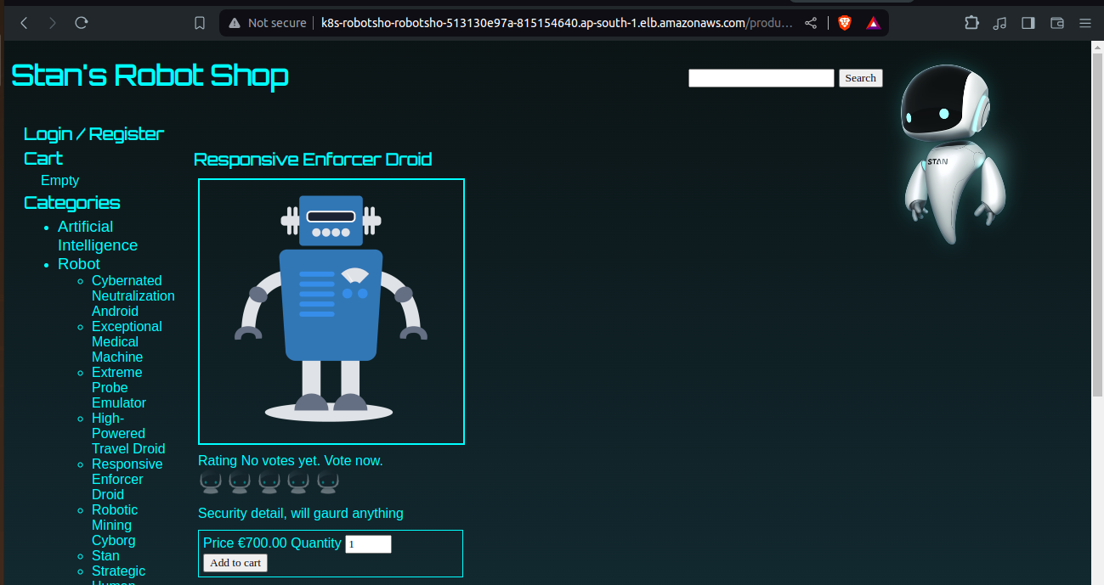
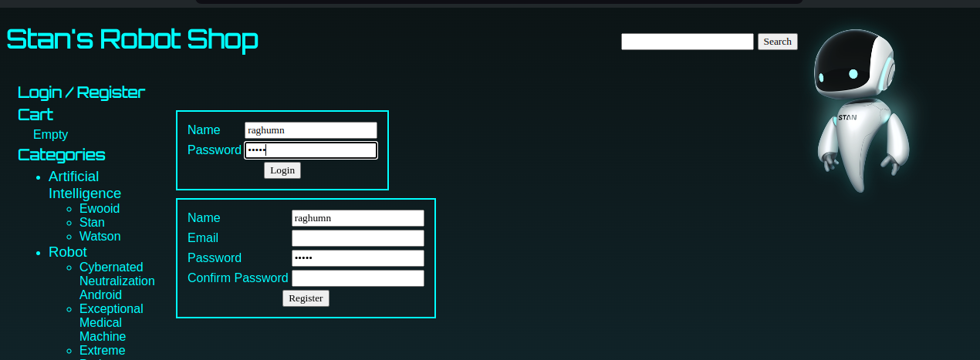
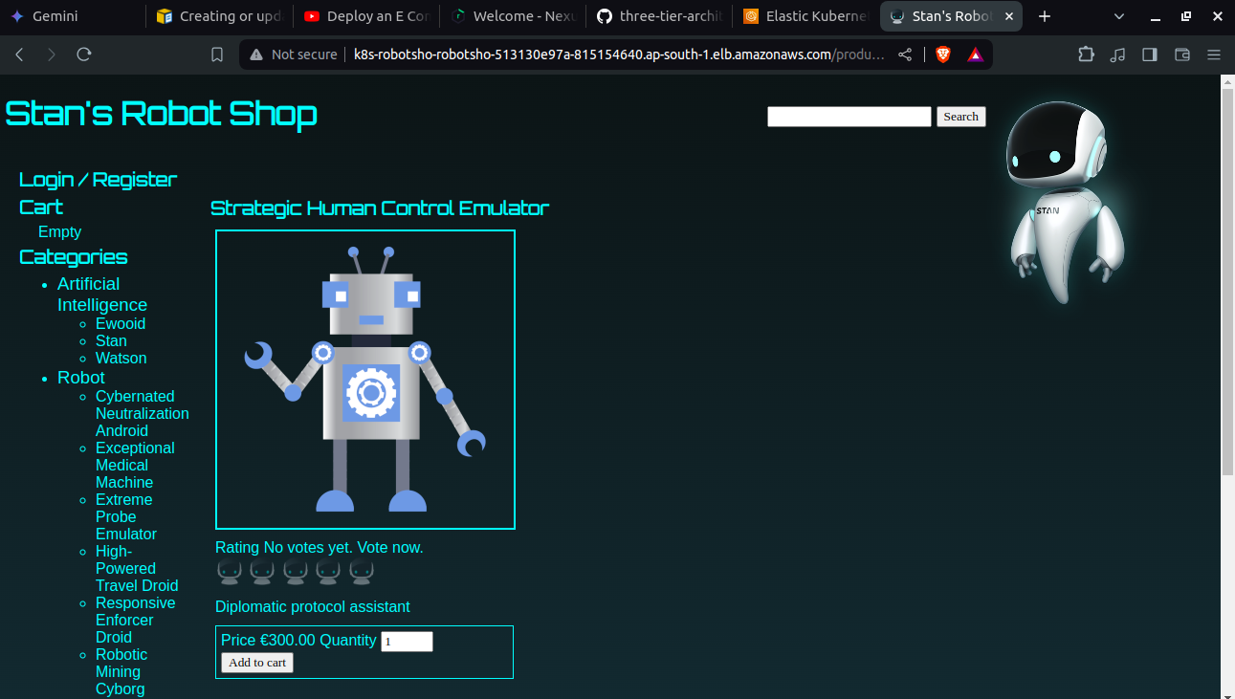

http://k8s-robotsho-robotsho-513130e97a-815154640.ap-south-1.elb.amazonaws.com/

Deleting the EKS cluster:
$ eksctl delete cluster --name demo-cluster-three-tier-app1 --region ap-south-1

