AWS ECR: Elastic Container Registry

container is a collection of your application dependences,code,libraries to run application.

ECR is container image registry service managed from aws,used to stote docker images as like Docker hub,quay.io, GCR .

https://quay.io/ --> container registry as like docker hub.

AWS Elastic Container Registry (ECR) is a fully managed container image registry service provided by Amazon Web Services (AWS). It enables you to store, manage, and deploy container images (Docker images) securely, making it an essential component of your containerized application development workflow. ECR integrates seamlessly with other AWS services like Amazon Elastic Container Service (ECS) and Amazon Elastic Kubernetes Service (EKS).

Whenever the word elastic you will create any aws service, means that service is scalable(we can increase resouces as the request increases) and highly available (aws will manage and provide service at all time)

Why we need registry?
To share docker image to any one in world,we need the registry.
We also make tar ball from docker image using docker save command and ship tar file but this is not good practice.

What is the difference between ECR and docker hub? Why we need to use the ECR instead using free docker hub for storing the images?

You can tell below and benifits of ECR.

Security:
Docker Hub:
*Docker hub is free and have public repository by default,any one can able to access images in public repository
Docker hub also support the private repository,based authencation able to access .
*You have create account for all user in your org to access docker hub private repository
*for personal projects,we can use the docker hub

ECR:
*ECR create private repository in nature by default,
*you can attach IAM users to access
you can also create public repository in ECR.
*if i am aws cloud engineer,better to use ECR or any other cloud engineer better to use the registry service provided from it’s cloud
*ECR have good intergration with other aws services.

Key Benefits of ECR:
Security: ECR offers encryption at rest, and images are stored in private repositories by default, ensuring the security of your container images.
- Integration: ECR integrates smoothly with AWS services like ECS and EKS, simplifying the deployment process.
- Scalability: As a managed service, ECR automatically scales to meet the demands of your container image storage.
- Availability: ECR guarantees high availability, reducing the risk of image unavailability during critical times.
- Lifecycle Policies: You can define lifecycle policies to automate the cleanup of unused or old container images, helping you save on storage costs.
Creation of ECR:
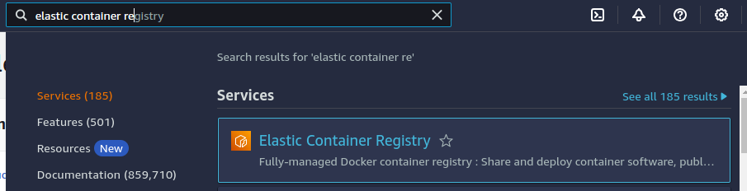


if you enable tag immutability,it will not allow you to push image with tag already exists in repository
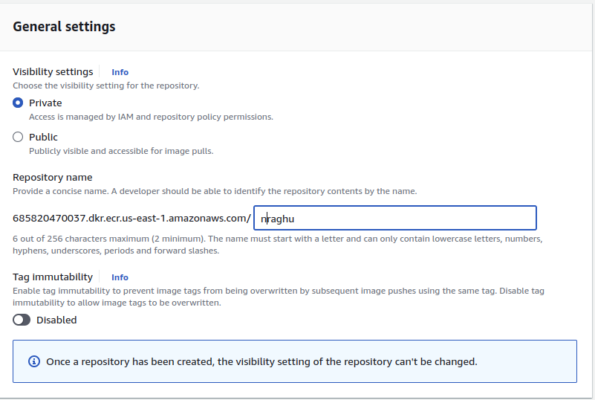

you can scan the images
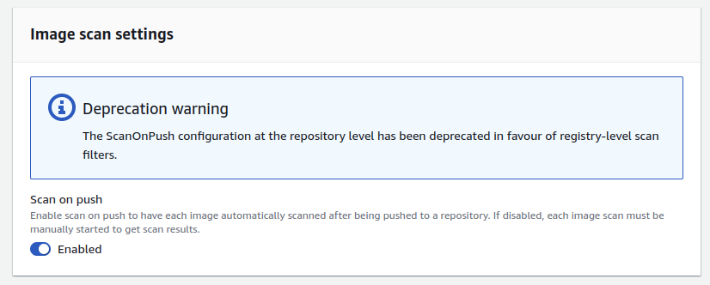

add encyption to images

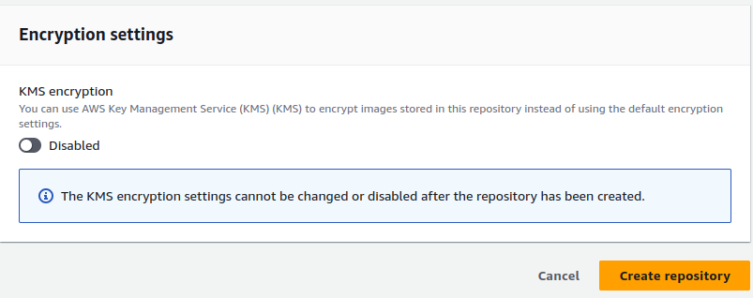
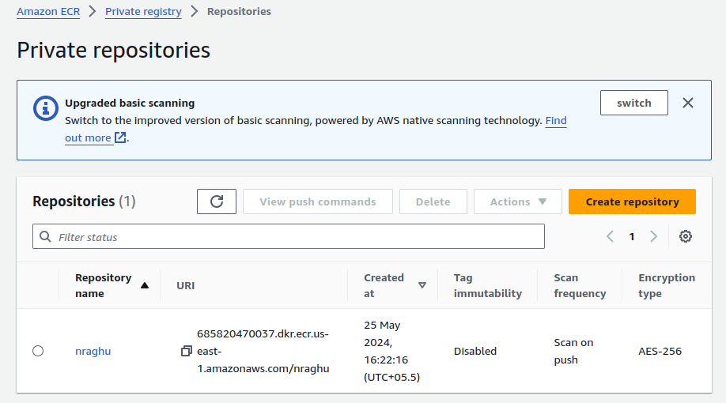

click on view command to push to get the commands.

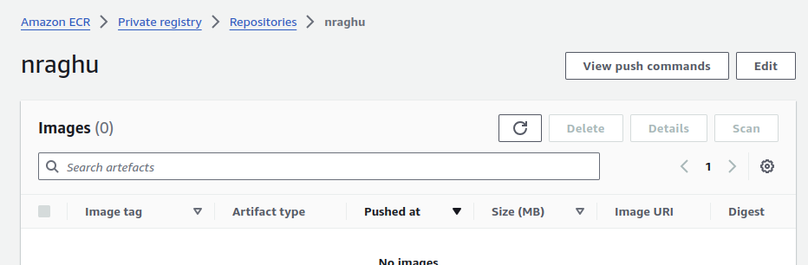

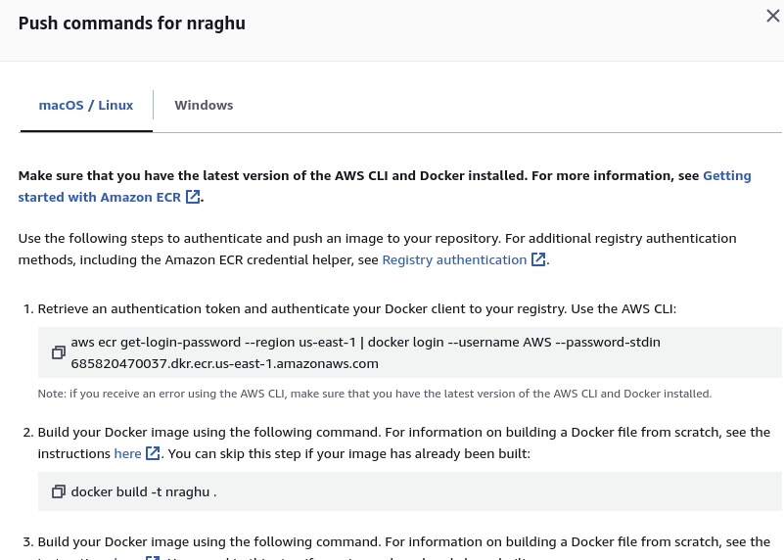

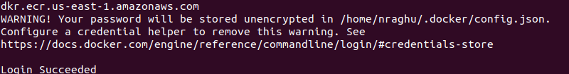

$ docker build nraghu-python-app

$ docker tag nraghu-python-app:latest 685820470037.dkr.ecr.us-east-1.amazonaws.com/nraghu:latest

$ docker push 685820470037.dkr.ecr.us-east-1.amazonaws.com/nraghu:latest

make repository name as application name to under which image is that

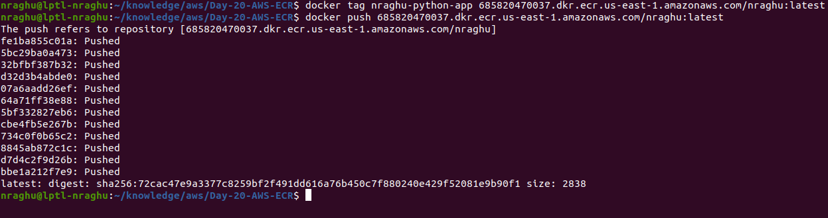

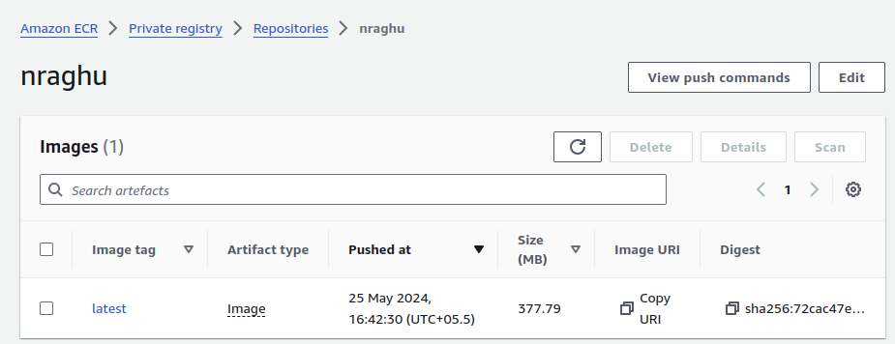
ECR is billable ,delete it once demo is done.

