AWS CodeDeploy --> CD part

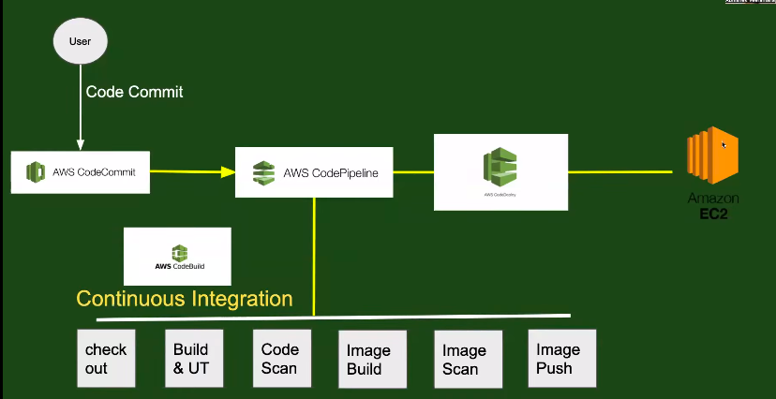

Create application in AWS codedeploy.

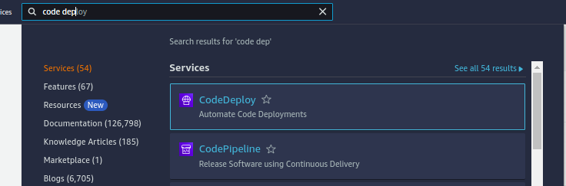

Click on create application
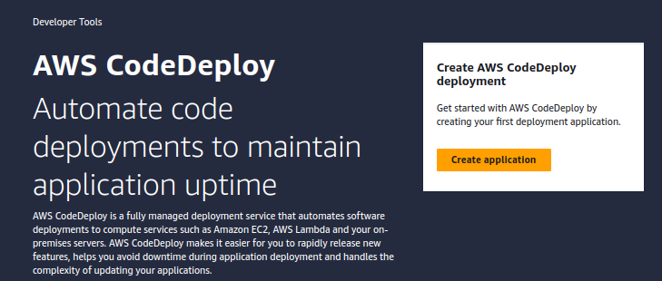
give name to app and select where you need to deploy,select ec2 and click creat application

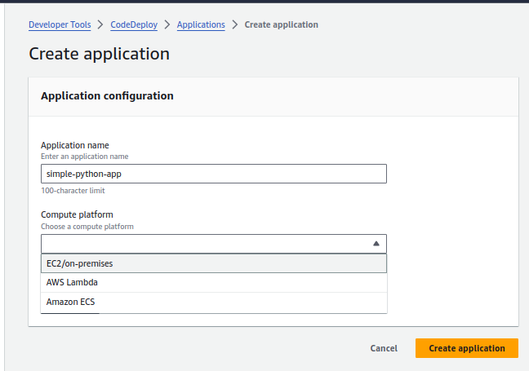

create ec2 instance to configure into code deploy
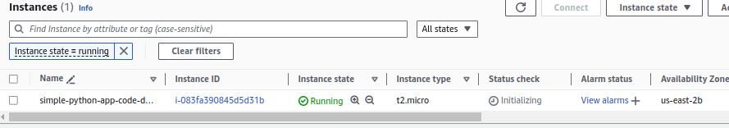
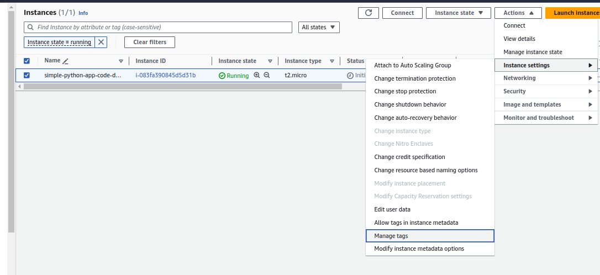
add a tag to instance
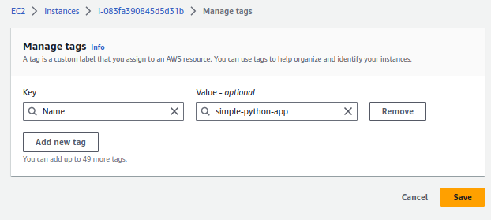
Install agent in ec2 instance to connect code deploy. Like in jenkins worker node we installed agent to connect to jenkins master like that

connected to ec2 instance

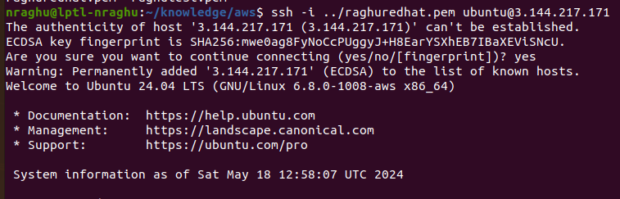

document to install the agent on ubuntu
https://docs.aws.amazon.com/codedeploy/latest/userguide/codedeploy-agent-operations-install-ubuntu.html

commads executed to install agent. Only install script download url will change based on your ec3 instance region and its bucket name

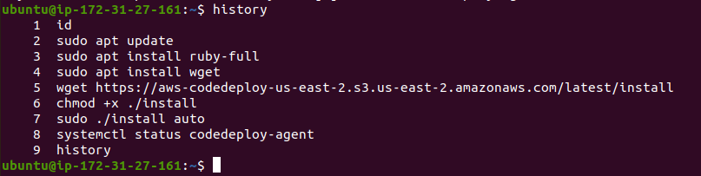

As we know,we need the role if any aws service will able to communicate with other aws service. Here aws code deploy need to communicate with ec2 instance

creating the role

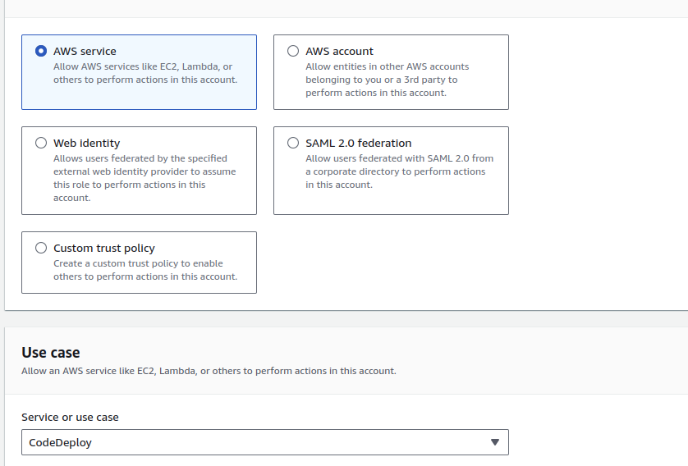

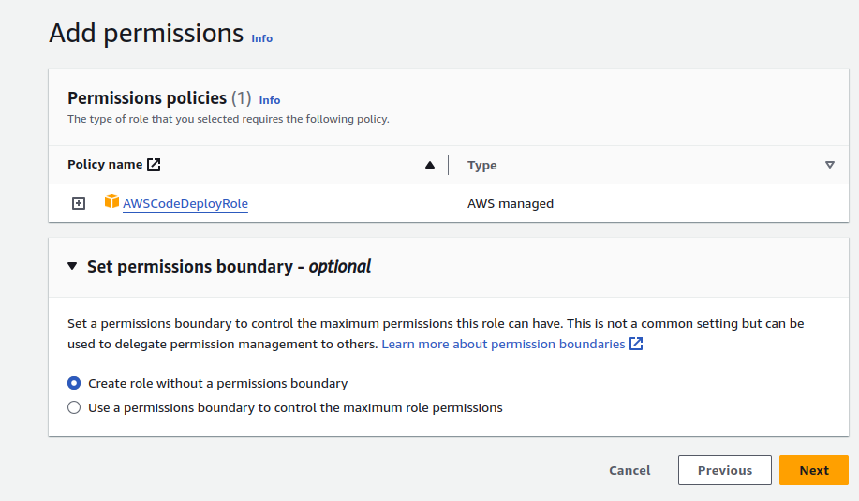
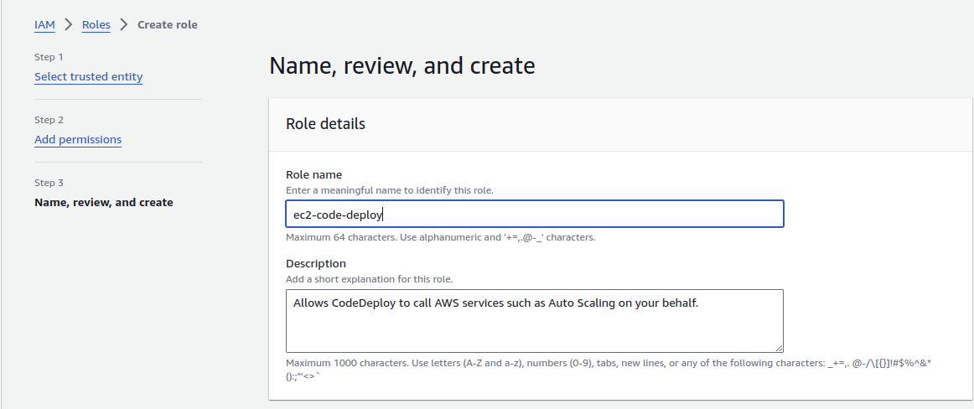
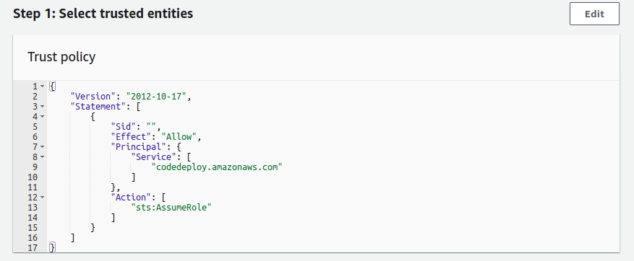
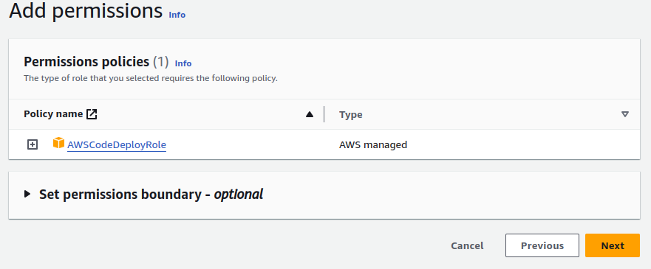

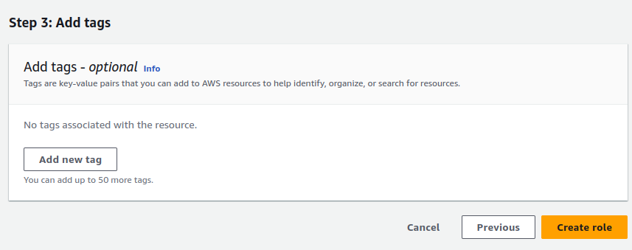
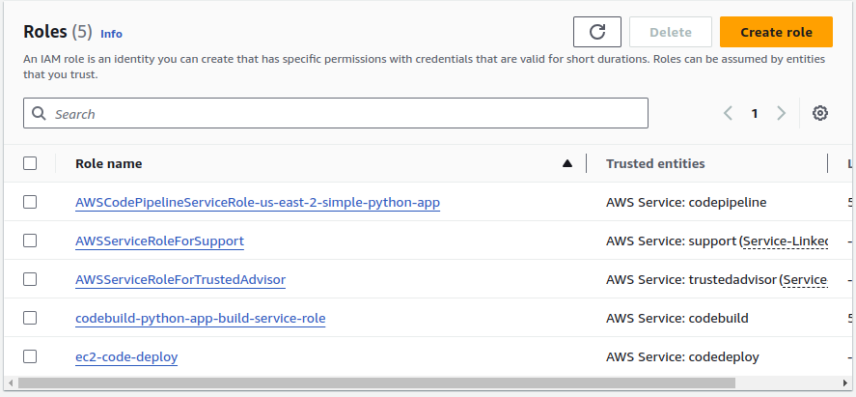

Go to Ec2 instance and attach the role

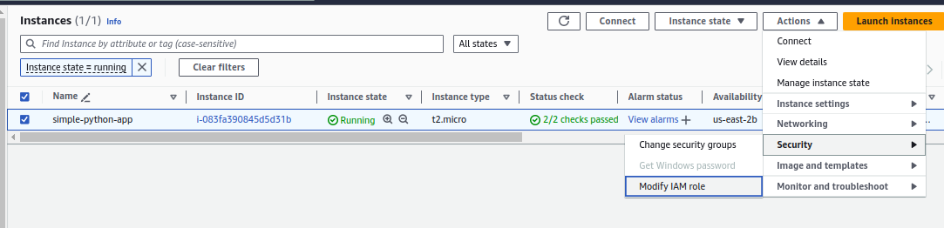
when i click on moify IAM role, role which i created was not getting listed.because of below issue
i created role by attaching only codedeploy policy, if we want to attach any role to any service,that service policy must be attached to that role.

Solution: created the new role by attaching the only EC2Fullaccess and then created seperate role for codedeploy policy,then it is worked.
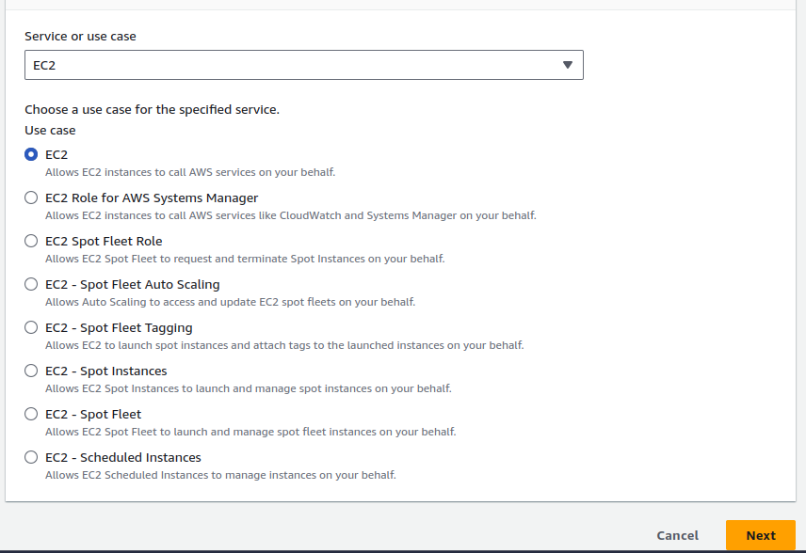

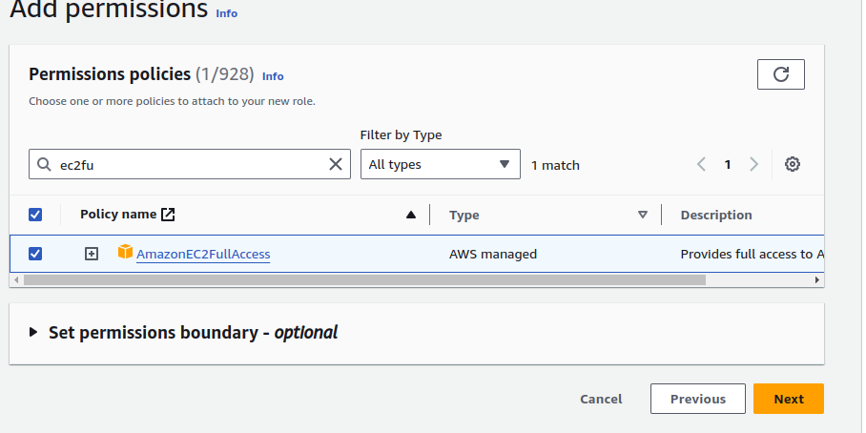

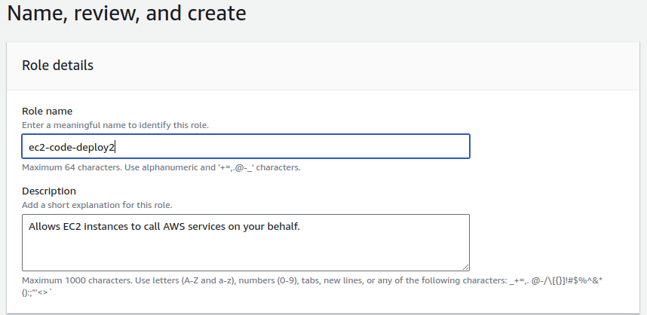

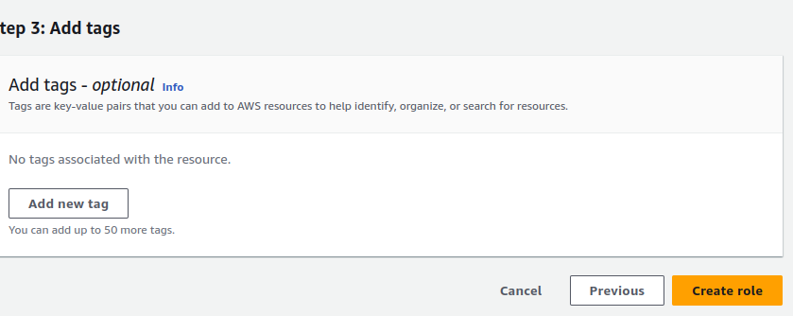

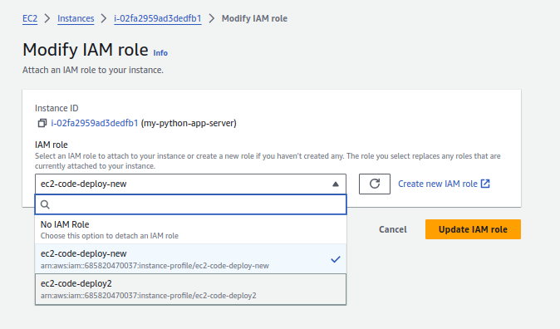

Successfully attached the role into ec2 instance,due to role issue i deleted earlier ec2 instance,follow the steps to install agent in new ec2 instance.

Creation of code deployment group:
we have many application to deploy on organization so that need to create code deployment group for every application and attach the target where we need to deploy,here we need to attach our ec2 instance.

Deployment group is required to understand where it need to deploy application.

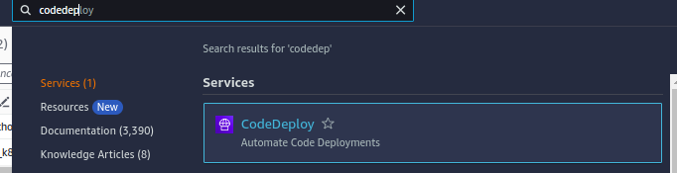

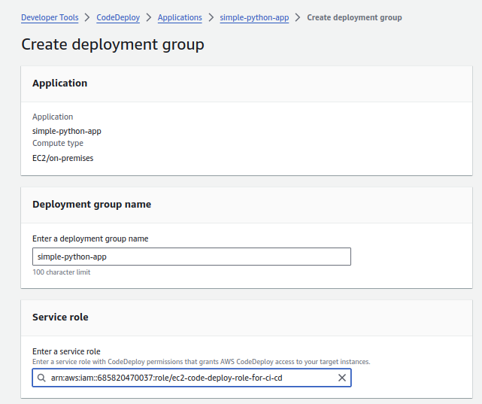

Select simple inplace statergy and target machine as ec2 instance.
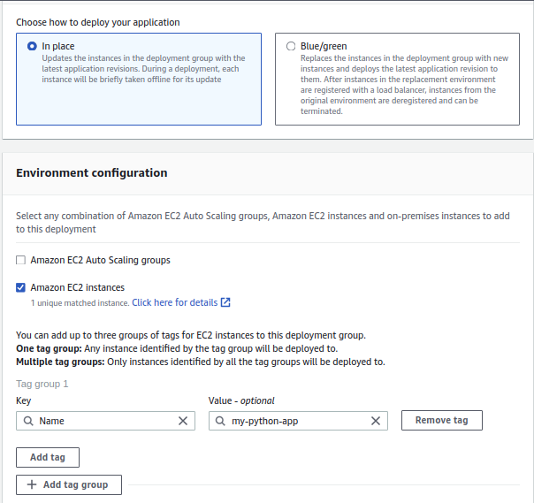
Add the tag to identify on which ec2 instance need to deploy.

Creation of depoyment: To deploy any application,deployment code is required. Now we are creating the deployment

Deployment is deployment code for your application.
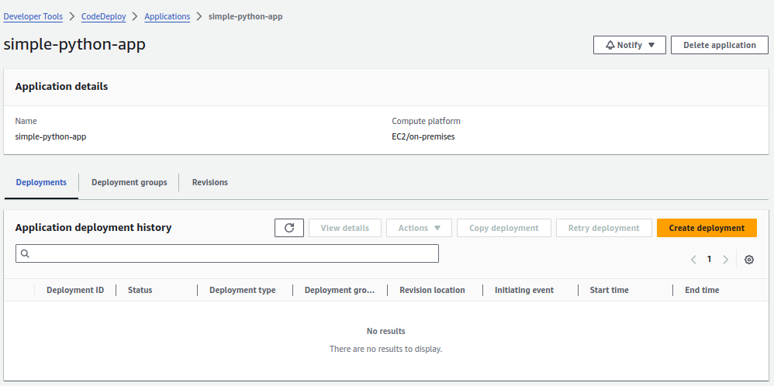
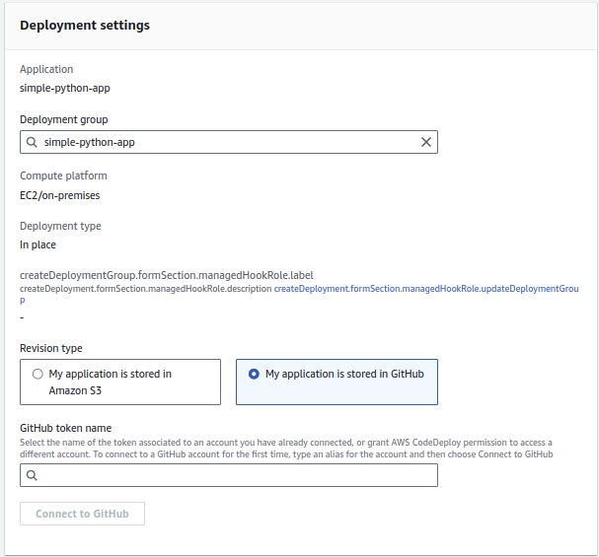

Give name to token and click on connect to github

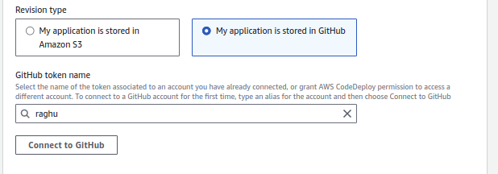

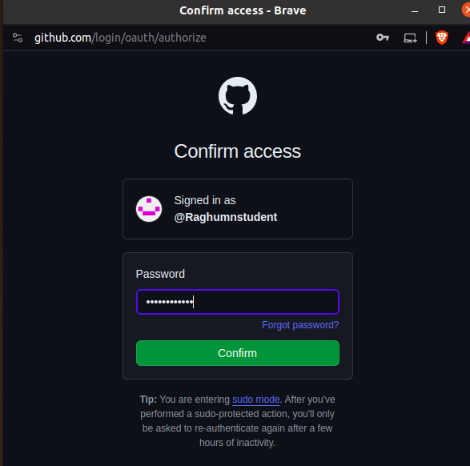

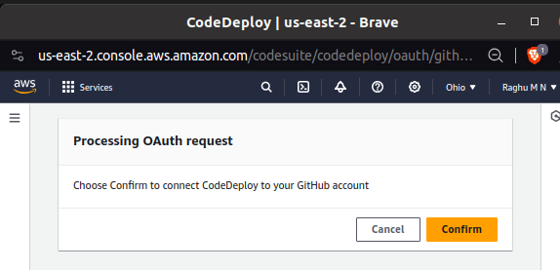
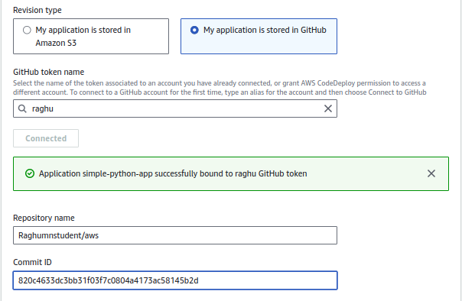
give repo name and latest commit id of that repo.deployment will fail because it expect the appspec.yaml file in root folder level. Don’t have flexible like aws build to provide path

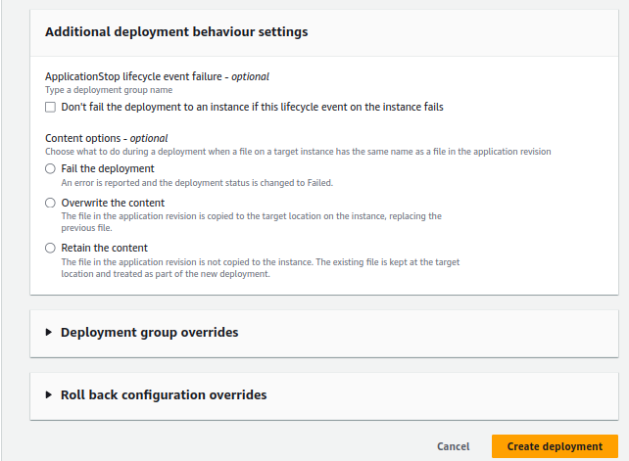
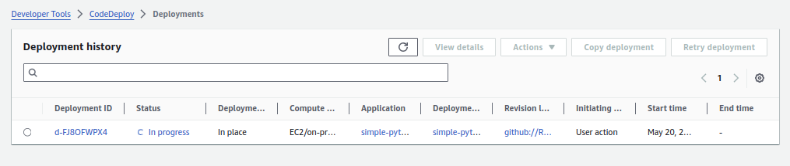
Created the appspec.yaml in root folder and pushed to git. Again newly created the deployment by giving latest commit.

