AWS Cloud Watch:

Cloud Watch is basically gatekeeper for my aws account which will help in altering,monitoring,reporting,and logging.
Cloud watch service will watch all activities performed in our account.
like creating of EC2 instance,s3 creation,monitoring the CPU usage of EC2 instance, any activity performed in cloud will be written log from cloud watch.

Advantages of cloud watch:

*Monitoring --> play important role in infrastructure monitoring.
*All you to create real-life metrics --> metrics is help to understand the utilization of service. Example in ec2 instance, getting the cpu usage,memory usage of last 30min,number of request recieved are the metrics in ec2.
*Alarms --> metric and alarms are closely assoiscated,cloud watch will go and read the metrics and set the condition to send alarm when condition spatisfies.
Ex: reading metric of cpu usage,when it reach 70%,send the alarm
*Logs insights --> provides the log message about accessing your services from account or other service.
Code deploy accessed ec2 instance to deploy application.
*Custom metrics --> by default cloud watch will monitor the cpu utilization,you need to track memory utilization,adding that custom metrics to enhance cloud watch
*cost optimization --> means reducing cost of aws,cloud watch pays crurial role in cost optimazation.
Like sending the alarts like your free tier usage is over,some service is using more cost
*scaling --> cloud watch have info abou the all services status,
Example: EC2 insatnce usage go to 100%, informing the auto scaling group to scale ec2 instances.

Two primary reason of moving into cloud
*Reduce the maintainance and improve the security
*cost optimization

Do demo on real-life metric,custom metric,alarms.

cost optimization in seperate video.

Log group --> making seperate group for every service.
Example: when we created application in code deploy,keep track of all that application related logs

Leftside you can see the logs,metrics,x-Ray traces, event are cloud watch featutes
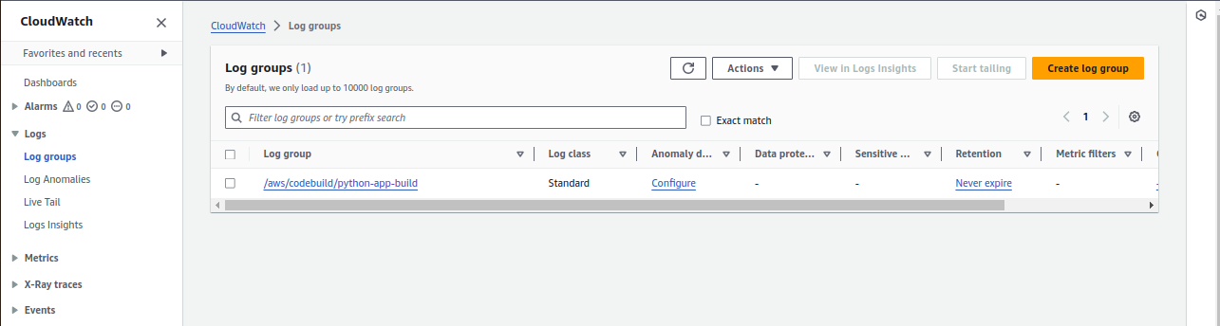
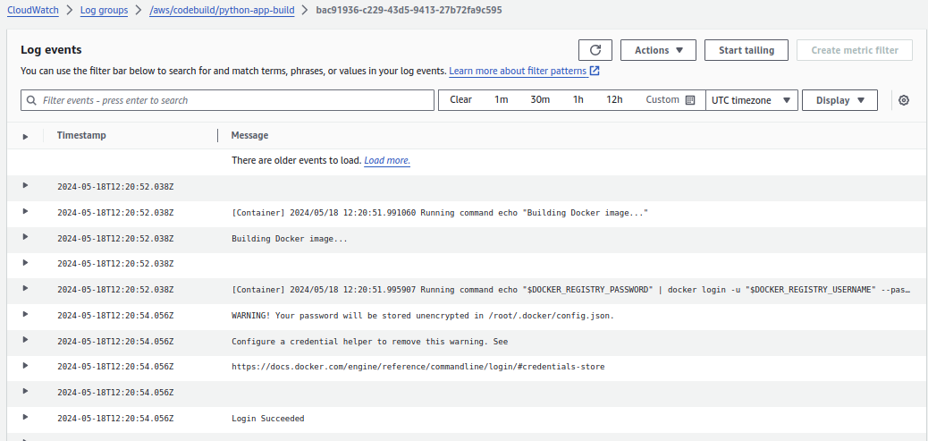
We created the deployment,for every build log will be recorded here irrespective of build fail or success
By default,aws is provide the 695 metrics to monitor the services

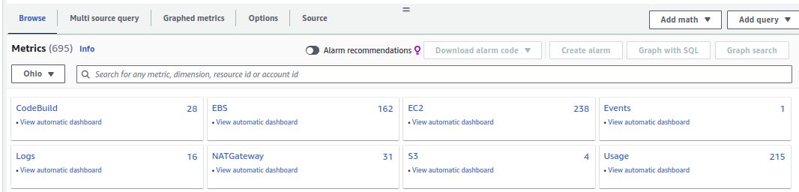
Checking the ec2 instance metrics:

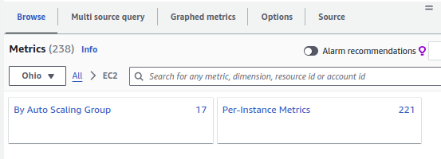
Per-instance metrics mean all instance metric with default metrics.
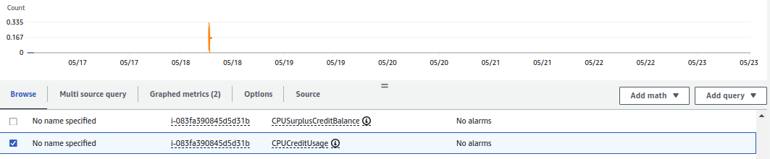
Creating the ec2 instance and written the python file which will inscrease and decrease cpu usage,we can check on the metrics log.

EC2 instance will send the details into cloud watch for every 5min.
Depends on aws services.

Click on monitoring tag in EC2 instance,you can able to see the metrics which are recorded from cloud watch

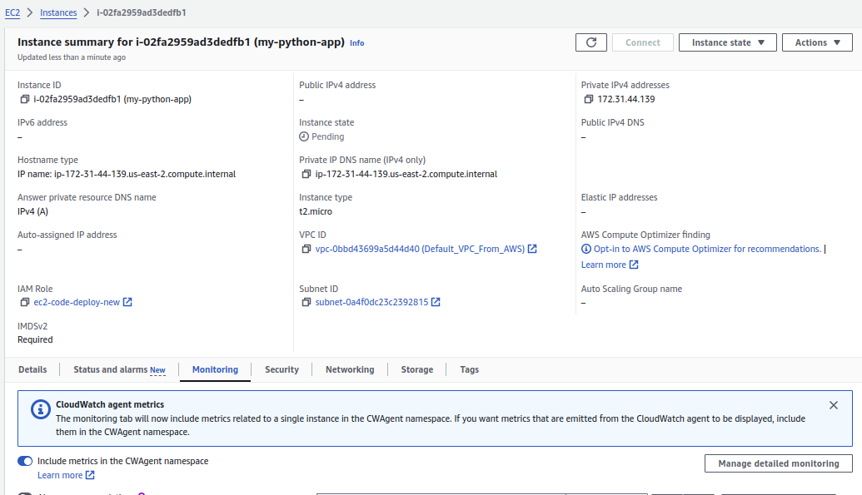
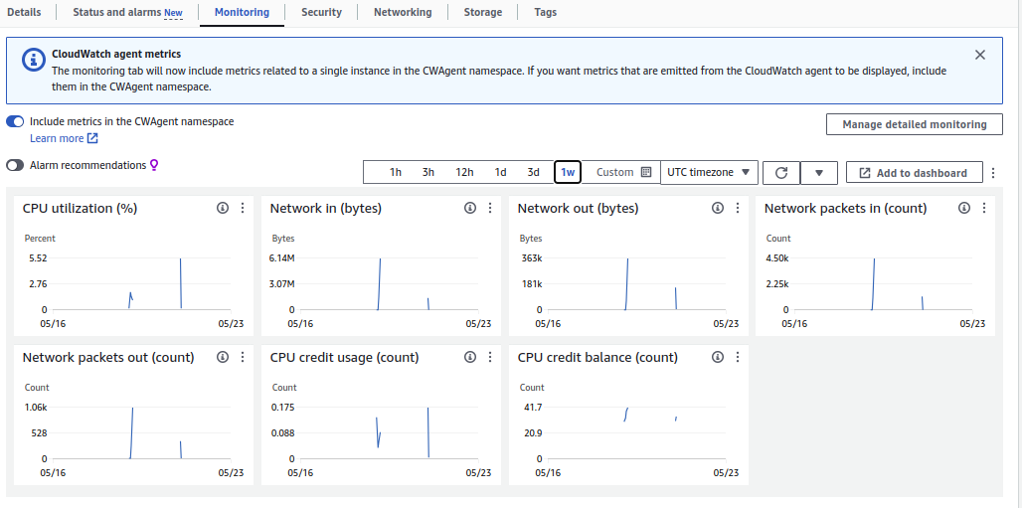

Enabling detailed monitoring:
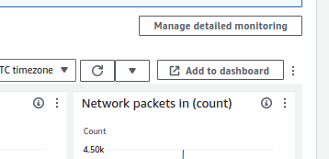

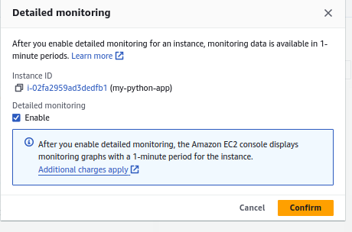

Running python script in EC2 instance:

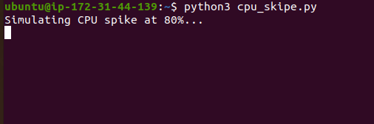

Checking cpu usage from monitoring tab:

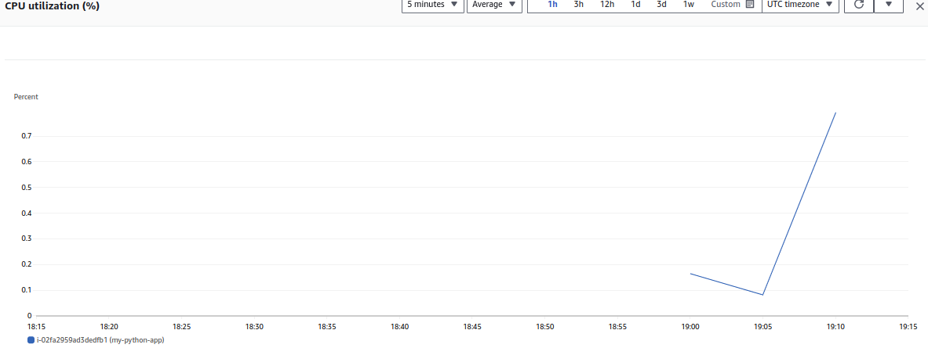
We have option to write query,setting the refresh time

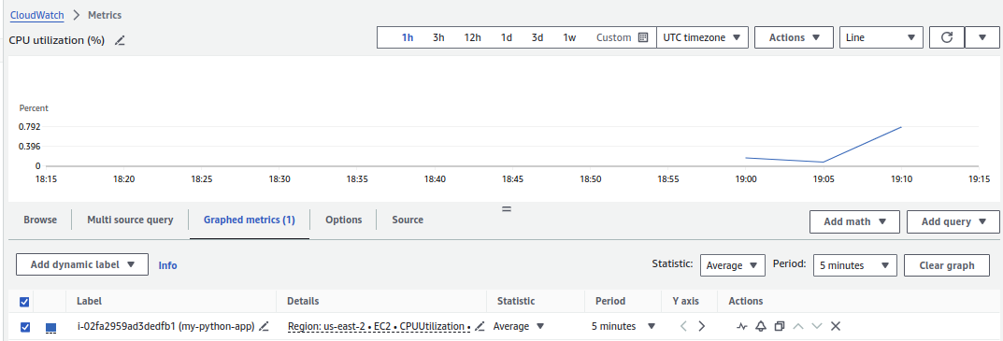

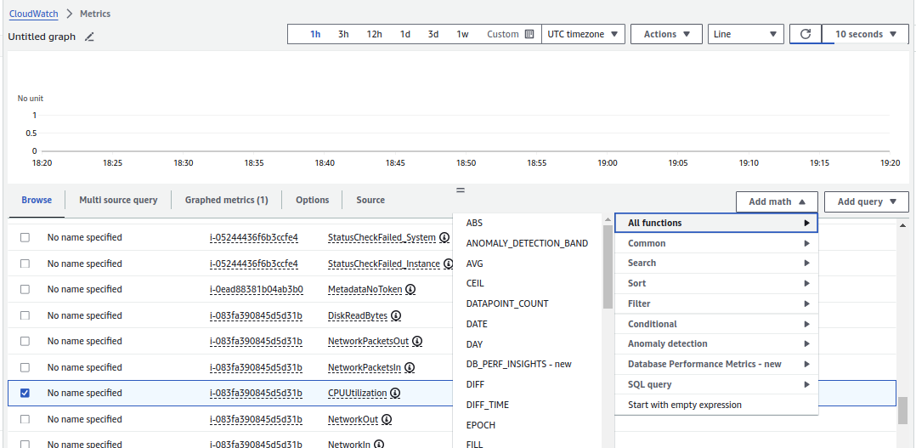
Taking the average usage of every 5min by selecting period and statistics.
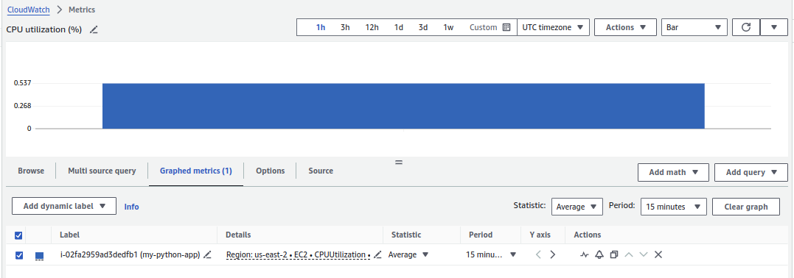

We got to know the usage,for this usage we cn set the alrams.

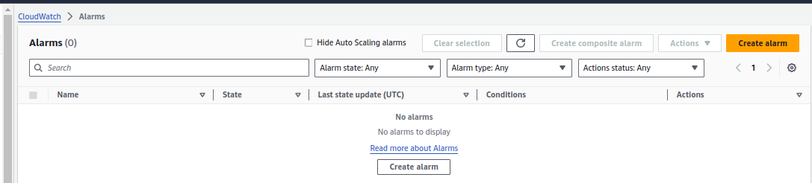

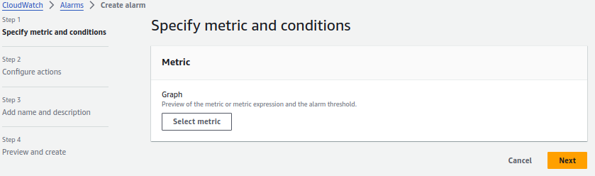
In organization,the statistics will be avrage and period will vary.
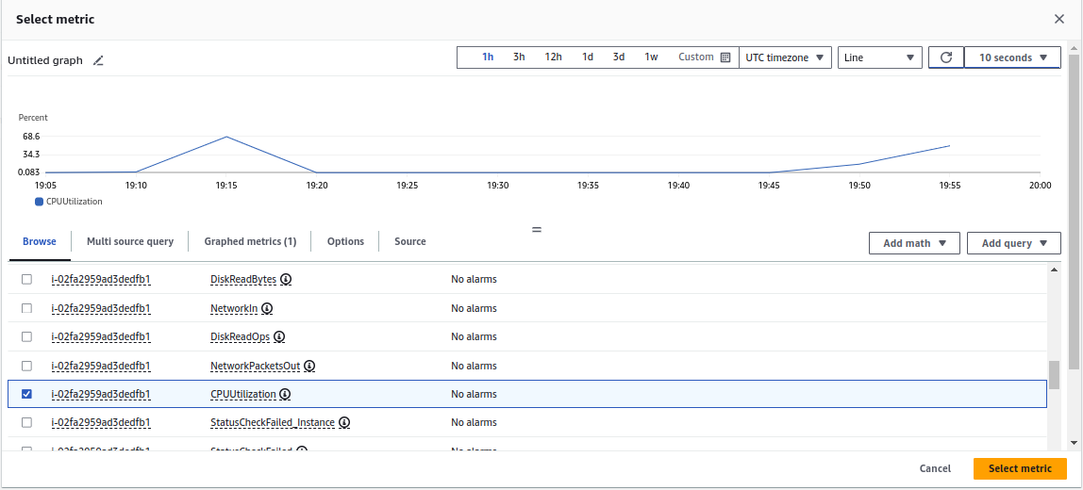
Select the instance properly,first time i selected wrong instance.
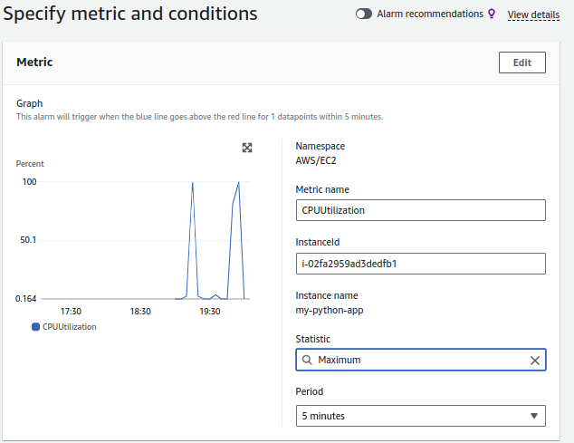

Select on how many percentage,the alarm will need to come.
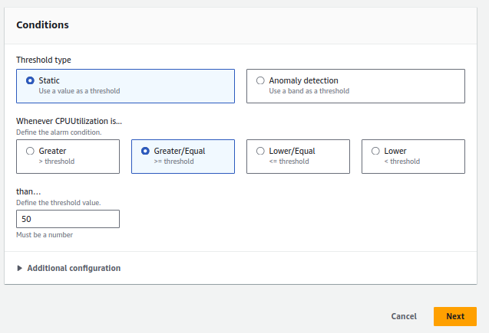
Click on new topic to add your gmail for notification
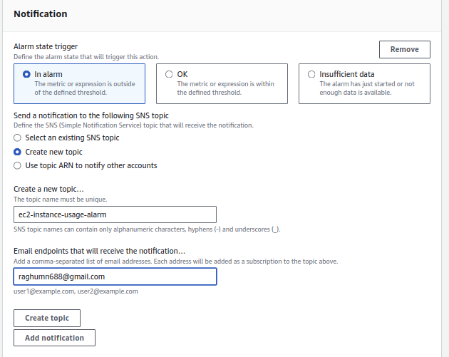
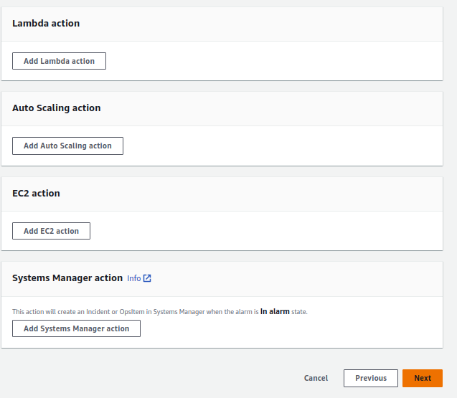
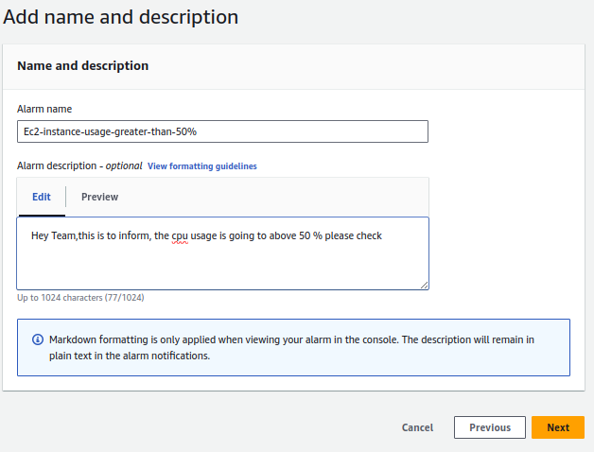
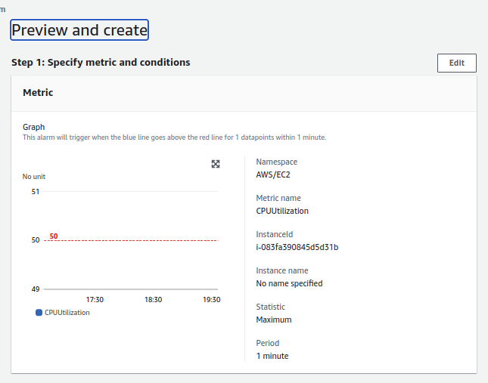
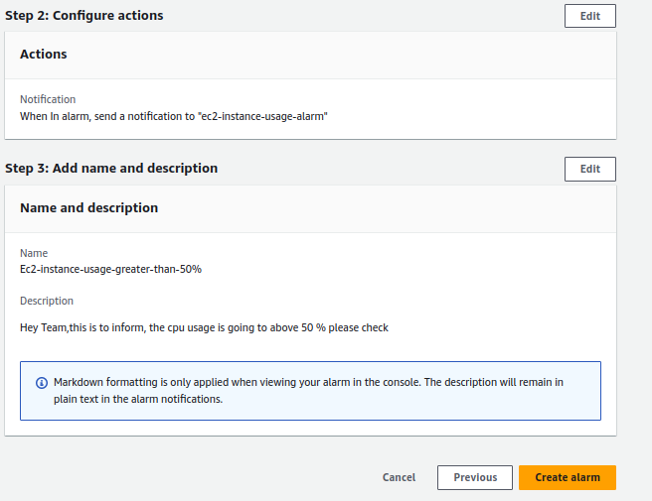
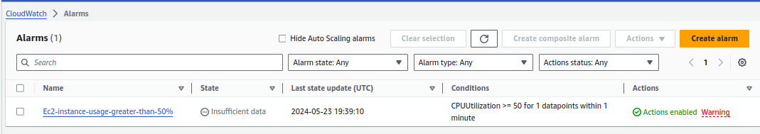
You are seeing the insufficient data right, go to your mail and click configm subcription.
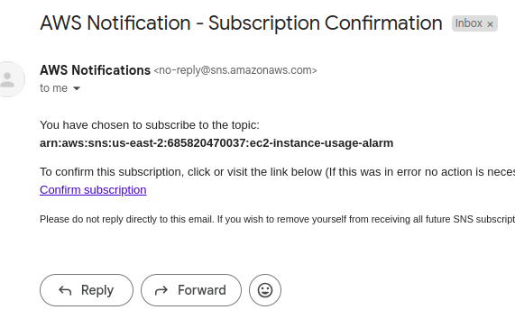

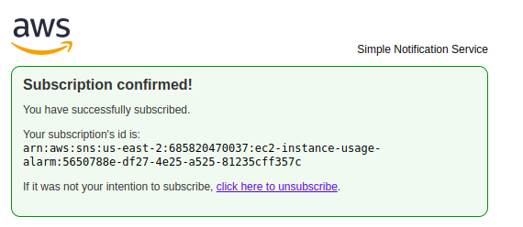
Refresh and check the alarm status,it will be moved to ok state.

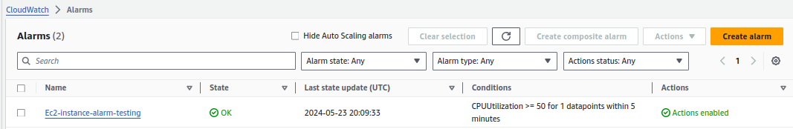

Run the python script to increase cpu usage.

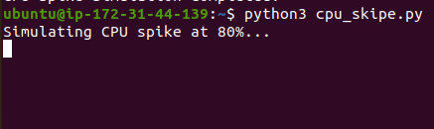

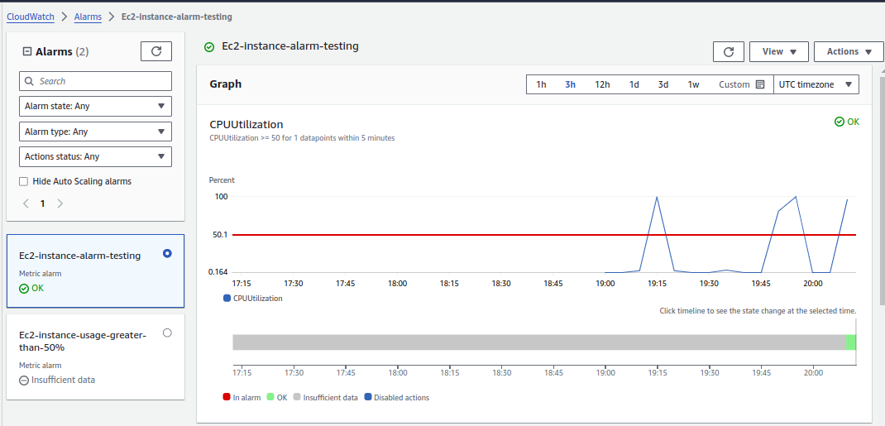
It is reached above 50%,it will send the notification,check mail

