AWS EKS

AWS EKS is managed control plan service provided from aws and provide easy way to attatch the worker planes.
ESK will go solve the belwo problems
*creattion of cluster is more complex,there will so many components we need to install
*Maintaining cluster and making it High available is difficult

Why we need EKS?Or why need to use the aws EKS?
To create a HA kubernetes cluster,we need to mutiple control plane and worker plane

In control plane,we have install the below kubernetes components
*API server
*scheduler
*etcd
*control manager
*cloud control manager
In worker plane,we have install below componets
*kubeproxy
*containerd
*kubelet
installing all these components take more time,it may be error occures and we have to maintain cluster have to be in High available

you can tell we will use KOPS to create cluster, KOPS will help to create the cluster but after cluster created,there will so many will occurs
*api server down
*certs expire
*etdc crased
*scheduler issue
efforts will go to sloving this issues
this is for one cluster,what if we want to maintainer 100 cluster.

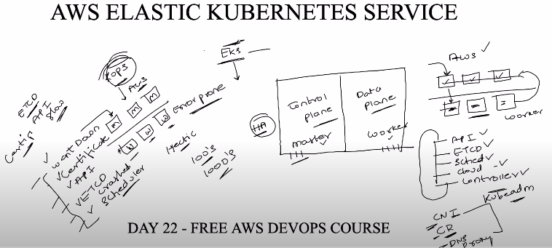

Reasons to choose EKS:
*cluster creation is easy
*maintainance will be done from aws team
*evenif something went down in cluster,we can ask them to check.

EKS --> allow to create the control plane/planes and provide easy way to attach the worker planes.

We can use the 1)EC2 or 2)Fargate as worker plane

Fargate is aws managed serverless compute like lambda(lambda will be used to run application once it is once ter down instance) but Fargate allow to containers.

Fargate or EC2 will takecare about the worker plane.

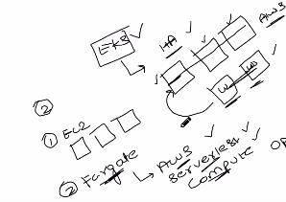

There are two ways to create cluster in AWS.

*Create ec2 instances and set the required componets
*Use EKS control plane service and attach worker planes. --> usage of EKS is significantly increased,most of all make use of EKS.

Why we need to go with ingress? And workflow of ingress in cluster?
Created the cluster and deployed the application,wanted to create service to provide access to application.
Service will provide three types of creation
1)cluster IP --> default type,able to access within cluster,need to login into one of node and access it, if we don’t mention any type, service will be create with cluster ip
2)nodeport --> able to access appliaction from any node ip address but user ust be in their private network
3)load balancer --> public access but pulic ip will given from cloud provider,they will charge more public ip
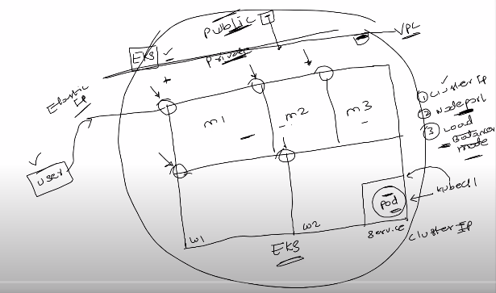

that is the reason we went with ingress.

Impartant Notes:

Create deployment,service for pods with clusterip or node port and create ingress,

Ingress allows the customer to access the application from cluster,ingress will rout the request come into application dsn into service,then service will route into application pod.

How application access will work with ingress and ingress controller?
Customer will request into application dsn,request will go to ingress controller(ingress controler is application load balancing controller in cluster,so many companies are proving the ingress controler to use in cluster ) which is present in public network,have the info about the all ingress resources or watch ingress resouces created on cluster,ingress controller will create application load balancer (ALB) and request go to ALB,update the ingress rule configuration into ALB,redirect request to ingress object , ingress object route into service and then service will route into application pod.

In diagram ihe written as ALB near to ingress controller,actually ingress controller is also calles as ALB controller.

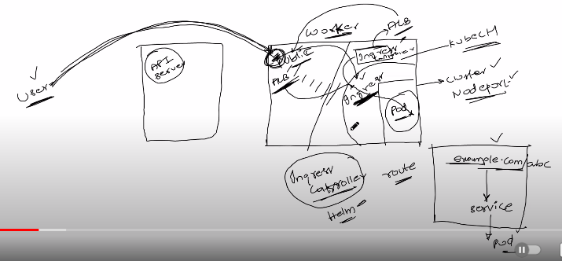

Prerequites:
kubectl – A command line tool for working with Kubernetes clusters. For more information, see Installing or updating kubectl.
eksctl – A command line tool for working with EKS clusters that automates many individual tasks. For more information, see Installing or updating.
https://docs.aws.amazon.com/emr/latest/EMR-on-EKS-DevelopmentGuide/setting-up-eksctl.html
AWS CLI – A command line tool for working with AWS services, including Amazon EKS. For more information, see Installing, updating, and uninstalling the AWS CLI in the AWS Command Line Interface User Guide. After installing the AWS CLI, we recommend that you also configure it. For more information, see Quick configuration with aws configure in the AWS Command Line Interface User Guide.

While running any command with its option use the long format of option,it will take time to type but it is very easy to remember.

Creation EKS cluster by attaching the fargate as worker node.

$ eksctl create cluster --name demo-cluster --region us-east-1 --fargate

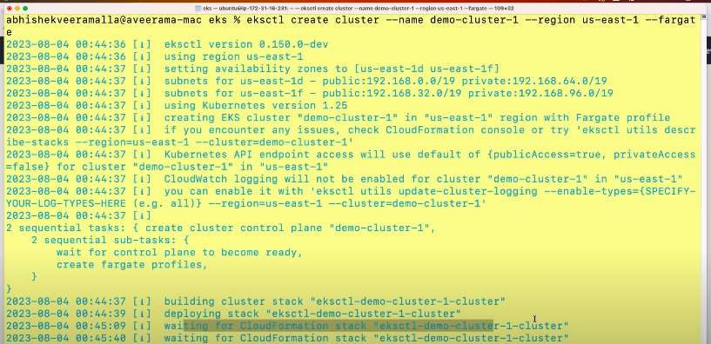

it will take 10 to 15 min to create the cluster.

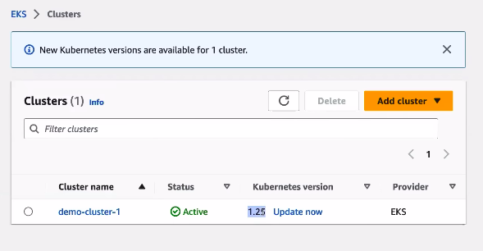
You will get the all resouces created in that cluster,get all resource details in this section
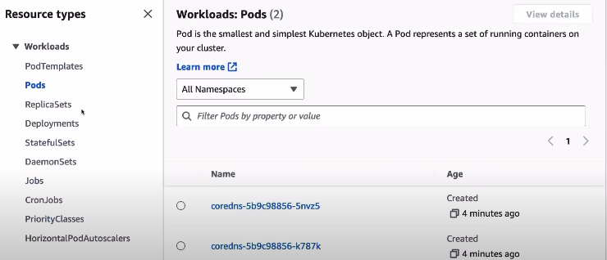
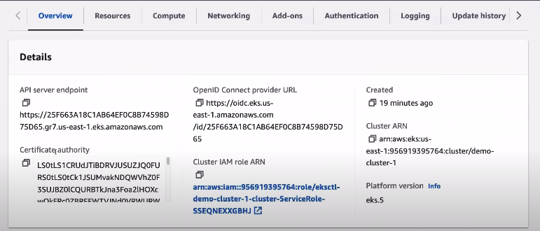
overview give info on api server end,OpenID end point
OpenId endpoint is used configure the identity provider,
mean identity provider contains the all users data,ldap is one identity provider,when user login with his credential,get it validate from identity provider,identity provider have info of user.

Compute:we are using fargate as worker planesm,we can also use the EC2

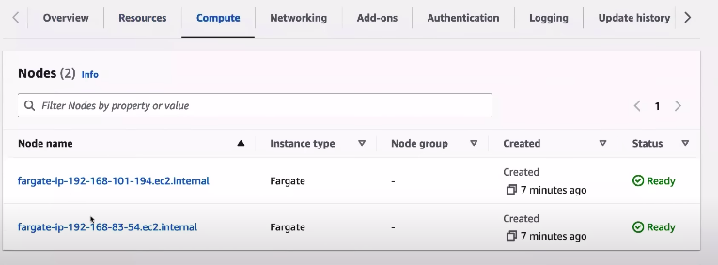
Fargate Profile: you can able to deploy application in default and kube-system
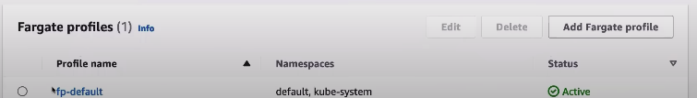
namespace if you want to deploy it in other namespace,we need to add new fargate profile

Identity provider: attach any identity provider like ldap,okta etc
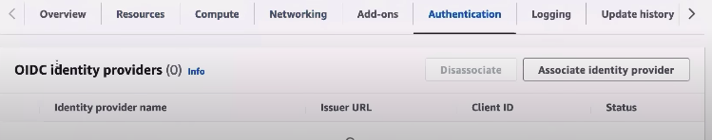

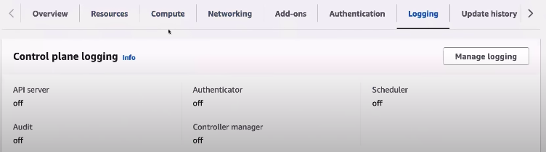
Logging: if you to enable logging of component,we can enable it

Update kubeconfig file into our local to access the cluster
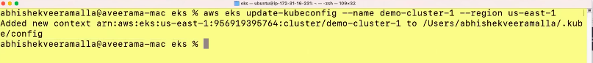
creating the fargate profile to deploy application in new namespace.

$ eksctl create fargateprofile \
--cluster demo-cluster \
--region us-east-1 \
--name alb-sample-app \
--namespace game-2048

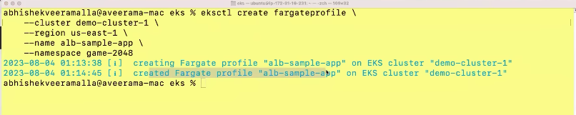
Deployming the game 2048 application:

$ kubectl apply -f https://raw.githubusercontent.com/kubernetes-sigs/aws-load-balancer-controller/v2.5.4/docs/examples/2048/2048_full.yaml
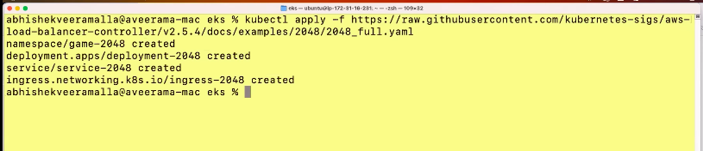
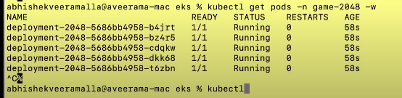
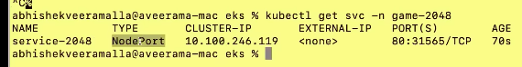

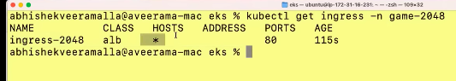
Address is not created because we are not installed ingress controller,
without ingress controller, ingress resource will have no effect

Ingress controller will create the load balancer,then configure the rules defined in ingress resouces into load balancer. Request will come load balancer,redirect into ingress resource --> service --> application pod.

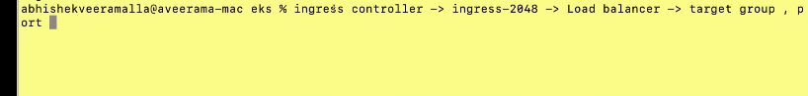
Create alb controller on EKS cluster,before creating it, configure the oidc connector.

Why we need oidc connector is?
APL contoller need to connect and talk with ALB

How to setup alb add on?

Download IAM policy
$ curl -O https://raw.githubusercontent.com/kubernetes-sigs/aws-load-balancer-controller/v2.5.4/docs/install/iam_policy.json

Create IAM Policy:
$ aws iam create-policy \
--policy-name AWSLoadBalancerControllerIAMPolicy \
--policy-document file://iam_policy.json

Create IAM Role:

$ eksctl create iamserviceaccount \
--cluster=<your-cluster-name> \
--namespace=kube-system \
--name=aws-load-balancer-controller \
--role-name AmazonEKSLoadBalancerControllerRole \
--attach-policy-arn=arn:aws:iam::<your-aws-account-id>:policy/AWSLoadBalancerControllerIAMPolicy \
--approve

Deploy ALB controller:

$ helm repo add eks https://aws.github.io/eks-charts

$ helm repo update eks

$ helm install aws-load-balancer-controller eks/aws-load-balancer-controller \
-n kube-system \
--set clusterName=<your-cluster-name> \
--set serviceAccount.create=false \
--set serviceAccount.name=aws-load-balancer-controller \
--set region=<region> \
--set vpcId=<your-vpc-id>

$ kubectl get deployment -n kube-system aws-load-balancer-controller
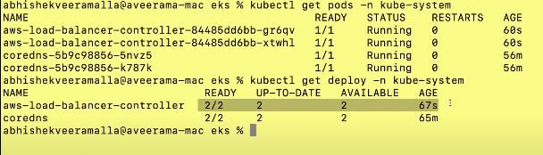
Once the ingress controller is installed,if you have any ingress resource immediatly create load balancer and assign the address
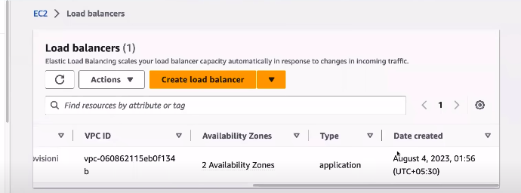

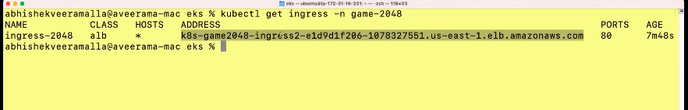
Paste the address in browser to access the application.

