Secret Management on AWS:

why we need to secrte management?
To store and use the sensitive information we need the secret management.

As devops engineer,we are dealing with CI/CD,building images and pushing to private docker registry require username and password.we can’t keep it as plan text,any one can misuse that.
Or connecting to database and getting the details,db username and password are very sensitive.

Secret management services offered from AWS
1)systems manager
2)secrets manager

Hashicorp vault provided from hashicord,widely used systems secret manager in all organizations. In our company also use the Hashicorp vault.

When two use system manager and when to use secrets manager?

Systems manager is very simple,you have create parameter store with type and retrieve,but IAM role of accessing the system parameters must be atached to service which is going to use.

secrets manager is have rotate feature to rotate the stored data like credentials,certs,tokens.
We have rotate feature attached to prevent the anautherized usage.

When we dealing with sensitive data,even it it leaked,they can’t harm the your service like docker username is leaked,they can’t deal with them.
Ex: docker registry url,docker username

when we dealing with very sensitive data and required modification of data frequently.
Ex: docker password, certs and tokens.

You can use the combination of both systems manager and secrets manager.

Storing the docker url and username in systems manager and storing password in secret manager helps optimize the cost.

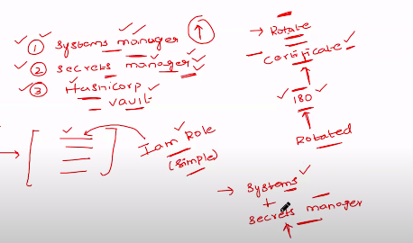

Why we need to go with Harshicorp vault?

Hashicorp vault is open source,dedicated secret management tool, have community support,different encryption methods.
it don’t have any dependency on cloud providers.

When your are using high brid cloud,Hashicorp will help to manage secrets easily.

