AWS Config: service is used to ensure our organization compliance rules (compliance means rules and regulation on reources) are following or not on resources.

Why we need aws config:
We have many aws service,we can’t go and keep on checking on the resources to ensure,is our company compliance rules are followed or not.

In AWS Config,we will create the rule,watch the resource and attach the lamaba function(aws provides some default rules) to check the compliance rules are followed or not on that resource.
Lamba functions are event driven,rule will trigger the lambda function when resource created or updated,lambda function have code to check the rules followed or not in resource.

Lambda functions are wtitten from DevOps engineer.

Ex:
whoever create ec2 instance,it must have detailed montinoting enabled.

Created rule in AWS config,watching ec2 instance and written the code to check detailed monitoring is enabled or not.
Rule will trigger when ec2 instance new created or update ec2 instance.

Creation of Lambda function:

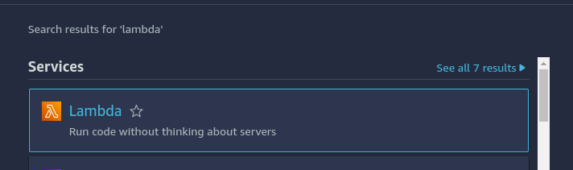

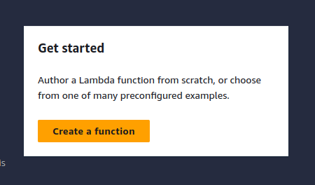

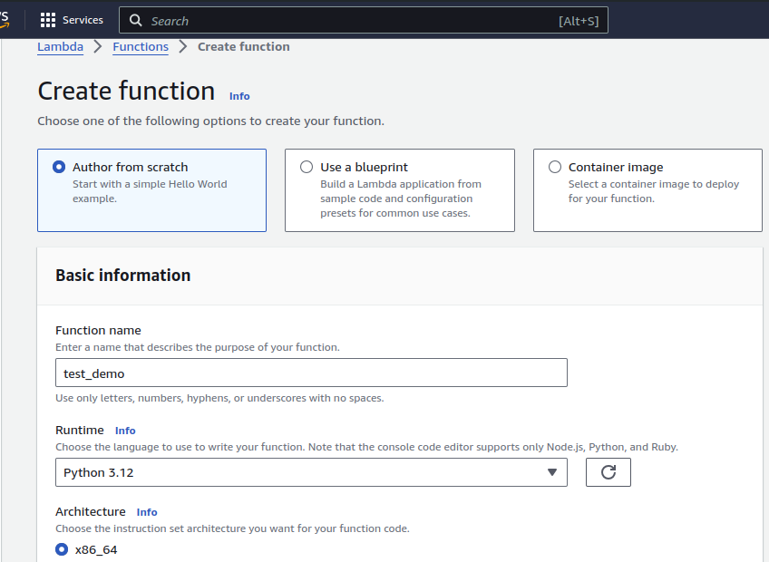

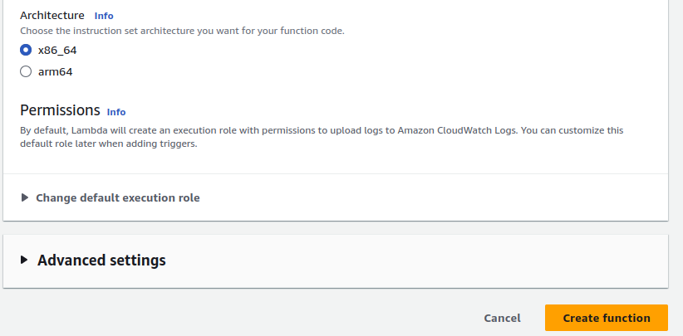
Paste your lambda code
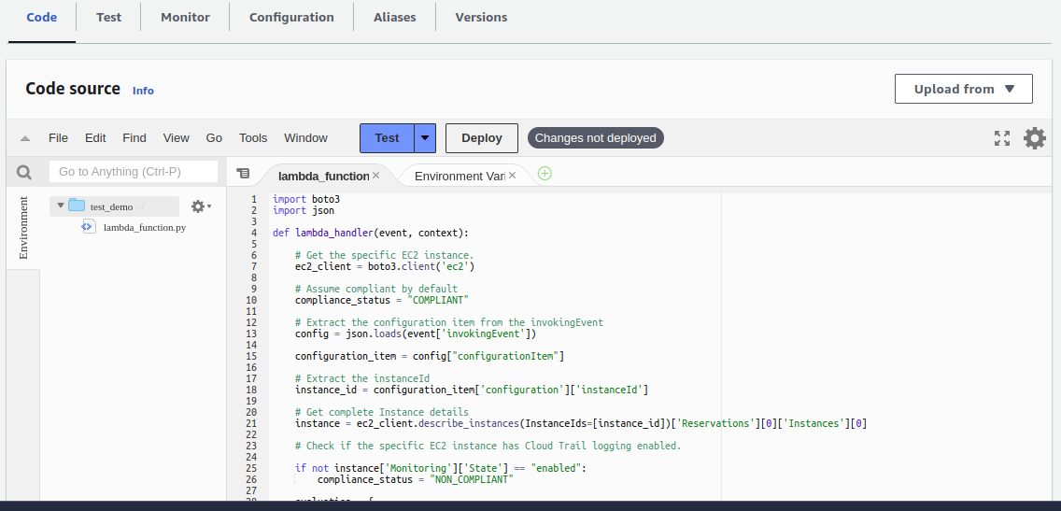
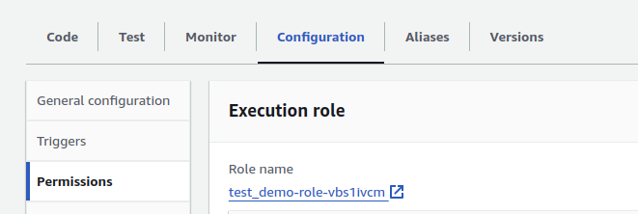
Give permissions to your role which is used for this lambda function

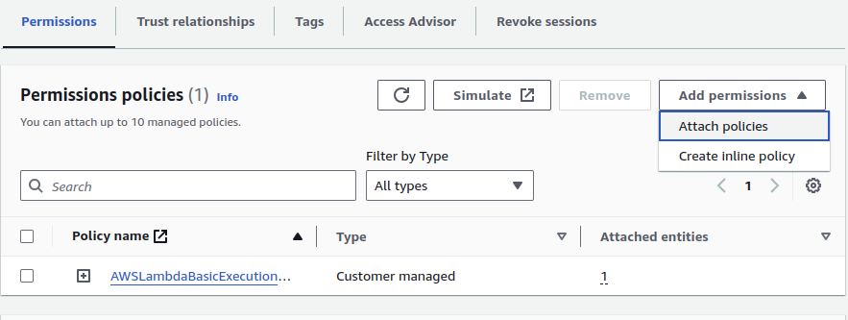

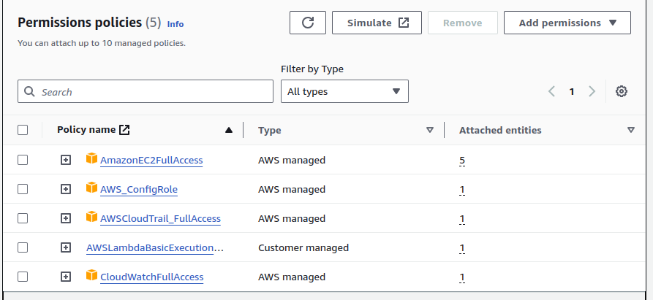
Setting up the AWS config:

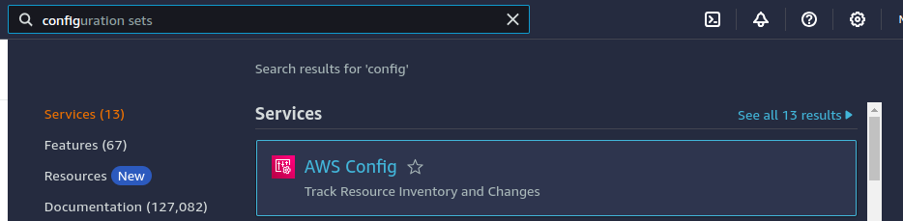

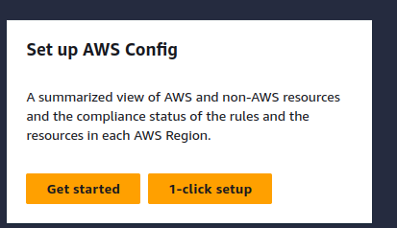

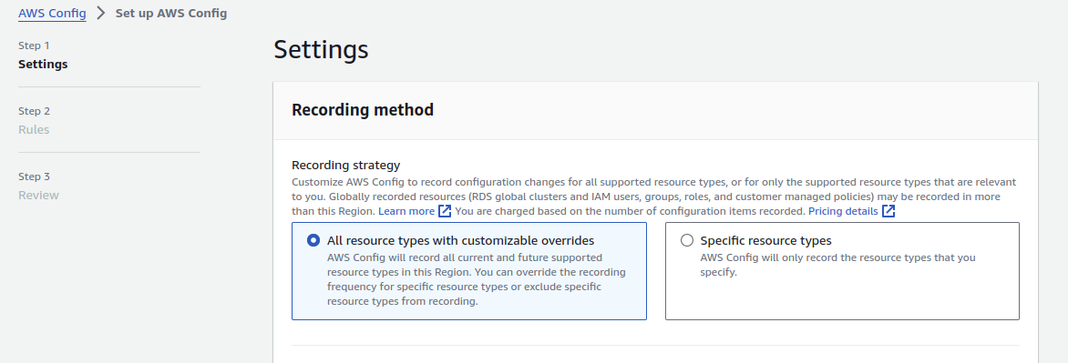

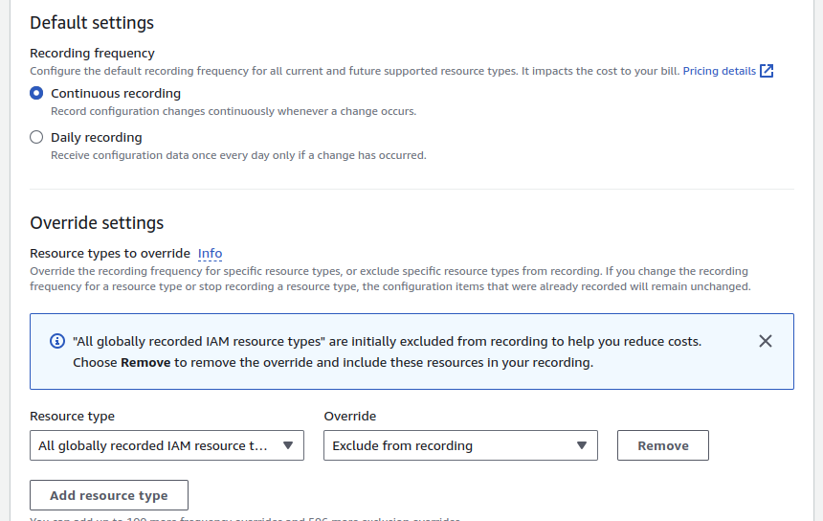

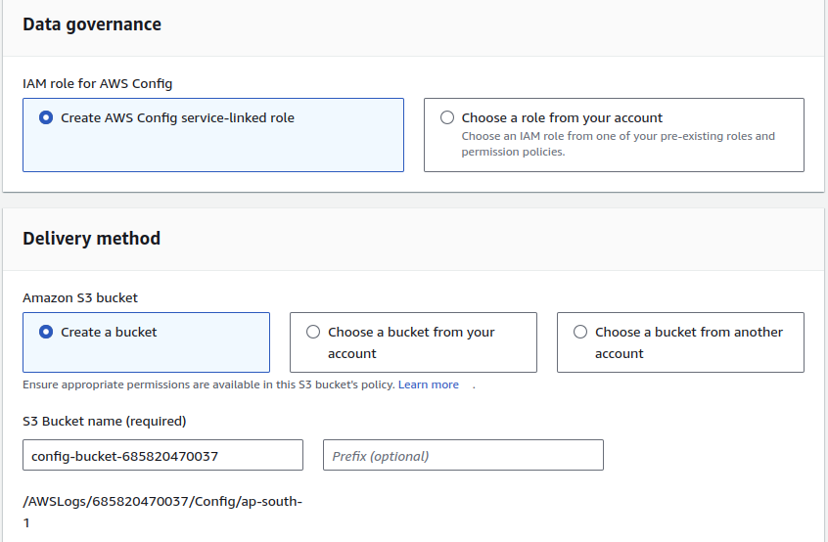
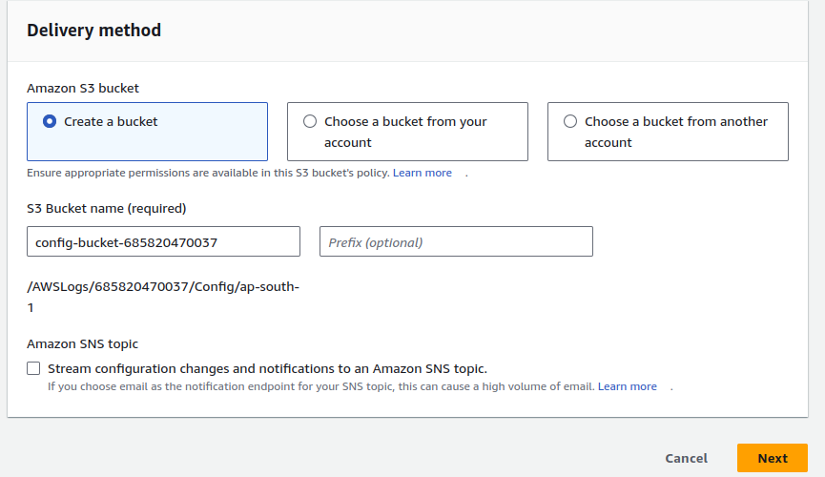

Click on next and create

Creating the rule in AWS config:

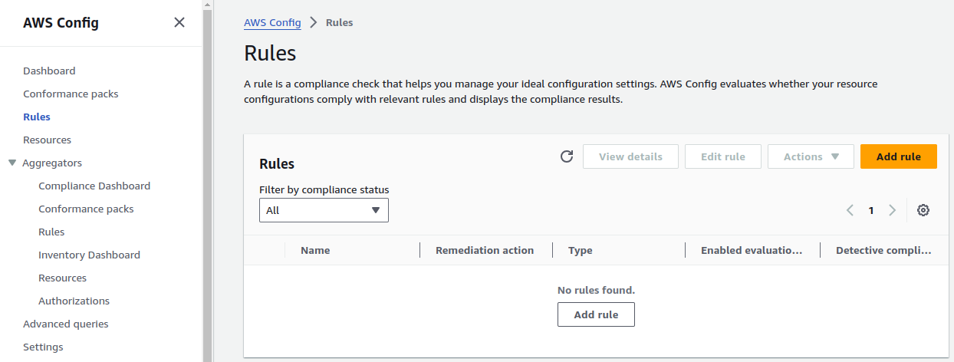
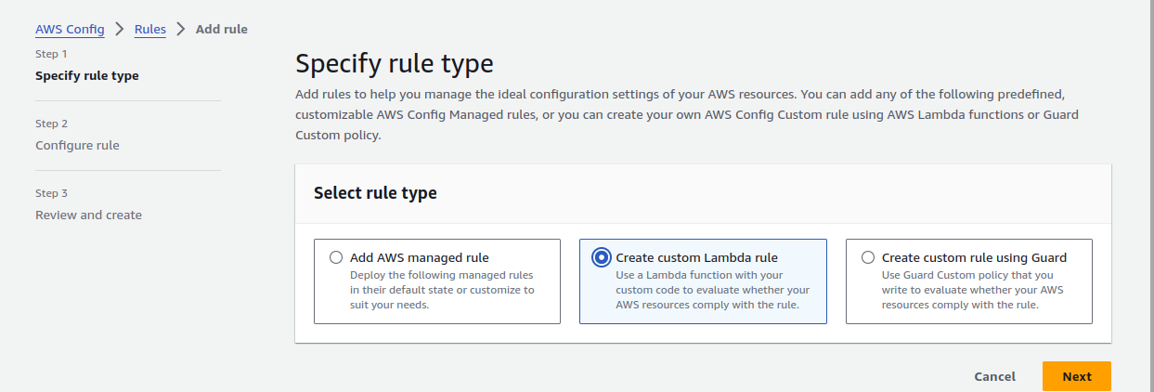

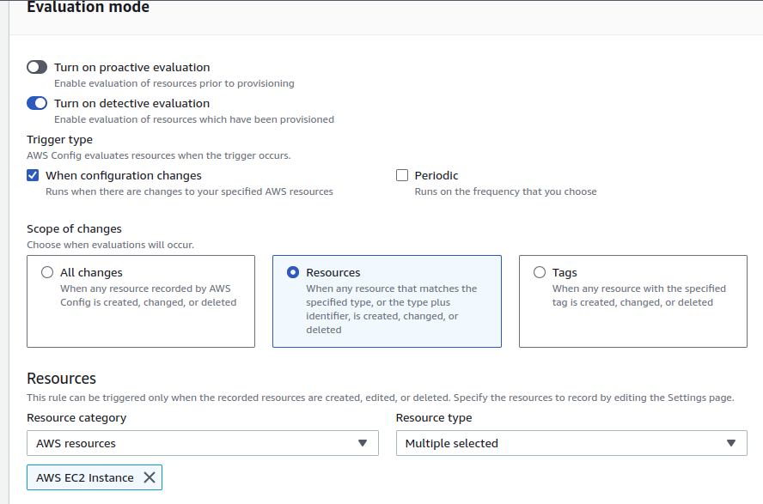
Selecting the resource with when configuration changes. EC2 instance

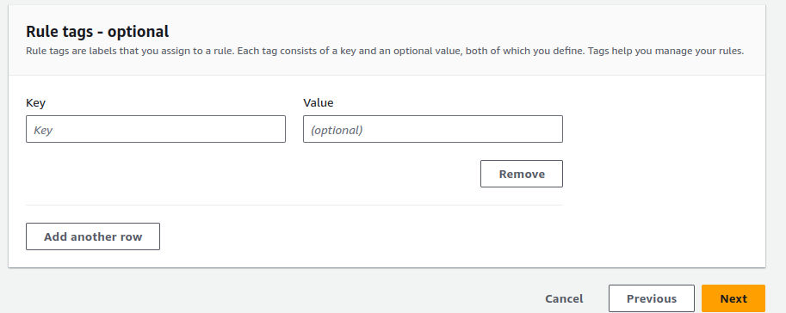

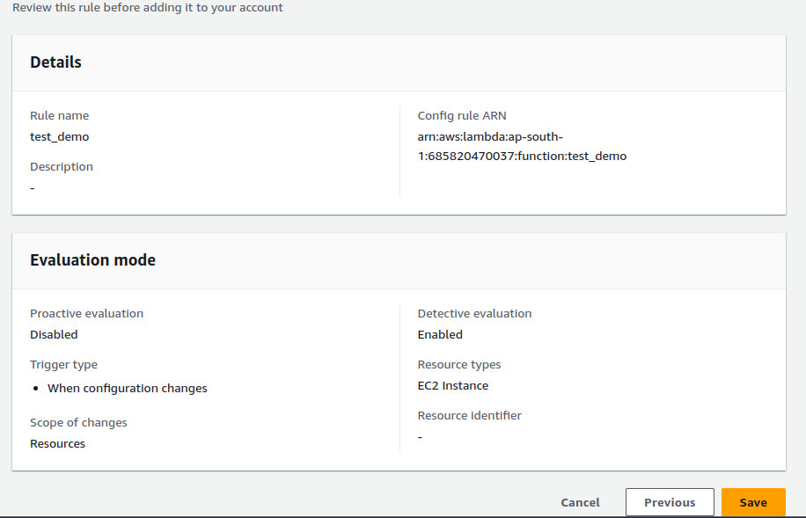
In lambda function below,click on add permison,give name and copy the role arn and clik save
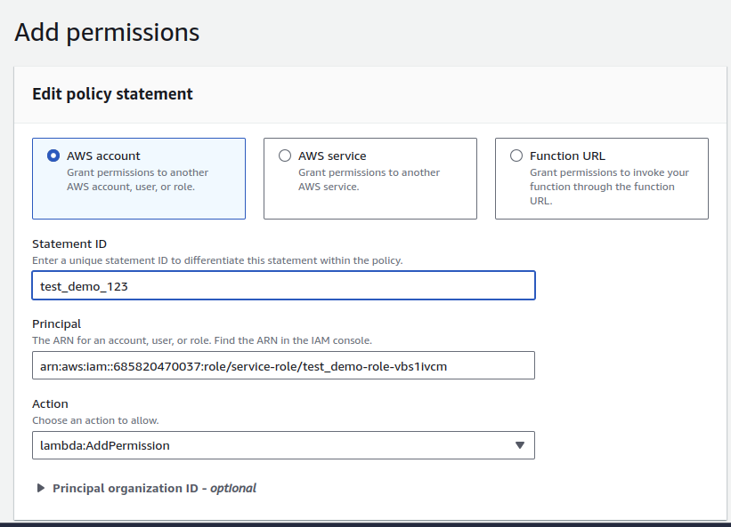
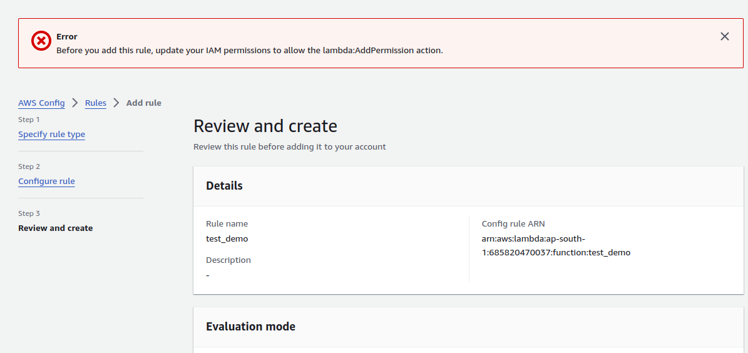
Below error i need to debug?

