AWS-Load Balancers:

AWS provide the three types of Load balancers
1) Application Load Balancer
2)Network Load Balancer
3)Gateway Load Balancer

First we will need to understand the what is Load balancer and packet flow from client to server(OSI layers)?

Load Balancer: Handle the more requests coming to application by distibuting into application servers.

Ex: we deployed gaming application,as now now we have few users accessing our game application, when game become popular, many users try to access at thar time application not able to served and user face slowless and downtime.

To solve this: we deployed application on many servers and places load balancer in front of all servers, LB will redirect the request based on load available in application server

There are many load balancer technics, that are round rabin,ration based load balancing

Many load balancer companies in market --> nginx, F5,Envoy,Traffic etc each of these will support difference load balancing technics

OSI layers:

how the packet transfer from Client to server?what are the layer inloved in traffic?

When search anything in browser,how data will go to search engine then from search engine to client.

7 layers functions
[client] --------------------------------------------------> [server]

When user open browser and send the http request ,by default browser will do http request

Application layer (L7) will decide what kind of protocal user will use to reach to server it may be http protocal,sftp protocal,smtp protocal etc.
http request means Application layer(L7)

From Application layer,your request go to Presentation layer (L6), Presentation layer will check is this request is secure request or not insecure request, Presentation layer encode request if it is secure request using tls otherwise send with insure request

Session layer (L5) will create the session object into request,session object contains the information about request when server receives request,server has to understand few thing about the resquest.
What kind of request is created,when request is created etc.

Transport Layer (L4) will create the small data packs of request to send and recive the response faster. Transpor layer ie ensuring your request is transmiting from client to server in secure way in small data packs.

Network layer (L3) once data packs are created,these has to travel through mutiple routers to reach to server with help of Network. (All router network layers are used here)

Datalink Layer (L2) your request will reach to datacenter,which means final router which is last router of before server, final router is connected to switch,server is connected to switch with phyical cable. Switch will be the datalink layer because it is linking server and inal router

Physical Layer(L1) from switch request will go to the server through physical cable connected from switch to server. Physical cable will be physical layer to data recieve and transfer.

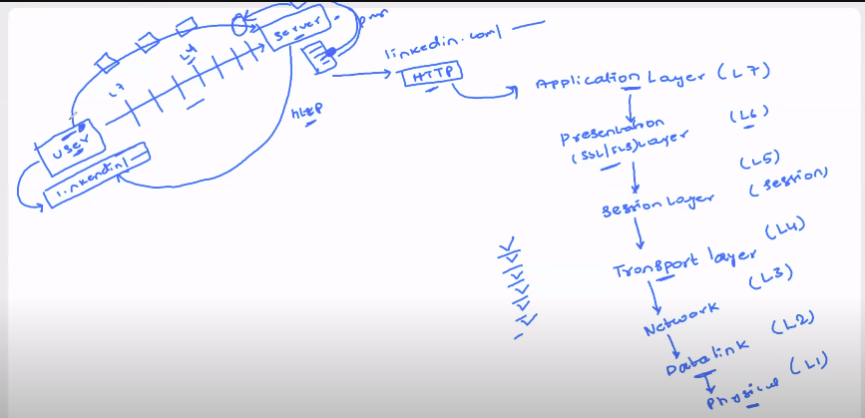

Devops engineer and application developer together discuss and choose the load balancer based load balancer and trafic layers.

When to choose which load balancer?

If you want to perform trafic load balancing at Layer 7(Application layer) choose ALB:

Layer 7 have mutiple protocal,lets consider http protocal
When you want to check the http request at Layer 7 and decide on load balancer based on host,path,domin you can choose Application Load balancer

Ex: when request is
http://amazon.in/log --> ALB will decide and forward request to login section server
http://amazon.in/payment --> ALB will decide and forward request to payment server

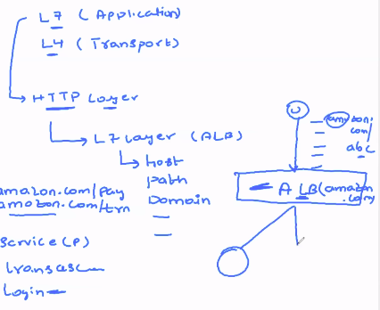

Making decing at the Application layer,that is the reason we are calling as Application laod balancer.
ALB is costly load Balancer because it have advaced capabilities like sending secure request from ALB to application.doing encryption , based request forwarding to application server ect.
And also slow becuase latency is added at the time of load balacing

if you want to perform trafic load balancing at Layer 4(Transport layer) choose NLB:

NLB --> don’t want to peform the load balacing based on request.
NLB will create small data pacts and ensure the low latency and High transmission of data into application server.

NLB is less cost and low latency,is used in gaming servers,video stream platfrom

In realtime, we need to use the NLB for faster response.

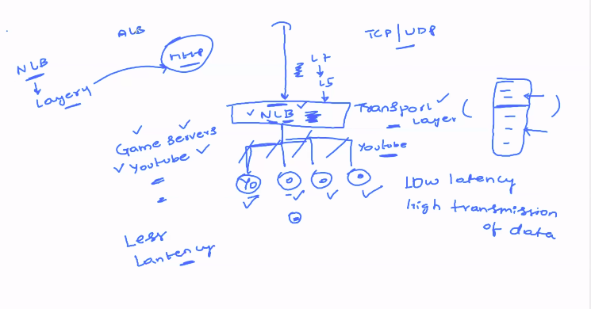

GWLB --> Gateway load balancer
When your company which is developing Virtual applances means VPN and firewall application.
Go with GWLB because it giving high security load balacing by doing advanced encryption. ALB and NLB is not giving the high security

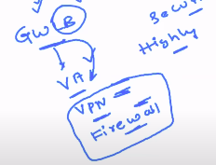
The request will be more specific when we deal with VPN, firewall application etc.

