What is a Database ?
=> A structured collection of data is called as Database. We can use database to store, manage and retrive data
in an efficient way

Types of Database:
1. Relational Databases (SQL Databases): Data is stored in tables which contains rows and columns. There
is a query language known as Structured Query Language used for
relational databases.
a. MySQL
b. PostgreSQL
c. Oracle
d. Microsoft SQL Server

2. NoSQL Databases: Data is stored in an unstructured way
a. MongoDB
b. Fitebase
c. Cassandra

My SQL Unified Strength
1. Speed and Reliability
2. Ease and Learning
3. Free and Open Source

SQL Commands:
1. Data Manipulation:
a. INSERT INTO
b. UPDATE
c. DELETE

2. Creating Tables:
a. CREATE TABLE
Example: New Table

3. Modifying Tables:
a. ALTER TABLE
Example: Modify Structure

4. Permission Management:
a. GRANT
b. USE database_name

Querying for Clarity: Database Insights
1. Show All Records
2. Select Specific Columns
3. Filter Records
4. Count Records
5. Calculate Average

Commands: Giving databse a command to get something
Queries: Getting something out of the database

Basic Commands:
1. CREATE DATABASE database_name;
2. DROP DATABASE database_name;
3. USE SchoolDB;

Key Terms:
1. Schema -> Blue print of databse which defines three things:
a. Tables
b. Columns
c. Relationships

2. Primary Key and Foreign key:
a. Primary Key: Thing which will be unique. For e.g: StudentID
b. Foreign Key: In other table if we refer to Primary key of the table

3. Normalization: We normalize the data so that there will be no duplicates. It removes redundancy.

Data Types:
1. Characters:

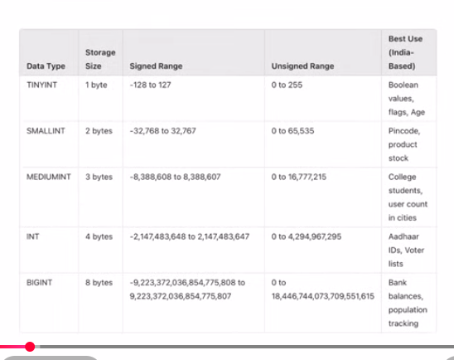

2. Numericals

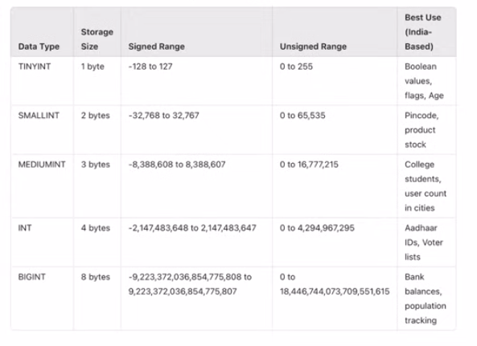

3. Decimal

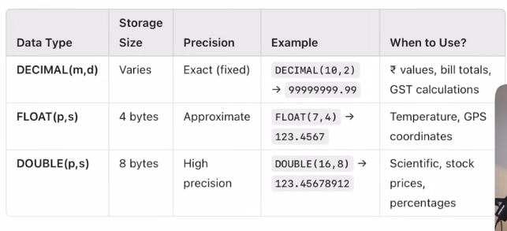

4. Date Time:

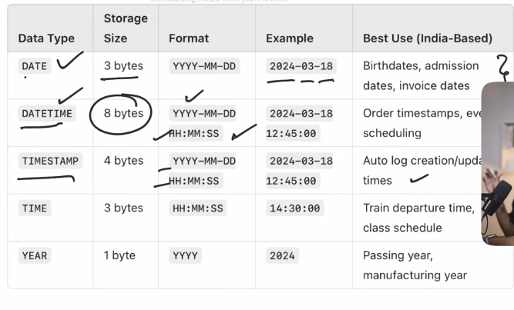

Relationships and Joins:

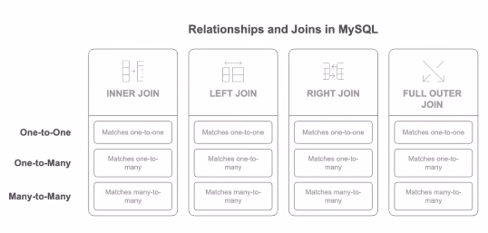

INNER JOIN:

SELECT A.column, B.column
FROM TableA A
INNER JOIN TableB B ON A.common_column = B.common_column;

LEFT JOIN:

SELECT A.column, B.column
FROM TableA A
LEFT JOIN TableB B ON A.common_column = B.common_column;

RIGHT JOIN:

SELECT A.column, B.column
FROM TableA A
RIGHT JOIN TableB B ON A.common_column = B.common_column;

SubQueries, CTEs and Views in SQL

