**Week-1**

**Problem-1**

Create a Navigation bar using HTML (With out CSS and Bootstarp), it should contain

-> Home

-> Signup

-> Login

-> Search Bar.

Note: once you create web page upload the page to Github account with public access

and submit that github link here : <https://github.com/Raghunani12/FWD-LAB.git>

Live Demo : <https://raghunani12.github.io/FWD-LAB/>

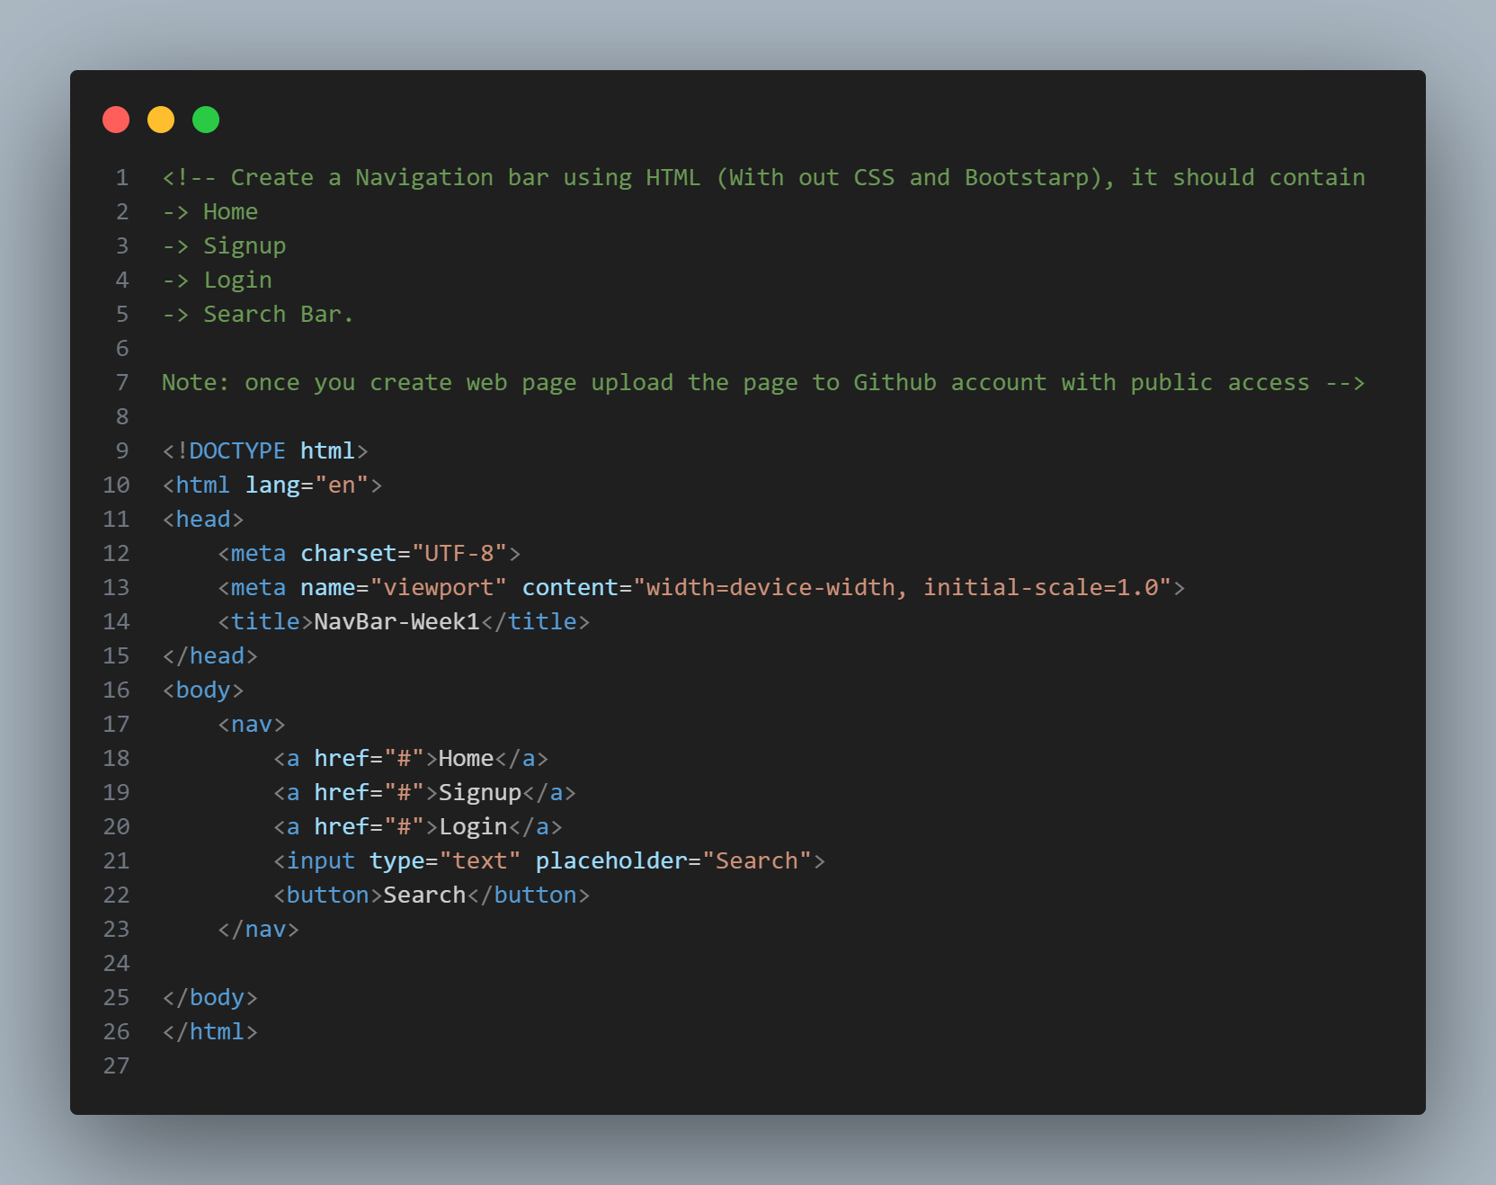

**OUTPUT:**

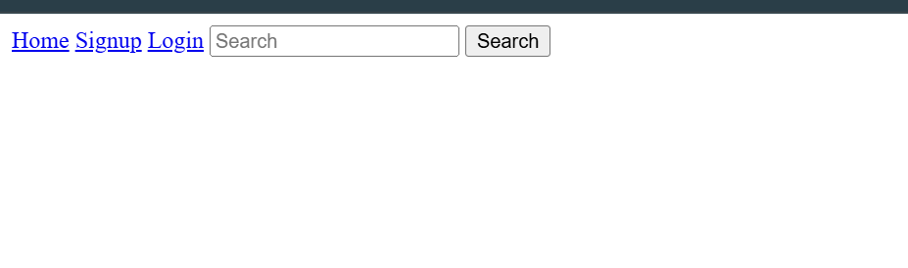

**Problem-2**

Create a Portfolio page using HTML , it should contain

-> Self introduction

-> skills

-> projects/work experiences (Git links)

-> Feedback /achivements

-> Education profile

-> Contact information.(Social media /phone /email)

Note: once you create the poftfolio upload the page with neccesary document to Github account with public access

and submit that github link here : <https://github.com/Raghunani12/FWD-LAB.git>

Live Demo : <https://raghunani12.github.io/FWD-LAB/>

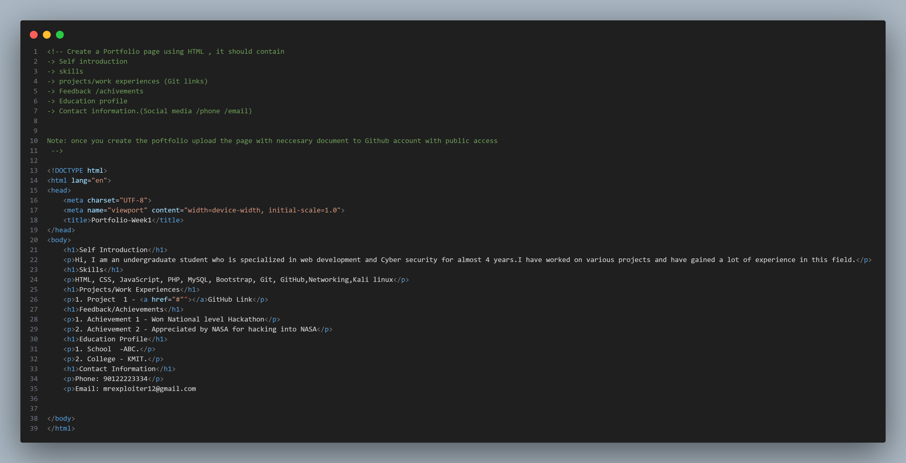

**OUTPUT:**

