**Week-2**

**problem-1**

Create a Feedback form using HTML (With Internal CSS), it should contain

-> Name (optional)

-> Email(Optional)

-> phone (optional)

-> Rating

-> Any Questions regarding product or service.

-> Additional comments (optional)

-> Submit button

Note: once you create web page upload the page to Github account with public access

and submit that github link here : <https://github.com/Raghunani12/FWD-LAB.git>

Live Demo : [https://raghunani12.github.io/FWD-LAB/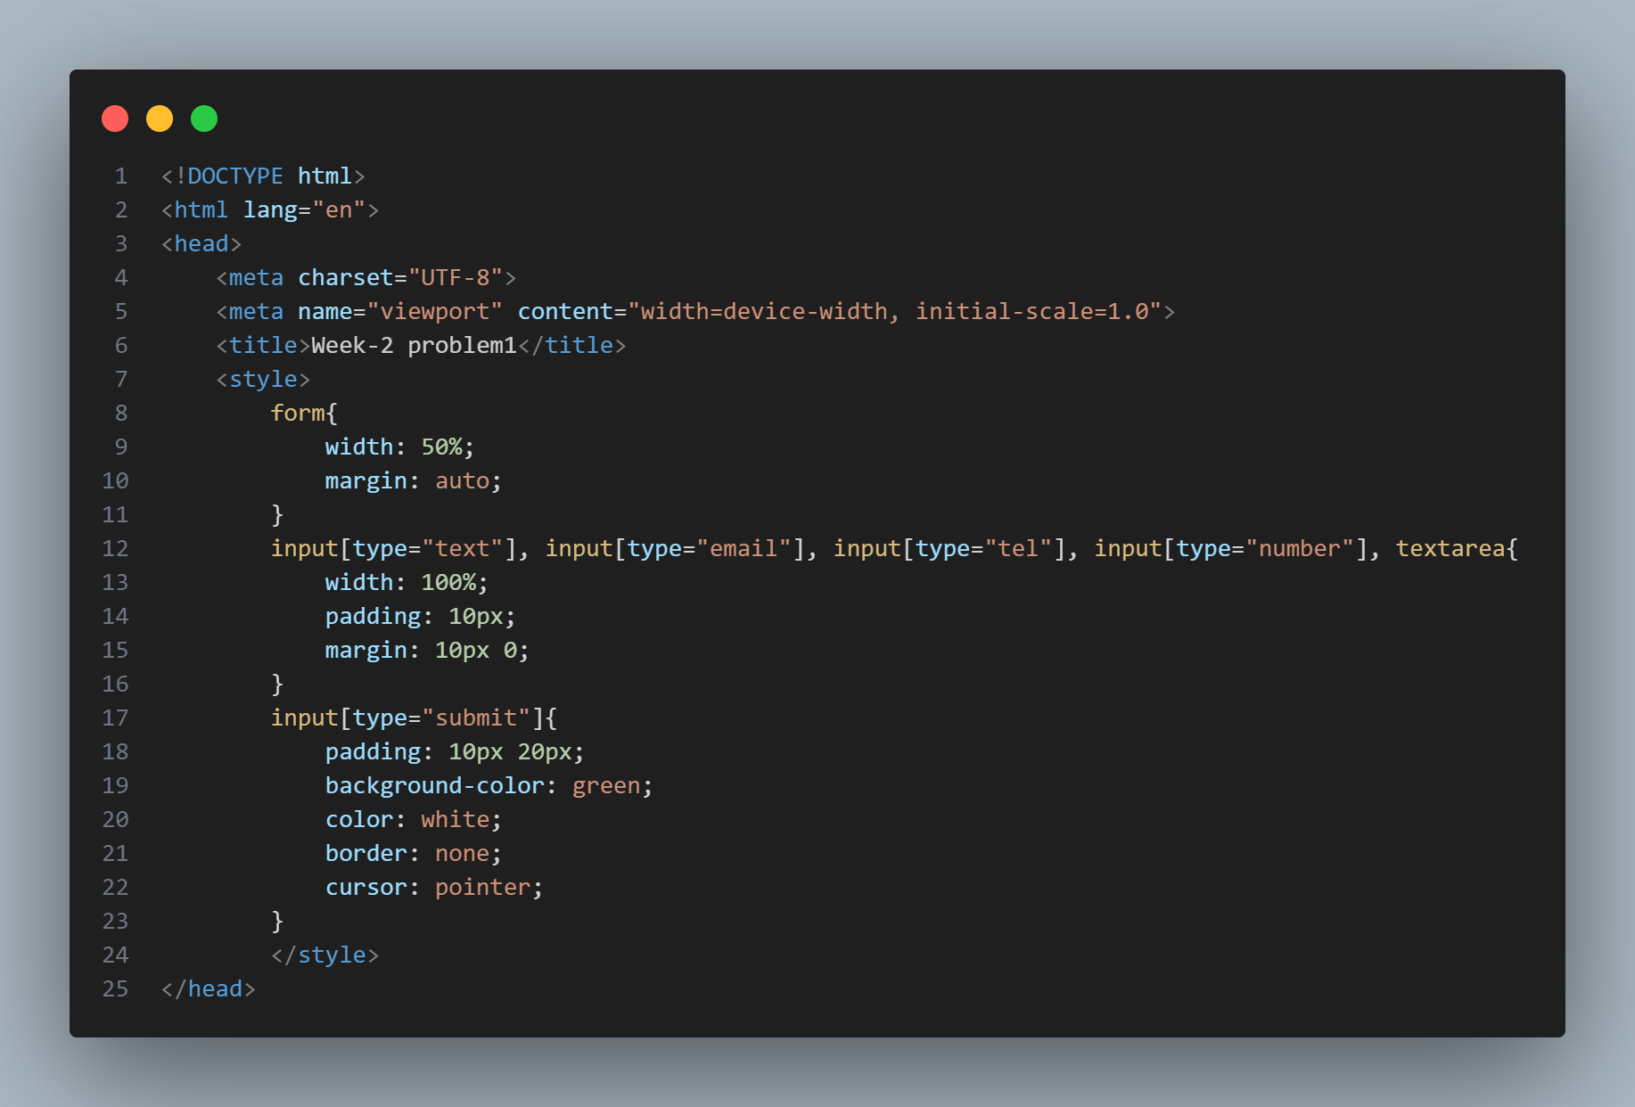](https://raghunani12.github.io/FWD-LAB/)

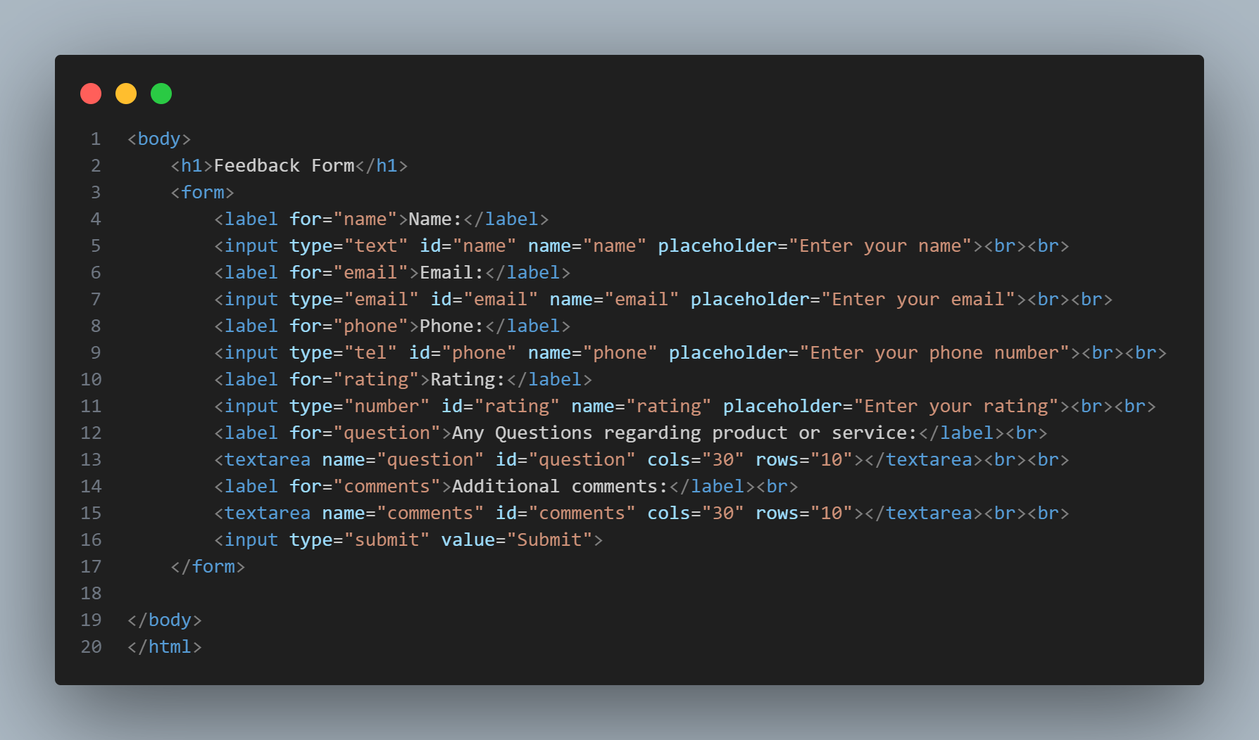

**output**

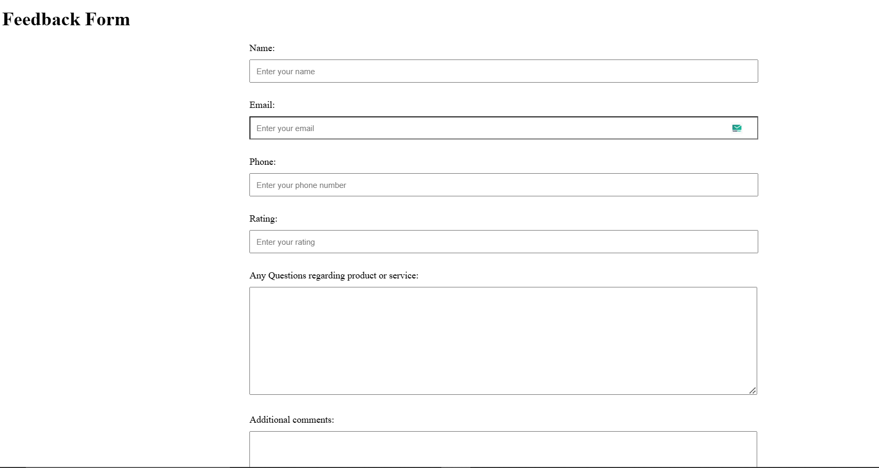

**Problem-2**

update a Portfolio page using internal CSS , it should contain

-> Self introduction

-> skills

-> projects/work experiences (Git links)

-> Feedback /achivements

-> Education profile

-> Contact information.(Social media /phone /email)

Note: add Internal CSS

Note: once you update the poftfolio page upload the page with neccesary documents to Github account with public access

and submit that github link here : <https://github.com/Raghunani12/FWD-LAB.git>

Live Demo : <https://raghunani12.github.io/FWD-LAB/>

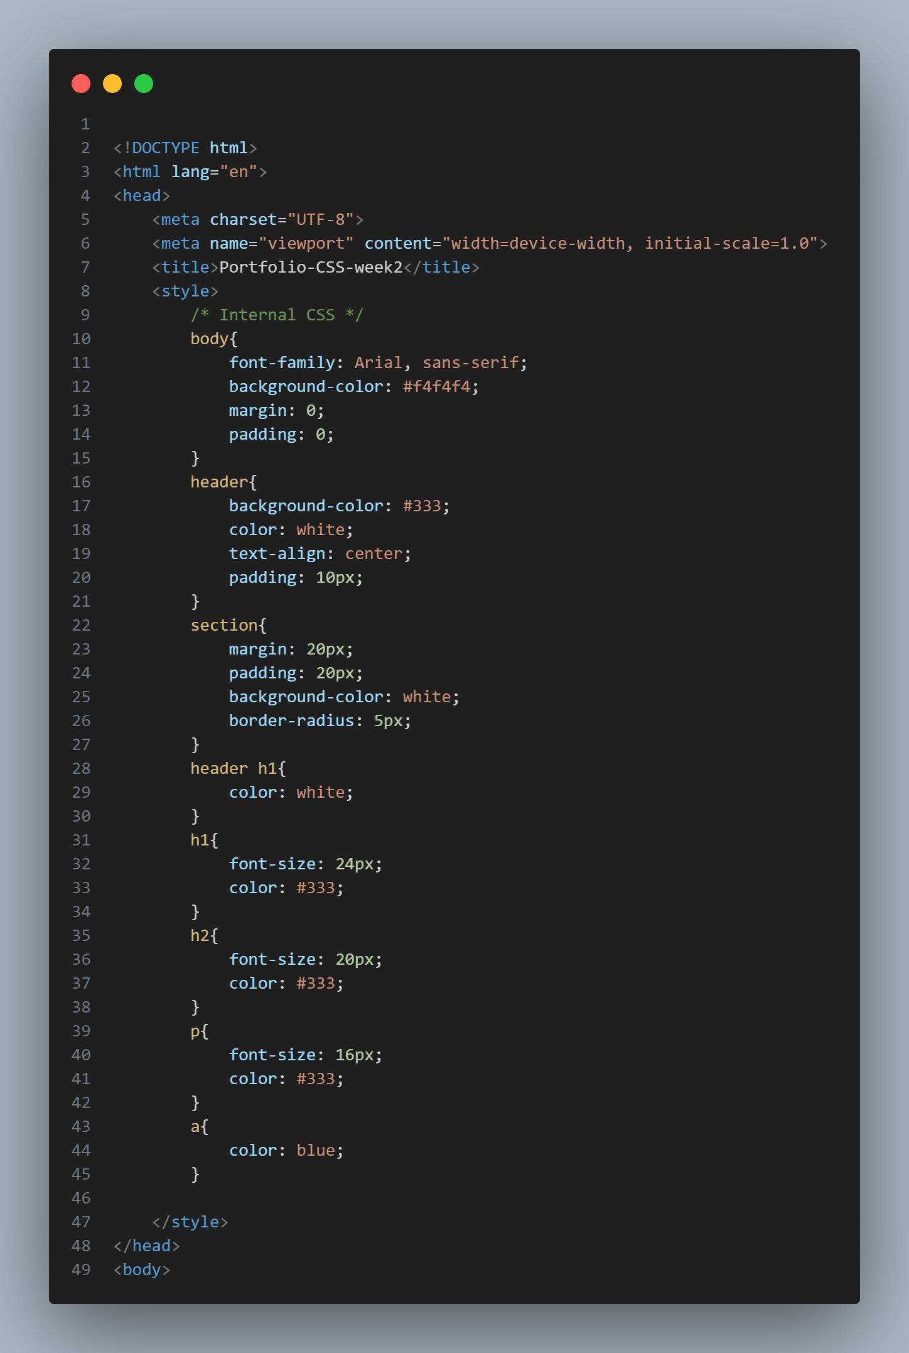

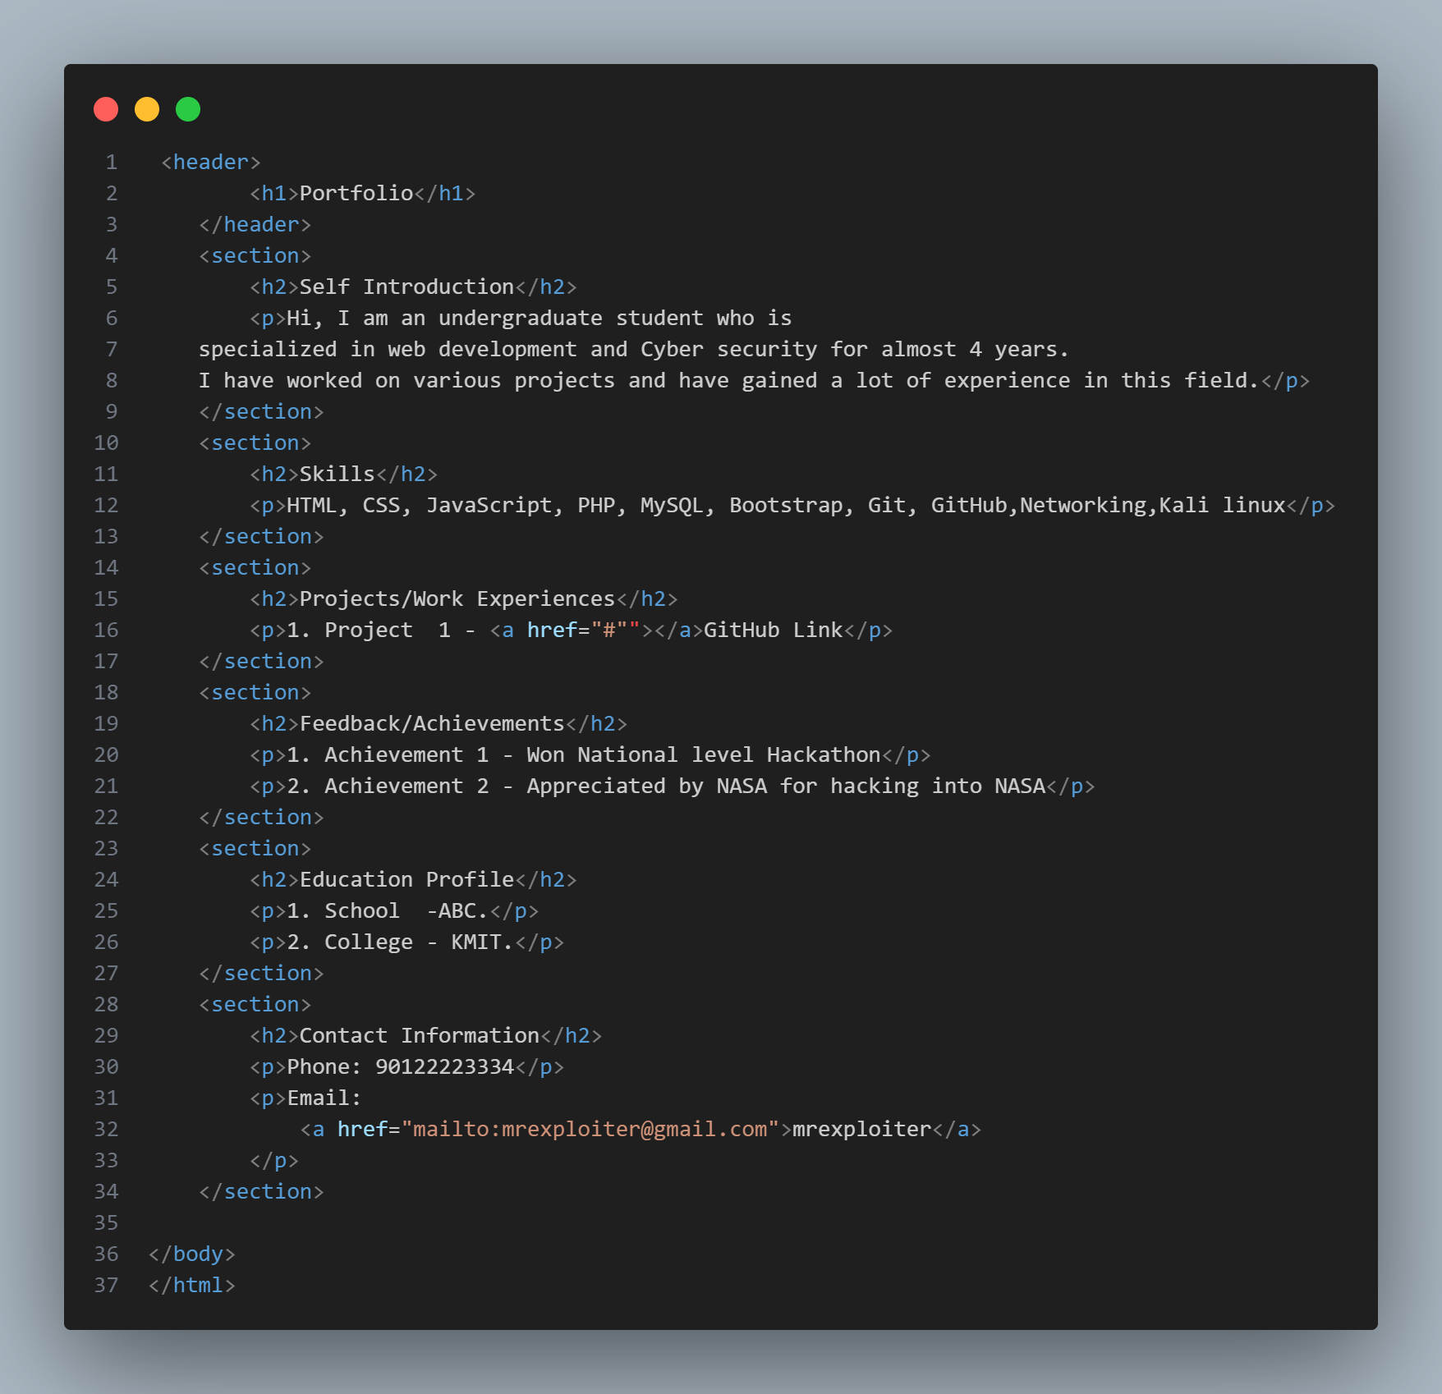

**OUTPUT:**

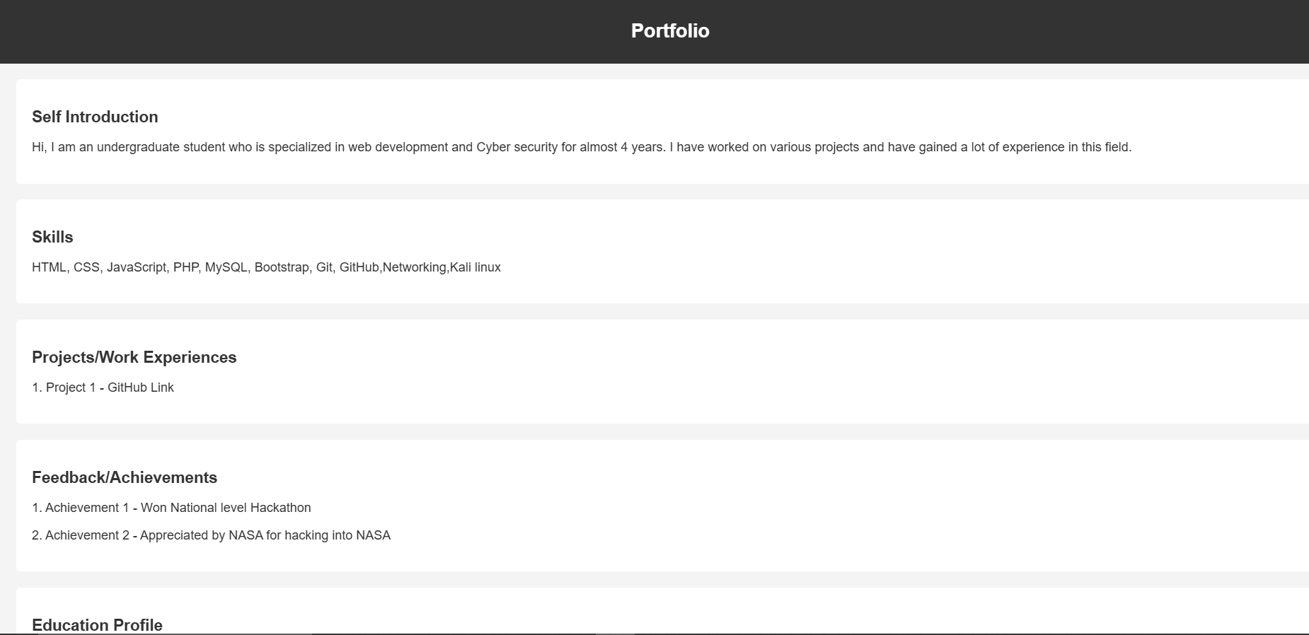

**problem-3**

Update the both (feedback and portfolio) pages with external css.

Note: once you update the poftfolio and Feedback pages upload the page with neccesary document to Github account with public access

and submit that github link here : <https://github.com/Raghunani12/FWD-LAB.git>

Live Demo : <https://raghunani12.github.io/FWD-LAB/>

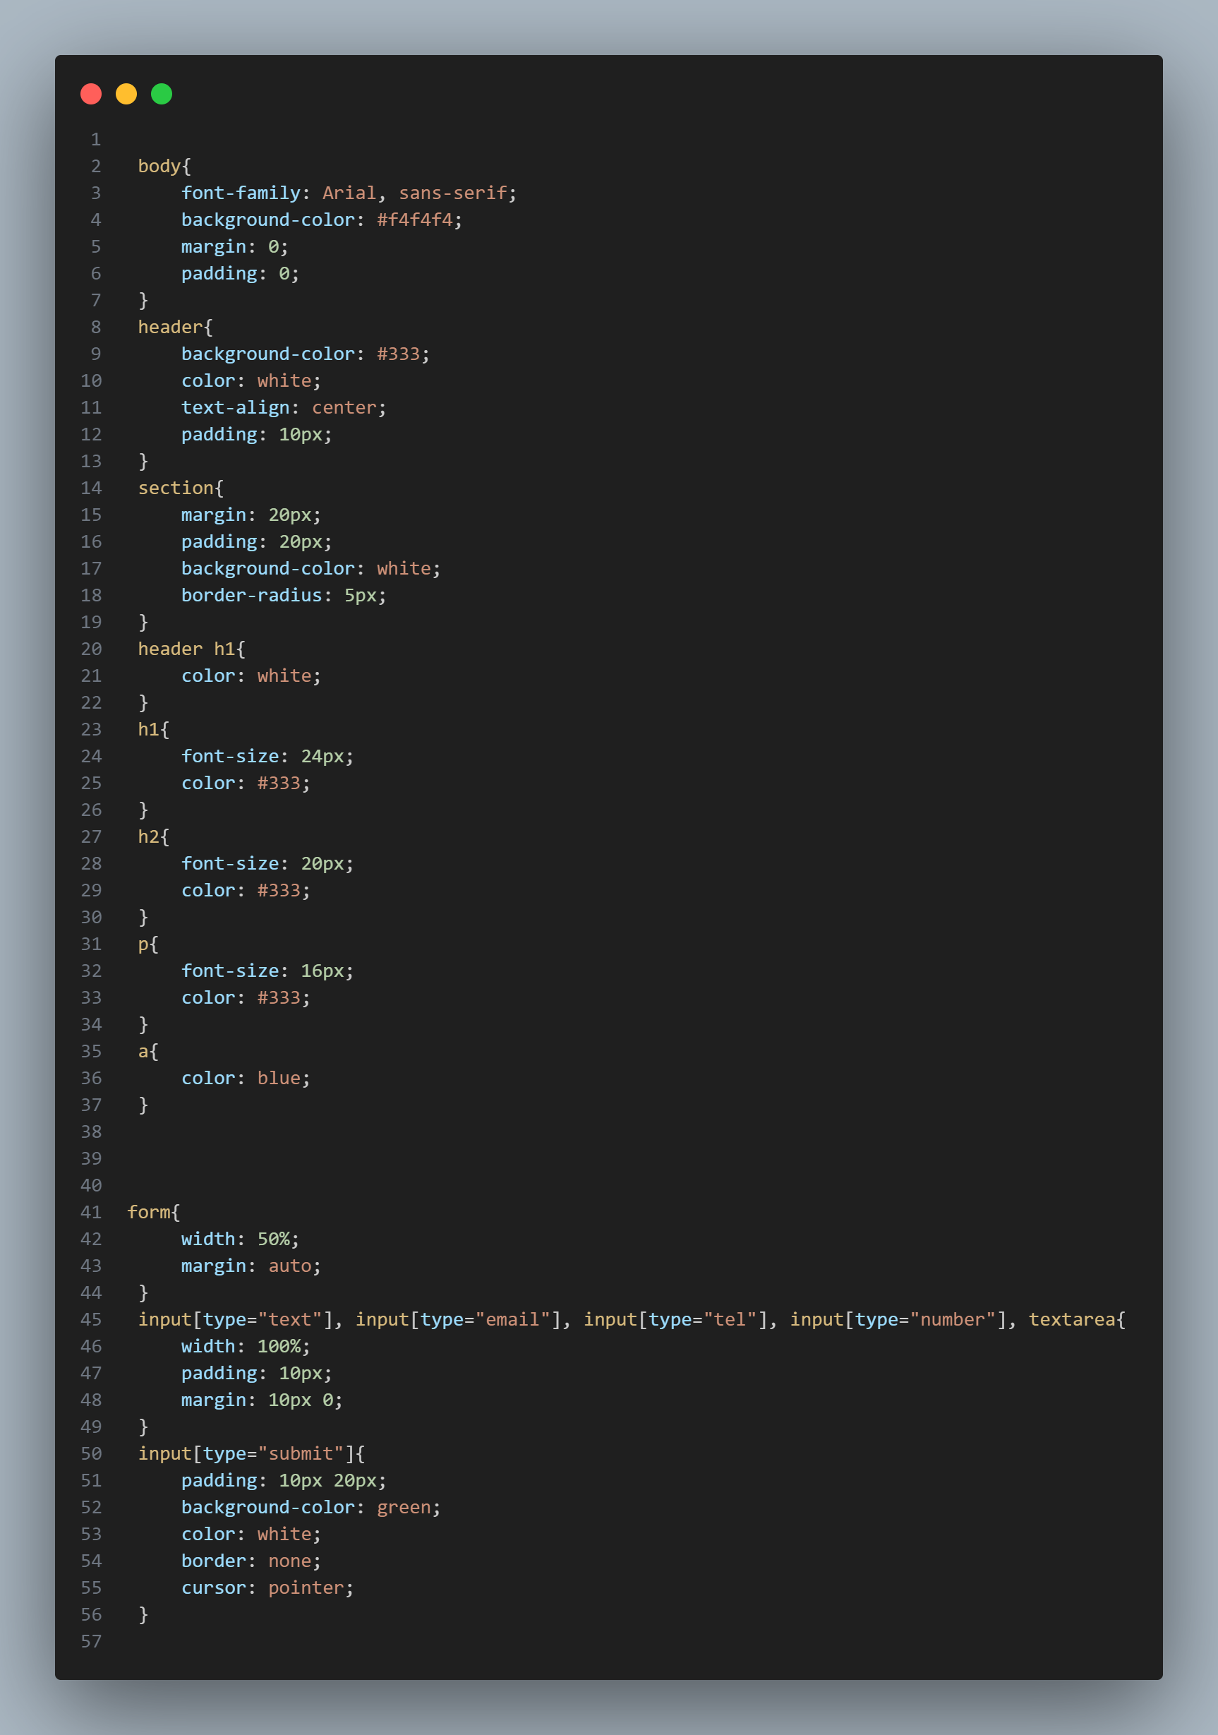

**External css file**

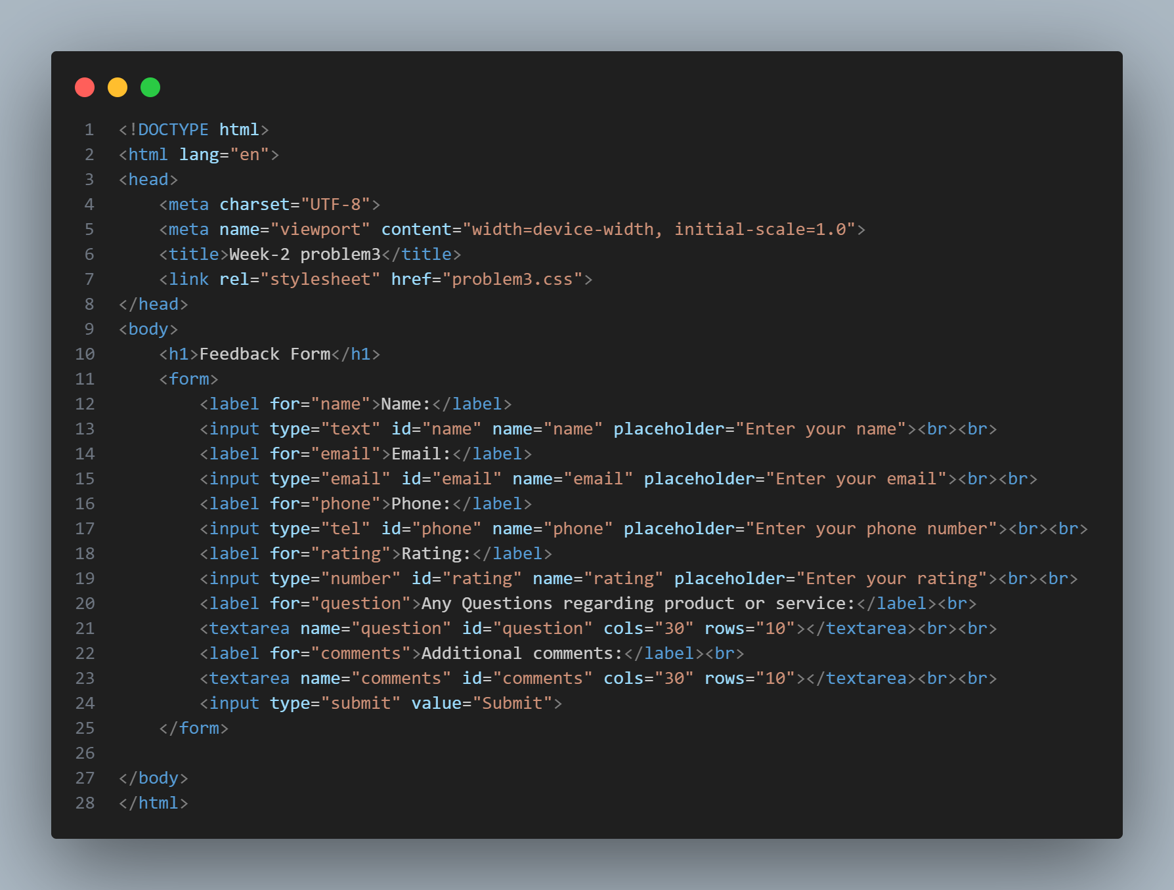

**Feedback.html**

**OUTPUT:**

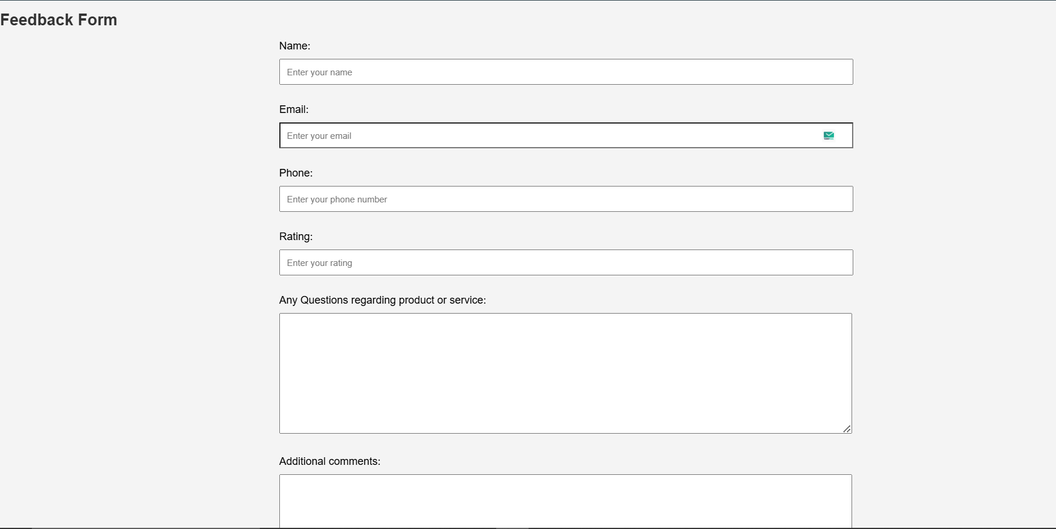

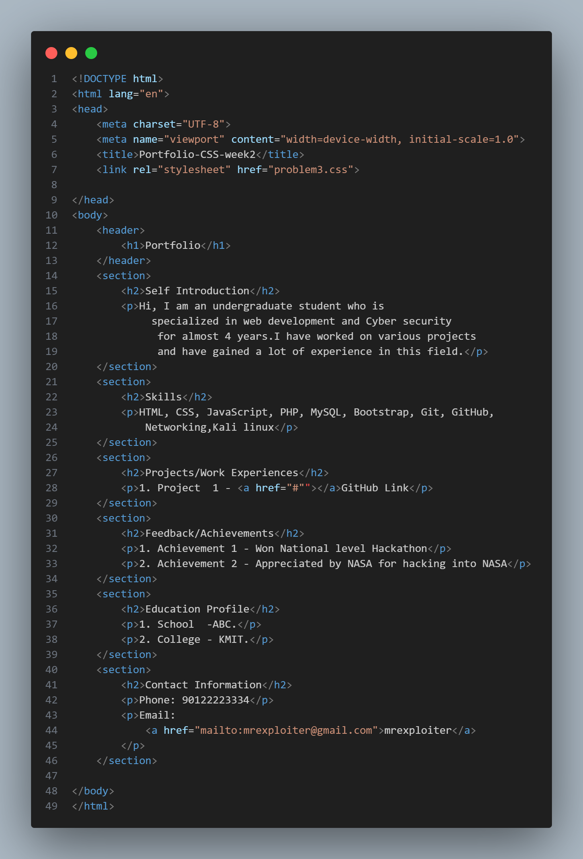

**Portfolio.html**

