**Week-3**

**Problem-1**

1. Update the portfolio and feedback forms using Bootstrap CDN

Note: once you update the poftfolio and Feedback pages upload the pages to Github account with public access

and submit that github link here : <https://github.com/Raghunani12/FWD-LAB.git>

Live Demo : <https://raghunani12.github.io/FWD-LAB/>

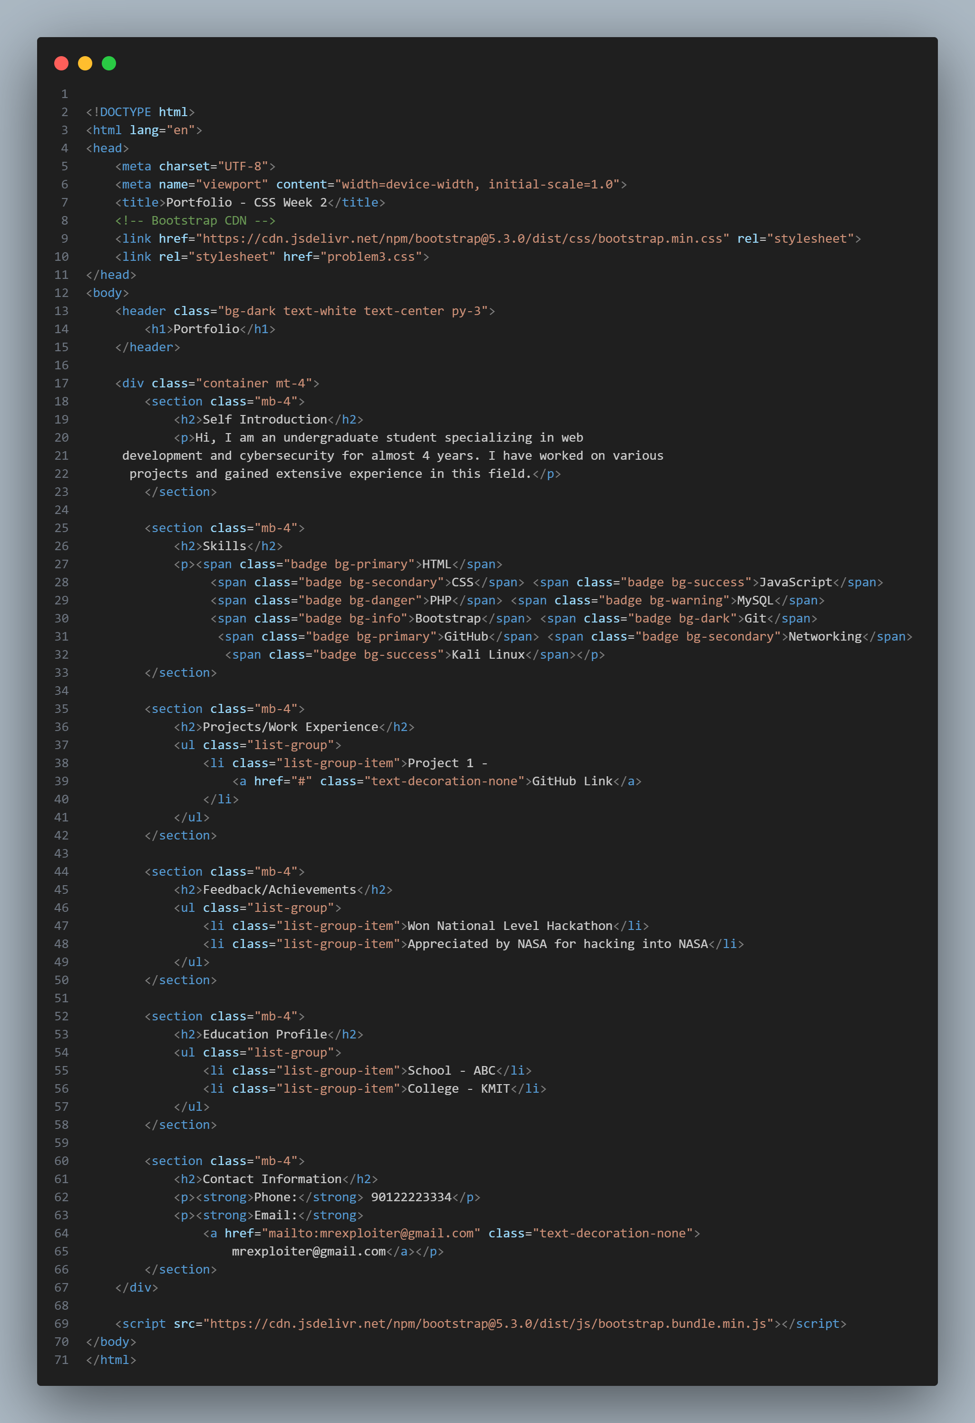

**Portfolio.html**

**OUTPUT:**

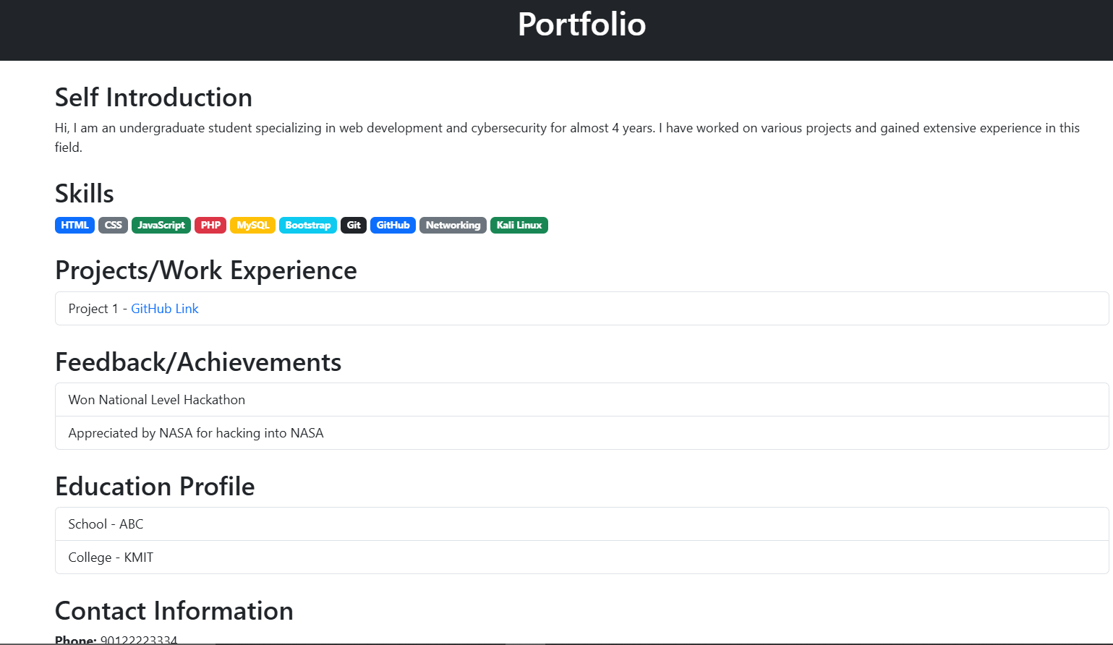

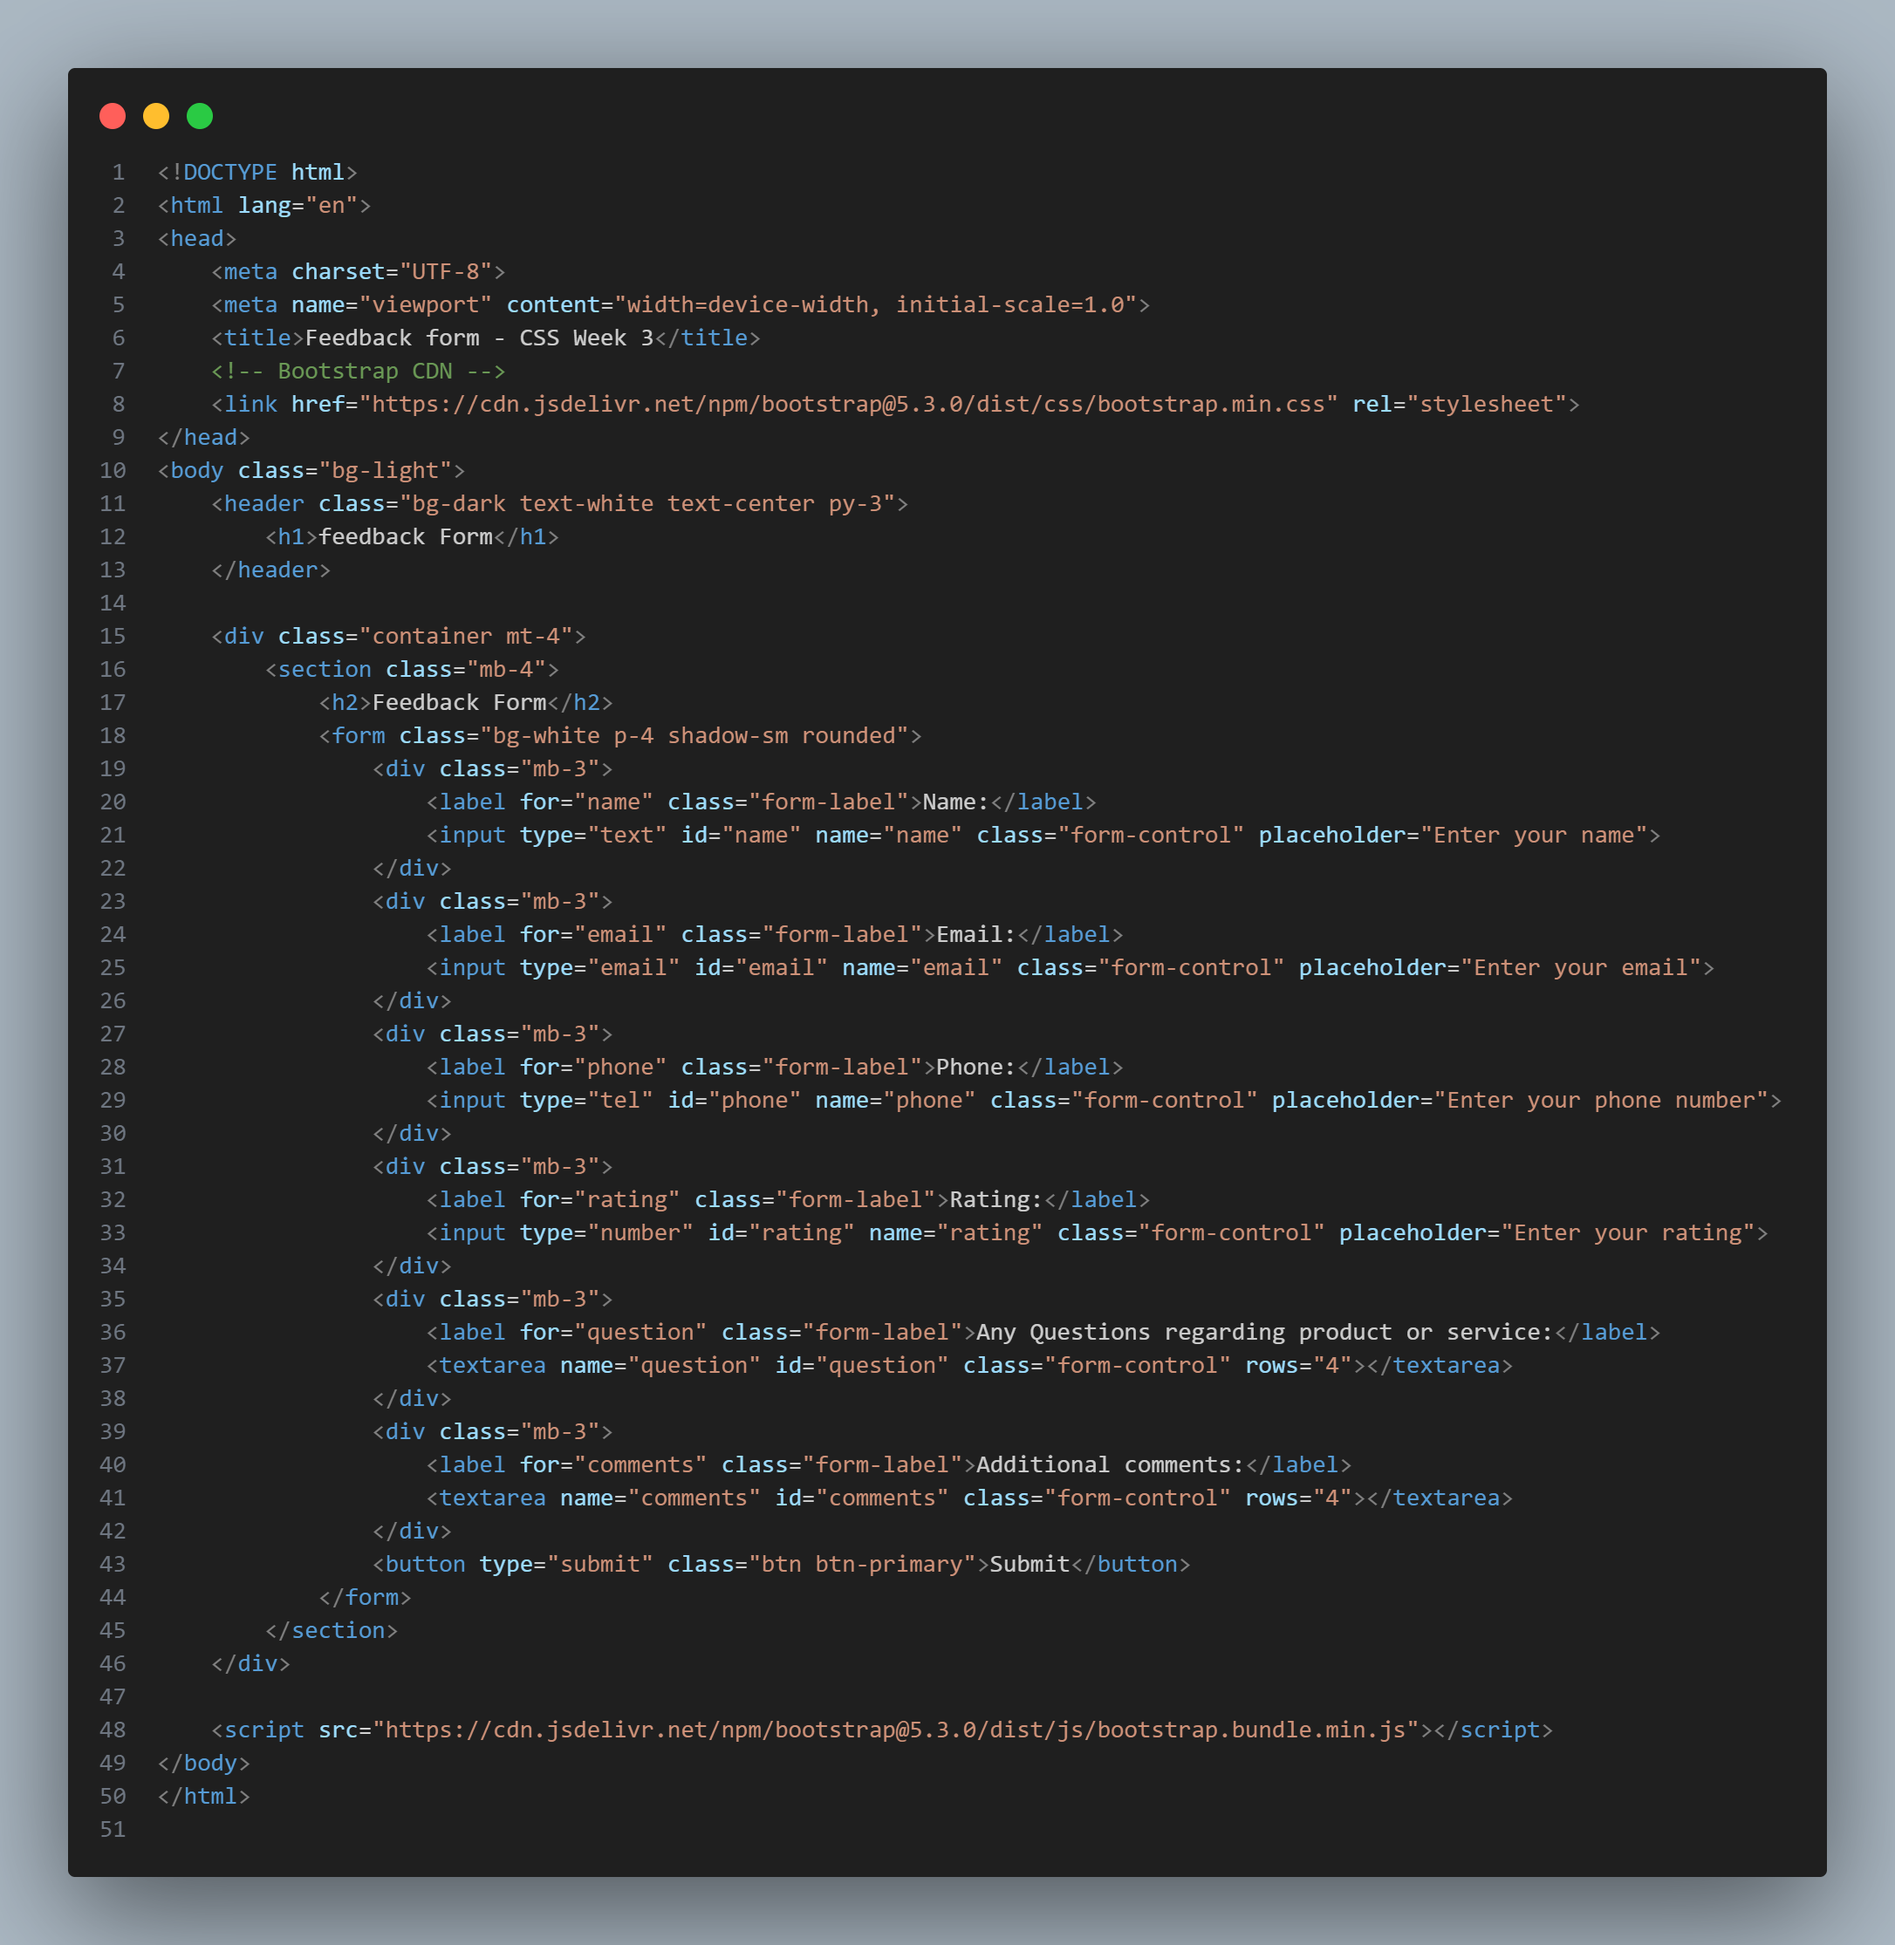

**Feedbackform.html**

**OUTPUT:**

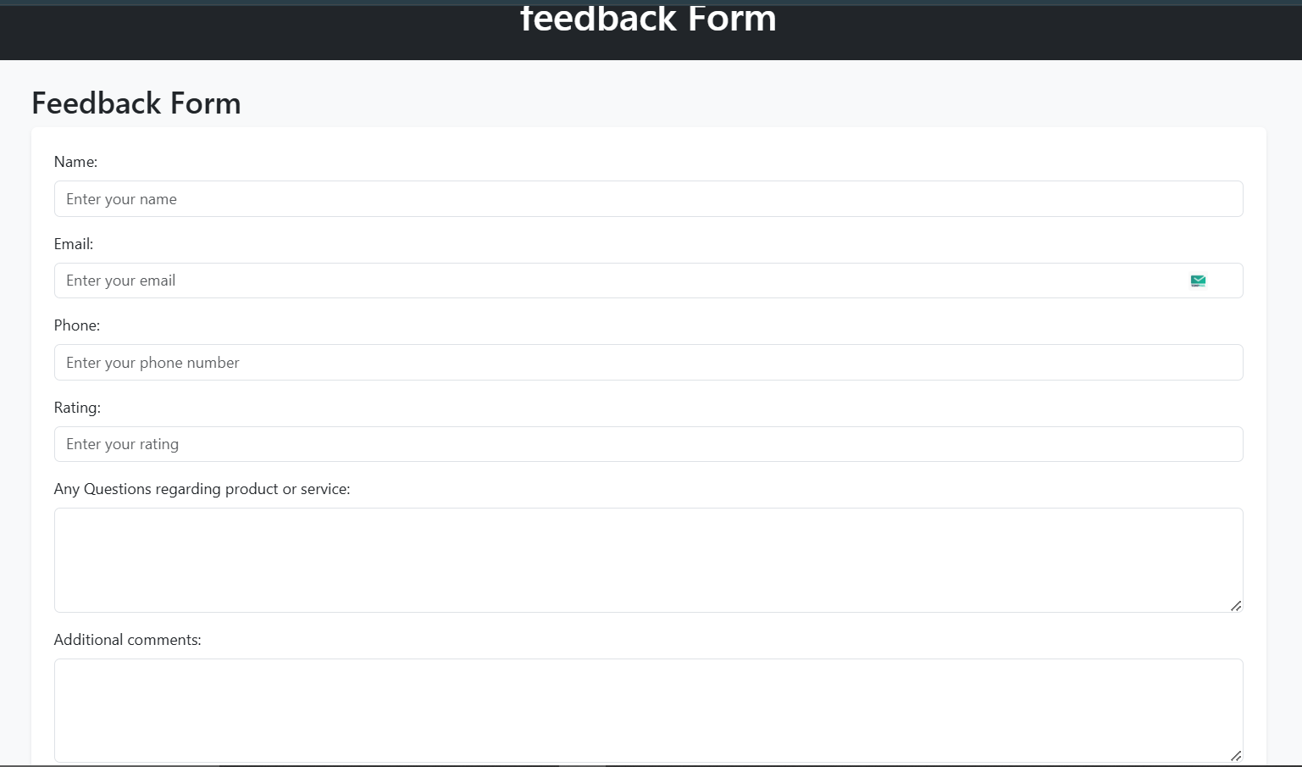

**Problem-2**

Update the portfolio and feedback forms using downloaded Bootstrap files

Note: once you update the poftfolio and Feedback pages upload the pages with neccesary documents to Github account with public access

and submit that github link here : <https://github.com/Raghunani12/FWD-LAB.git>

Live Demo : <https://raghunani12.github.io/FWD-LAB/>

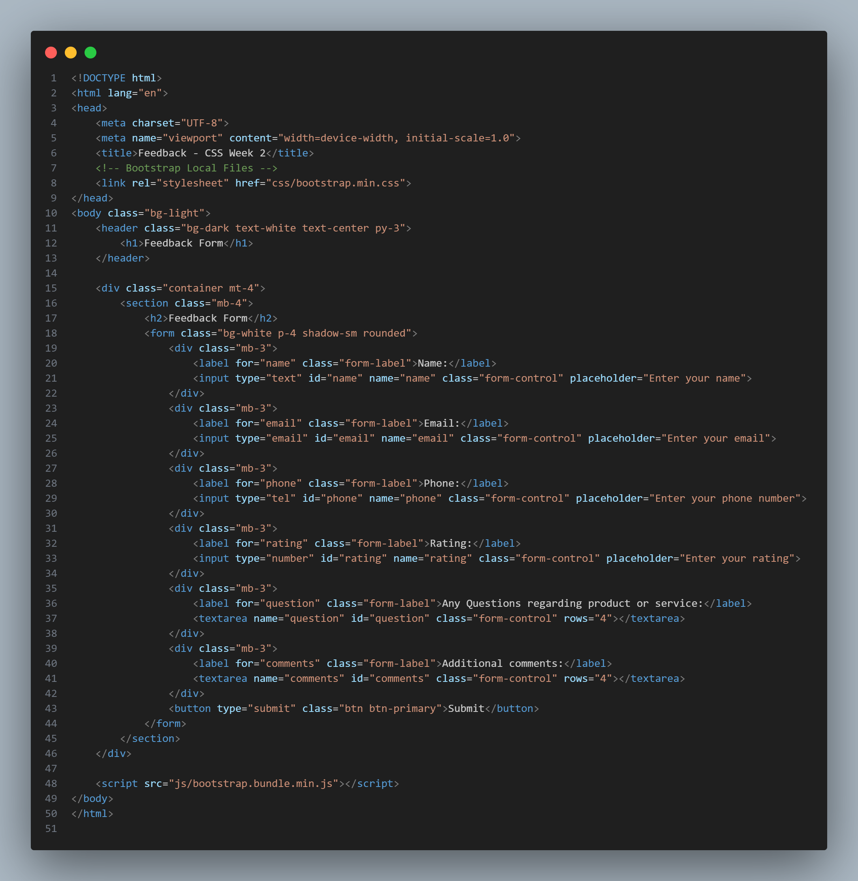

**Feedbackform-localbootstrap.css**

**Output:**



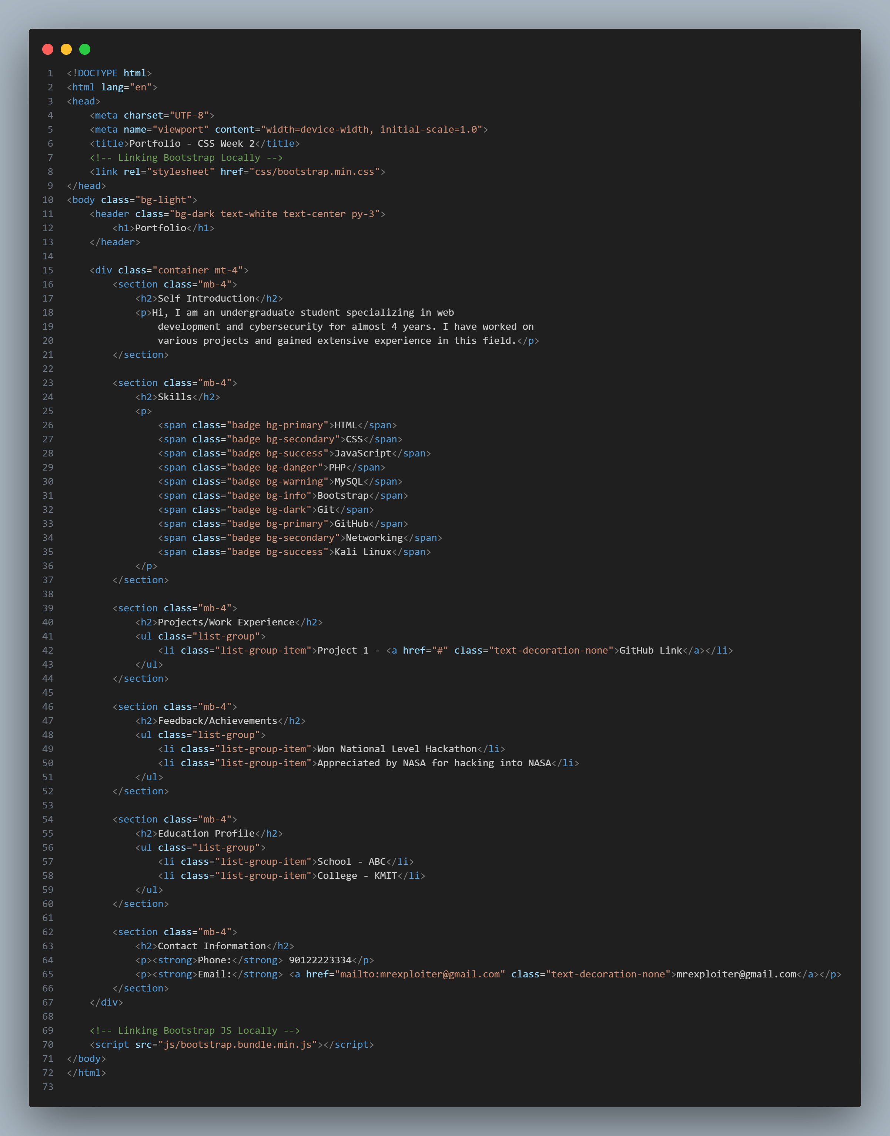

Portfolio-local-bootstrap.html

**OUTPUT:**

