A project report on

HOUSE PRICE PREDICTION USING ENSEMBLE LEARNING TECHNIQUE

Submitted in partial fulfillment for the award of the degree of

Bachelor of Technology
In
Computer science and Engineering

by
RAGHUNATH SINGH (20BCI7012)



SCHOOL OF COMPUTER SCIENCE AND ENGINEERING

VIT-AP UNIVERSITY

AMARAVATI - 522237

MAY 2024





ABSTRACT

Predicting home prices is vital for stakeholders in the real estate industry, aiding homeowners, buyers, and investors in making informed decisions. Traditional regression methods often struggle to capture the intricate patterns within the real estate market, leading to inaccuracies in predictions.

A successful approach to blended learning, specifically an ensemble learning methodology, for forecasting housing values is presented in our study. Techniques such as Random Forest, Gradient Boosting, XGBoost, and various other algorithms are employed to create a collaborative model that leverages the strengths of each algorithm while minimizing their weaknesses. Valuable insights into the variables impacting house prices are provided, and the contributions of each model and feature to prediction performance are highlighted.

By integrating multiple models, including regression, a comprehensive analysis of the factors influencing housing values is offered. This thorough understanding aids stakeholders in making informed decisions, thereby enhancing market efficiency. The importance of a blended learning framework in producing more accurate and reliable predictions in the real estate market is underscored by the study.

Additionally, a better understanding of the factors that influence home prices is provided by our approach, helping stakeholders make informed decisions. Effective and efficient solutions to solve the complexities of the real estate industry are provided by our approach, using the collective wisdom of many models.

Finally, practical answers to the difficulties of the real estate sector are provided by utilizing ensemble learning techniques to access the combined knowledge of numerous models.

CONTENTS

CONTENTS……………………………………………………..6
LIST OF FIGURES………….……………………………...…..9
LIST OF TABLES…...…...……………………………………12
LIST OF ACRONYMS…………….………………………….13

CHAPTER 1 INTRODUCTION
  - OVERVIEW…………………………………………………………………….……….14
  - PROBLEM STATEMENT…………………………………………………...................14
  - TRADITIONAL VS MACHINE LEARNING APPROACH…………………………..14
    - TRADITIONAL APPROACH………………………………………………………15
    - MACHINE LEARNING APPROACH……………………………………………...15
  - MACHINE LEARNING VS DEEP LEARNING………………………………………15
  - OBJECTIVE……………………………………………………………………………..16
  - LITERATURE SURVEY……………………………………………………………….16
  - ANALYSIS OF SURVEY………………………………………………………………18
  - PROJECT SCOPE……………………………………………………………………….18
  - CHALLENGES………………………………………………………………………….19
    - SELECTION OF MODELS…………………………………………………………19
    - FEATURE ENGINEERING…………………………………………………………19
    - ENSEMBLE TECHNIQUE SELECTION…………………………………………..20
    - MODEL INTERPRETABILITY…………………………………………………….20
    - OVERFITTING……………………………………………………….……..............20
    - DEPLOYMENT COMPLEXITY……………………………………………………20
CHAPTER 2
PROJECT BUILDING
  - PROJECT STATEMENT………………………………………………………………..21
  - DATASET………………………………………………………………………………..22
  - METHODOLOGY……………………………………………………………………….24
    - DATA COLLECTION AND PREPROCESSING……………………......................24
      - DATA VISUALIZATION…………………………………………………………...24
      - FEATURE SELECTION…………………………………………………………….35
    - FEATURE ENGINEERING…………………………………………………………36
    - MODEL SELECTION……………………………………………………………….37
    - TRAIN BASE MODELS…………………………………………………………….38
    - ENSEMBLE CONSTRUCTION…………………………………………………….39
    - PERFORMANCE EVALUATION………………………………………………….39
    - INTEGRATION AND DEPLOYMENT WITH WEBSITE………………………...40

CHAPTER 3 IMPLEMENTATION AND RESULT
3.1 SOFTWARE INSTALLATION…………………………………………………………41
3.1.1 VS CODE STUDIO INSTALLATION………………………………………………..41
3.1.2 PYTHON INSTALLATION…………………………………………………………...46
3.1.3 ANACONDA INSTALLATION………………………………………………………51
3.1.4 VS CODE EXTENSION INSTALLATION…………………………………………..55
3.1.5 HOW TO RUN PROGRAM…………………………………………………………...56

CHAPTER 4 CONCLUSION AND FUTURE WORK
  - CONCLUSION…………………………………………………………………………..61

4.2 FUTURE WORKS……………………………………………………………………….61

  - APPENDICES……………………………………………………………………………62

4.4 REFERENCES…………………………………………………………………………...65

LIST OF FIGURES
2.1COUNT VS NUMBER OF BEDROOMS………………………………………………..24
2.2 COUNT VS NUMBER OF BATHROOMS……………………………………………..25
2.3 COUNT VS NUMBER OF FLOORS…………………………………………………...26
2.4 COUNT VS NUMBER OF WATERFRONT PRESENT……………………………….26
2.5 COUNT VS NUMBER OF NUMBER OF VIEWS……………………………………..27
2.6 LONGITUDE VS LATITUDE…………………………………………………………..28
2.7 COUNT VS CONDITION OF HOUSE…………………………………………………28
2.8 COUNT VS GRADE OF HOUSE……………………………………………………….29
2.9 COUNT VS NUMBER OF SCHOOLS NEARBY……………………………………...29
2.10 COUNT VS PRICE……………………………………………………………………..30
2.11 COUNT VS DISTANCE FROM THE AIRPORT……………………………………..30
2.12 PRICE VS NUMBER OF SCHOOL NEARBY………………………………………..31
2.13PRICE VS NUMBER OF BATHROOMS……………………………………………...31
2.14 PRICE VS NUMBER OF BEDROOMS……………………………………………….32
2.15 PRICE VS NUMBER OF GRADE OF THE HOUSE…………………………………32
2.16 PRICE VS NUMBER OF BEDROOMS BOXPLOT………………………………….33
2.17 FREQUENCE VS DISTANCE………………………………………………………...34
2.18 OVERALL DATA VISUALIZATION.………………………………………………..34
2.19 CORRELATION MATRIX…………………………………………………………….35
2.20 HEAT MAP……………………………………………………………………………..36
2.21 FEATURE ENGINEERING……………………………………………………………37
2.22 MODEL AND ITS R-SQUARE VALUE……………………………………………...38
2.23 TRAIN BASE MODEL………………………………………………………………...38
3.1 DOWNLOAD VS CODE………………………………………………………………..41
3.2 PRESS DOWNLOAD……………………………………………………………………42
3.3 VS CODE ICON…………………………………………………………………………42
3.4 VS CODE AGREEMENT……………………………………………………………….43
3.5 CHOOSE LOCATION TO INSTALL…………………………………………………..43
3.6 CLICK INSTALL………………………………………………………………………..44
3.7 INSTALLING VS CODE ……………………………………………………………….44
3.8 INSTALLATION COMPLETE………………………………………………………….45
3.9 VS CODE INSTALLATION…………………………………………………………….44
3.10 DOWNLOAD PYTHON……………………………………………………………….47
3.11 INSTALL PYTHON……………………………………………………………………48
3.12 INSTALLING PYTHON……………………………………………………………….49
3.13 PYTHON INSTALLED………………………………………………………………...50
3.14 CHECK PYTHON VERSION………………………………………………………….50
3.15 DOWNLOAD ANACONDA…………………………………………………………..49
3.16 CLICK NEXT…………………………………………………………………………..51
3.17 LICENSE AGREEMENT………………………………………………………………51
3.18 INSTALLATION FOR…………………………………………………………………51
3.19 INSTALLATION LOCATION………………………………………………………...53
3.20 ADVANCE INSTALLATION…………………………………………………………53
3.21 ANACONDA INSTALLING…………………………………………………………..54
3.22 PYCHARM INSTALL…………………………………………………………………54
3.23 ANACONDA INSTALLED……………………………………………………………55
3.24 PYTHON POWERSHELL……………………………………………………………..55
3.25 INSTALLING EXTENSION…………………………………………………………...56
3.26 VS CODE OPEN……………………………………………………………………….57
3.27 TEMPLATE FOLDER…………………………………………………………………57
3.28 PYTHON FILE CREATION…………………………………………………………...58
3.29 FILE RUNNING………………………………………………………………………..58
3.30 WEB INTERFACE……………………………………………………………………..59
3.31 INPUT VALUES IN THE FORM……………………………………………………...59

3.32 PREDICTED PRICE……………………………………………………………………60

LIST OF TABLES
2.1 IDEAL DATASET …………………………………………………………………22
2.2 MODEL AND ITS R- SQUARED VALUE……………………………………......40

LIST OF ACRONYMS
SVM: SUPPORT VECTOR MACHINE
ML: MACHINE LEARNING
XG BOOST: EXTREME GRADIENT BOOST
MAE: MEAN ABSOLUTE ERROR
MSE: MEAN SQUARE ERROR
RMSE: ROOT MEAN SQUARE ERROR
SVR: SUPPORT VECTOR REGRESSOR
RMSLE: ROOT MEAN SQUARE LOGARITHMIC ERROR
ANN: ARTIFICIAL NEURAL NETWORK
CNN: CONVOLUTIONAL NEURAL NETWORK
GBM: GRADIENT BOOSTING MACHINES
BPNN: BACK PROPAATION NEURAL NETWORK
MAPE: MEAN ABSOLUTE PERCENTAGE ERROR
PCA: PRINCIPAL COMPONENT ANALYSIS

CHAPTER 1 INTRODUCTION

  - OVERVIEW

This project is focused on figuring out how much houses might cost. First, a large amount of information about houses is collected and cleaned thoroughly. Then, this data is deeply analyzed to find interesting patterns and enhance the information for predicting house prices. After that, advanced mathematical techniques such as Random Forest, XGBoost, CatBoost, Lasso, Ridge, and Support Vector Regression (SVR) are used to make intelligent predictions about house prices.

However, the process does not stop there. All these mathematical techniques are combined to make even better predictions. To evaluate the accuracy of these predictions, a special score called R-squared is used. This score helps in selecting the best mathematical technique for predicting house prices. By blending traditional mathematical methods with advanced computational techniques, it is hoped that a better understanding and more accurate predictions of the ever-changing housing market can be achieved.

  - PROBLEM STATEMENT

The importance of accurately predicting house prices is underscored by the project, and the challenges inherent in traditional valuation methods are addressed. Conventionally, property rates are determined by comparing the sale prices of nearby properties. However, precise values are often not provided by this approach due to inherent differences between properties. Moreover, inflated property values are often encountered by buyers, as presented by real estate agents, stemming from a lack of prior knowledge during the purchasing process. This occurs due to the absence of the necessary prior knowledge while buying.

  - TRADITIONAL VS MACHINE LEARNING APPROACH

The traditional approach to predicting house prices is reliant on manual methods, such as comparing property rates from nearby sales. However, accuracy is often lacking in this method because not all relevant data is considered, and subjective factors influence it. Biases and inconsistencies in valuation are also prone to occur, requiring a significant amount of manual effort and expertise. Additionally, changes in the market are challenging for traditional methods to adapt to.

On the other hand, house price prediction is revolutionized by machine learning, as advanced algorithms are used to analyze large datasets and find complex patterns. Various features and factors are incorporated into machine learning models, leading to more accurate predictions while biases and errors are reduced through automated data processing. Prices can also be predicted faster and more precisely, and models can adapt to changes in the market over time for continuous improvement.

1.3.1 Traditional Approach:

The traditional approach to property valuation relies heavily on manual methods, such as comparing property rates of nearby sales. This method often lacks accuracy due to the influence of subjective factors and the consideration of limited data. As a result, valuations are vulnerable to biases and inconsistencies, which can significantly impact their reliability. Moreover, this approach requires extensive manual effort and expertise, making it labor-intensive and time-consuming. Additionally, the traditional method is limited in its scalability and adaptability to changing market dynamics, often failing to keep pace with evolving trends and demands in the real estate market.

1.3.2 Machine Learning Approach:

In contrast, the machine learning approach leverages advanced algorithms to analyze large datasets and identify patterns, leading to more accurate property valuations. This method incorporates a wide range of features and factors, allowing it to predict house prices with higher precision. By minimizing biases and errors through automated data processing and modeling, machine learning enables faster and more reliable predictions. Furthermore, this approach is highly adaptable to evolving market conditions, with the capability to continuously improve over time as it processes more data. As a result, the machine learning approach offers a scalable and efficient alternative to traditional property valuation methods.

  - MACHINE LEARNING VS DEEP LEARNING

Machine learning algorithms are generally easier to understand and interpret compared to deep learning models. They often require less computational resources, making them more efficient in terms of training time and processing power. Additionally, machine learning models perform well with structured data and are capable of handling a wide range of tasks, including classification, regression, and clustering. They are particularly suitable for scenarios with limited data availability or when the dataset is not large enough to effectively train deep learning models. Moreover, machine learning algorithms offer greater flexibility in feature engineering and model customization, resulting in more transparent and interpretable solutions.

  - OBJECTIVE

To overcome the complexities of the real estate market and achieve our objectives, implementing intuitive and accessible solutions is imperative. Therefore, we aim to create a user-friendly web application that simplifies the process of predicting fair house sale prices, empowering home buyers with essential knowledge and insights, and fostering trust and confidence in the housing market.

Predict fair house sale prices – Develop accurate predictive models to ensure transparency and fairness in house price, reducing the risk of deception in real estate transaction.

To create user-friendly web application – Designing an intuitive and accessible web interface to simplify the house buying process, enhancing usability for all stockholders.

Empower home buyers with knowledge and insights.

Build Trust and Confidence – Establish trust and confidence among buyers, seller and investors by ensuring transparency, reliability, and fairness in house prediction and transactions.

To streamline processes and reduce inefficiencies associated with manual paperwork, thereby improving user experience and overall efficiency.

  - LITERATURE SURVEY

In the paper titled "Housing prices prediction with deep learning" by Choujun Zhan et al., [1] the authors investigate Taiwan's real estate market using deep learning techniques to forecast home values. They highlight the challenges posed by the multitude of variables impacting housing prices, emphasizing the need for alternative techniques like deep learning due to the complexity of relationships. The study examines the effect of macroeconomic factors on house price forecasts, revealing significant correlations with certain characteristics such as income-to-house price ratio and housing loan burden. Their analysis demonstrates the superior performance of CNN over BPNN in predicting house prices, with CNN exhibiting higher R2 values and lower error metrics like RMSE, MAE, MAPE, and RMSLE.

In the paper titled "Prediction of House Pricing Using Machine Learning with Python" by Mansi Jain et al., [2] the researchers explore ensemble learning techniques, such as stacking, boosting, and bagging, for improving prediction performance in housing price prediction. They employ cross-validation methods like holdout validation and k-fold cross-validation to evaluate model effectiveness and address potential overfitting issues. The study evaluates prediction accuracy using metrics like mean absolute error (MAE), mean square error (MSE), and root mean square error (RMSE).

In the paper titled "House Price Prediction Using Optimal Regression Techniques" by Vivek Singh Rana et al., [3] the authors compare various regression algorithms, including XGBoost, SVR, Random Forest Regression, and Decision Tree Regression, for predicting house prices. They analyze the effectiveness of these algorithms in capturing features such as size, total square feet, number of bathrooms, and balconies, along with area type and location. The study evaluates model performance using metrics like test accuracy, training accuracy, MSE, RMSE, and MAE.

In the paper titled "House Resale Price Prediction Using Classification Algorithms" by P. Durganjali and Vani Pujitha, [4] the authors discuss the use of machine learning algorithms, particularly ensemble learning, for estimating home resale values. They highlight the challenges in accurately predicting house resale values, including market volatility, data availability, and model interpretability. The study emphasizes the need for multidisciplinary research efforts to address these challenges effectively.

In the paper titled "Housing Price Prediction via Improved Machine Learning Techniques" by Quang Truong et al., [5] the authors explore various machine learning methods, such as Random Forest, Artificial Neural Networks (ANN), Gradient Boosting Machines (GBM), and Support Vector Machines (SVM), for housing price prediction. They discuss the potential of deep learning models, specifically ANNs, in automatically extracting high-level features and recognizing intricate patterns from data. The study evaluates predictive model performance using common assessment measures such as R-squared (R^2), MAE, and RMSE, along with techniques like train-test splitting and cross-validation.

In the paper titled "House Price Prediction using Random Forest Machine Learning Technique" by Abigail Bola Adetunjia et al., [6] the authors advocate for the use of ensemble learning technique, specifically Random Forest, for predicting housing prices due to its ability to handle both numerical and categorical data effectively. They highlight the success of Random Forest in various real estate markets and emphasize the importance of evaluating predictive accuracy and generalization capacity using metrics like RMSE, R2, and MAE.

In the paper titled "Advanced Machine Learning Algorithms for House Price Prediction: Case Study in Kuala Lumpur" by Shuzlina Abdul-Rahman et al., [7] the authors discuss the significance of model selection and assessment criteria in forecasting home values. They compare various algorithms, including XGBoost, LightGBM, ridge regression, multiple regression, and ANN, to find the best strategy for housing price prediction. The study emphasizes the importance of feature comprehension and model evaluation using metrics like adjusted R-squared, MAE, and RMSE, along with techniques like correlation analysis and model validation.

In the paper titled “House Price Prediction Using Machine Learning” by anand g. rawool , dattatray v. rogye , sainath g. rane , dr. vinayk a. bharadi[8]. The author proposed a methodology for house resale price prediction using classification algorithms. By employing techniques such as Linear Regression, Decision Trees, K-Means, and Random Forest, Durganjali aimed to capture the complexities of housing markets and provide insights into resale price trends. The study highlighted the importance of considering various attributes and their interactions in predicting house prices accurately.

In the paper titled “house price forecasting using machine learning” by alisha kuvalekar, sidhika mahadik, shivani manchewar, shila jawale (guide)[9]. The author urned to more sophisticated ML algorithms, such as decision trees, random forests, and gradient boosting machines. These ensemble methods offered improved predictive performance by combining the strengths of multiple models and mitigating the weaknesses of individual algorithms. Studies by Breiman (Year) and Friedman (Year) highlighted the effectiveness of ensemble techniques in handling nonlinear relationships and capturing interactions among predictors.

In the paper titled “house price prediction using machine learning” by ms.a.vidhyavani1 ,o.bhargav sathwik2 ,hemanth.t3 , vishnu vardhan yadav.m[10]. Researchers began exploring more advanced ML algorithms, including decision trees, random forests, and gradient boosting machines, to improve prediction accuracy further. Ensemble methods, such as bagging and boosting, combined the strengths of multiple models and addressed the limitations of individual algorithms. Studies by Breiman and Friedman highlighted the effectiveness of ensemble techniques in capturing complex patterns in housing market data. Feature engineering techniques became crucial for extracting meaningful information from high-dimensional datasets and reducing model complexity. Researchers explored methods like polynomial features, interaction terms, and categorical encoding to enhance prediction accuracy. Additionally, dimensionality reduction techniques like principal component analysis (PCA) helped identify the most informative variables for modeling purposes.

Each of these studies expands our understanding of forecasting housing prices by delving into a range of machine learning techniques. They analyze the effectiveness of different models, their performance metrics, and their ability to address the unique obstacles encountered in the real estate sector.

  - ANALYSIS OF SURVEY

Upon analysing several research articles on housing price prediction, it can be shown that Random Forest is frequently used as the main model and is then enhanced using ensemble approaches like stacking, bagging, boosting, and CatBoost to improve accuracy. However, difficulties are presented by overfitting in the application of ensemble learning approaches, which researchers try to overcome via methods like cross-validation. To lower the risk of overfitting by verifying the model with unobserved data, cross-validation entails splitting the dataset into subsets for training and validation. Furthermore, several assessment measures are frequently utilized to evaluate prediction accuracy throughout this research, including mean absolute error (MAE), mean square error (MSE), and root mean square error (RMSE). In studies examining approaches outside conventional machine learning, the intricacy of housing price factors is emphasized, and the significance of alternative techniques like deep learning in solving these issues is highlighted.

  - PROJECT SCOPE

In a landscape characterized by dynamic shifts in the real estate market and evolving consumer preferences, the necessity for accurate and reliable house price prediction tools has become increasingly apparent. This need is aimed to be addressed by our project through the development of a comprehensive machine learning-based solution tailored to predict house prices effectively and empower stakeholders with actionable insights.

The creation of a web-based platform equipped with advanced machine learning models for predicting house prices is encompassed within the project scope. Python is leveraged as the primary programming language, facilitating the seamless integration of various machine learning algorithms, including Random Forest, XGBoost, CatBoost, Lasso, Ridge, and Support Vector Regression (SVR), among others. The robustness and adaptability of the prediction models to diverse real estate market scenarios are ensured by this multifaceted approach.

The user interface will be intuitively designed to accommodate users with varying levels of technical proficiency, ensuring accessibility across desktop. The ability to input relevant features of properties, such as size, location, amenities, and historical sales data, to generate accurate price predictions will be provided to users. Overall, a cutting-edge solution that empowers stakeholders in the real estate industry with the tools and insights needed to make informed decisions and navigate the dynamic landscape of housing market trends effectively is aimed to be delivered by the project.

  - CHALLENGES

In view of making any project, everyone has to face and overcome challenges. In the machine learning project, several processes such as data analysis, model selection, model building, and model analysis are all working together to create a project. While performing any of these processes in machine learning, it is common to face some problems such as datasets having lots of empty fields, models providing less accuracy, difficulty in applying models, or models becoming too complex after applying ensemble learning, resulting in a lot of time being taken to compute the code.

Many challenges are faced and overcome during this project, which are listed below.: -

    - SELECTION OF MODELS

The selection of the models plays a crucial role in the output and its accuracy. So, choosing the correct base models that provide the best performance is a significant challenge that impacts the overall project and its quality. Multiple machine learning algorithms and their hyperparameters have been experimented with to obtain the optimal solution.

Given the model selection, Random Forest, Random Forest with XG Boost, Random Forest with Cat Boost, Ensemble model, Ensemble model with XG Boost, and Ensemble model with Cat Boost, along with Lasso and Ridge regression algorithms, have been applied. In this project, the model with the best accuracy among all the applied models has been selected. Applying all these models and combinations is the challenge faced by us.

    - FEATURED ENGINEERING

By the help of attributes in the dataset, some attributes were dug out and framed as new attributes, such as the area of the property being found as the addition of all areas given and the age of the property being found from the date of construction till now. These types of engineering significantly affect the result and accuracy and lower the bias and variance.

After examining the correlation matrix and heat map among the attributes, some attributes from the attribute that cannot be used directly and given in the dataset have to be featured. Finding the relation between the attributes was the main challenge faced while feature engineering.

    - ENSEMBLE TECHNIQUE SELECTION

The combination of Random Forest, Random Forest and bagging, and Random Forest and boosting was experimented with. The model with the best accuracy among all the applied models was selected in this project. Ensemble learning itself is a complex algorithm, and applying and experimenting with it is a challenge that was faced.

In this project, ensemble learning was used, with different improvement techniques that increase accuracy and speed of computation. Multiple base models were combined to improve predictive performance. By associating the diversity of different algorithms, biases and variance can be weakened by ensemble methods, leading to better and more generalizable models. Various ensemble techniques such as stacking, bagging, and boosting were applied, providing strengths to the applications in house price prediction. The most suitable and efficient technique had to be selected according to our dataset and our problem domain.

    - MODEL INTERPRETABILITY

Ensemble learning models like random forest with gradient boosting could be less interpretable if compared to any other base models. Additional effort might be needed for understanding and interpreting such complex models.

After applying the most suitable model, the challenge of increasing its accuracy by applying several ways such as data refining, boosting, and algorithm tuning is encountered.

    - OVERFITTING

Overfitting can be led to by ensemble models, especially if not properly computed or if too many models are included. Techniques like regularization, early stopping, and cross-validation can help mitigate overfitting.

After the model was successfully applied, it was observed that it was also computing more than data and also computing noise. In simple words, it was overfitted due to its complexity. Here, one more challenge is waiting, that is overfitting. Overfitting has low bias and high variance that states learning was held well but the result is not accurate.

    - DEPLOYMENT COMPLEXITY

Integration of the machine learning project made in Python with a web application is considered a difficult task. For the integration of the project with the web application, flask and pickle have been chosen. Studying a new language at this time is considered a difficult challenge.

Deploying a single model is not that much complex, but deploying such a complex model having a combination of ensemble learning techniques and bagging, stacking, and boosting is considered another level challenge.

CHAPTER 2 PROJECT BUILDING

2.1 PROJECT STATEMENT

The housing sector serves as a cornerstone of economic activity worldwide, while simultaneously holding immense personal significance for individuals and families. For many, owning a home represents a lifelong aspiration, emphasizing the critical importance of accurately predicting housing prices for buyers, sellers, and investors. However, traditional machine learning models, such as regression models, have often struggled to capture the intricate patterns and relationships within housing data, leading to inaccuracies and unreliable predictions. To address this challenge, leveraging ensemble learning, a powerful machine learning technique renowned for its robustness and accuracy, is proposed by our project.

The primary objective is to develop a model capable of accurately predicting house prices based on multiple features, thereby providing stakeholders with reliable insights for informed decision-making. Ensemble learning techniques amalgamate the predictions of various individual machine learning models, resulting in a more precise and resilient outcome, effectively mitigating biases and variances inherent in single-model approaches.

A pivotal step in our project involves extensive exploration and preprocessing of housing datasets, encompassing various parameters impacting housing prices. This process includes data cleansing, handling missing values, and feature engineering to ensure the data's suitability for our predictive model. Through meticulous refinement of the dataset, the aim is to enhance the model's accuracy and performance.

Following data preprocessing, various ensemble learning techniques, such as Random Forest, stacking, gradient boosting, and bagging, are employed to train and evaluate multiple machine learning models. Each technique offers distinct advantages and approaches, guiding the identification of the most effective model for accurate price prediction. Performance evaluation using metrics such as R-squared score serves as a guiding beacon in the model selection process, ensuring the chosen model meets stringent accuracy requirements.

To enhance user interaction and deployment, a user-friendly web application is developed enabling users to input house parameters and receive predicted prices seamlessly. This entails generating a pickle file to store the trained model's learning and deploying the application using Flask, a Python library, on a local host. The application's accessibility and intuitive interface cater to stakeholders' diverse needs, including property dealers, buyers, and sellers, fostering transparency and fairness in housing transactions.

Ultimately, the project endeavors to address real-world challenges encountered by both buyers and sellers in the housing market. By harnessing the power of ensemble learning techniques and deploying a user-friendly web application, an accurate and robust machine learning model is aspired to be delivered, enriching stakeholders' decision-making processes and championing transparency and fairness in housing pricing.

In conclusion, the real-world problem encountered by house buyers and sellers is solved by this project. A model is provided which uses ensemble learning technique to solve such complex problems. The project aims to bring an accurate and robust machine learning model that can give a boost to the stakeholders.

  - DATASET

One of the key problems faced by every researcher is getting the relevant dataset that is most adequate and ideal for their project as it plays a crucial role in the machine learning project. The training of a machine learning model is obtained from the dataset, and the output is provided according to its learning. High accuracy and low bias as well as variance are required for a model. This directly depends on the correctness of the dataset for obtaining accurate output. So, an ideal dataset needs to be searched for.

An ideal dataset should have following properties: -

Characteristic | How it is measured?
Completeness | Broadness of information.
Relevance | Usefulness of information.
Accuracy | Correctness of information
Timeliness | Information should be updated.
Reliability | How it differs from other trusted resources

Table 2.1 Ideal dataset

After applying our efforts on searching and manipulation of many datasets, an ideal dataset which is adequate with our project has been found. A "house price dataset of India" was found, uploaded by Mohamed Afsal [17] on Kaggle. No null values or empty fields which affect the accuracy of the project have been found.

Attributes of Dataset: -

Id: This feature contains a unique identifier for each house listing.
Date: This feature contains the date of the house listing.

Number of Bedrooms: This feature contains information about the total count of bedrooms in the house.

Number of Bathrooms: This feature contains information regarding the number of bathrooms a house has.

Living Area: This feature contains the total area of the living space in square feet.

Lot Area: This feature contains the total area of the lot or land in square feet.

Number of Floors: This feature contains the total number of floors in the house.

Waterfront Present: This feature indicates whether the house has a waterfront view (1 for present, 0 for not present).

Number of Views: This feature contains the total count of views the house has received.

Condition of House: This feature contains the overall condition of the house on a scale from 1 to 5, with 5 being the best condition.

Grade of House: This feature contains the overall grade of the house on a scale from 1 to 13, with 13 being the highest grade.

Area of House (excluding Basement): This feature contains the total area of the house excluding the basement in square feet.

Area of the Basement: This feature contains the total area of the basement in square feet.

Built Year: This feature contains the year the house was originally built.

Renovation Year: This feature contains the year the house was last renovated.

Postal Code: This feature contains the postal code of the house location.

Latitude: This feature contains the latitude coordinate of the house location.

Longitude: This feature contains the longitude coordinate of the house location.

Living Area Renovation: This feature contains the area of the living space that was renovated.

Lot Area Renovation: This feature contains the area of the lot or land that was renovated.

Number of Schools: This feature contains the total count of schools in the vicinity of the house.

Distance from Airport: This feature contains the distance of the house from the nearest airport in miles.
Price: This feature contains the price of the house listing.

METHODOLOGY

In this project, Ensemble learning, a powerful machine learning technique which works with the combination of multiple models, is going to be applied. If we talk about the prediction of price, it can be a more effective technique due to the complexity of the housing market. The following method has been applied for the successful completion.

    - DATA COLLECTION AND PREPROCESSING

Collection of data is another challenge encountered before starting a machine learning project. For our project, several resources such as government databases, real estate sites, private sites, and Kaggle were searched in.

2.3.1.1 DATA VISUALIZATION
For data visualization and studying the dataset of Housing price of India, some graphs have been plotted for finding the relation between the number attributes.

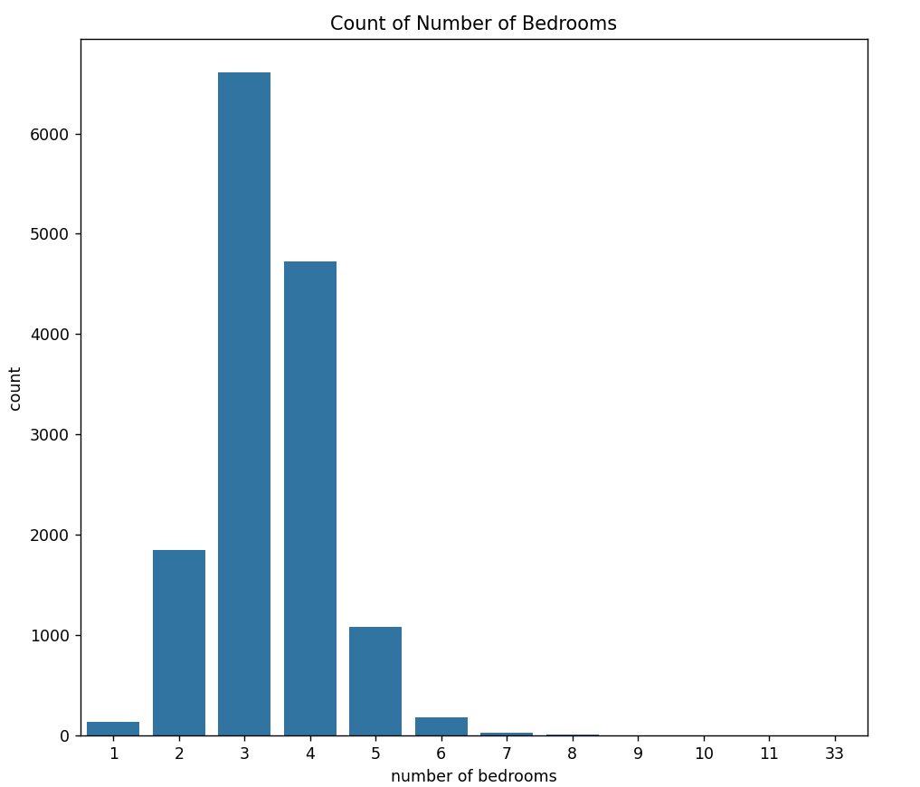
Fig 2.1 Count vs Number of Bedrooms

Figure 2.1 shows the distribution of houses by the number of bedrooms in the dataset. Three-bedroom houses are the most prevalent, with over 6,000 listings falling into this category, indicating high demand or supply for such configurations. Conversely, houses with one bedroom or more than five bedrooms are relatively scarce, each having less than 500 listings. This suggests a concentration of houses with two to four bedrooms, catering to common family living arrangements. Overall, this insight is crucial for real estate decisions, highlighting prevailing housing preferences.

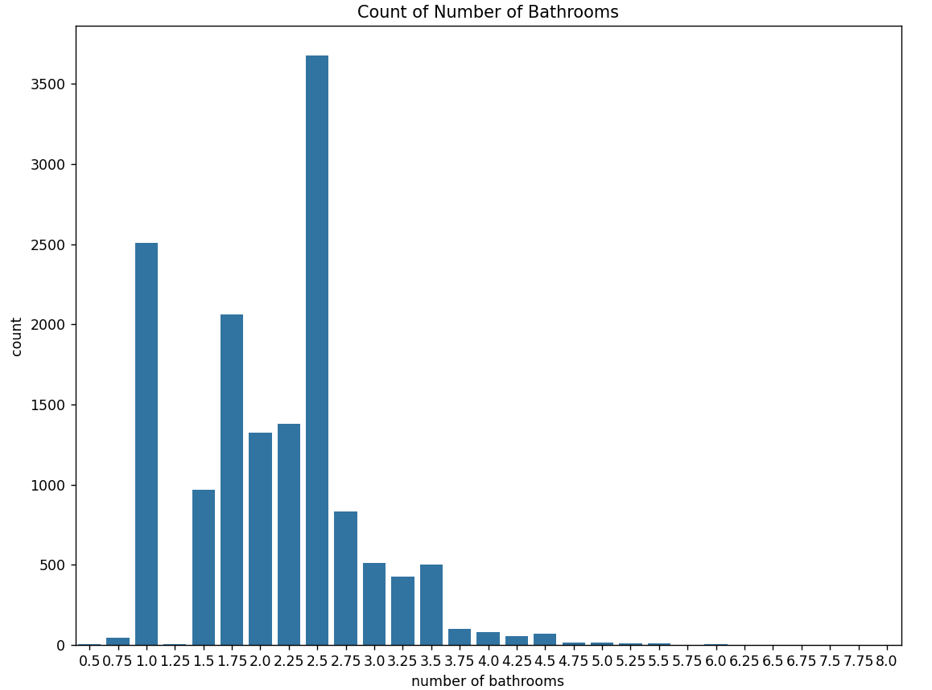

Fig 2.2 count vs number of bathrooms

Figure 2.2 depicts the distribution of houses by the number of bathrooms in the dataset. The graph indicates that two-bathroom houses are the most prevalent, with over 3,500 listings falling into this category. Conversely, houses with one bathroom or more than three bathrooms are relatively rare, with less than 500 listings each. This suggests a standard preference for two-bathroom configurations, likely catering to medium-sized families' needs. The lower counts of one-bathroom houses may reflect limited demand, while houses with more than three bathrooms cater to niche markets. Overall, this insight can guide real estate decisions to align with prevalent housing preferences.
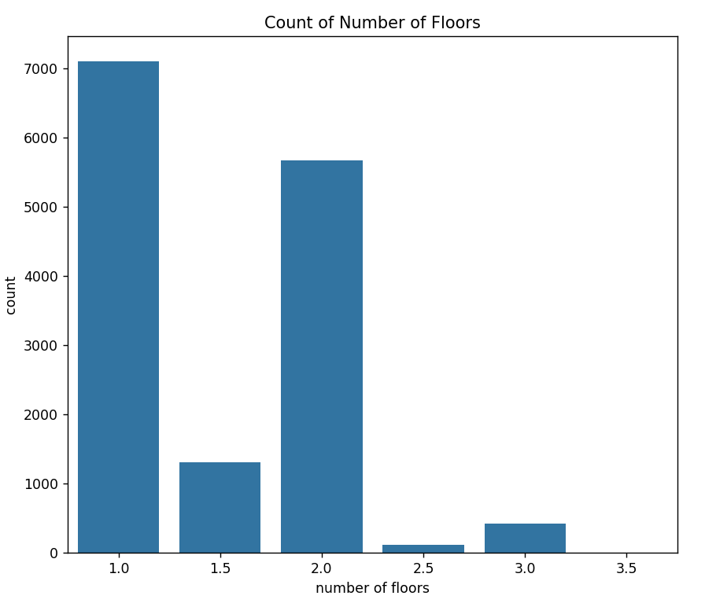
Fig 2.3 count vs number of floors

Figure 2.3 displays the distribution of houses by the number of floors in the dataset. The graph reveals that single-story houses are the most prevalent, with over 7,000 listings having only one floor, reflecting a common preference for accessibility and cost-effectiveness. Additionally, around 6,000 houses are two-story structures, suggesting a significant portion of the market favors additional living space without expanding the property's footprint. Conversely, houses with more than two floors are scarce, likely catering to niche markets or specific preferences. Overall, this insight informs real estate decisions by highlighting prevalent housing preferences.

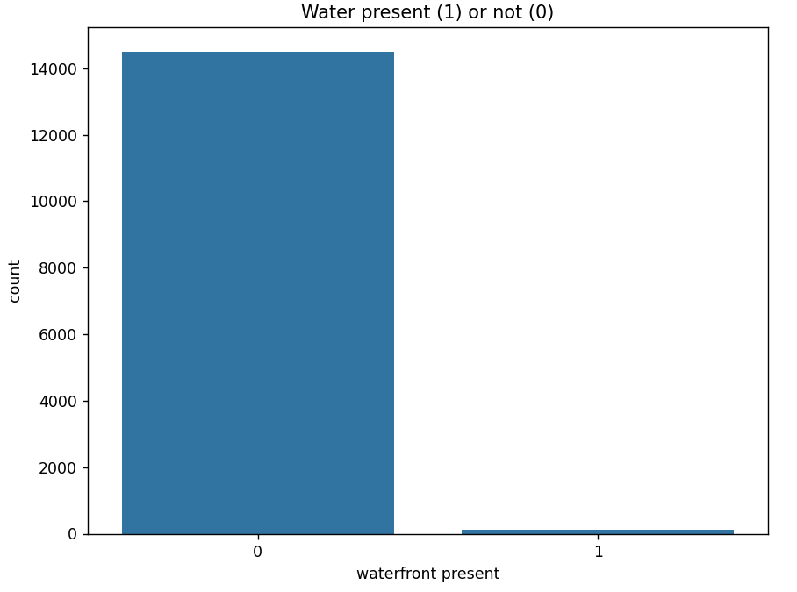
Fig 2.4 count vs waterfront present

Figure 2.4 presents a comparison of houses based on the presence of waterfront views in the dataset. The graph indicates that the majority of houses listed do not have waterfront views, significantly outnumbering those with waterfront presence. Typically, waterfront properties, such as those facing rivers or seas, are relatively fewer in number. However, they are often considered premium real estate due to their desirable locations and scenic views. While the graph does not directly reference prices, it suggests that waterfront properties may hold higher market value or desirability, as they represent a smaller portion of the overall housing supply.

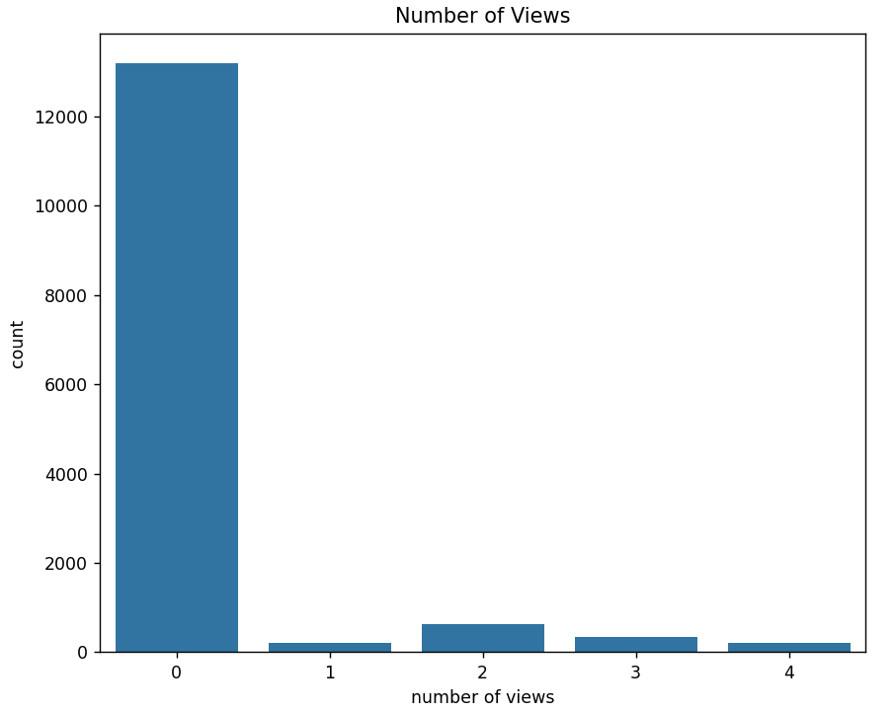
Fig 2.5 count vs number of views

Figure 2.5 depicts the distribution of houses based on the number of views nearby. The graph reveals that the majority of houses listed do not have any nearby views, indicating that properties with views are relatively uncommon in the dataset. While the graph does not specify the types of views, it suggests that scenic attractions may not be prevalent among the listed properties. This insight can be valuable for understanding the availability of desirable features and their potential influence on market demand and pricing.

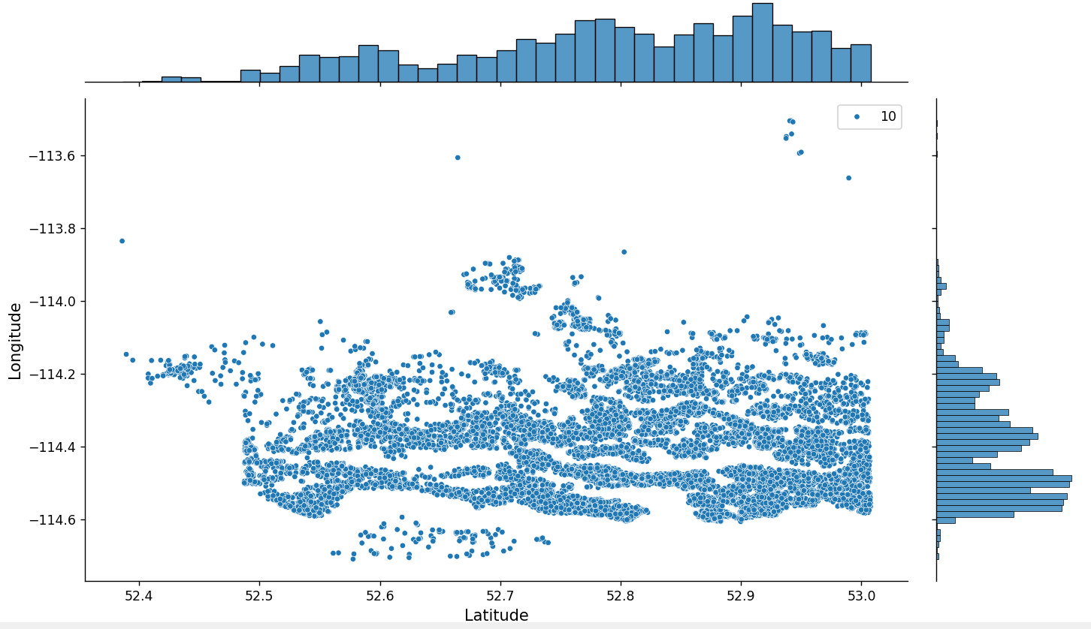
Fig 2.6 longitude and latitude

Fig 2.6 This graph is plotting the house location according to the given longitude and latitude in the dataset.

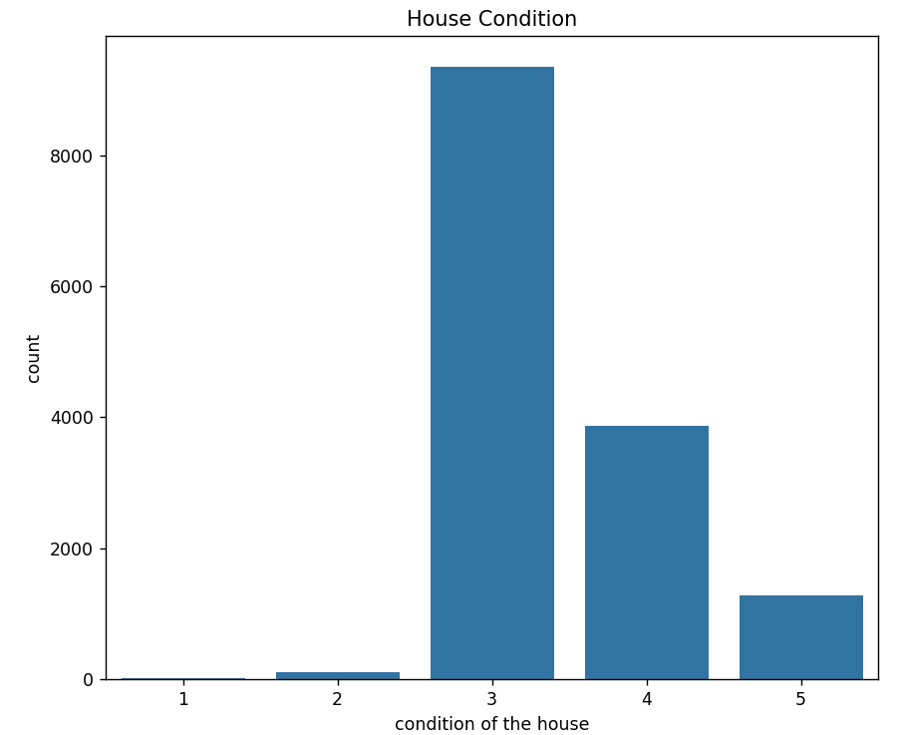

Fig 2.7 count vs condition of the house

Figure 2.7 depicts the distribution of houses based on their condition in the dataset. The graph shows that the majority of houses are in average condition, with over 8,000 houses falling into this category (condition 3). This suggests that a significant portion of the housing market comprises properties with moderate maintenance requirements or typical wear and tear. Understanding this distribution is valuable for assessing prevailing quality standards and informing pricing and renovation decisions within the market.

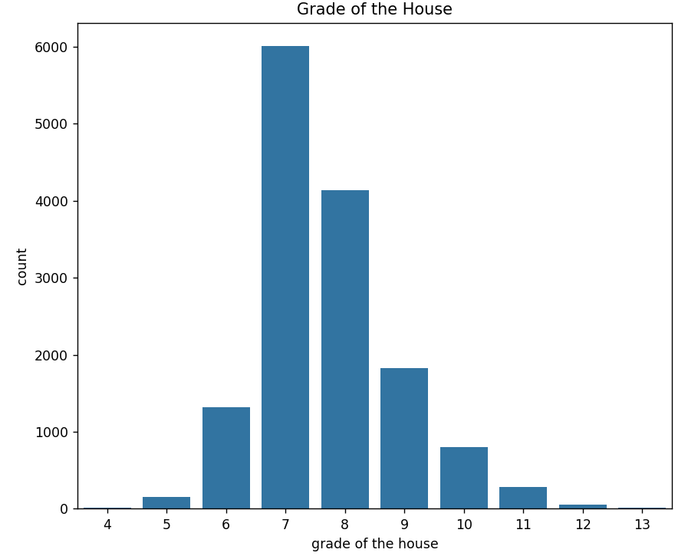

Fig 2.8 count vs grade of the house

Figure 2.8 displays the distribution of houses by grade in the dataset. Approximately 6,000 houses are graded as 7, indicating average condition and representing the most common grade among the listed properties. This insight aids in evaluating prevailing quality standards, guiding decisions on pricing, renovations, and investments.

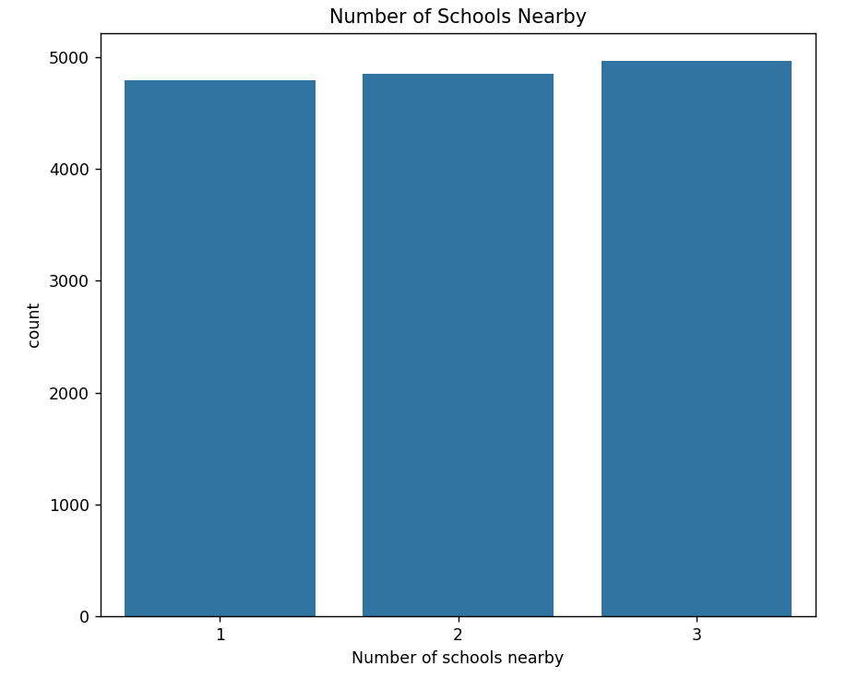
Fig 2.9 count vs number of schools nearby

Fig 2.9 graph is plotting the count of houses given in the dataset with number of houses with number of schools nearby. From this graph we can say that most of the houses have presence of school nearby. As child in a family need education, So, presence of school is the plus point for increase price of house.
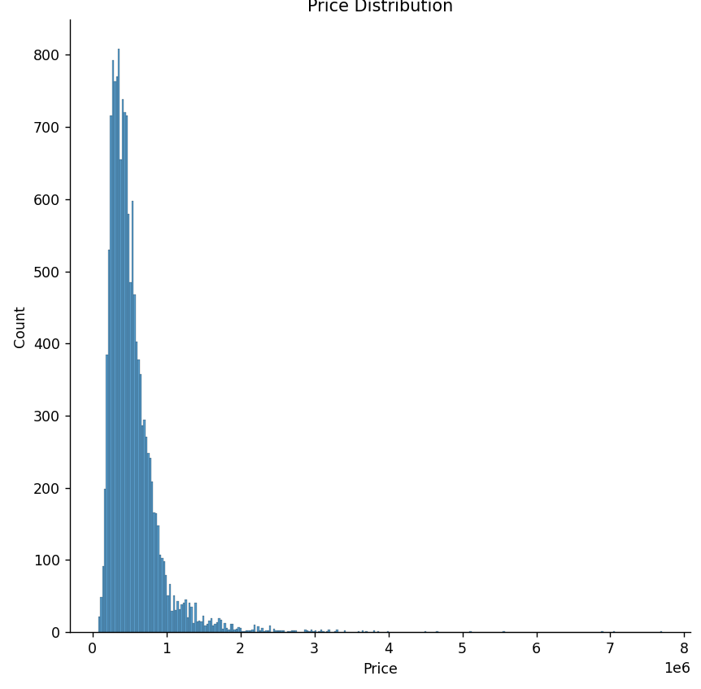
Fig 2.10 count vs price

Figure 2.10 shows that the majority of house prices in the dataset fall within the 0 to 1 scale range. This indicates a diverse range of properties catering to various budget ranges. Understanding this distribution is crucial for buyers and sellers to gauge market trends and set competitive pricing strategies.

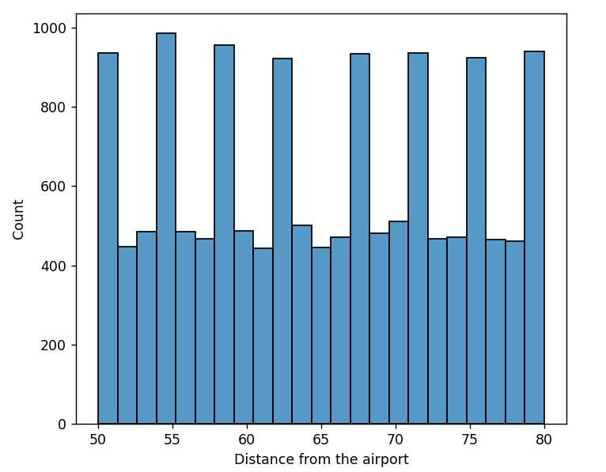
Fig 2.11 count vs distance from airport
Fig 2.11 graph is plotting the count of houses given in the dataset with distance of airport from house. From this graph we can say that half of the houses are nearby and half of the house are far from airport.

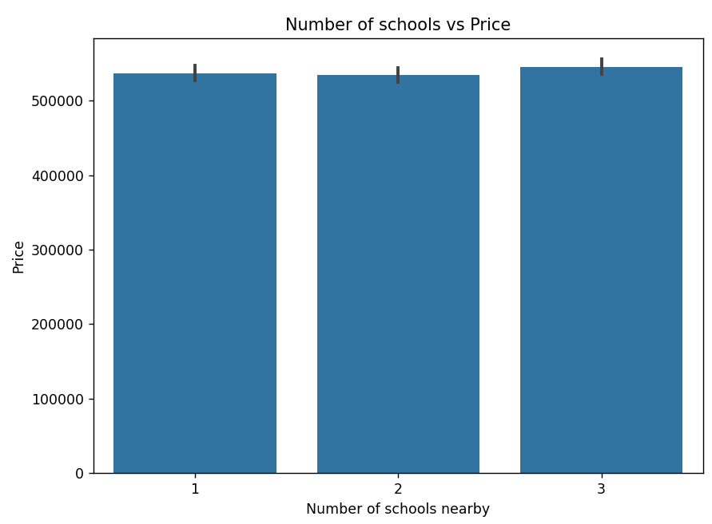
Fig 2.12 price vs number of schools nearby

Figure 2.12 shows a positive correlation between house price and the number of nearby schools. Houses located near schools tend to have higher prices, with some reaching around $500,000. This highlights the influence of school proximity on housing prices, which is crucial for buyers seeking family-friendly neighborhoods and sellers looking to leverage this feature to attract buyers.

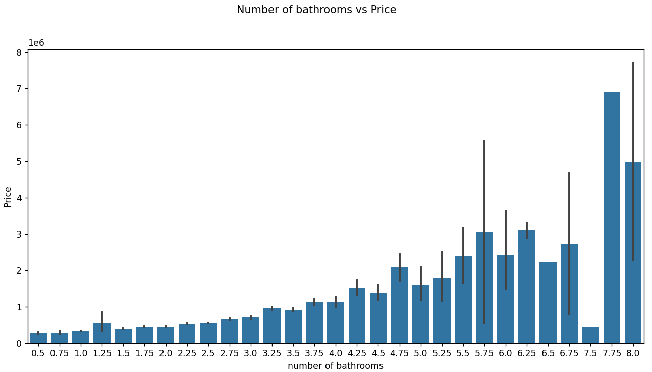
Fig 2.13 price vs number of bathrooms

Figure 2.13 suggests a direct relationship between house price and the number of bathrooms. As the number of bathrooms increases, the house price tends to rise as well. This highlights the significance of bathrooms in influencing housing prices, crucial for both buyers and sellers in assessing property value and pricing strategies.

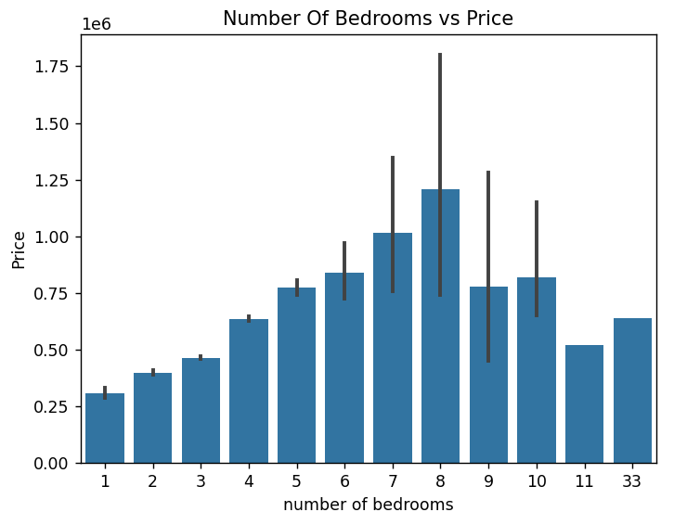
Fig 2.14 price vs number of bedrooms

Fig 2.14 graph is plotting the price of the house with the number of bedrooms. From this graph we can conclude that as the number of bedrooms increases price also increases but up to 8 bedrooms, after that due to unusefulness of rooms price decreases.

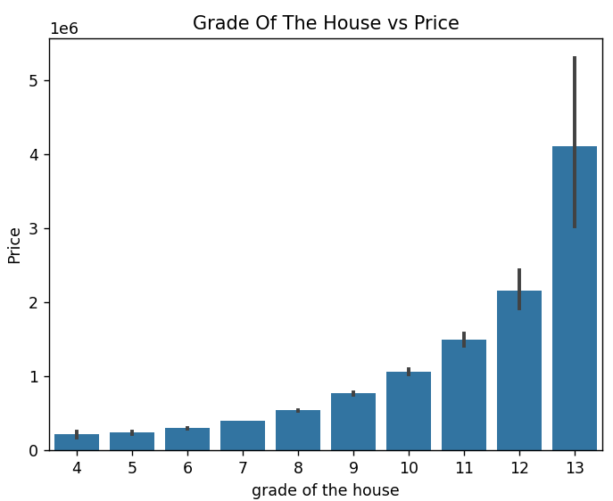
Fig 2.15 price vs grade of the house

Figure 2.15 illustrates the relationship between house price and the grade of the house. The graph indicates a clear positive correlation, where higher grades correspond to higher house prices.
This observation highlights the importance of the grade as a determinant of house prices. Grades typically reflect the overall quality, condition, and features of the house, with higher grades indicating superior attributes. Consequently, houses with higher grades are often perceived as more desirable and command higher prices in the real estate market.
Understanding this relationship is essential for both buyers and sellers. Buyers can use the grade as an indicator of property quality and value, while sellers can leverage high-grade properties to justify higher asking prices and attract potential buyers.
In summary, Figure 2.15 underscores the positive correlation between house price and the grade of the house, emphasizing the significance of house grading in determining housing prices.
.

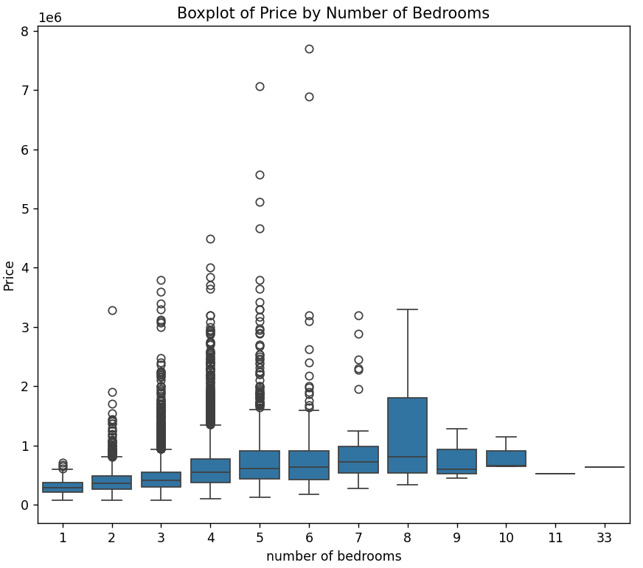
Fig 2.16 price vs number of bedrooms
Figure 2.16 illustrates the relationship between house price and the number of bedrooms. The graph suggests that as the number of bedrooms increases, the house price generally rises, but this trend levels off beyond a certain point. This indicates diminishing returns on price with additional bedrooms, highlighting the importance of other factors like location and amenities in determining house prices. Understanding this relationship is crucial for buyers and sellers to set realistic expectations and pricing strategies in the real estate market.

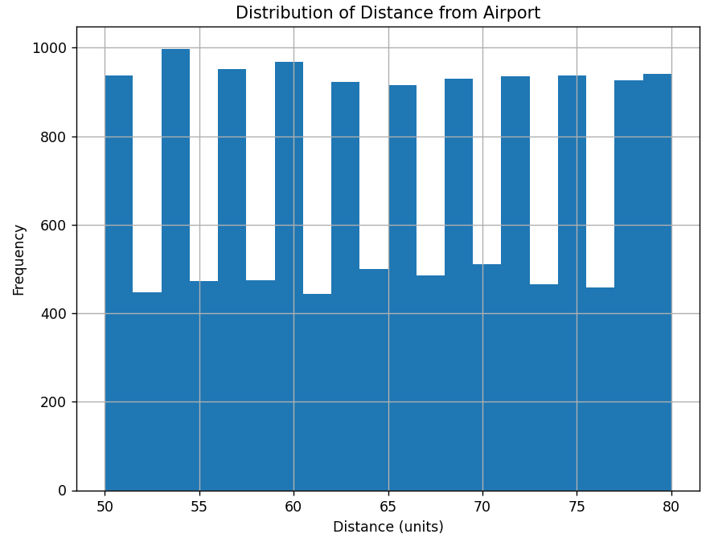
Fig 2.17 frequency vs distance

Figure 2.17 indicates a balanced distribution of houses based on their proximity to the airport. Approximately half of the houses are near the airport, while the other half are farther away. This suggests a diverse range of housing options catering to varying preferences regarding airport proximity. Understanding this distribution is crucial for buyers and sellers, as it informs decisions about location preferences and market dynamics.

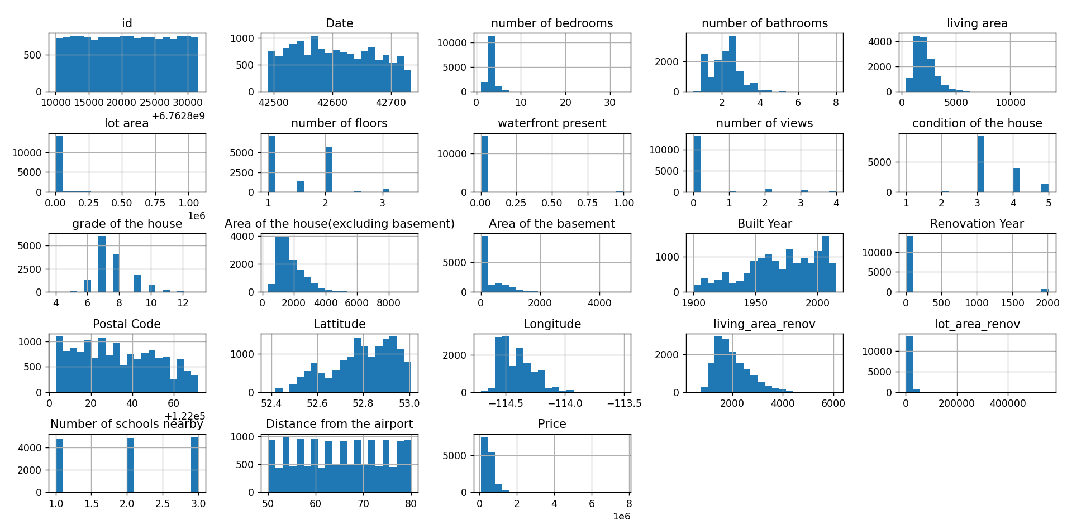

Fig 2.18 Overall data visualization

Figure 2.18 provides an overarching visualization representing the relationships between various attributes within the dataset. This comprehensive graph enables a holistic understanding of how different factors relate to each other and contribute to the overall dataset dynamics.
By examining Figure 2.18, we can glean insights into the interplay between different attributes and their impact on the dataset as a whole. This includes understanding correlations, trends, and patterns that may exist among the attributes, aiding in identifying key features and factors influencing the dataset.
The visualization serves as a valuable tool for data analysis, allowing stakeholders to explore relationships and draw meaningful conclusions. It facilitates the identification of potential insights and trends that may guide decision-making processes in various domains, such as real estate investment, market analysis, and urban planning.
In summary, Figure 2.18 offers a comprehensive overview of the dataset, highlighting the relationships between attributes and providing a basis for deeper analysis and interpretation.

2.3.1.2 FEATURE SELECTION

CORRELATION MATRIX
A square matrix that defines the correlation coefficients between the variables is used. Each of the cells represents the correlation between pairs. Its value ranges from -1, 0, and 1, which indicates:
- 1 indicates that they both are directly proportional,
- -1 indicates inversely proportional, and
- 0 indicates no relation.

In this project, a correlation matrix has been used for feature selection and also to reduce data and unwanted noise. Higher correlation provides similar information to the model. So, highly correlated features have been removed to improve computational speed and performance. In addition to that, the correlation matrix helps in exploring, analyzing, and understanding the relationship between pairs of variables in the dataset.

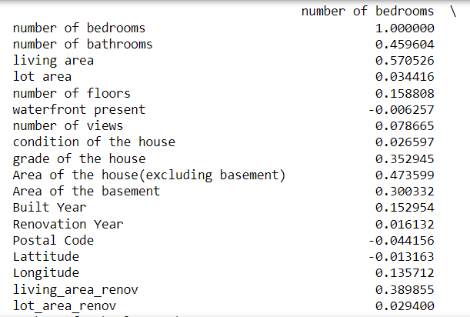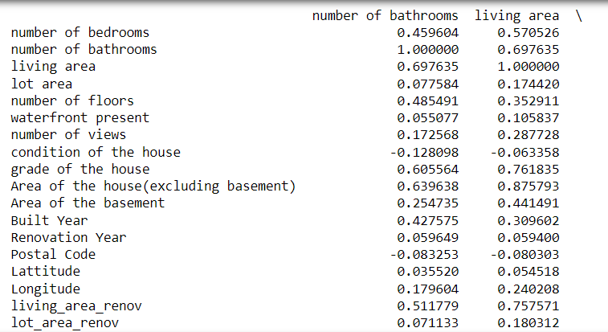
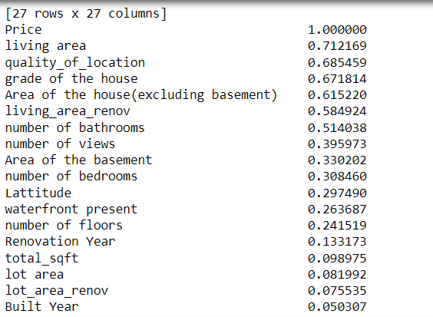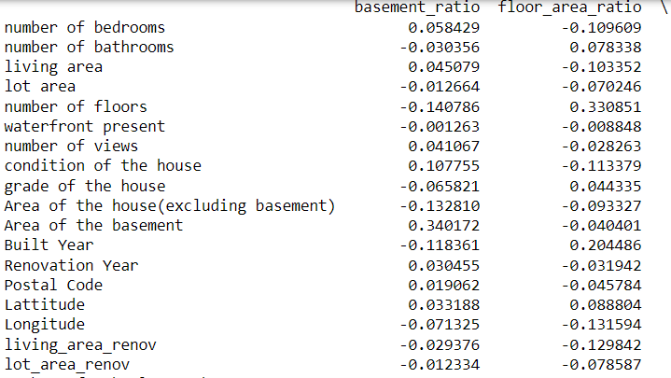
Fig 2.19 correlation matrix

HEAT MAP

The correlation matrix tells us about the correlation between the features, but for visualization of the correlation matrix, a heatmap has been used. It is an easy way to visualize data in an understandable manner. The color of each cell represents the strength between the pair, indicating as follows:

- Colors like red and orange indicate high positive correlation.
- Colors like blue or green represent high negative correlation, and
- Neutral colors like white and gray represent no relation.
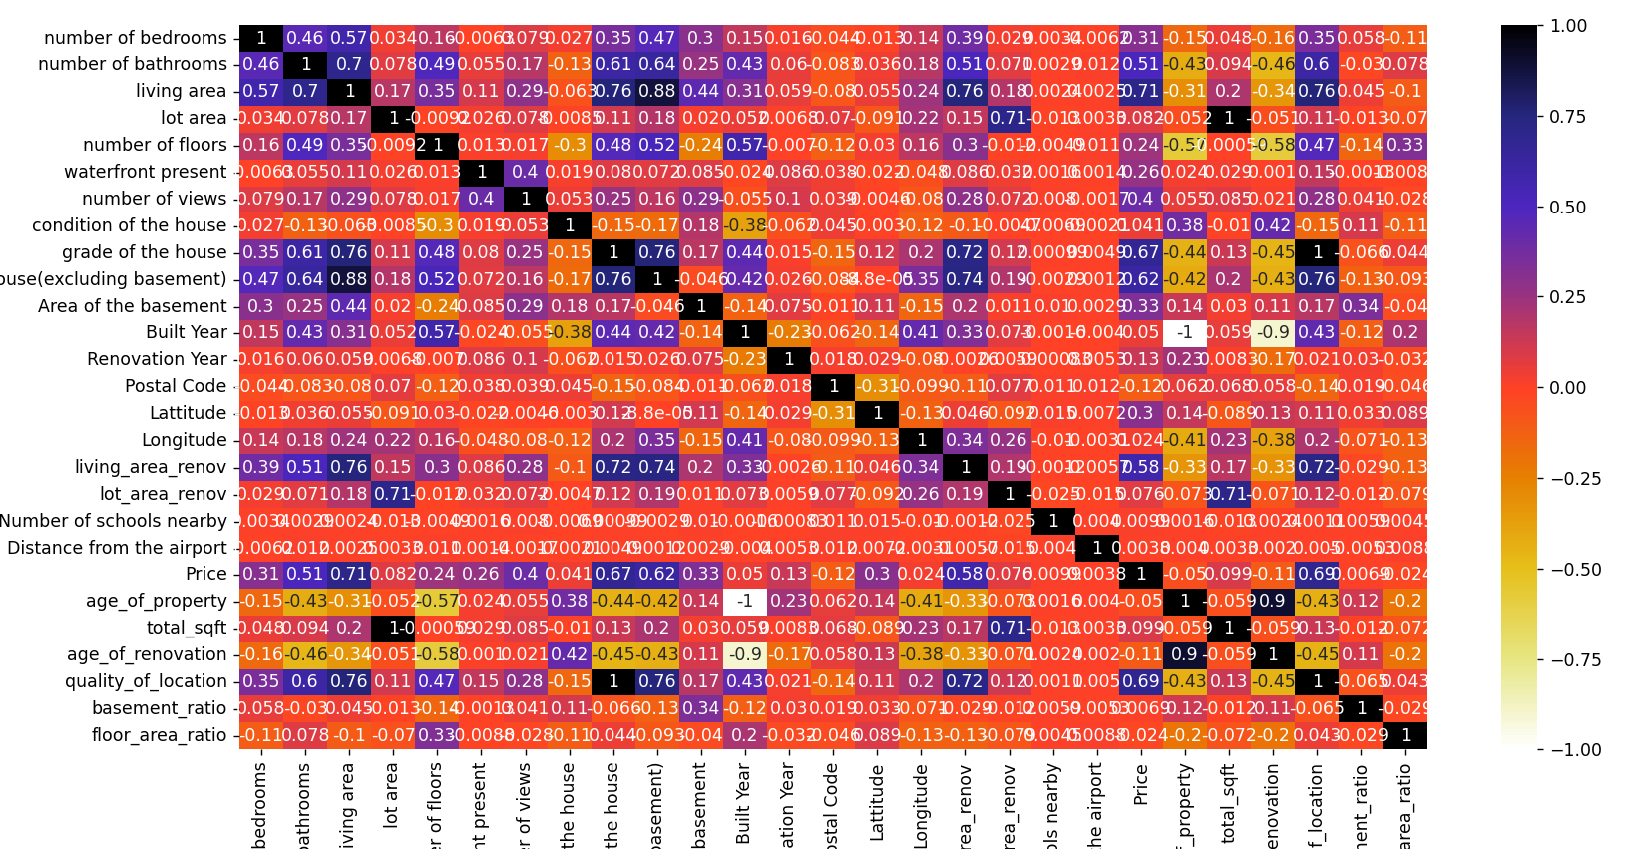
Fig 2.20 Heat Map

    - FEATURE ENGINEERING

The technique of creating new features by using the data which was already present in the dataset is employed. For the creation of new features, the dataset needs to be examined to determine what new features can be made from it. The goal is to improve accuracy and performance of the machine learning model.

After visualization of the correlation matrix and heat map, some new attributes have been featured which were manufactured by computation of the attributes already present in dataset.
These featured attributes are as follows: -

- Age of property = current year – built year
- Total area = Living area + Lot area
- Age of renovation = current year – renovation year
- Quality of Location = Grade of house + Waterfront present
- Basement Ratio = Area of basement / Area of the house
- Floor Area Ration = Living area / lot area

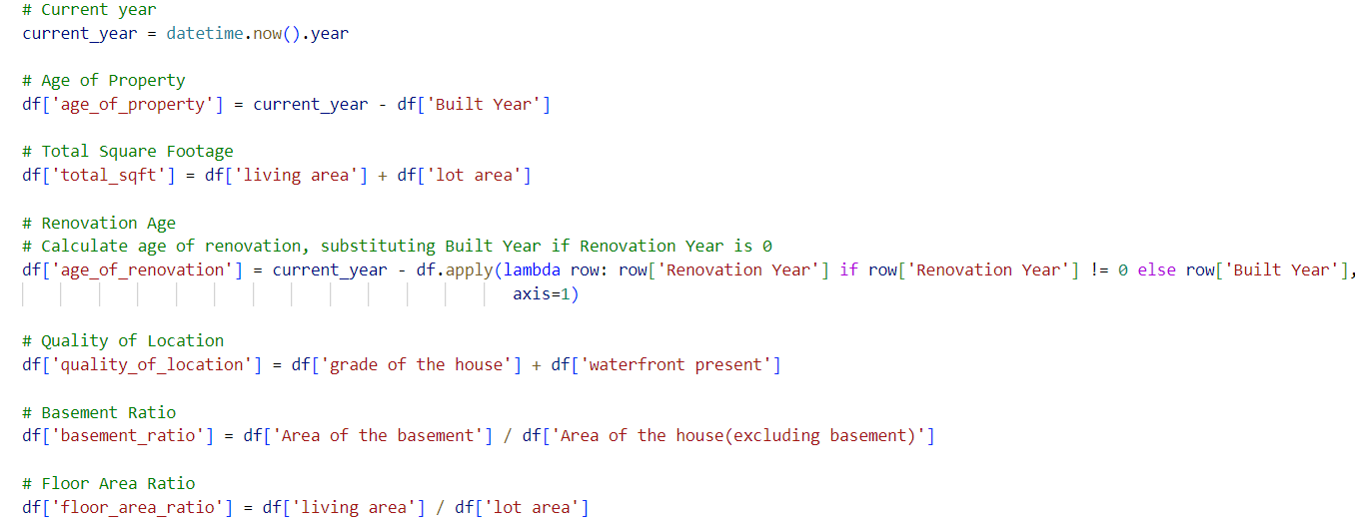
Fig 2.21 feature engineering

    - MODEL SELECTION

Model selection is a vital stage in a machine learning project in which the algorithm that is most reliable and provides the most accurate output is chosen to handle the problem and dataset. This process begins after data preprocessing that makes the dataset suitable for application in machine learning models. After that, several machine learning algorithms are applied, and their accuracy is analyzed and compared with each other. Now the algorithm having the best accuracy is being selected as our base model and given the responsibility of providing the prediction or output.

Experimentation was conducted with the individual and combination of algorithms, including Random Forest, Random Forest and stacking, Random Forest and bagging, and Random Forest and boosting. In this project, the model whose accuracy is the best among all the models applied has been selected. Ensemble learning itself is a complex algorithm, and applying and experimenting with it is a challenge that was faced.

Here is the experimented result: -

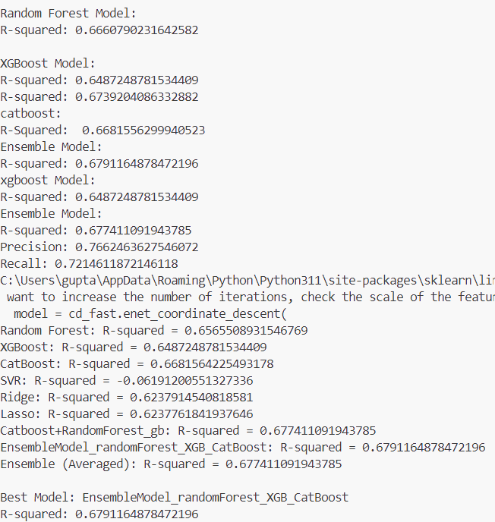
Fig 2.22 Model and their r square value

Between all the r-square values of all the applied models, it can be seen that the combination of Random Forest, XG Boost, and Cat Boost has the maximum r-square value, which is 0.679. So, it has been selected as our base model.

    - TRAIN BASE MODEL

After the successful selection of the base model, the data has been made compatible according to the model. Firstly, the data needs to be divided into training data and testing data in an 80:20 ratio. Both the data are further divided into features and prices. Now, our data is ready to be computed.
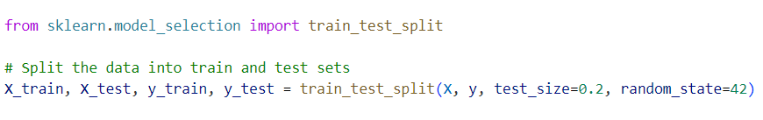
Fig 2.23 Data splitting

Python has its inbuilt library which consists of inbuilt machine learning models. So, an object of the model has to be created. An object of Random Forest was made and the data was applied into it.

    - ENSEMBLE CONSTRUCTION

Now we need to choose the ensemble learning technique that is compatible for our project. There are several ensemble learning techniques such as Bagging, Boosting, Stacking and Cat Boost.

- Bagging: Bagging in machine learning involves the creation of multiple bootstrap samples from the original training dataset. Each sample is used to train a base model, and predictions are aggregated to reduce variance and improve stability. It is commonly employed in algorithms like Random Forest to enhance predictive accuracy. The prediction made by multiple models is combined, and its average is taken or, in simple words, it operates on the principle of majority vote.

- Boosting: Boosting algorithms, such as AdaBoost (Adaptive Boosting) and Gradient Boosting Machines (GBM), iteratively improve the model's performance by sequentially learning from the errors made by previous weak learners. This process continues until a predetermined number of weak learners have been trained or until a desired level of accuracy is achieved. Boosting is effective for improving predictive performance, especially when used with weak base models.

- Stacking: In this technique, the model will be utilized according to the weightage given to it. Stacking in machine learning is an ensemble learning technique where multiple base models are combined through a meta-learner to improve prediction accuracy. Base models' predictions serve as input to the meta-learner, which learns to predict the final outcome. Stacking is effective in capturing diverse patterns and reducing model bias.

- Cat boost: CatBoost is a gradient boosting algorithm developed by Yandex, designed for high-performance and efficient training of machine learning models. It stands for "Categorical Boosting" and is particularly effective for datasets with categorical features. Categorical variables are automatically handled by CatBoost, reducing the need for manual preprocessing. Robust handling of missing data is also incorporated, and built-in support is provided for handling features of different types. CatBoost is known for its fast training speed and competitive predictive performance. It operates on the basis of gradient boosted decision trees.

Now we have to examine which ensemble learning technique works the best for tour project.

    - PERFORMANCE EVALUATION

Evaluation of the models is a very important step to make changes accordingly that can help in increasing the accuracy. R-square values of each model have been calculated, which are the basis of comparing the performance of our model.

Here is the list of the r square value of each of the model we got: -

Machine learning model | R-Square value
Random Forest | 0.66681
XG Boost | 0.64872
Cat boost | 0.66815
Ensemble Model | 0.67811
Random Forest and XG Boost | 0.64872
Random Forest, XG Boost and Cat boost | 0.67911

Table 2.2 Model and its R squared value

    - INTEGERATION AND DEPLOYMENT WITH WESITE

The end of our project has been reached. The model construction and its performance evaluation have been completed. Now, the project needs to be integrated with the website for real-time use. Making it available for everyone is considered a good practice, as the aim is to help the buyer as well as the seller to make it easy for them to calculate the price and to increase the fairness and social justice between them.

As this time, we have created a website taking 8 input that is listed below: -

- Number of bedrooms
- Number of bathrooms
- Living area
- Lot area
- Number of Floors
- Waterfront present
- Number of Views
- Age of property

There are total 23 attributes and above are the main 8 attributes that is mostly affecting the house price. So, this model is capable of providing output with accuracy with the help above stated values

Chapter 3 Implementation and Result

3.1 SOFTWARE INSTALLATION
3.1.1 VS CODE STUDIO
Step 1: Visit the Official Website of the Visual Studio Code using any web browser like Google Chrome, Microsoft Edge, etc. 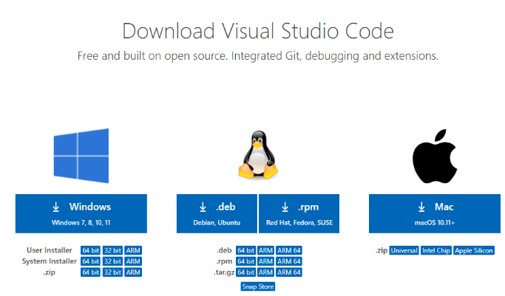
Fig 3.1 Download vs code

Step 2: Press the “Download for Windows” button on the website to start the download of the Visual Studio Code Application.

Fig 3.2 Press download

Step 3: When the download finishes, then the Visual Studio Code Icon appears in the downloads folder.

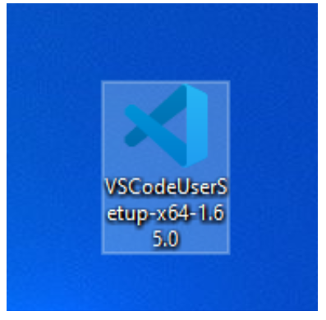
Fig 3.3 VS Code icon

Step 4: Click on the Installer icon to start the installation process of the Visual Studio Code.

Step 5: After the Installer opens, it will ask you to accept the terms and conditions of the Visual Studio Code. Click on I accept the agreement and then click the Next button.

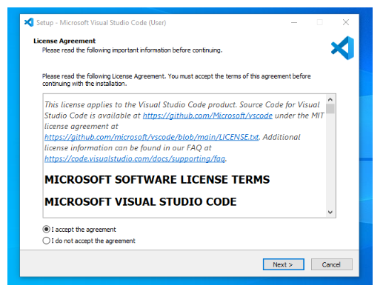
Fig 3.4 Agreement
Step 6: Choose the location data for running the Visual Studio Code. It will then ask you to browse the location. Then click on the Next button.

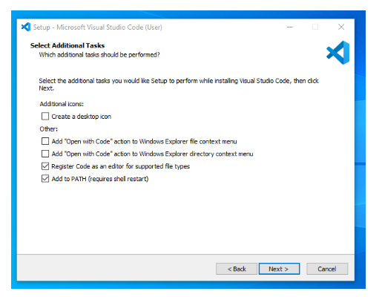
Fig 3.5 Choose location to install

Step 7: Then it will ask to begin the installation setup. Click on the Install button.

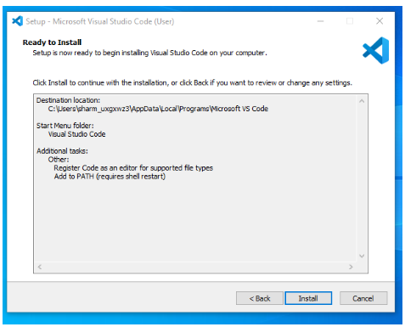
Fig 3.6 Click Install

Step 8: After clicking on Install, it will take about 1 minute to install the Visual Studio Code on your device.
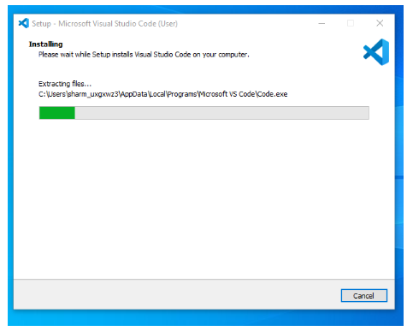
Fig 3.7 Installing VS Code

Step 9: After the Installation setup for Visual Studio Code is finished, it will show a window like this below. Tick the “Launch Visual Studio Code” checkbox and then click Next.
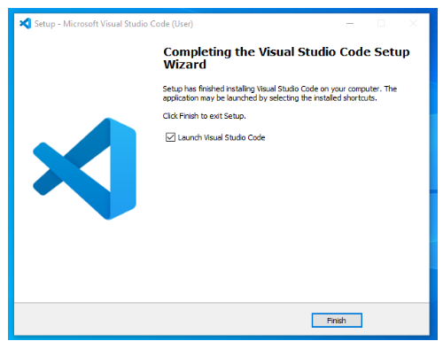
Fig 3.8 Installation Complete

Step 10: After the previous step, the Visual Studio Code window opens successfully. Now you can create a new file in the Visual Studio Code window and choose a language of yours to begin your programming journey!

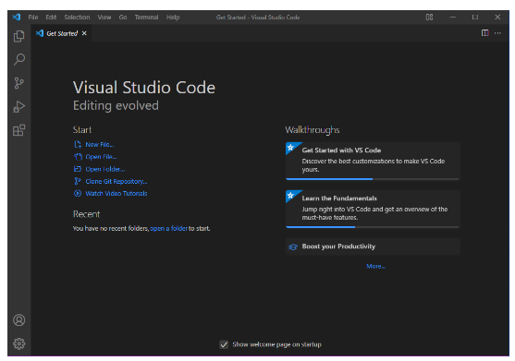
Fig 3.9 VS Studio interface

3.1.2 PYTHON INSTALLATION

Step 1: Select Version to Install Python
Visit the official page for Python https://www.python.org/downloads/ on the Windows operating system. Locate a reliable version of Python 3, preferably version 3.10.11, which was used in testing this tutorial. Choose the correct link for your device from the options provided: either Windows installer (64-bit) or Windows installer (32-bit) and proceed to download the executable file.

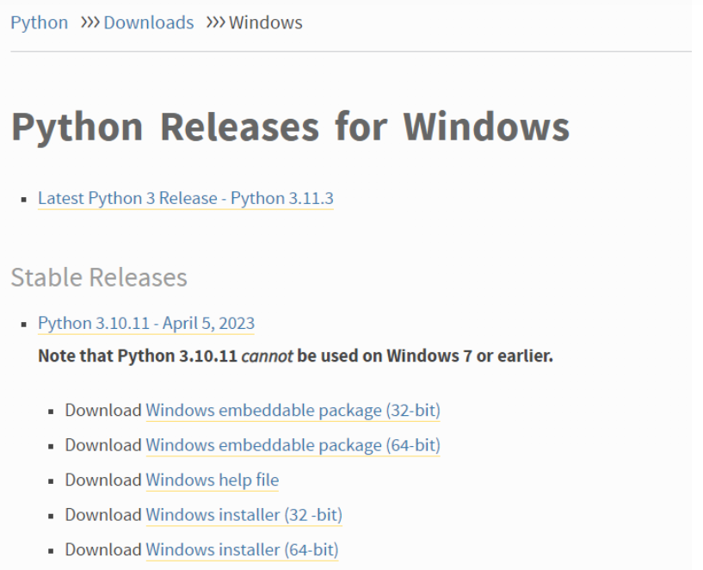
Fig 3.10 Download Python

Step 2: Downloading the Python Installer
Once you have downloaded the installer, open the .exe file, such as python-3.10.11-amd64.exe, by double-clicking it to launch the Python installer. Choose the option to Install the launcher for all users by checking the corresponding checkbox, so that all users of the computer can access the Python launcher application.Enable users to run Python from the command line by checking the Add python.exe to PATH checkbox.

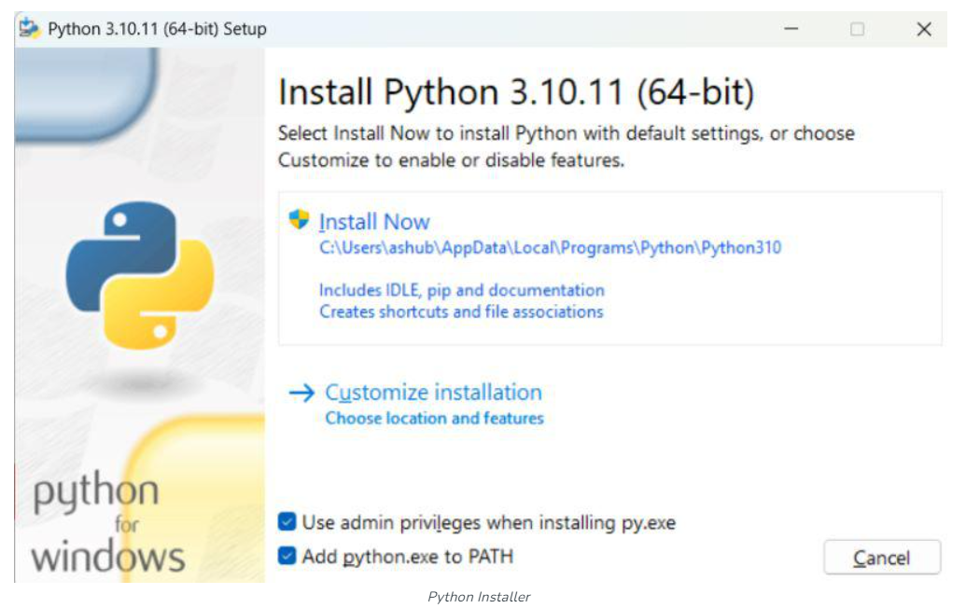
Fig 3.11 Install Python

Step 3: After Clicking the Install Now Button the setup will start installing Python on your Windows system. You will see a window like this.

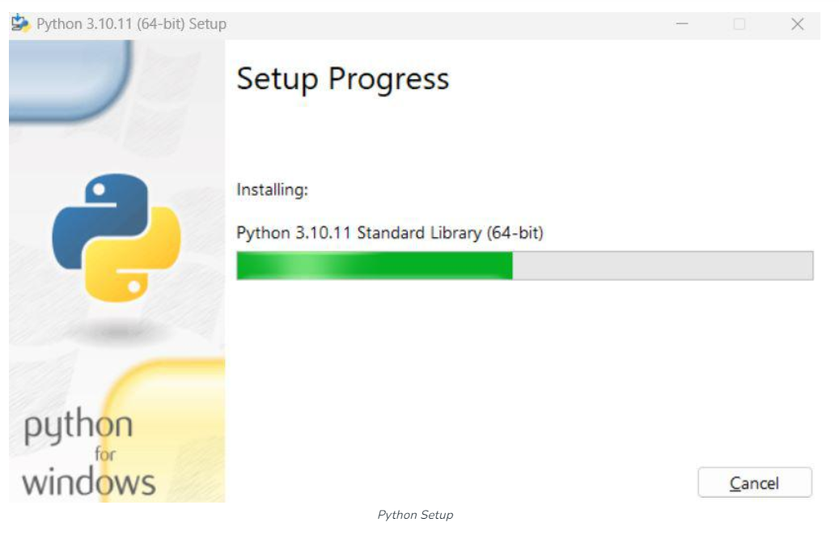
Fig 3.12 Installing Python

Step 4: Running the Executable Installer
After completing the setup. Python will be installed on your Windows system. You will see a successful message.

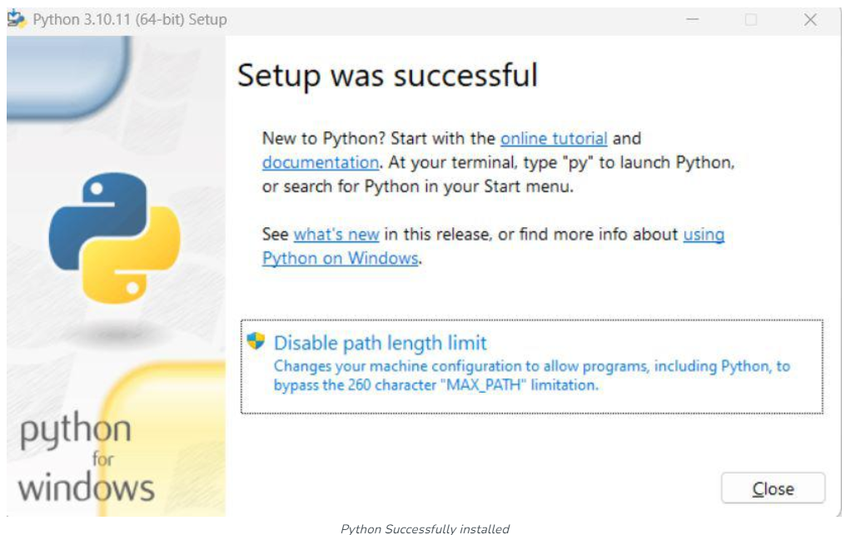
Fig 3.13 Python installed

Step 4: Verify the Python Installation in Windows
Close the window after successful installation of Python. You can check if the installation of Python was successful by using either the command line or the Integrated Development Environment (IDLE), which you may have installed. To access the command line, click on the Start menu and type “cmd” in the search bar. Then click on Command Prompt. Python –version

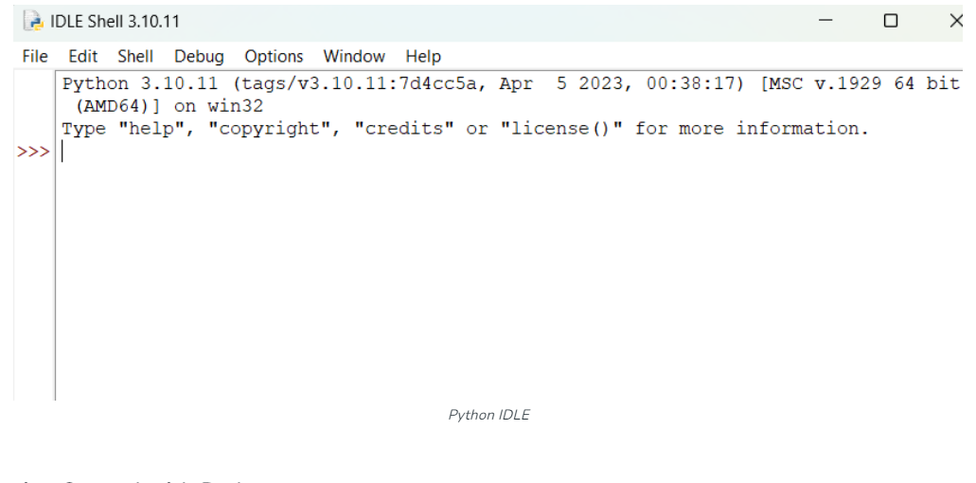
Fig 3.14 Check python version

3.1.3 Anaconda Installation

Step 1: Head over to anaconda.com and install the latest version of Anaconda. Make sure to download the “Python 3.7 Version” for the appropriate architecture.


Fig 3.15 Download Anaconda

Step 2: Getting Started:


Fig 3.16 Click next

Step 3: Getting through the License Agreement

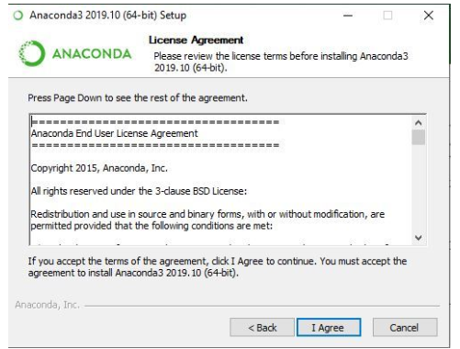
Fig 3.17 License Agreement

Step 4: Select Installation Type: Select Just Me if you want the software to be used by a single User

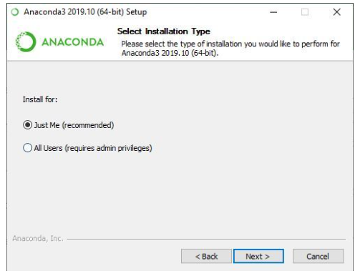
Fig 3.18 Installation for

Step 5: Choose Installation Location

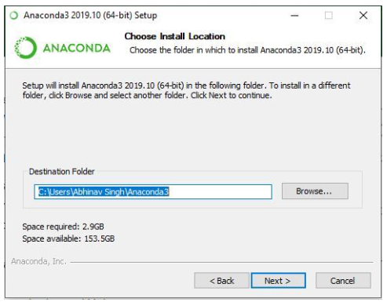
Fig 3.19 Installation location

Step 6: Advanced Installation Option

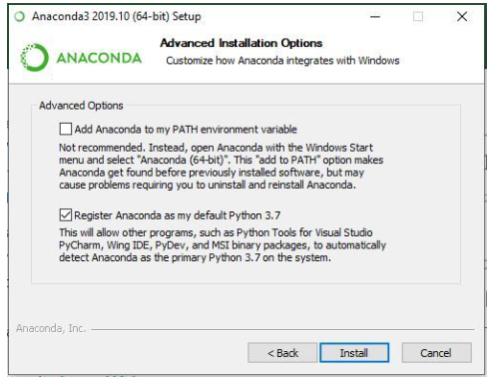
Fig 3.20 Advance installation

Step 7: Getting through the Installation Process


Fig 3.21 Anaconda Installing

Step 8: Recommendation to Install Pycharm:


Fig 3.22 Pycharm install

Step 9: Finishing up the Installation


Fig 3.23 Anaconda Installed

3.1.4 VS CODE EXTENSION INSTALLATON
Step 1: Open CMD
Fig 3.24 Python powershell

Step 2: Type
- python -m pip install pandas
- python -m pip install numpy
- python -m pip install scikit- learn
- python -m pip install matplotlib
- python -m pip install xgboost
- python -m pip install catboost

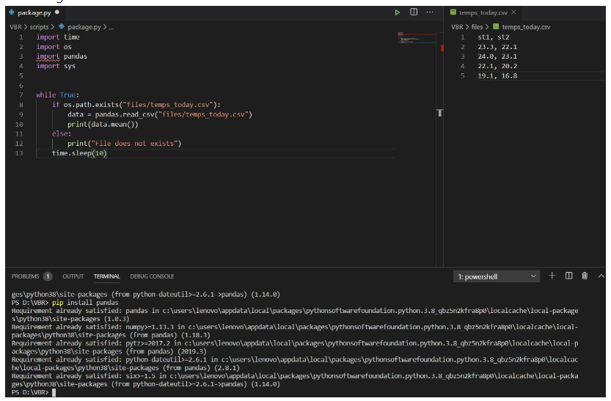
Fig 3.25 Installing extension

Step 3: Restart your VS Code studio

3.1.5 HOW TO RUN PROGRAM
Step 1: Open VS Code
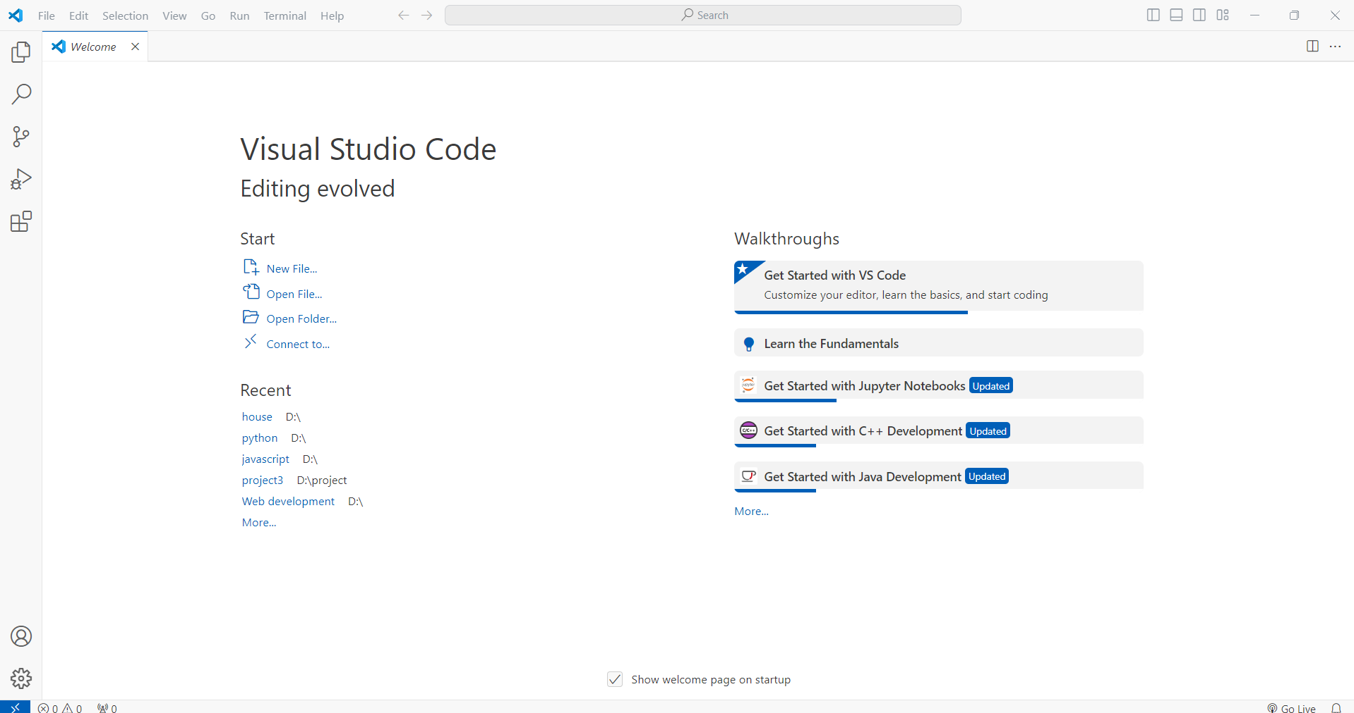
Fig 3.26 VS code open

Step 2: Open Create one folder with any name let say house.
Step 3: Create one folder in it with the name template and put html file with name index.html
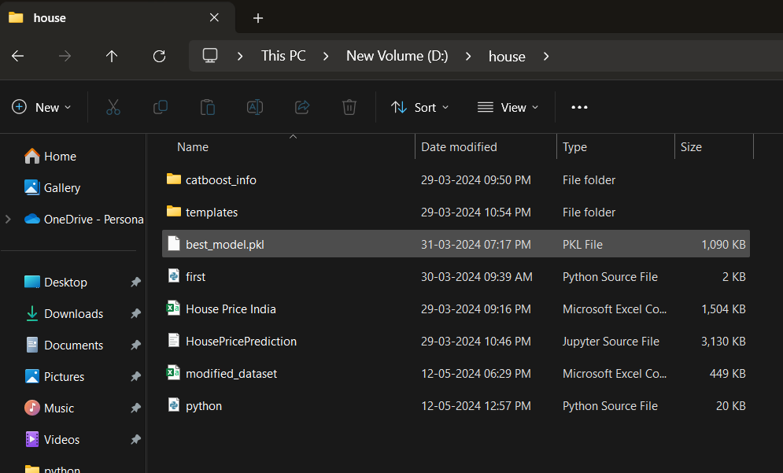
Fig 3.27 Template folder

Step 4: Create two python file with python.py as name and put the code.

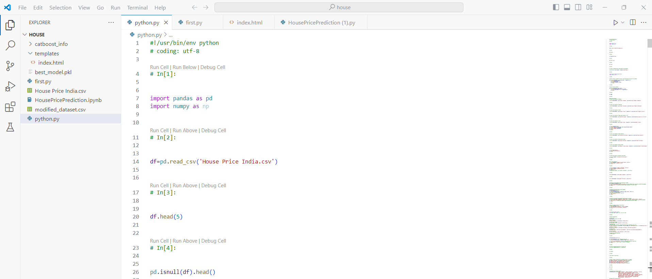
Fig 3.28 Python file creation

Step 5: Click on top right Run button.
Step 6: Run first.py file

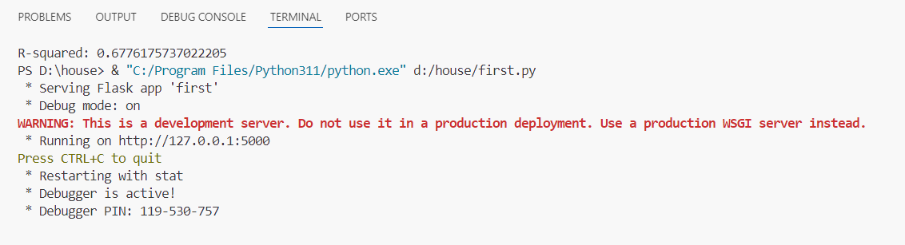
Fig 3.29 File Running

Step 7: Click on the http://127.0.0.1:5000 and open in browser.
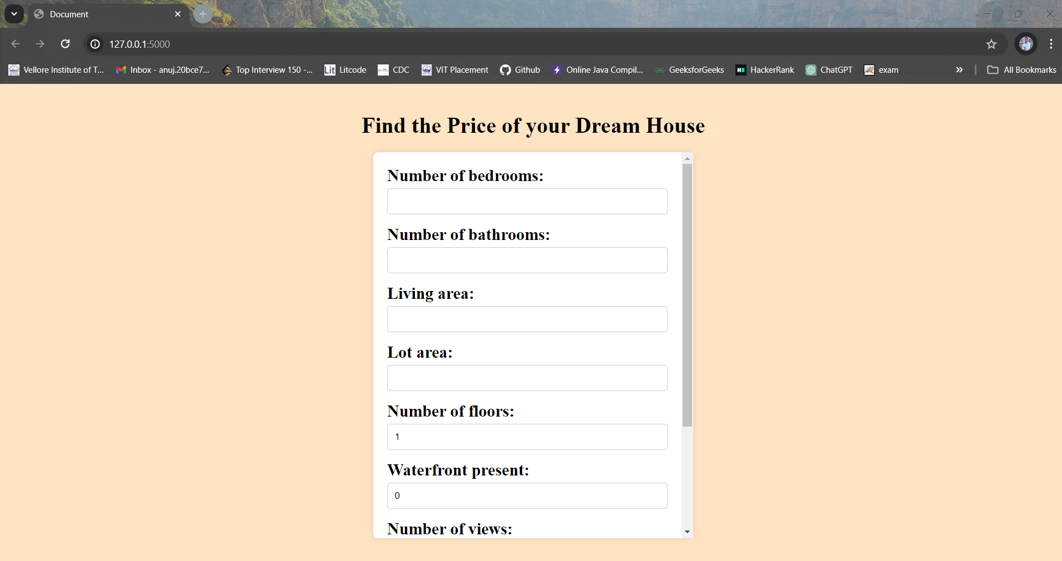
Fig 3.30 Web interface

Step 8: Put the attributes into the form and click submit.
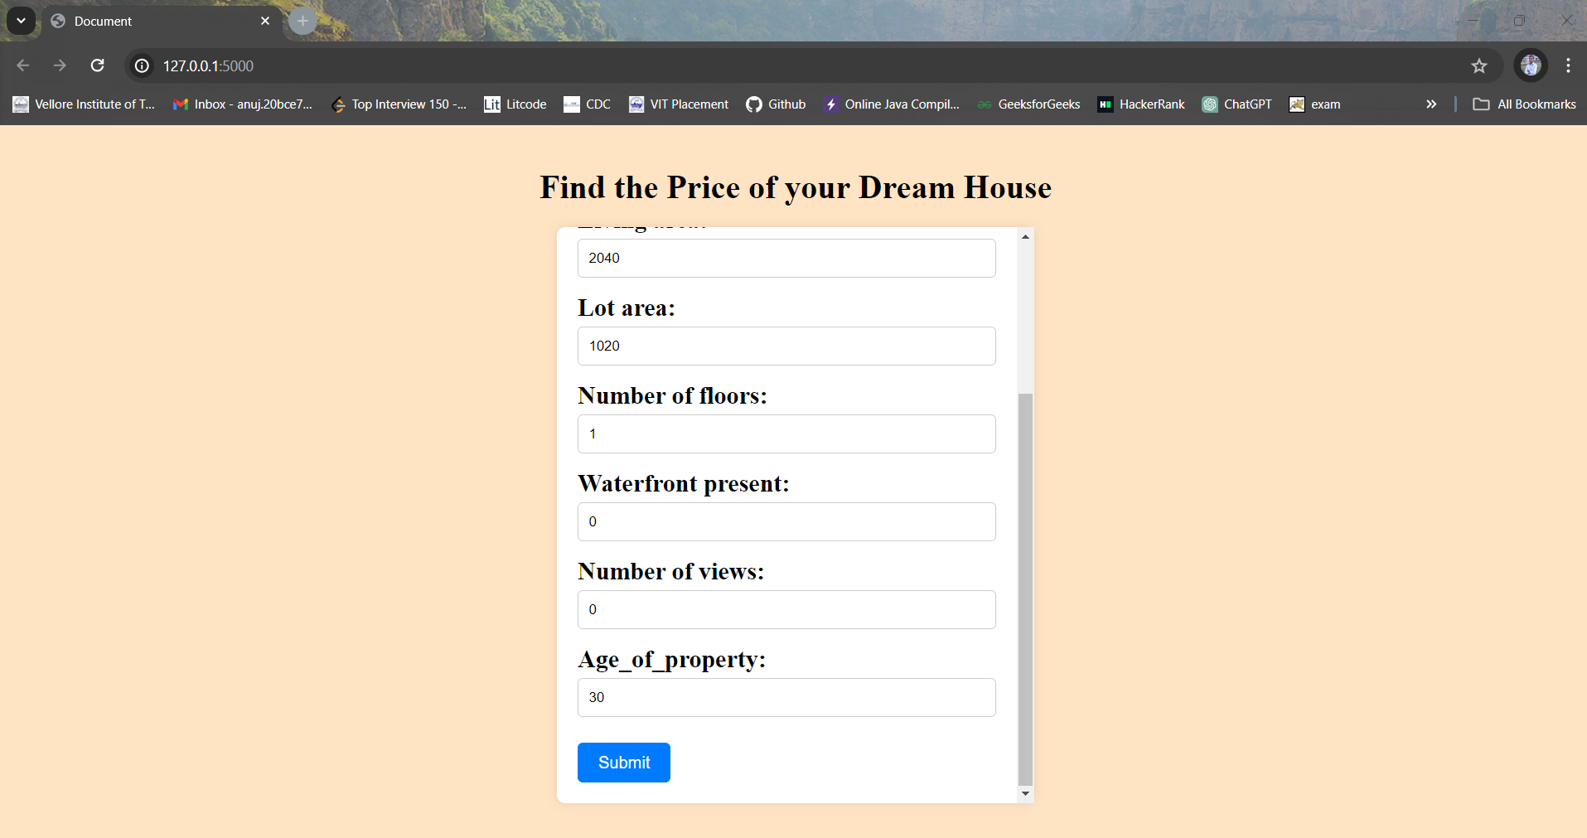
Fig 3.31 Input values in the form
Step 9: Now House predicted price will be given

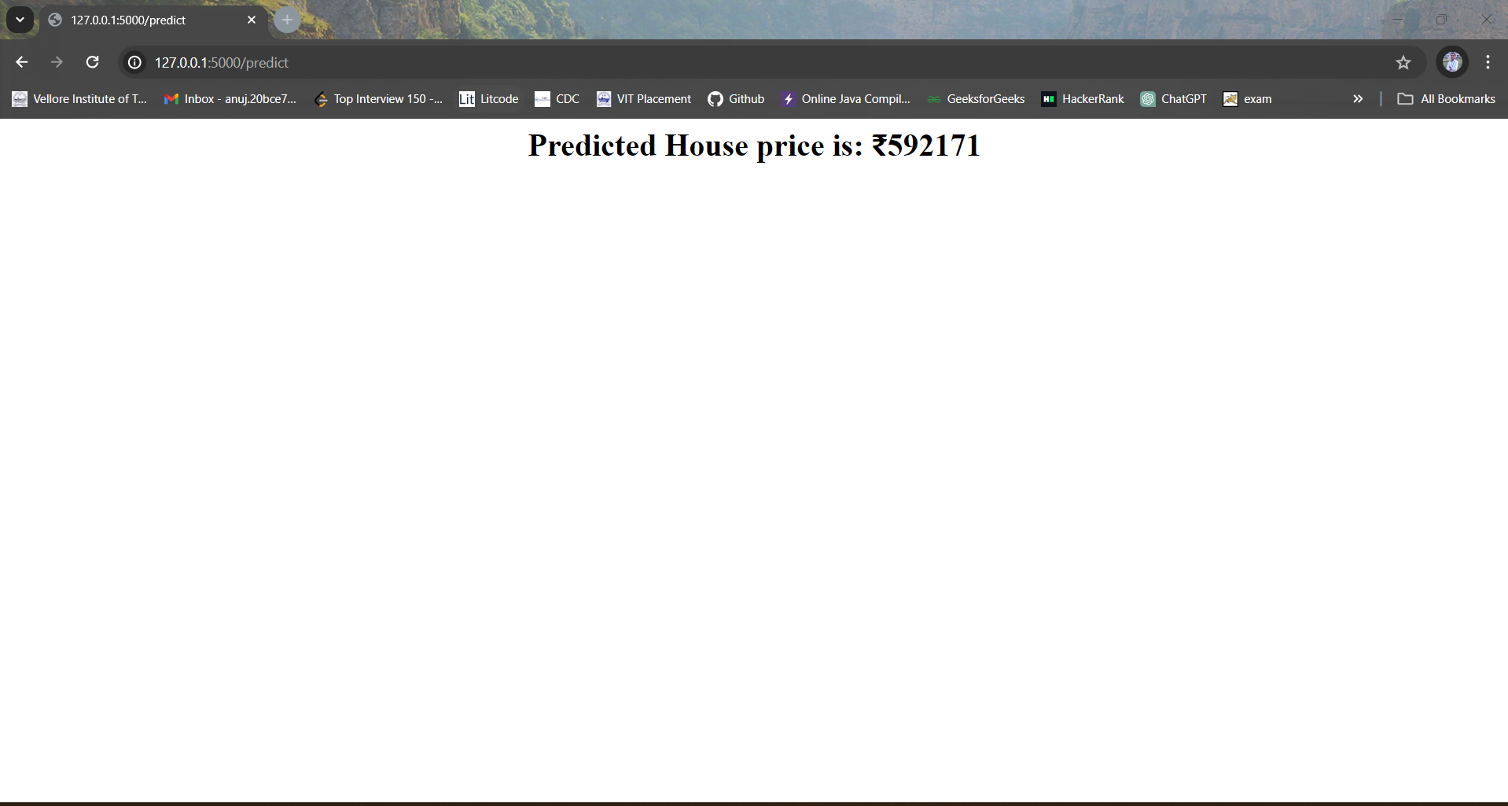
Fig 3.32 Predicted Price

CHAPTER 4 CONCLUSION AND FUTURE WORK
4.1 Conclusion
To sum up, there are a lot of advantages in terms of accuracy and robustness when ensemble learning approaches are used to predict house prices. The combined knowledge of several models, including decision trees, random forests, and gradient boosting machines, is utilized by our ensemble model, outperforming individual models alone in terms of prediction performance.

Our ensemble approach is routinely outperformed by single algorithms through thorough assessment and validation, reducing overfitting and improving generalization to new data. More accurate predictions across a range of scenarios and datasets are ensured by the ensemble's capacity to recognize a variety of patterns and take advantage of the complementing capabilities of its models.

Moreover, flexibility and scalability are provided by ensemble learning, facilitating the easy incorporation of fresh data sources and model modifications to adjust to changing real estate market conditions. This flexibility increases the model's applicability.

  - Future works

Future research endeavours will be centred on augmenting the prediction powers of the ensemble model through the integration of sophisticated feature engineering methodologies and investigation of innovative ensemble tactics. In order to gather more information impacting home values, attempts will also be made to integrate alternative data sources, such as sentiment analysis on social media or satellite imagery. Interpretability techniques will be explored to give stakeholders transparent decision-making procedures and useful information. Maintaining the model's effectiveness and applicability in changing real estate markets will require constant model improvement and validation against real-world data.

4.2 APPENDICES
from sklearn.ensemble import RandomForestRegressor
from xgboost import XGBRegressor
from sklearn.model_selection import train_test_split
from sklearn.metrics import mean_squared_error, mean_absolute_error, r2_score

# Define individual base models
random_forest_model = RandomForestRegressor()
xgboost_model = XGBRegressor()

# Train individual base models
random_forest_model.fit(X_train_scaled, y_train)
xgboost_model.fit(X_train_scaled, y_train)

# Make predictions using individual base models
y_pred_rf = random_forest_model.predict(X_test_scaled)
y_pred_xgb = xgboost_model.predict(X_test_scaled)

y_pred_rf
y_pred_xgb

r2_rf = r2_score(y_test, y_pred_rf)

# Evaluate XGBoost model
r2_xgb = r2_score(y_test, y_pred_xgb)

print("Random Forest Model:")
print("R-squared:", r2_rf)

print("\nXGBoost Model:")
print("R-squared:", r2_xgb)

ensemble_predictions = (y_pred_rf + y_pred_xgb) / 2

# Evaluate ensemble model
r2_rf_xgb = r2_score(y_test, ensemble_predictions)

print("R-squared:", r2_rf_xgb)

xgboost_model = XGBRegressor()
catboost_model = CatBoostRegressor(verbose=0)

# Train individual base models
random_forest_model.fit(X_train, y_train)
xgboost_model.fit(X_train, y_train)
catboost_model.fit(X_train, y_train)

# Make predictions using individual base models
y_pred_rf = random_forest_model.predict(X_test)
y_pred_xgb = xgboost_model.predict(X_test)
y_pred_cb = catboost_model.predict(X_test)

r_cb=r2_score(y_test,y_pred_cb)
print("catboost:")
print("R-Squared: ",r_cb)

# Combine predictions using averaging
ensemble_predictions = (y_pred_rf + y_pred_xgb + y_pred_cb) / 3

# Evaluate ensemble model
r2_rf_xgb_cb = r2_score(y_test, ensemble_predictions)

print("Ensemble Model:")
print("R-squared:", r2_rf_xgb_cb)

import pickle
# Save the selected model as a pickle file
with open('best_model.pkl', 'wb') as f:
pickle.dump(best_model, f)

# Select the model with the highest R-squared score
best_model_name = max(r2_scores, key=r2_scores.get)
best_model_r2 = r2_scores[best_model_name]

# Print R-squared scores of all models for comparison
for model_name, r2_score in r2_scores.items():
print(f"{model_name}: R-squared = {r2_score}")

# Print the best model and its R-squared score
print("\nBest Model:", best_model_name)
print("R-squared:", best_model_r2)

# Get the best model
best_model = models[best_model_name] if best_model_name != 'Ensemble (Averaged)' else None

import pickle
# Save the selected model as a pickle file
with open('best_model.pkl', 'wb') as f:
pickle.dump(best_model, f)

first.py
from flask import Flask, render_template, request
import pickle
import numpy as np

model = pickle.load(open('best_model.pkl', 'rb'))

app = Flask(__name__)

@app.route('/')
def man():
return render_template('index.html')

@app.route('/predict', methods=['POST'])
def home():
data1 = request.form['a']
data2 = request.form['b']
data3 = request.form['c']
data4 = request.form['d']
data5 = request.form['e']
data6 = request.form['f']
data7 = request.form['g']
data8 = request.form['h']

input_data = np.array([int(data1), int(data2), int(data3), int(data4),int(data5),int(data6),int(data7),int(data8),None,None,None,None,None,None,None,None])
input_data_as_numpy_array= np.asarray(input_data)

# reshape the numpy array as we are predicting for only on instance
input_data_reshaped = input_data_as_numpy_array.reshape(1,-1)

prediction = model.predict(input_data_reshaped)
print(prediction)
return '<h1 style="text-align:center;">'+"Predicted House price is: ₹"+str(round(prediction[0]))+'</h1>'

if __name__ == "__main__":
app.run(debug=True)
4.4 REFERENCES

[1] C. Zhan, Z. Wu, Y. Liu, Z. Xie and W. Chen, "Housing prices prediction with deep learning: an application for the real estate market in Taiwan," 2020 IEEE 18th International Conference on Industrial Informatics (INDIN), Warwick, United Kingdom, 2020, pp. 719-724, doi: 10.1109/INDIN45582.2020.9442244.
[2] M. Jain, H. Rajput, N. Garg and P. Chawla, "Prediction of House Pricing using Machine Learning with Python," 2020 International Conference on Electronics and Sustainable Communication Systems (ICESC), Coimbatore, India, 2020, pp. 570-574, doi: 10.1109/ICESC48915.2020.9155839.
[3] V. S. Rana, J. Mondal, A. Sharma and I. Kashyap, "House Price Prediction Using Optimal Regression Techniques," 2020 2nd International Conference on Advances in Computing, Communication Control and Networking (ICACCCN), Greater Noida, India, 2020, pp. 203-208, doi: 10.1109/ICACCCN51052.2020.9362864.
[4] P. Durganjali and M. V. Pujitha, "House Resale Price Prediction Using Classification Algorithms," 2019 International Conference on Smart Structures and Systems (ICSSS), Chennai, India, 2019, pp. 1-4, doi: 10.1109/ICSSS.2019.8882842.
[5] Fan C, Cui Z, Zhong X. House Prices Prediction with Machine Learning Algorithms. Proceedings of the 2018 10th International Conference on Machine Learning and Computing ICMLC 2018. doi:10.1145/3195106.3195133.
[6] Garriga, C., Hedlund, A., Tang, Y., & Wang, P. (2020). Regional Science and Urban Economics Rural-urban migration and house prices in China. Regional Science and Urban Economics, March, 103613.
[7] TY - JOUR AU - Rahman, Shuzlina AU - Zulkifley, Nor AU - Ibrahim, Ismail AU - Mutalib, Sofianita PY - 2021/12/31 SP - T1 - Advanced Machine Learning Algorithms for House Price Prediction: Case Study in Kuala Lumpur VL - 12 DO - 10.14569/IJACSA.2021.0121291 JO - International Journal of Advanced Computer Science and Applications ER -
[8] A. P. Singh, K. Rastogi and S. Rajpoot, "House Price Prediction Using Machine Learning," 2021 3rd International Conference on Advances in Computing, Communication Control and Networking (ICAC3N), Greater Noida, India, 2021, pp. 203-206, doi: 10.1109/ICAC3N53548.2021.9725552.
[9] Kuvalekar, Alisha and Manchewar, Shivani and Mahadik, Sidhika and Jawale, Shila, House Price Forecasting Using Machine Learning (April 8, 2020). Proceedings of the 3rd International Conference on Advances in Science & Technology (ICAST)
[10] ms.a.vidhyavani1 ,o.bhargav sathwik2 ,hemanth.t3 , vishnu vardhan yadav.m Issue 11 November 2021 IJCRT house price prediction using machine learning 2021 IJCRT Volume 9, ISSN: 2320-2882
[11] A. Varma, A. Sarma, S. Doshi and R. Nair, "House Price Prediction Using Machine Learning and Neural Networks," 2018 Second International Conference on Inventive Communication and Computational Technologies (ICICCT), Coimbatore, India, 2018, pp. 1936-1939, doi: 10.1109/ICICCT.2018.8473231.
[12] A. Verma, C. Nagar, N. Singhi, N. Dongariya and N. Sethi, "Predicting House Price in India Using Linear Regression Machine Learning Algorithms," 2022 3rd International Conference on Intelligent Engineering and Management (ICIEM), London, United Kingdom, 2022, pp. 917-924, doi: 10.1109/ICIEM54221.2022.9853185.
[13] R. Dwivedi, R. Gupta and P. K. Pal, "House Price Prediction using regression techniques," 2022 4th International Conference on Advances in Computing, Communication Control and Networking (ICAC3N), Greater Noida, India, 2022, pp. 165-170, doi: 10.1109/ICAC3N56670.2022.10074128.
[14] A. Gupta, S. K. Dargar and A. Dargar, "House Prices Prediction Using Machine Learning Regression Models," 2022 IEEE 2nd International Conference on Mobile Networks and Wireless Communications (ICMNWC), Tumkur, Karnataka, India, 2022, pp. 1-5, doi: 10.1109/ICMNWC56175.2022.10031728.
[15] Y. Chen, R. Xue and Y. Zhang, "House price prediction based on machine learning and deep learning methods," 2021 International Conference on Electronic Information Engineering and Computer Science (EIECS), Changchun, China, 2021, pp. 699-702, doi: 10.1109/EIECS53707.2021.9587907.
[16] M. S. Supriya, G. S. Vinayak, V. R. Patgar and V. Mahajan, "House Price Prediction System using Machine Learning Algorithms and Visualization," 2023 IEEE International Conference on Electronics, Computing and Communication Technologies (CONECCT), Bangalore, India, 2023, pp. 1-6, doi: 10.1109/CONECCT57959.2023.10234749.
[17] Mohammed Afsal (2019) Kaggle dataset Housing Price of India

