Software Development Fundamentals
Client-server architecture and data flow in a FinTech application

Concepts for a Data Analyst
Concept | What to understand
Frontend vs backend | Frontend collects input and displays screens; backend validates requests and enforces business rules.
REST API and JSON | HTTP interface to resources/actions; JSON carries structured request/response data.
Authentication / authorization | Identity verification vs checking permissions. Protect tokens and secrets.
Database | Persists customers, orders, trades, holdings and event records with constraints/transactions.
Data pipeline | Extract, validate, transform and load data into analytical models.
Logging / error handling | Track failures, latency and request IDs; avoid logging secrets or excessive personal data.
SDLC | Requirements, design, build, test/review, deploy, monitor and maintain.

Data-flow diagram
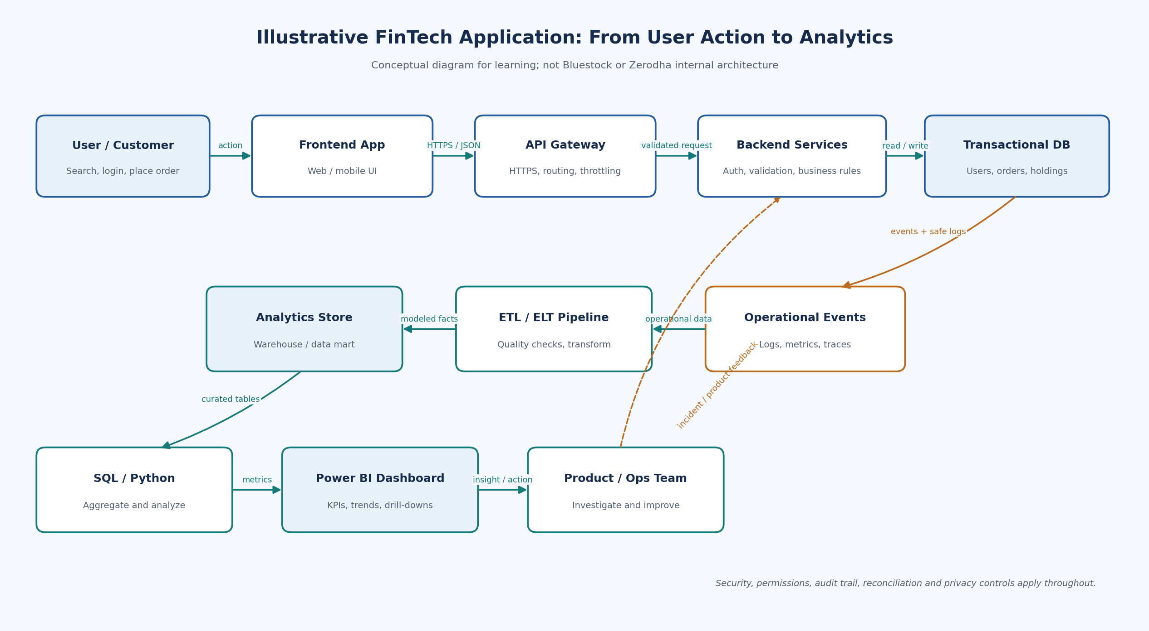
Conceptual learning diagram only. A real order lifecycle also involves exchange, clearing corporation, depository, broker risk systems, reconciliation and regulatory controls.

