**Hello World:**

1. 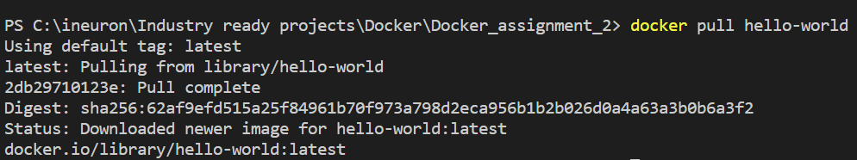**docker pull hello-world:**
2. 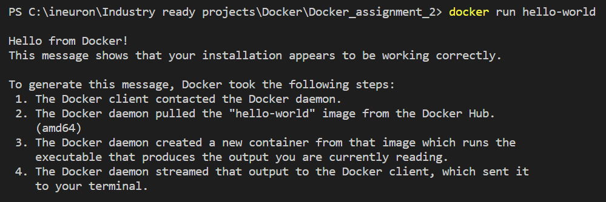**docker run hello-world:**
3. 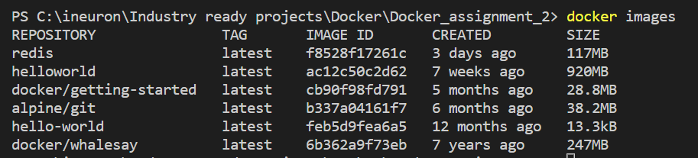**docker images:** is used to show list of images present locally.