**Docker commands:**

1. 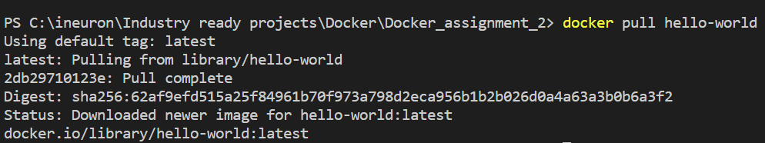**docker pull**: is used to pull/download docker images from docker hub to local system.
2. 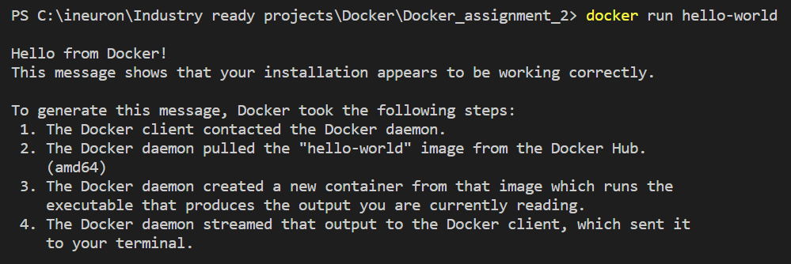**docker run:** is used to run the docker images and create containers of it and bind it to a local port.
3. 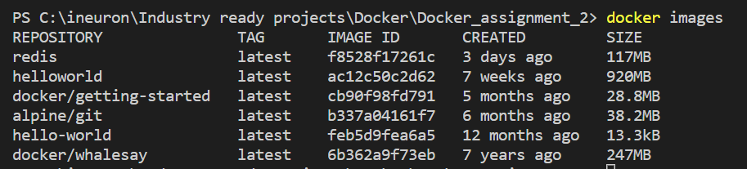**docker images:** is used to show list of images present locally.
4. **docker ps:** is used to show list if images which are currently running.
5. 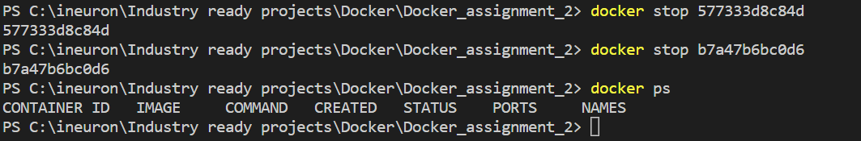**docker stop <container id>:** is used to stop any docker container
6. 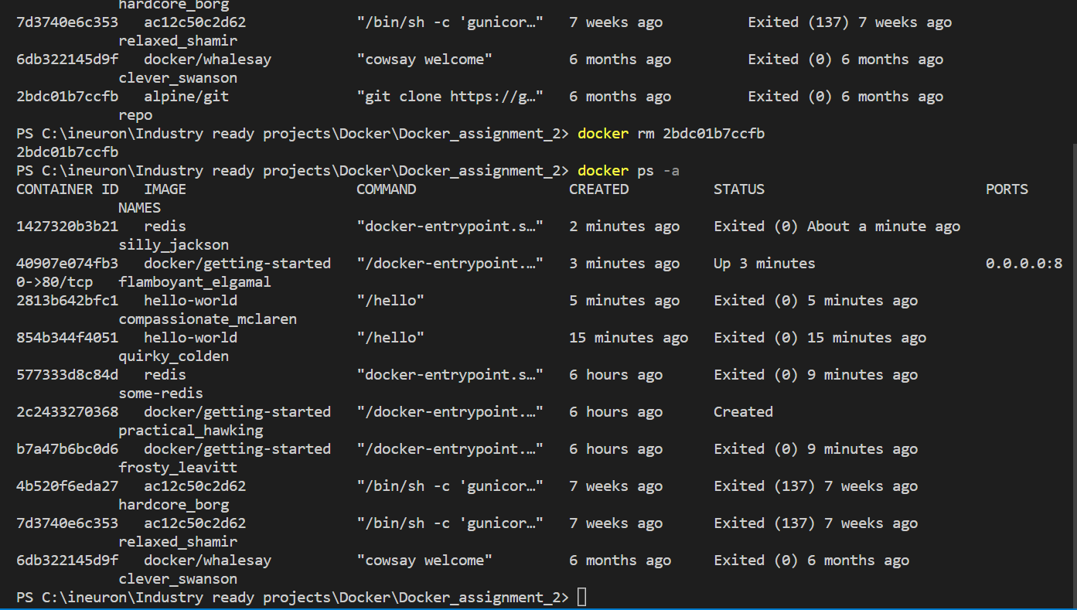**docker rm <container id>:**  remove the specified container from machine
7. **docker ps -a:** list all the containers even the ones that are not running currently
8. **docker rmi <image name>:** remove the specified image from machine

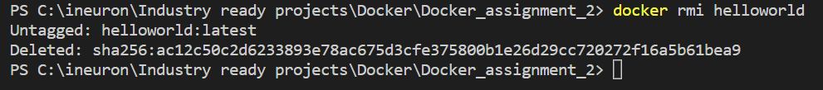

1. **docker logs <container id>:** shows logs of the specified container

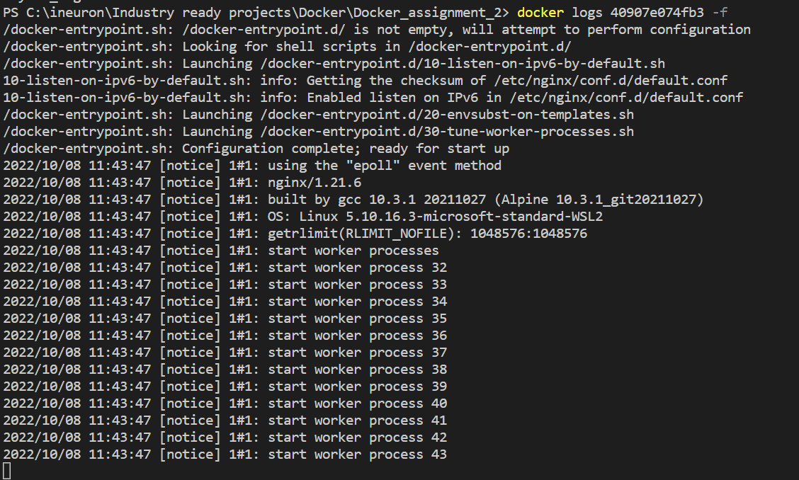

1. **docker rm $(docker ps -a -q):** remove all the containers from the machine.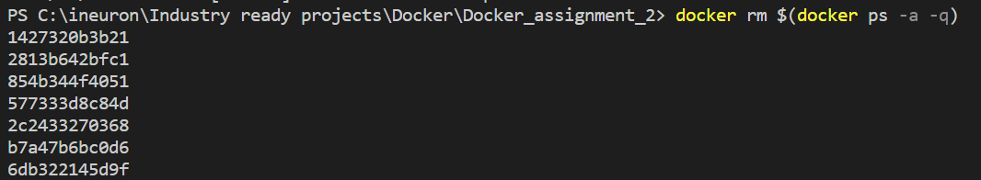
2. 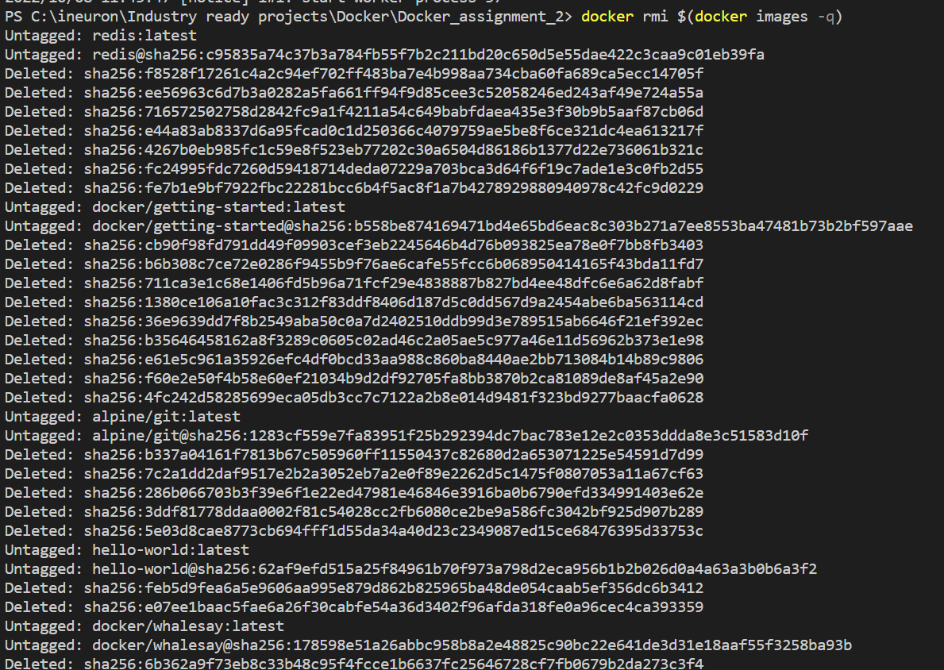**docker rmi $(docker images -q):** remove all the machines from the machine.
3. **docker system prune:** Remove all unused containers, networks, images (both dangling and unreferenced).

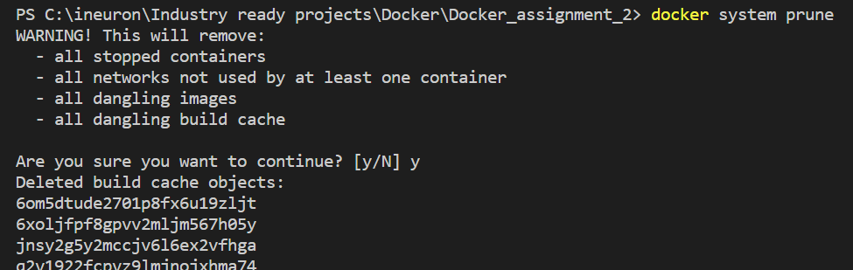

1. **docker system prune -a:** Remove all unused containers, networks, images not just dangling ones.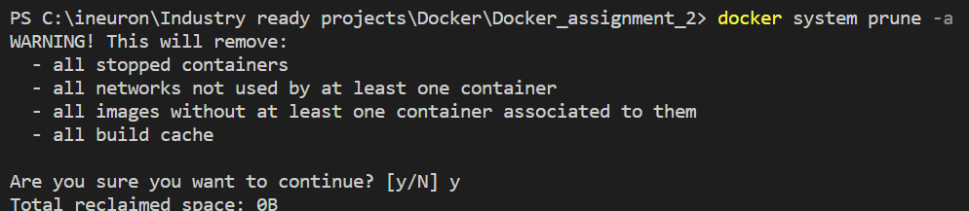
2. 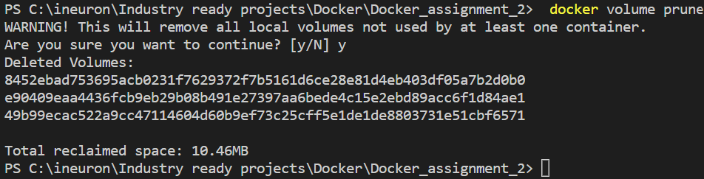**docker volume prune:** Remove all unused local volumes.
3. **docker** **network prune:** Remove all unused networks

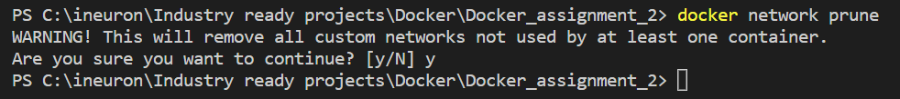

1. **docker build:** build a docker image from a docker file

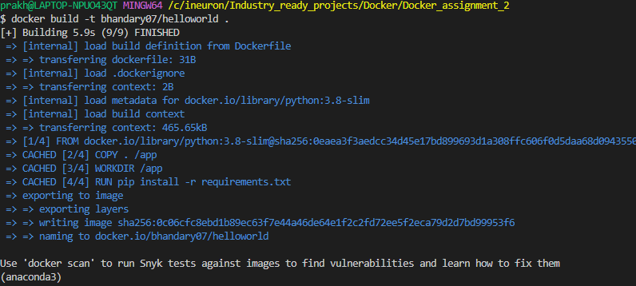

1. 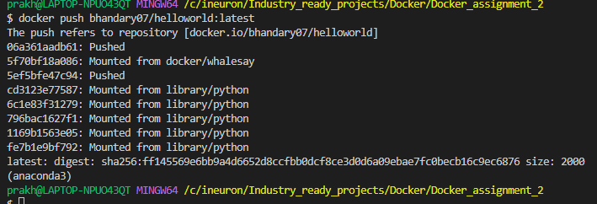**docker push:** upload docker images to remote repo in docker hub