1. Git init



1. git status

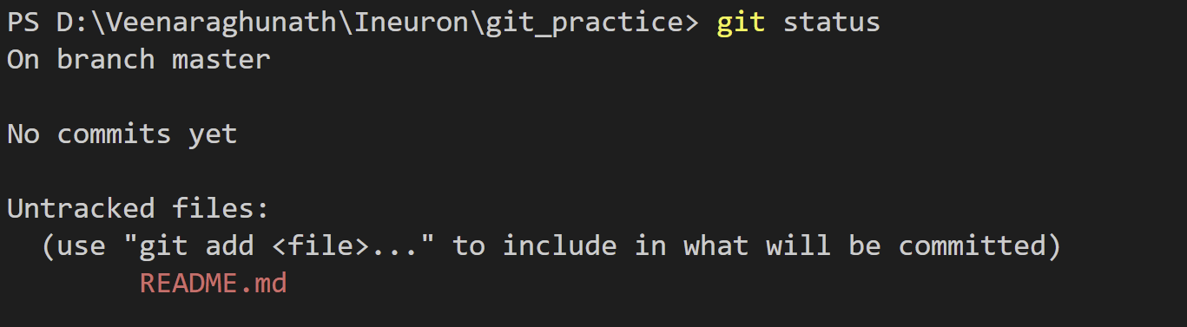

1. Git add



1. Git commit -m “first commit”

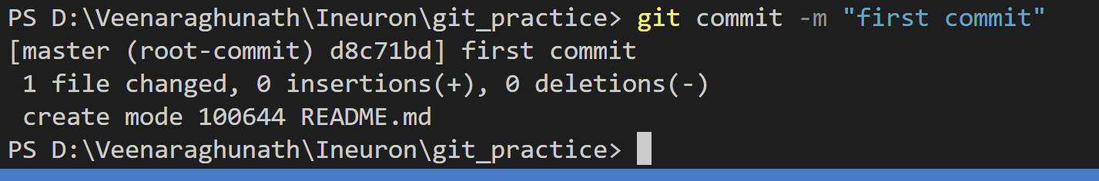

1. Git branch



1. Git branch -M main

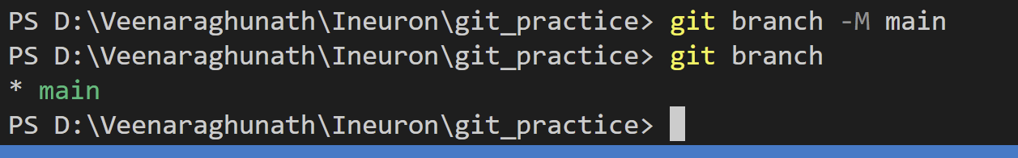

1. git remote add origin <https://github.com/Raghunathans123/Ineuron_git-practice.git>

