1. **git init**



1. **git status**

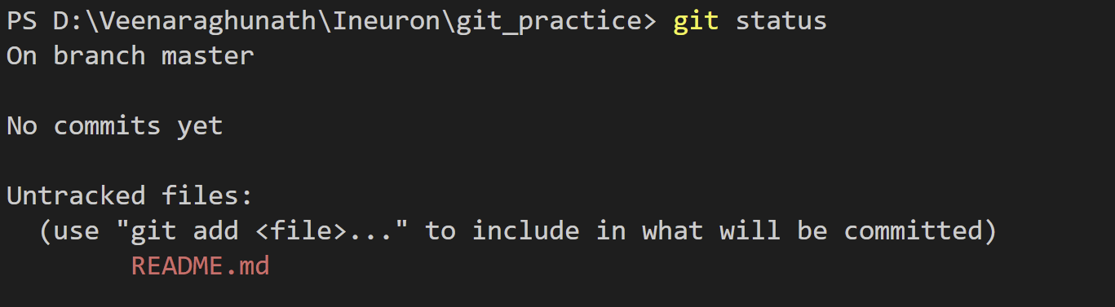

1. **Git add**



1. **Git commit -m “first commit”**

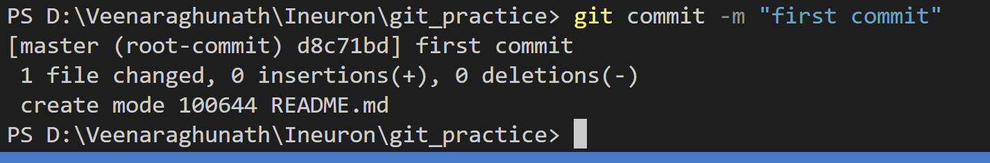

1. **Git branch**

This command mentions the current branch name



1. **Git branch -M main**

This command changes master branch into main branch

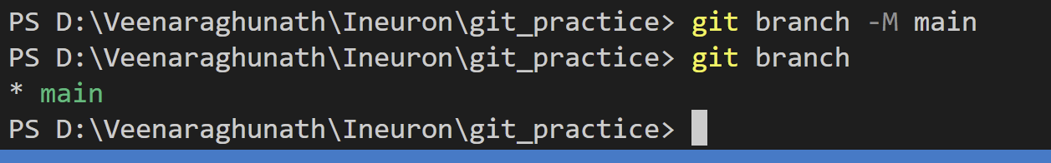

1. **git remote add origin** [**https://github.com/Raghunathans123/Ineuron_git-practice.git**](https://github.com/Raghunathans123/Ineuron_git-practice.git)



1. **git branch < branch name>:**



1. **git checkout** **< branch name>:**

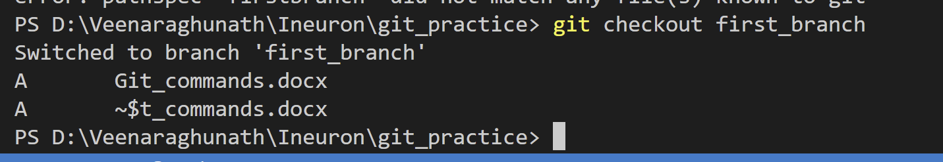

1. **git push -u origin main**

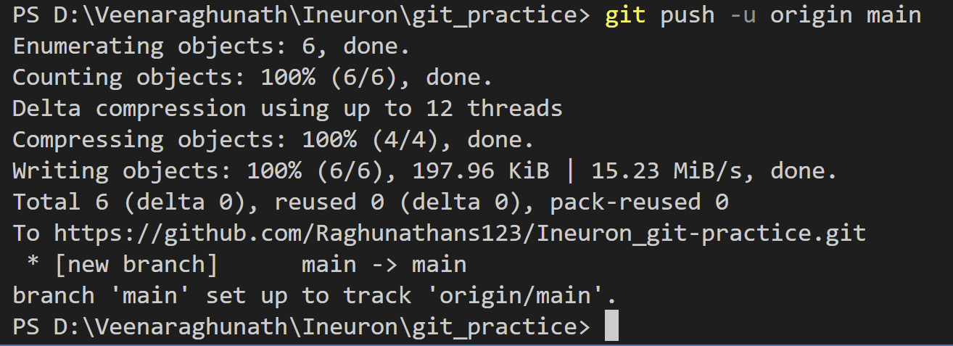

1. **git push origin < branch name>:**

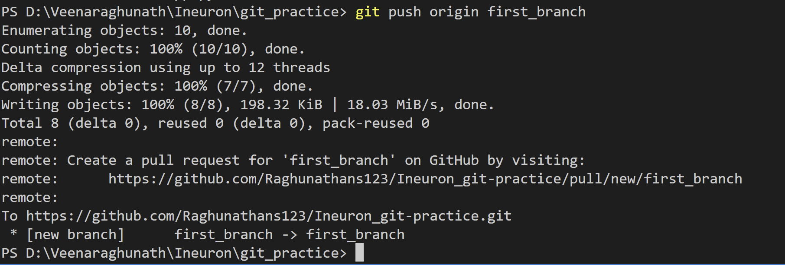

1. **git merge< branch name>:**

This command is used to merge the specified branch’s history into the current branch.

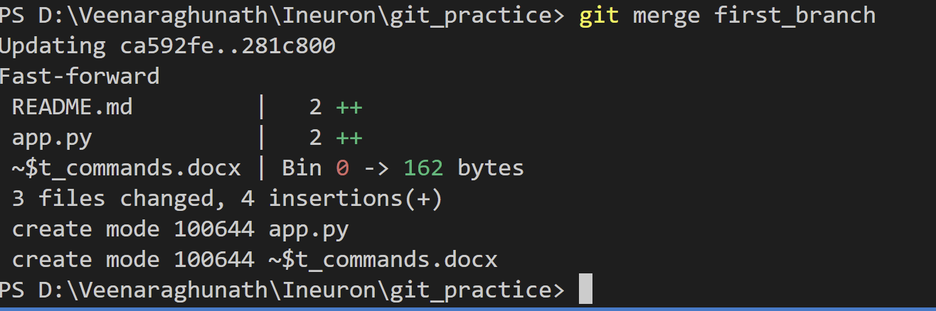

1. **git config:**

This command configures the user. The Git config command is the first and necessary command used on the Git command line. This command sets the author name and email address to be used with your commits.



1. **git rm –cached <filename>::**

Remove files from the Git But keep the files in your local repository.