Home Screen, Added Authentiction using EntraId loggedin user email populates on right, From this Home Screen users can navigate

Provided Options to Upload Lease Document and Start Extraction in this phase once user clicks Upload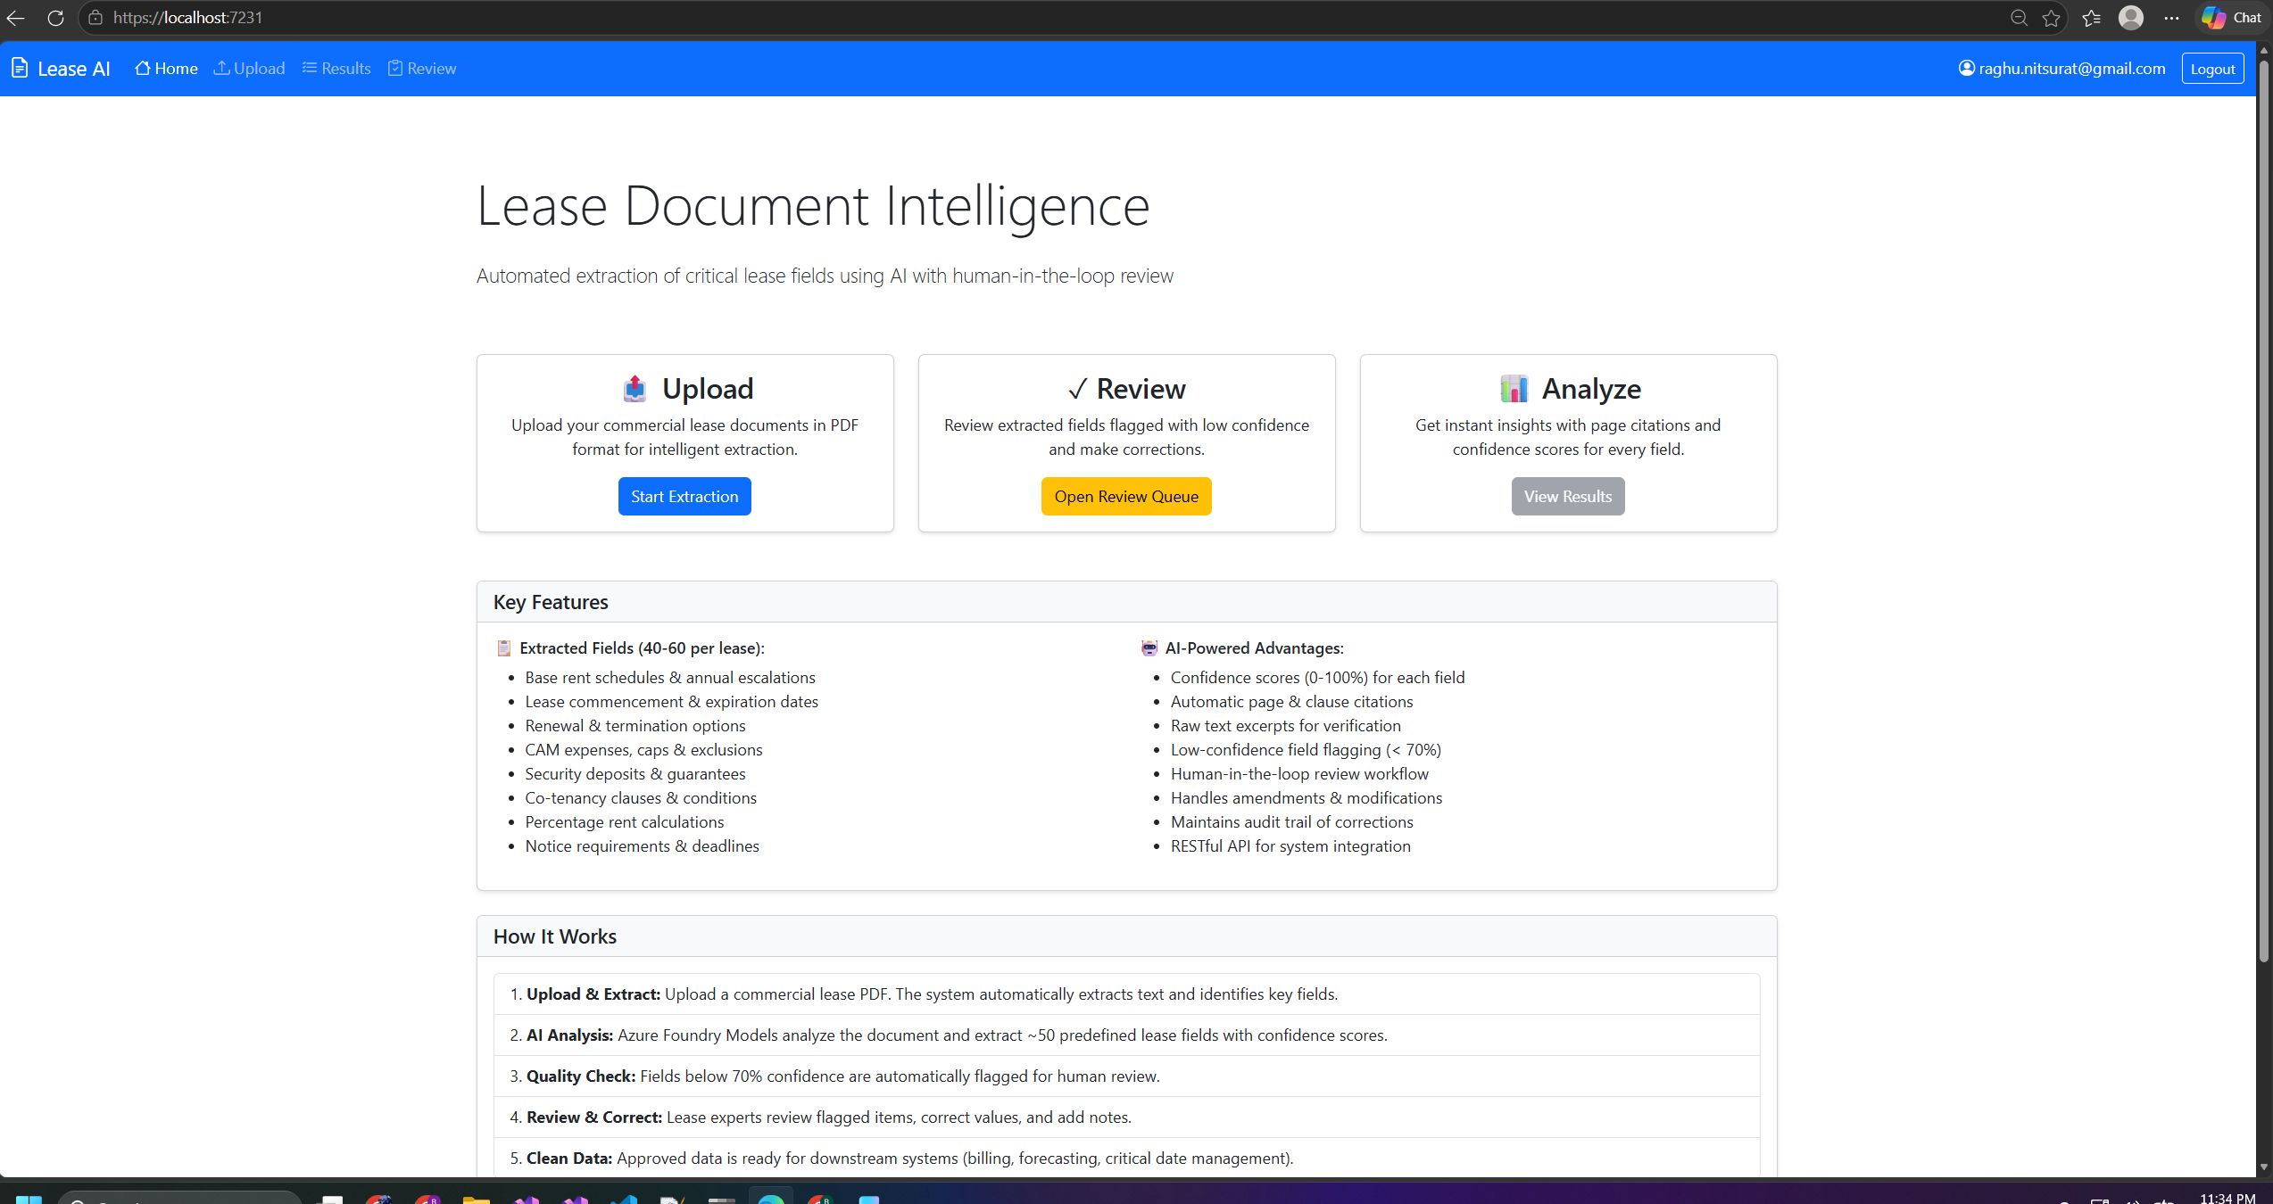
Once Upload It navigates and asks user to upload lease pdf and once added and clicked Upload & Extract which will upload the doc to Blob) parsing pdf happens, and starts extracting fields from document calling Open AI
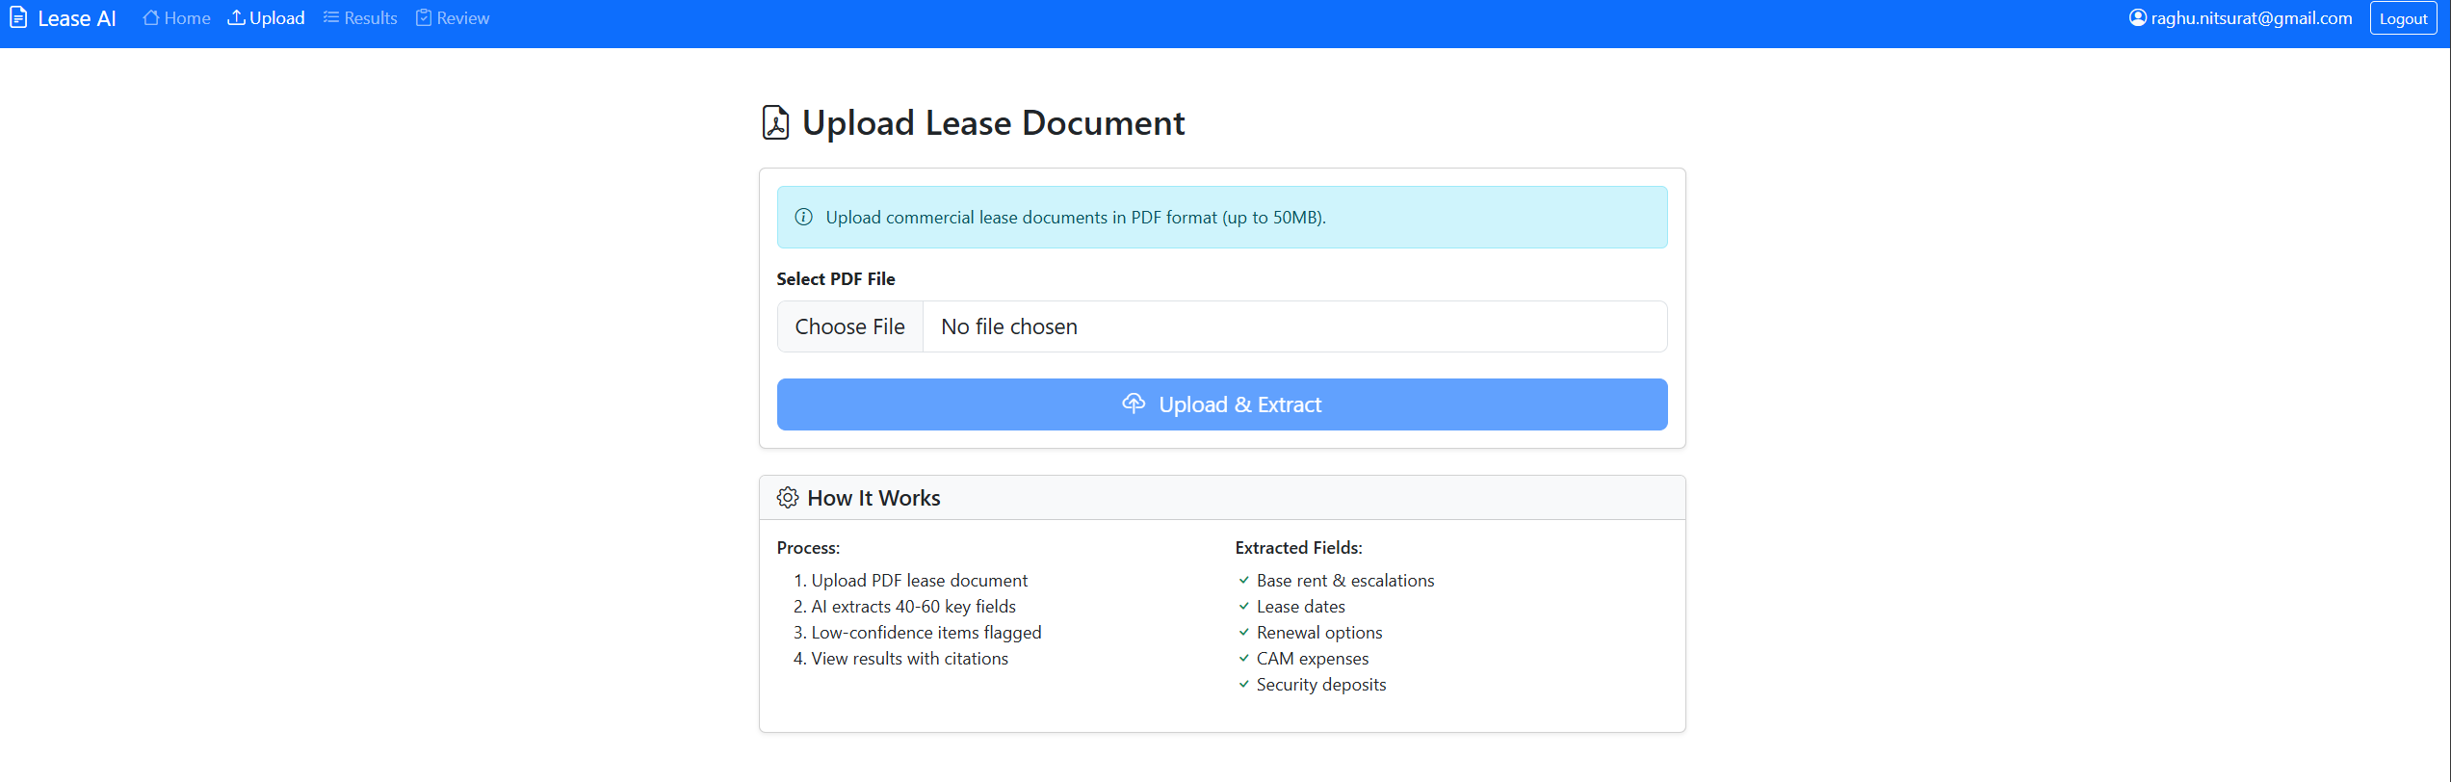

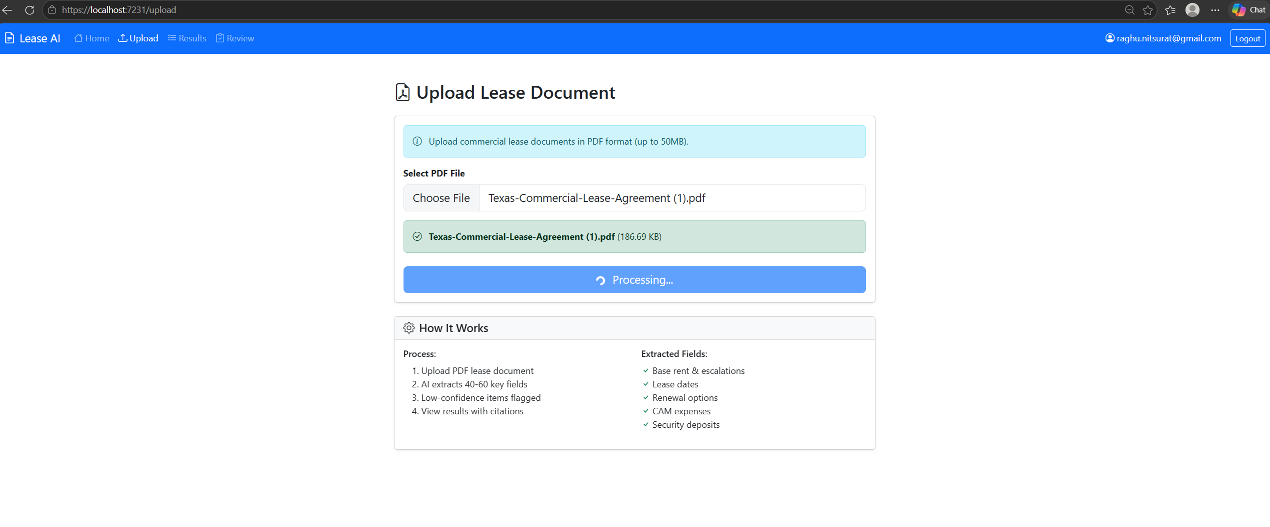

This is the Results view of each fields currently configured for 15 fields gives confidence Rubric Score and suggests whether confidence is High or Low
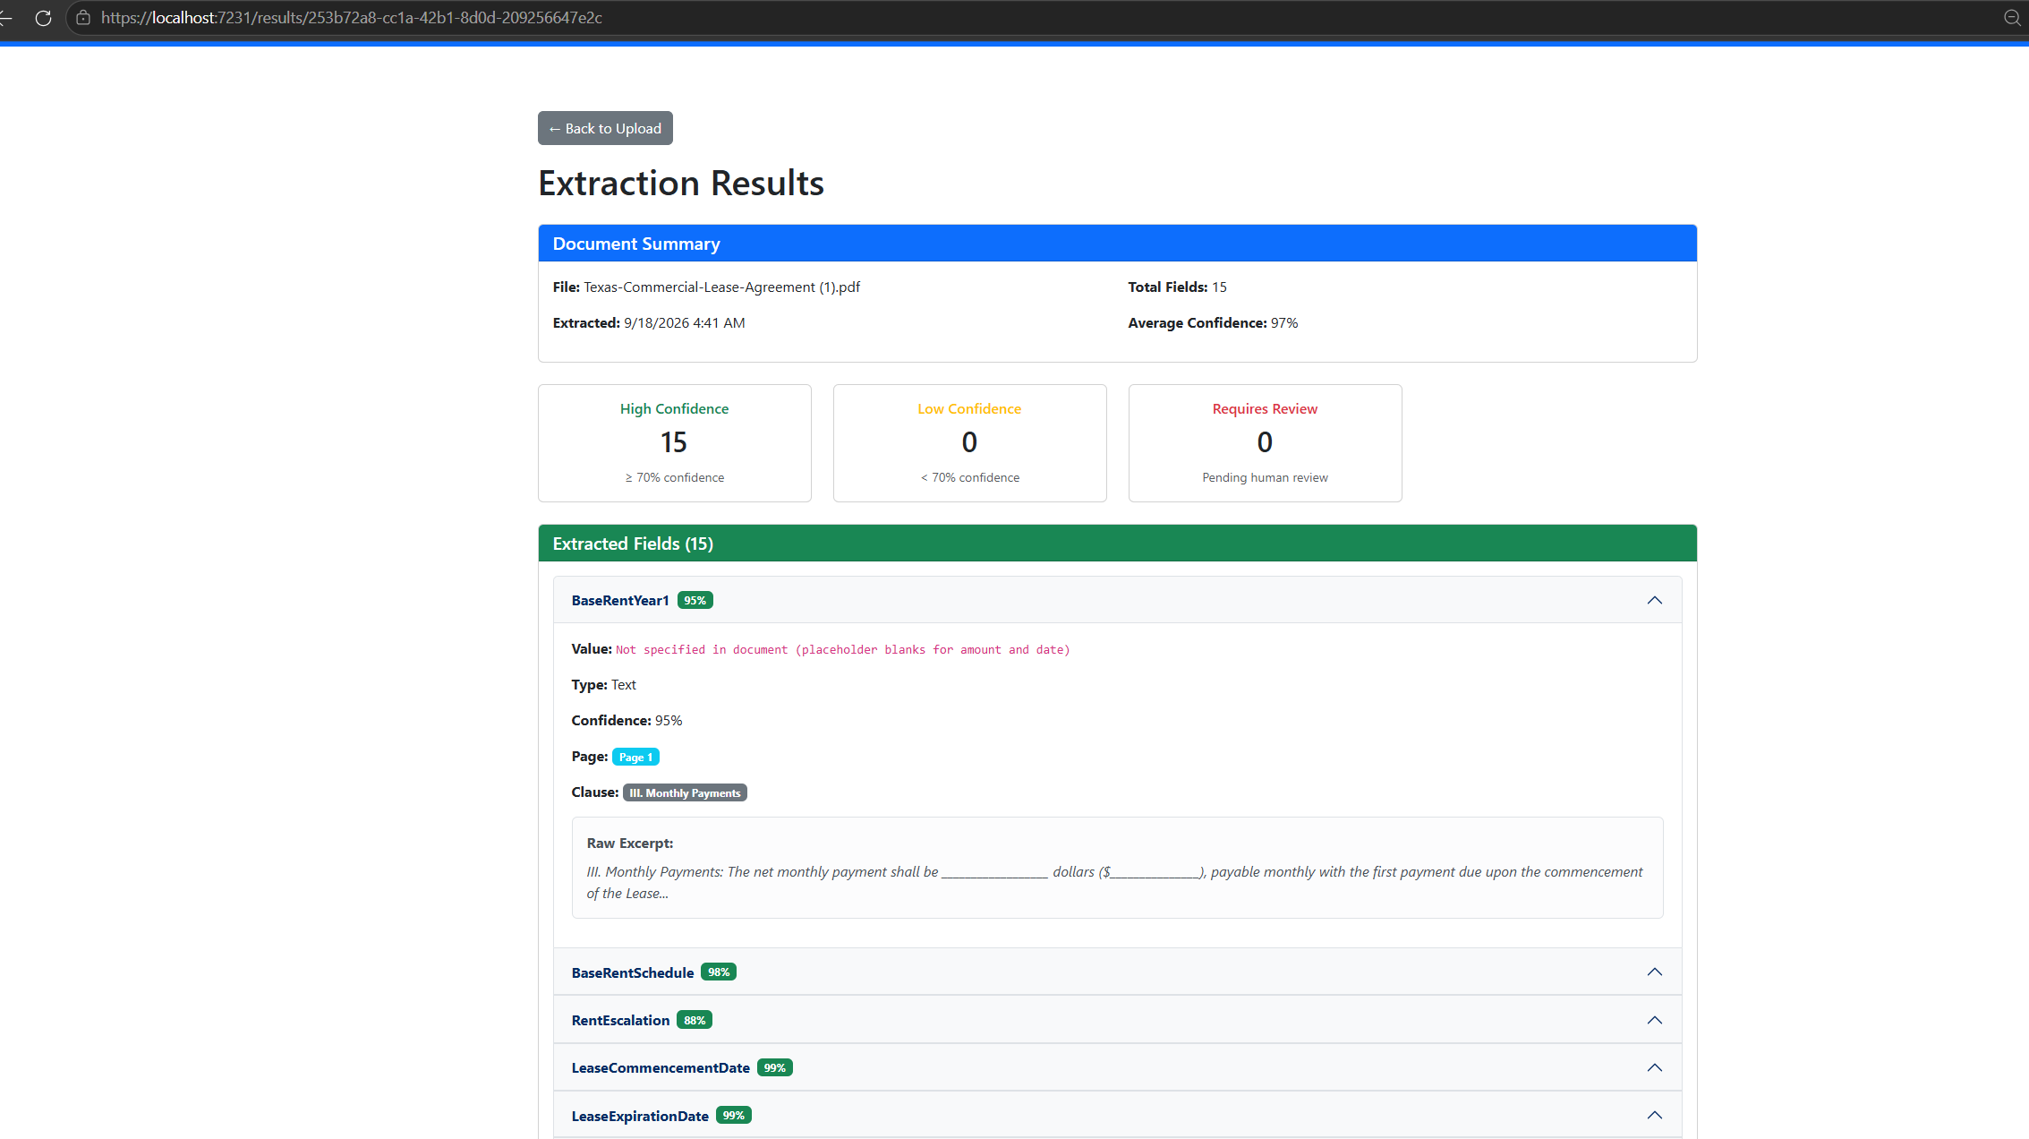

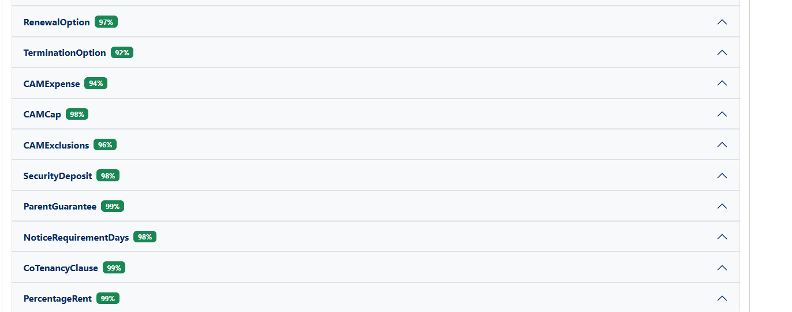

Review:
This is require check if any actions are needed, goes for approval corrective actions, human in loop
