* ‘carbon_nano’ table is created in the mentioned database ‘carbon’

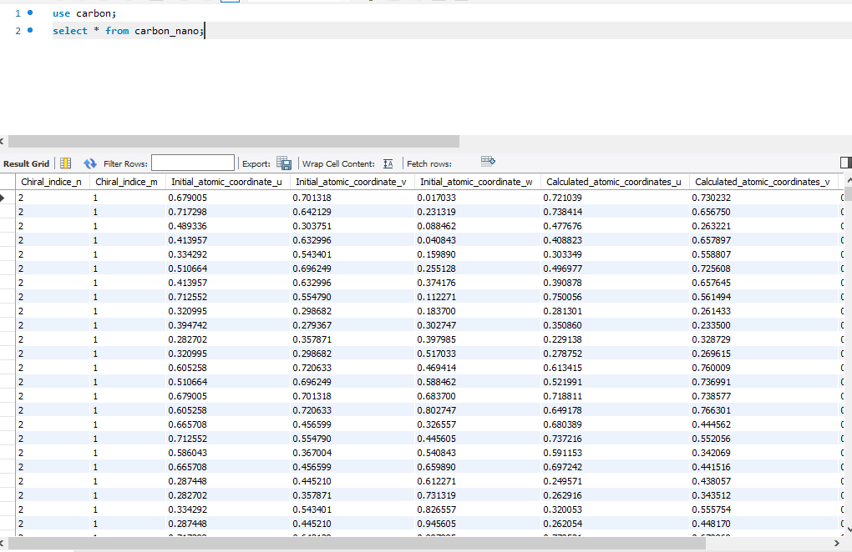

1. **Selecting from table**

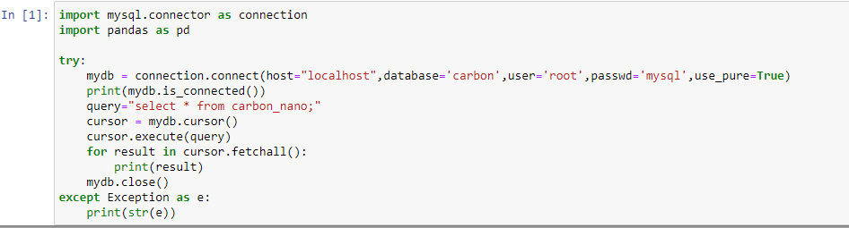

Result:

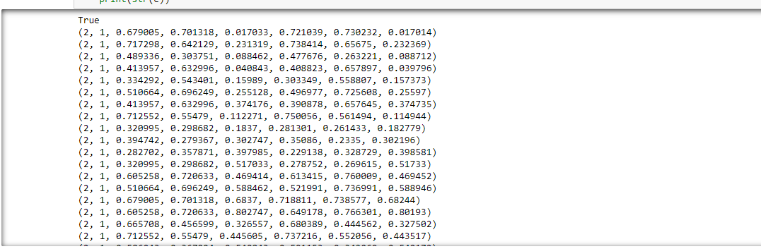

**pandas.read_sql** to store the values in a dataframe.

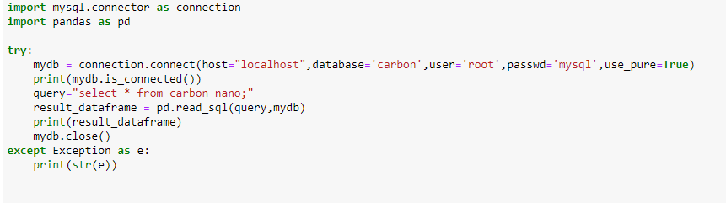

Result:

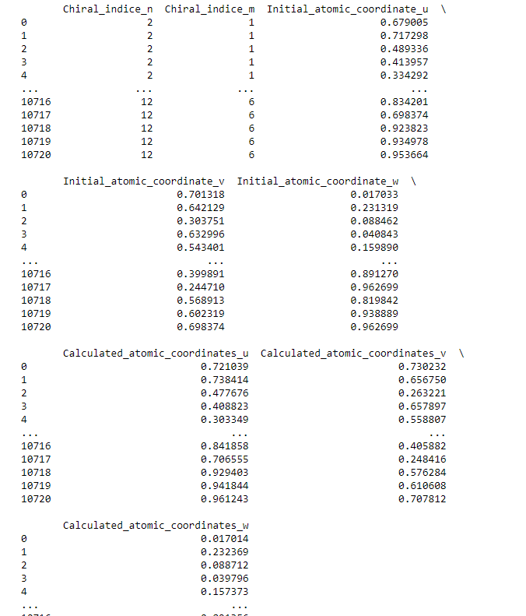

Update statement:

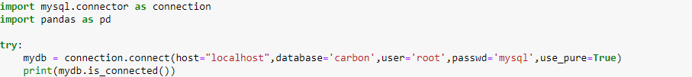





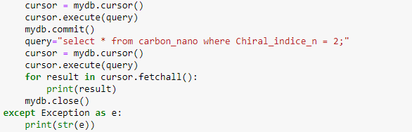

Result:

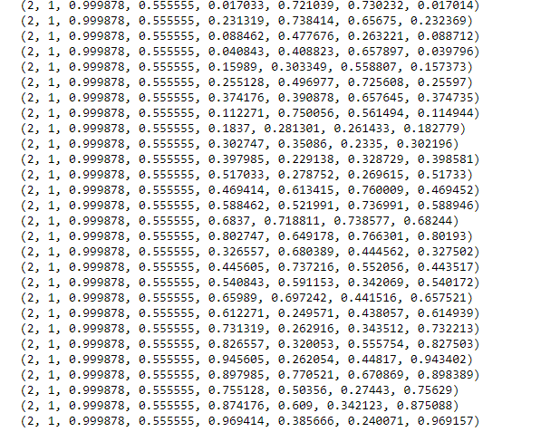

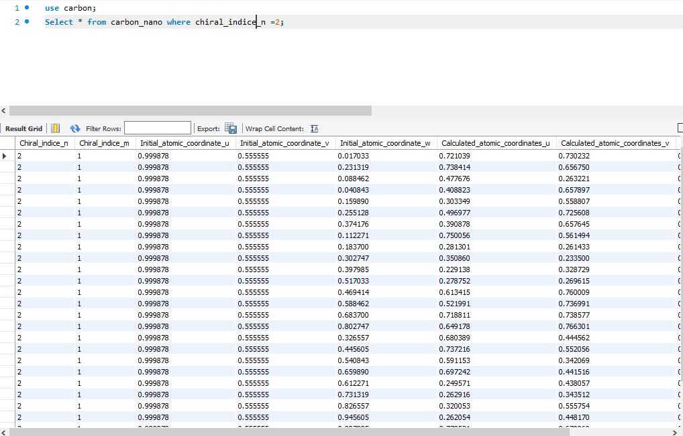

Delete statement:

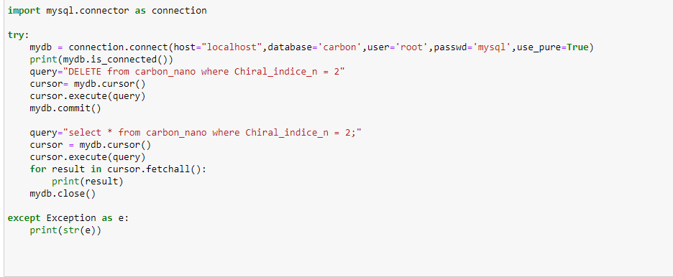

Result:

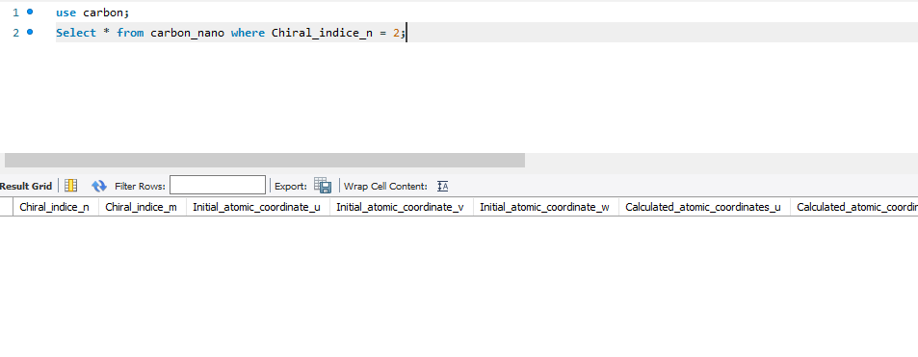

Group by,order by:

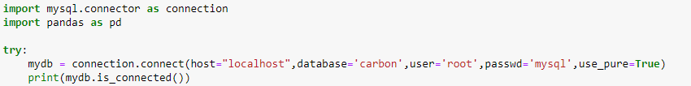

 

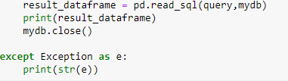

Result:

