DESIGN AND SIMULATION OF ROBOT PATH TRACING SYSTEM

SUMMER INTERNSHIP 2026
PROJECT REPORT
submitted by
SAI NIRAML S 3122241002091 SSN COLLEGE OF ENGINEERING

SARVESH K 3122241002100 SSN COLLEGE OF ENGINEERING

SCoE-MIT Summer Internship – 2026
On
INDUSTRIAL ROBOTICS USING KUKA ROBOTS


SIEMENS CENTRE OF EXCELLENCE (SCoE-MIT)
in collaboration with
DEPARTMENT OF PRODUCTION TECHNOLOGY
MIT CAMPUS, ANNA UNIVERSITY, CHENNAI – 600044
12.06.2026

BONAFIDE CERTIFICATE

Certified that the SCoE-MIT Summer Internship Project Report entitled DESIGN AND SIMULATION OF ROBOT PATH TRACING SYSTEM
is the bonafide work of
SAI NIRAML S 3122241002091 SSN COLLEGE OF
ENGINEERING

SARVESH K 3122241002100 SSN COLLEGE OF
ENGINEERING

who carried out the project work. Certified further that, to the best of my knowledge, the work reported here does not form part of any project on the basis of which degree or award was conferred on an earlier occasion on this or any other candidate.

Internship Co-Ordinator Nodal Officer
Dr. V. Mugendiran Dr. Sabitha Ramakrishnan
Assistant Professor Professor
Production Technology Instrumentation Engineering

ACKNOWLEDGEMENT

We would like to record our sincere thanks to Prof. P. JAYASHREE, Dean, MIT, for having given consent to carry out the summer internship work at Siemens Centre of Excellence, Madras Institute of Technology Campus, Anna University.

We wish to express our sincere appreciation and gratitude to Dr. Sabitha Ramakrishnan, Nodal Officer, Siemens Centre of Excellence, MIT cum Chief Coordinator of the Summer Internship Programme-2026, for selecting us to undergo the programme.

We wish to thank all the resource persons, both teaching and non-teaching staff members of MIT campus, for conducting the theory and practical sessions during the programme which enabled us to complete the internship successfully.

SAI NIRMAL S
SARVESH K

ABSTRACT
The Summer Internship Programme on KUKA Robot Programming and KUKA.Sim Pro provided practical exposure to industrial robotics, offline programming, and robotic automation. The course covered the fundamentals of industrial robots, coordinate systems, tool and base data configuration, robot jogging, motion commands such as PTP and LIN, robot programming using KUKA Robot Language (KRL), and simulation-based validation. KUKA.Sim Pro was utilized to create virtual robotic workcells, perform reachability analysis, detect collisions, optimize robot movements, and evaluate robotic operations before deployment. The training enhanced understanding of modern automation technologies and their applications in manufacturing industries.

As part of the internship, a robotic pick-and-place system was designed and simulated using KUKA.Sim Pro. In the developed workcell, a KUKA industrial robot picks cube-shaped components from a magazine and places them at predefined locations on a flat platform. The project demonstrates the application of robotic material handling, automated part transfer, and offline robot programming. Tool data, base frames, motion paths, and pick-and-place sequences were configured to achieve accurate and collision-free operation. The simulation successfully validated the robot’s ability to perform repetitive handling tasks efficiently, highlighting the importance of robotic automation in improving productivity, accuracy, and operational safety in industrial environments.

 | TABLE OF CONTENTS
CHAPTR  NO. | TITLE | PG NO.
1 | INTRODUCTION | 1
2 | OBJECTIVE OF THE PROJECT | 4
3 | SOFTWARE TOOL | 6
4 | DESIGN STEPS | 7
5 | IMPLEMENTATION | 9
6 | RESULTS | 10
7 | CONCLUSION AND FUTURE WORK | 12
8 | REFERENCES | 14

INTRODUCTION

Industrial robots are widely employed in manufacturing industries for precision tasks such as material handling, assembly, welding, painting, inspection, engraving, and drawing applications. Modern robotic systems can be programmed to follow predefined trajectories with high accuracy and repeatability. These capabilities make industrial robots suitable for operations that require precise path control and continuous motion. The increasing adoption of robotic automation has enabled industries to improve productivity, maintain consistent quality, reduce human intervention, and enhance workplace safety.
Industrial robots are capable of performing repetitive tasks with minimal errors while maintaining high operational efficiency. Their flexibility allows them to be integrated into various industrial sectors including automotive manufacturing, aerospace production, electronics assembly, packaging industries, pharmaceutical processing, and logistics operations. The use of robots also minimizes production downtime and improves overall process reliability. As industries move towards smart manufacturing and Industry 4.0 concepts, robotic systems are becoming an essential component of modern production facilities.
KUKA is a globally recognized manufacturer of industrial robots and automation solutions. KUKA robots are known for their precision, reliability, and versatility in performing a wide range of industrial operations. These robots can be programmed to perform complex tasks involving motion control, path planning, material transfer, and process automation. To facilitate efficient robot development and deployment, KUKA provides advanced simulation software known as KUKA.Sim Pro.
KUKA.Sim Pro is an offline programming and simulation platform that enables users to create virtual robotic workcells, develop robot programs, analyze robot reachability, and validate operations before implementation on physical hardware. The software helps engineers optimize robot movements, detect collisions, estimate cycle times, and reduce commissioning costs. Offline simulation significantly reduces development time while improving the overall quality of robotic applications.
The present project focuses on the development of a robotic trajectory tracing system using a KUKA industrial robot. In this application, the robot picks a pen-like tool from a magazine and moves it to a working platform where predefined geometric shapes are traced using programmed edge points. The robot follows the specified path using accurately taught positions and controlled linear motions to achieve smooth and precise tracing. Upon completion of the tracing operation, the robot returns the pen-like tool to its original location in the magazine and moves back to the home position.
This project demonstrates the practical implementation of robot programming, tool handling, trajectory generation, coordinate systems, path planning, and automation techniques using KUKA Sim Pro. The simulation highlights how industrial robots can be utilized for precision-based applications requiring accurate motion control and repeatability.

Applications of Similar Robotic Systems:
• Automated drawing and plotting systems
• Robotic painting and coating operations
• Laser cutting and engraving
• Arc welding and seam tracking
• Adhesive dispensing applications
• PCB marking and electronic manufacturing
• Surface inspection and quality control
• Signature and handwriting automation
The project provides valuable knowledge in industrial robotics, simulation-based design, and automated trajectory control while demonstrating the effectiveness of KUKA robots in precision-oriented industrial applications.

OBJECTIVE OF THE PROJECT
The primary objective of this project is to design, program, and simulate a robotic trajectory tracing system using a KUKA industrial robot in KUKA Sim Pro. The project aims to demonstrate how industrial robots can perform precision-based tasks involving tool handling and path-following operations. Through the simulation environment, the robot is programmed to pick a pen-like object from a magazine, trace predefined geometric shapes on a working surface, and return the tool to its original location after completing the operation.
The project also focuses on understanding the fundamentals of robot programming, coordinate systems, motion planning, and offline simulation techniques. By implementing a complete robotic work cell, the project provides practical exposure to industrial automation concepts and robotic applications used in modern manufacturing industries.

Objectives
• To understand the working principles of industrial robots.
• To learn robot programming using KUKA Sim Pro.
• To create a virtual robotic work cell.
• To simulate tool pickup and placement operations.
• To generate robot trajectories using programmed points.
• To perform shape tracing using linear robot motions.
• To understand the importance of TCP and Base Frames.
• To validate robot reachability and motion accuracy.
• To study industrial safety practices in robotic systems.
• To explore the industrial applications of trajectory-based robotic operations.

SOFTWARE TOOL

KUKA Sim Pro 3.0.3 is an advanced robotic simulation and offline programming software developed by KUKA. It provides a realistic three-dimensional environment where robotic systems can be designed, programmed, tested, and optimized before implementation on physical hardware. The software is widely used in industries, educational institutions, and research laboratories for robotic application development.
The software allows users to create complete robotic workcells, configure robot tools and workpiece frames, generate motion paths, and perform simulation-based analysis. It significantly reduces development time and helps identify potential issues such as collisions and unreachable positions before actual deployment.

Key features and advantages of KUKA SIM PRO are,
• 3D robotic cell modelling.
• Offline robot programming.
• Collision detection and avoidance.
• Reachability analysis.
• Multi-robot simulation.
• Tool and base frame configuration.
• Reduces commissioning cost.
• Improves system safety.
• Minimizes programming errors.

DESIGN STEPS
The design and development of the robotic tracing system were carried out systematically using KUKA Sim Pro. The project involved creating a complete robotic workstation, configuring the robot, defining motion paths, and validating the operation through simulation.
Step 1: Selection of Robot
A suitable KUKA industrial robot was selected based on workspace requirements and motion capabilities.
Step 2: Work cell Creation
A virtual robotic work cell was created with safety fencing, operator area, and working platform.
Step 3: Magazine Placement
A magazine containing pen-like objects was positioned within the robot's reachable workspace.
Step 4: Drawing Surface Setup
A flat working platform was created to serve as the tracing surface.
Step 5: Tool Configuration
The gripper tool was configured and attached to the robot flange.
Step 6: Definition of Coordinate Systems
Tool Data (TCP) and Base Frame were defined for accurate positioning.
Step 7: Teaching Robot Positions
Important positions such as Home, Pick, Approach, Trace Start, Trace End, and Place positions were taught.
Step 8: Shape Point Generation
Edge points were generated to represent the required geometric shapes.
Step 9: Motion Programming
PTP and LIN movements were used to create smooth robot motion.
Step 10: Simulation and Verification
The complete sequence was simulated and validated for collision-free operation.
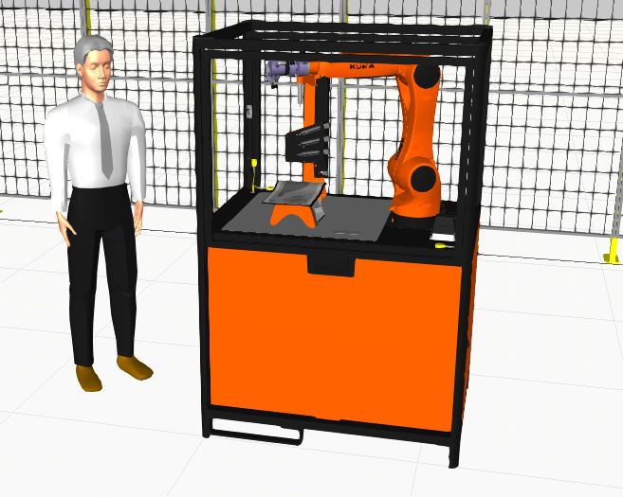
FIG 1: PRECISION DRAWING CELL

IMPLEMENTATION

The implementation phase involved programming the KUKA robot to perform the complete tracing operation within the simulation environment. The robotic work cell consists of a KUKA robot, a magazine containing pen-like tools, a tracing platform, and a safety enclosure.
Initially, the robot remains at its Home Position. When the program starts, the robot moves towards the magazine using Point-to-Point (PTP) motion. The robot approaches the pen-like object, activates the gripper, and securely grasps the tool. After picking the tool, the robot moves to a predefined tracing position above the working platform.
A sequence of edge points was created to represent geometric shapes. The robot follows these points using Linear (LIN) motion commands to ensure smooth and accurate tracing. The trajectory generated by the robot closely follows the defined path while maintaining precision and repeatability.
After completing the tracing operation, the robot moves back to the magazine location and places the pen-like object in its original position. Finally, the robot returns to the Home Position, completing one full operating cycle.
Throughout the simulation, collision checks and motion validations were performed to ensure safe and reliable robot operation.

RESULTS

The robotic tracing system was successfully simulated using KUKA.Sim Pro. The robot completed the entire sequence of operations without any collisions or operational errors. The programmed trajectory accurately followed the predefined geometric shapes, demonstrating the robot's capability to perform precision path-following tasks.
The simulation verified the effectiveness of robot programming, motion planning, and trajectory generation techniques. The robot consistently repeated the tracing operation with high accuracy and maintained smooth motion throughout the process.

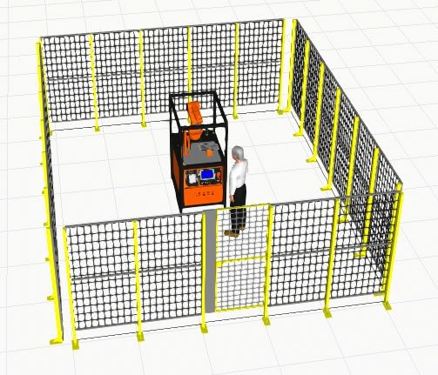
FIG 2: COMPLETE LAYOUT OF THE PROJECT

Results Obtained:
• Successful pickup of pen-like object from magazine.
• Accurate tracing of predefined geometric shapes.
• Smooth and continuous robot movement.
• Collision-free operation.
• Successful return of the tool to the magazine.
• High repeatability and consistency.
• Effective utilization of KUKA.Sim Pro features.

Industrial Significance:
• Demonstrates trajectory planning concepts.
• Represents robotic drawing and marking systems.
• Similar to robotic painting applications.

CONCLUSION AND FUTURE WORK

Conclusion
The project successfully demonstrated the design and simulation of a robotic trajectory tracing system using KUKA.Sim Pro. The KUKA robot was programmed to pick a pen-like object from a magazine, trace predefined geometric shapes using programmed edge points, and return the tool to its original location. The simulation validated the robot's motion planning, tool handling, and path-following capabilities. The project provided valuable experience in industrial robot programming and highlighted the importance of offline simulation in modern automation systems.
Future Work
The project can be further enhanced by integrating advanced automation technologies and intelligent control systems. Future developments may focus on increasing flexibility, improving accuracy, and expanding industrial applicability.

Future Enhancements:
• Vision-based object detection.
• Automatic shape recognition.
• Real-time trajectory generation.
• PLC integration.
• AI-based path optimization.
• Conveyor-based automation.
• Multi-robot coordination.
• Robotic painting applications.
• Laser engraving simulation.

REFERENCES

[1] Craig, J. J., Introduction to Robotics: Mechanics and Control, 4th Edition, Pearson Education, 2018.
[2] Groover, M. P., Automation, Production Systems, and Computer-Integrated Manufacturing, 5th Edition, Pearson Education, 2019.
[3] Niku, S. B., Introduction to Robotics: Analysis, Control, Applications, 3rd Edition, Wiley India, 2020.
[4] Siciliano, B., Sciavicco, L., Villani, L., and Oriolo, G., Robotics: Modelling, Planning and Control, Springer Publications, 2010.
[5] Spong, M. W., Hutchinson, S., and Vidyasagar, M., Robot Modeling and Control, Wiley Publications, 2020.
[6] KUKA AG, KUKA System Software (KSS) 8.x Operating and Programming Instructions for System Integrators, KUKA AG, Augsburg, Germany.
[7] KUKA AG, KUKA.Sim Pro User Manual and Documentation, KUKA Robotics, Germany.
[8] Groover, M. P., Industrial Robotics: Technology, Programming and Applications, McGraw-Hill Education.
[9] Siciliano, B., and Khatib, O., Springer Handbook of Robotics, Springer International Publishing, 2016.

