DDL, DML, DCL commands
Yes — you want one combined SQL script that you can paste into MySQL and run section-by-section.
The CREATE command is used to create a new database object. For example, CREATE DATABASE college; creates a database named college. Similarly, CREATE TABLE Student (id INT, name VARCHAR(50)); creates a Student table with an ID and name column.
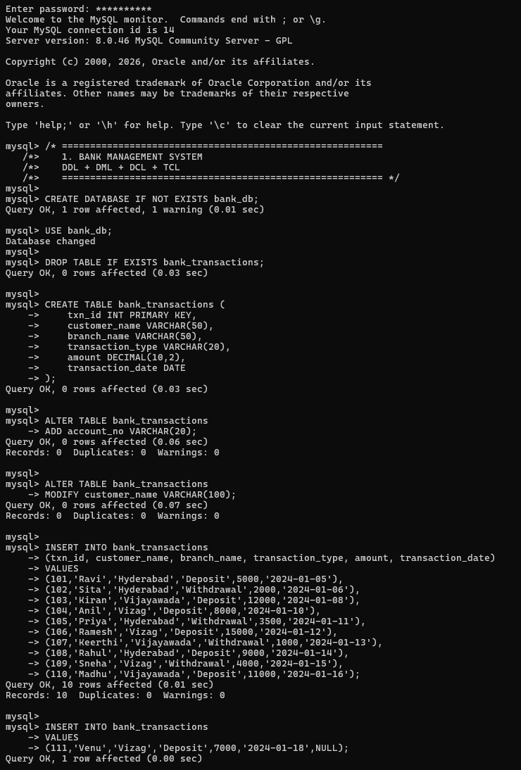
The ALTER command is used to modify the structure of an existing table. It can be used to add, modify, or remove columns. For example, ALTER TABLE Student ADD age INT; adds an age column to the Student table.
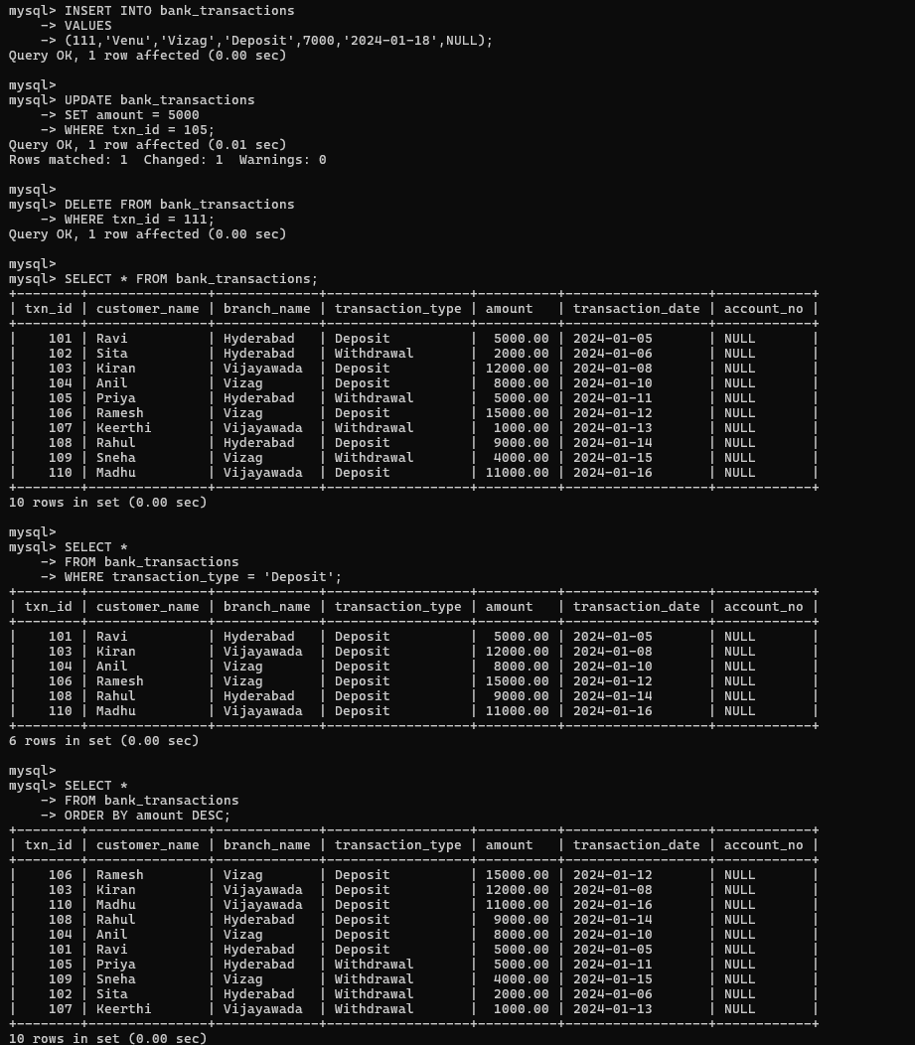
The DROP command is used to permanently delete a database object, including its structure and stored data. For example, DROP TABLE Student; completely removes the Student table from the database.
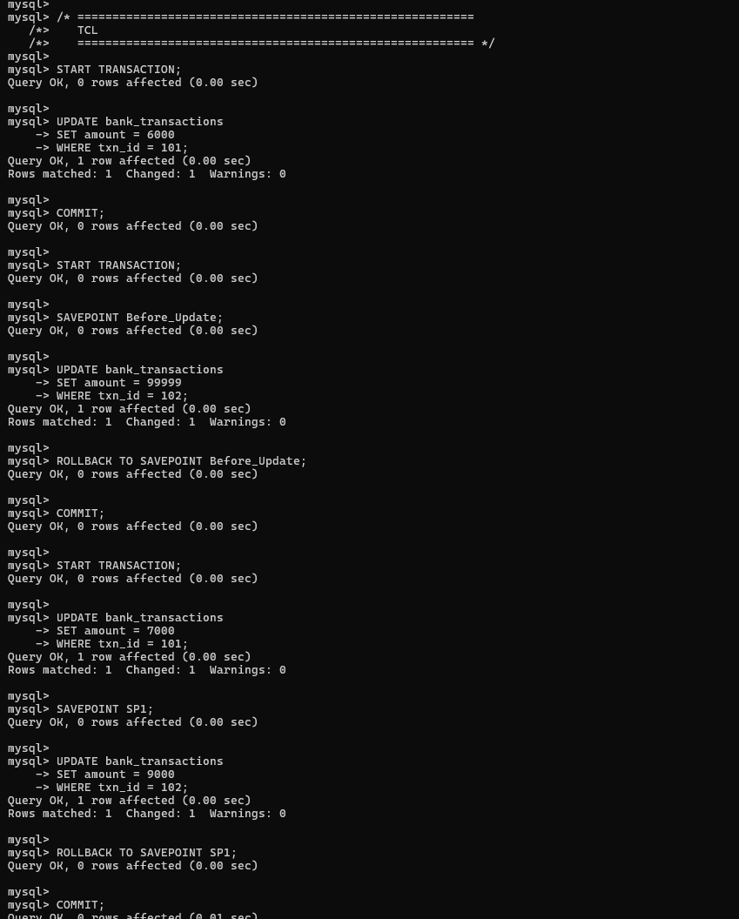
The TRUNCATE command is used to remove all records from a table while keeping the table structure. For example, TRUNCATE TABLE Student; deletes all rows from the Student table, but the table itself remains available for future use.
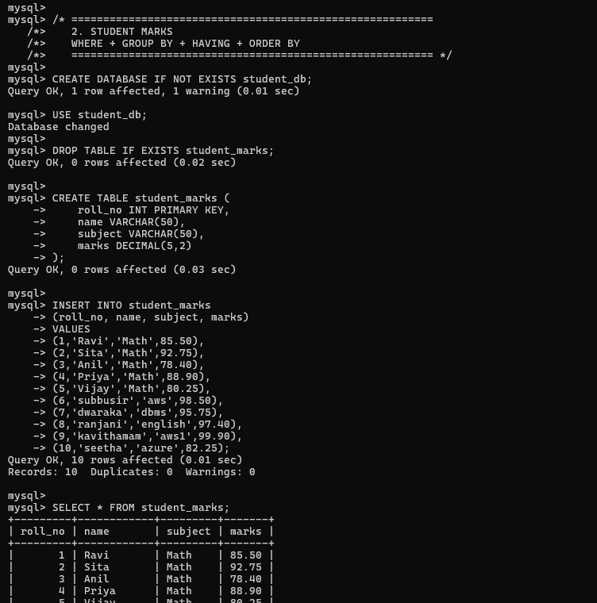
The ALTER command is used to modify the structure of an existing table. It can be used to add, modify, or remove columns. For example, ALTER TABLE Student ADD age INT; adds an age column to the Student table.
