The Librarian’s Dashboard Scenario The library is now digital! The head librarianneeds a report to see which members are active and which books are in the collection. You also need to handle a "Book Donation" process where a new bookis added and assigned to a category at the exact same time—if one part fails, thewhole process must stop to keep the catalog accurate. Task to be Done 1. TheCatalog Search (JOINs): Create a third table called Loans that connects member_idto book_id. Write a query to show the Member Name and the Book Title they havecurrently borrowed. 2. Collection Stats (Aggregations): Write a query to find thetotal number of books published in each year. o Hint: Use COUNT(book_id) andGROUP BY published_year. 3. The Donation Transaction (ACID): Use aTransaction (BEGIN...COMMIT) to add a new book to the Books table andsimultaneously log the entry in a Donation_History table. 4. Search Speed(Indexing): Create an Index on the isbn column. Explain why searching by ISBN isnow faster for the librarian than searching by Title. Skill Set Gained • RelationalLogic: Connecting independent tables (Books + Members) through a Junction table(Loans). • Analytical SQL: Using GROUP BY to generate business insights. •Atomic Operations: Using Transactions to ensure multiple database changessucceed or fail as a single unit.
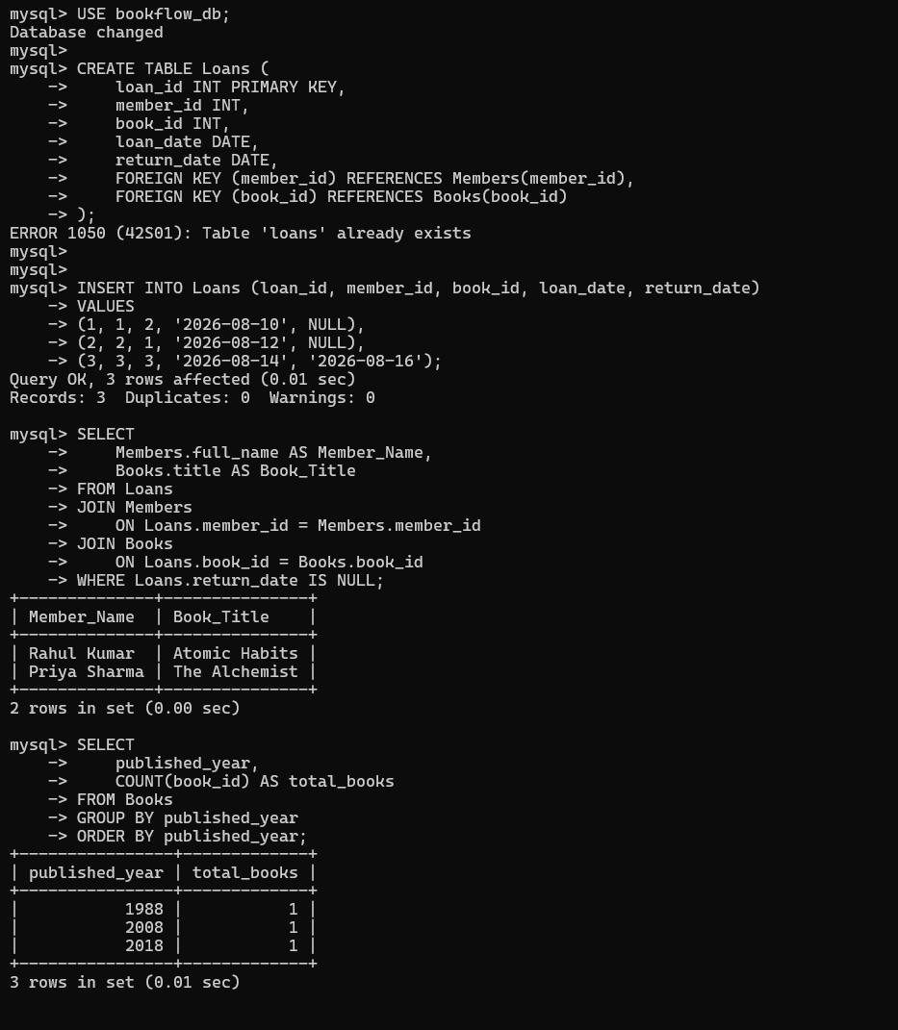
The book_id column is defined as the PRIMARY KEY of the Books table. A primary key uniquely identifies each record in a table and prevents duplicate identification values. The title column has a NOT NULL constraint, which ensures that every book record must contain a book name. The isbn column has a UNIQUE constraint to prevent duplicate ISBN numbers. A CHECK constraint is also applied to the published_year column so that books cannot have a future publication year. For example, the year must be less than 2027.
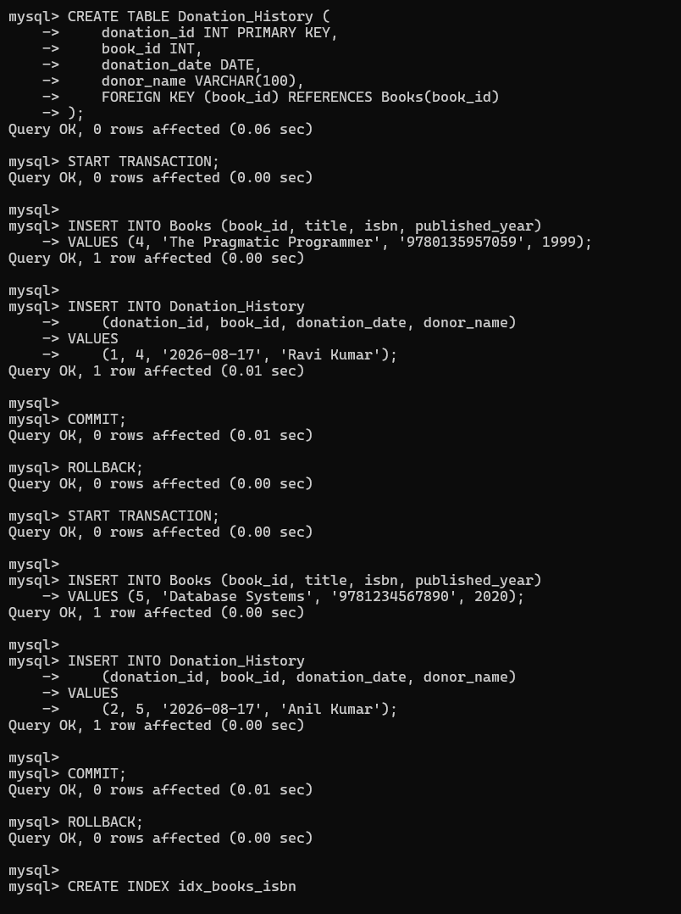
The member_id column is defined as the PRIMARY KEY, ensuring that every member has a unique identification number. The email column has a UNIQUE constraint, which prevents the same email address from being registered for multiple members. These constraints help maintain accurate and consistent member information.
