- Anonymous Pipes:
#include <stdio.h>
#include <unistd.h>
#include <string.h>
#include <sys/types.h>
int main()
{
int fd[2];
pid_t pid;
char message[] = "Hello from Parent!";
char buffer[100];
// Create pipe
pipe(fd);
// Create child process
pid = fork();
if (pid > 0)
{
// Parent process
close(fd[0]); // Close reading end
write(fd[1], message, strlen(message) + 1);
close(fd[1]); // Close writing end
}
else if (pid == 0)
{
// Child process
close(fd[1]); // Close writing end

read(fd[0], buffer, sizeof(buffer));
printf("Child received: %s\n", buffer);
close(fd[0]); // Close reading end
}
return 0;
}
Output:
Child received: Hello from Parent!
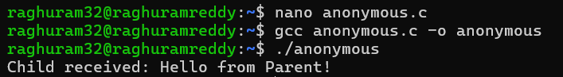

- Named Pipes / FIFO:

- Create a FIFO
#include <stdio.h>
#include <sys/types.h>
#include <sys/stat.h>
int main()
{
if (mkfifo("myfifo", 0666) == -1)
{
perror("mkfifo");
return 1;
}
printf("FIFO created\n");
return 0;
}
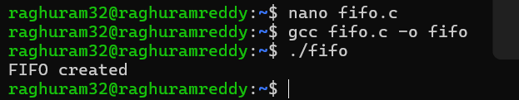
b) FIFO_READ
#include <stdio.h>
#include <fcntl.h>
#include <unistd.h>

int main()
{
int fd;
char buffer[100];

fd = open("myfifo", O_RDONLY);

read(fd, buffer, sizeof(buffer));

printf("Received: %s\n", buffer);

close(fd);

return 0;
}
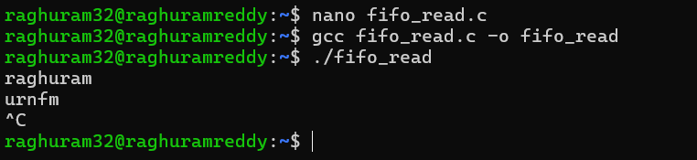

- FIFO_write.c

#include <stdio.h>
#include <fcntl.h>
#include <unistd.h>
#include <string.h>

int main()
{
int fd;
char message[] = "Hello from Writer";

fd = open("myfifo", O_WRONLY);

write(fd, message, strlen(message) + 1);

close(fd);

printf("Message sent\n");

return 0;
}

