Program 1: Simple Signal Handler — SIGINT

#include <stdio.h> #include <signal.h> #include <unistd.h>

void handle_signal(int sig)
{
printf("\nSIGINT received!\n");
}
int main()
{
signal(SIGINT, handle_signal);

while (1)
{
printf("Program is running...\n"); sleep(2);
}
return 0;
}
gcc signal1.c -o signal1
./signal1

Output:
Program is running... Program is running... Program is running...

Now press:

Ctrl + C
You can see: SIGINT received!
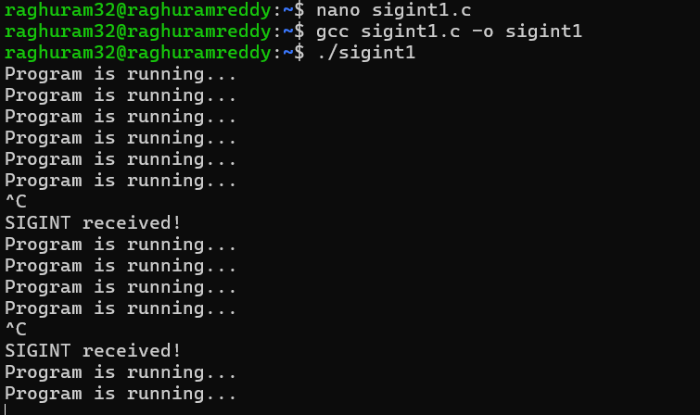

Program 2: SIGINT Without a Handler
#include <stdio.h> #include <unistd.h> int main()
{
while (1)
{
printf("Program is running...\n"); sleep(2);
}
return 0;
}
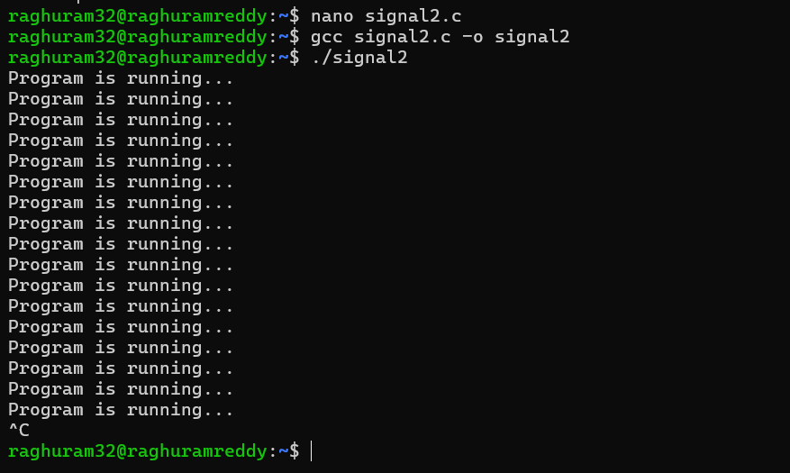

Run : ./signal2 Press:
Ctrl+C
The program terminates.

