Project Title
Plagiarism Detection Engine for Academic Submissions
Project Report submitted for the partial fulfilment of grade for the course

Data Structures and Algorithms -3 (25CS2103E)
in

A.Y. 2026-2027

Submitted by
Raghuram Reddy (2520090024)
Prem Manikanta (2520090045)

Team Number: 14
Section: 13

Under the guidance of

K Chandusha

Assistant Professor, CS&IT
Hyderabad-500090, Telangana, India.

K L (Deemed to be) University
DEPARTMENT OF COMPUTER SCIENCE AND INFORMATION TECHNOLOGY



DECLARATION

The Mini Project Report entitled “Plagiarism Detection Engine for Academic Submissions” is a record of Bonafide work of Raghuram Reddy – 2520090024, Prem Manikanta – 2520090045 submitted in partial fulfillment for the award of B. Tech in Computer Science and Information Technology to the K L University. The results embodied in this report have not been copied from any other departments/University/Institute.

Raghuram Reddy – 2520090024
Prem Manikanta – 2520090045

K L (Deemed to be) University
DEPARTMENT OF COMPUTER SCIENCE AND INFORMATION TECHNOLOGY
CERTIFICATE

This is to certify that the mini project based report entitled “Plagiarism Detection Engine for Academic Submissions” is a bonafide work done and submitted by Raghuram Reddy – 2520090024, Prem Manikanta – 2520090045 in partial fulfillment of the requirements for the award of the degree of BACHELOR OF TECHNOLOGY in Department of Computer Science and Information Technology, K L (Deemed to be University), during the academic year 2026-2027.

Signature of the Supervisor

Signature of the HOD Signature of the External Examiner

ACKNOWLEDGEMENT

The success in this project would not have been possible but for the timely help and guidance rendered by many people. We wish to express our sincere thanks to all those who have assisted us in one way or the other for the completion of our project.

Our greatest appreciation goes to our guide, K Chandusha, Assistant Professor, Department of Computer Science and Information Technology which cannot be expressed in words for her tremendous support, encouragement and guidance for this project.

We express our gratitude to Dr. Khaja Shareef (CSIT), Head of the Department of Computer Science and Information Technology for providing us with adequate facilities, ways and means by which we are able to complete this project.

We thank all the members of teaching and non-teaching staff members, and also who have assisted us directly or indirectly for successful completion of this project. Finally, we sincerely thank our parents, friends and classmates for their kind help and cooperation during our work.

Raghuram Reddy – 2520090024
Prem Manikanta – 2520090045

TABLE OF CONTENTS

S.No. | Contents | Page no.
1. | Abstract | 6
2. | Introduction | 7
3. | Literature survey | 8
4. | Problem Statement and Objectives | 10
5. | Hardware and Software requirements | 11
6. | Implementation | 12
7. | Results & Discussion | 15
8. | Conclusion & Future Scope | 17
9. | References | 18
1.ABSTRACT

Academic plagiarism has become a major challenge with the rapid growth of digital learning platforms and the number of student submissions. Manually comparing assignments is time-consuming, error-prone and impractical for large classes. This project presents a Plagiarism Detection Engine for Academic Submissions that efficiently identifies near-duplicate passages using string-processing algorithms from the DSA-3 curriculum. Submitted documents are first normalised and converted into token sequences. The Rabin-Karp rolling hash produces fingerprints for every k-gram, and the Winnowing algorithm keeps only representative fingerprints, which are stored in an inverted index so that candidate document pairs are found without exhaustive comparison. For each suspicious pair, a Suffix Array is built and the Longest Common Prefix (LCP) array is computed with the Kasai algorithm to locate maximal common substrings above a similarity threshold. The matches are presented as a side-by-side highlighted comparison with an overall similarity score. A false-positive analysis on a hand-labelled dataset separates genuine plagiarism from templates, common phrases and references. On our 10-document labelled set the engine skipped 42 of 45 pairwise comparisons and detected all three plagiarised pairs with no false positives, giving a transparent, scalable and computationally efficient solution.
Team Name: Team 14
Team Logo (if any): Not applicable
Team Members:
- Raghuram Reddy, 2520090024
- Prem Manikanta, 2520090045
- INTRODUCTION

Background. Digital submission portals, online courses and the easy availability of web content have made it simple for students to copy text from classmates, past batches or the internet. A class of 300 students already produces 44,850 pairs of submissions, so checking assignments by hand is impossible, and a naive comparison of every pair of full documents is slow and wasteful. Instructors therefore need an automated way to find the few pairs that really deserve a closer look.
Motivation. Students rarely copy word for word: they reorder sentences, delete or add a few words and keep the rest. Many commercial checkers are black boxes that give a percentage without showing why. Cover pages, headings, reference lists and stock phrases are shared by honest submissions as well and cause false alarms that make instructors distrust the tool. A transparent engine that finds copied passages, shows exactly where they occur and ignores shared templates is therefore valuable, and it also gives a real-world setting for the string algorithms studied in DSA-3.
What the project does. The Plagiarism Detection Engine for Academic Submissions reads a collection of text submissions, shortlists the document pairs that probably share content, locates the exact copied passages in each shortlisted pair, and reports them as a side-by-side highlighted comparison with an overall similarity score. A false-positive analysis on a hand-labelled dataset checks that genuine plagiarism is separated from common phrases, templates and references.
How it works. The text is first normalised and split into tokens. A Rabin-Karp rolling hash computes a fingerprint for every k-gram of tokens in linear time, and the Winnowing algorithm keeps only the smallest hash in every window, so each document is represented by a small set of fingerprints. These are stored in an inverted index, and only pairs that share enough fingerprints become candidates. For every candidate pair a Suffix Array is built over the two token sequences and the Kasai algorithm computes the LCP array; adjacent suffixes from different documents with a long common prefix reveal the maximal common passages. Their total length gives the similarity score.
Organisation of the report. Chapter 3 surveys related plagiarism detection systems and the algorithms they use. Chapter 4 states the problem and the objectives. Chapter 5 lists the hardware and software requirements. Chapter 6 presents the implementation of the four modules, Chapter 7 shows the results with screenshots and discussion, Chapter 8 gives the conclusion and future scope, and Chapter 9 lists the references.
- LITERATURE SURVEY

MOSS (Measure Of Software Similarity), Stanford University [1]. MOSS is a web service developed by Alex Aiken that compares all pairs of submissions in a programming course and reports the number of matching lines and the matched regions. It normalises the input, hashes k-grams and uses the winnowing algorithm to select fingerprints, which makes it robust to renamed variables and moved statements. Its results, however, are a list of matches rather than an explanation, and it is aimed at source code. Our project borrows the fingerprint-and-winnow idea but adds an exact suffix-array verification step for natural-language text.
Winnowing: Local Algorithms for Document Fingerprinting [2]. Schleimer, Wilkerson and Aiken introduced the class of local fingerprinting algorithms and proposed winnowing, which keeps the minimum hash of every window of w consecutive k-gram hashes. The paper proves that any shared substring at least w+k-1 characters long produces a common fingerprint, while the expected density of selected hashes is only 2/(w+1). This guarantee is the theoretical basis of the fingerprinting module of our engine.
JPlag, Karlsruhe Institute of Technology [3]. JPlag is an open-source system that finds pairwise similarities among a set of submissions. It converts every submission into a language-independent token sequence and compares the sequences with a similarity algorithm, then produces a report that highlights the matching sections of each pair. All comparisons run locally, so student work is not uploaded, and recent versions also accept natural-language text. We adopt its token-based view of documents and its highlighted side-by-side report.
Dolos, Ghent University [4]. Dolos is a free, open-source plagiarism detector for programming exercises that offers a web app, a command-line tool and a library. It focuses on usability and on visualising results with interactive views of matching fragments and clusters of students who share similar work, so that teachers can prove and discuss a case instead of only receiving a score. This motivated the transparent, highlighted output of our engine.
Turnitin [5]. Turnitin is a commercial similarity-checking service that is integrated into many learning-management systems. It compares a submission against web pages, published sources and a repository of earlier student papers, and returns a similarity report with the matched text highlighted. Its matching methods are proprietary and quoted material or reference lists can inflate the percentage, which is why our design includes an explicit false-positive analysis and template removal.
PAN Plagiarism Detection Evaluation Labs [6]. PAN is a series of shared tasks organised by the Webis group that provides benchmark corpora and evaluation measures for plagiarism detection and text re-use. These campaigns show that detectors must be judged with labelled data, using precision and recall rather than a single similarity number. Following this practice, we built a hand-labelled dataset and report precision, recall and F1 for several configurations of our engine.
Efficient Randomized Pattern-Matching Algorithms [7]. Karp and Rabin proposed comparing a pattern with a text through polynomial fingerprints that can be updated in constant time when the window slides by one position. The expected running time is linear in the text length, and hash equality is only a strong hint of equality. Our fingerprinting module applies the same rolling update to token k-grams of a document.
Suffix Arrays: A New Method for On-Line String Searches [8]. Manber and Myers introduced the suffix array, a sorted array of all suffix start positions of a string that needs far less memory than a suffix tree and still supports fast substring search. They gave an O(N log N) construction based on repeated doubling of the compared prefix length. We build the suffix array of the two documents joined by a unique separator using the same prefix-doubling idea.
Linear-Time Longest-Common-Prefix Computation in Suffix Arrays [9]. Kasai and co-authors showed how to compute the LCP array, which stores the longest common prefix of adjacent suffixes, in linear time from the suffix array and its inverse. The algorithm exploits the fact that the LCP value can drop by at most one when moving from a suffix to the next one in text order. The LCP array lets our engine locate every maximal common passage of a document pair in a single scan.
Algorithms on Strings, Trees, and Sequences [10]. Gusfield's textbook presents suffix structures and shows how the longest common substring of two or more strings is found with a generalised suffix tree or suffix array. It also discusses applications ranging from bioinformatics to text comparison. This book is the theoretical reference for the common-passage extraction step of the engine.
- Problem Statement and Objectives
Problem Statement: To design an efficient and accurate plagiarism detection engine that finds copied and near-duplicate passages across a large set of student submissions without exhaustive pairwise comparison and with few false positives.
Problem Description: Manual checking is slow and error-prone, and naive pairwise text comparison does not scale; templates and common phrases also trigger false alarms, so a fast, explainable and precise string-matching approach is needed.
Objectives:
Identify the Project's Purpose:
The project was initiated to give instructors a fast and transparent way to check large batches of submissions for copied text, and to apply the DSA-3 string algorithms (rolling hash, suffix array and LCP array) to a real academic problem. The objectives of the project are:
1. To preprocess submissions by normalising the text, removing unnecessary characters and generating fixed-length token k-grams.
2. To generate compact fingerprints with the Rabin-Karp rolling hash and select representative ones with the Winnowing algorithm.
3. To index the fingerprints in an inverted index so that candidate document pairs are found without exhaustive comparison.
4. To build a Suffix Array and the Kasai LCP array for each suspicious pair and extract maximal common passages above a threshold.
5. To present the matches as a side-by-side highlighted comparison with an overall similarity score for every pair.
6. To measure and reduce false positives caused by templates, common phrases and references using a hand-labelled dataset.
- HARDWARE AND SOFTWARE REQUIREMENTS
Hardware Requirements:
- Processor: Intel Core i3 / AMD Ryzen 3 or higher (2.0 GHz or above)
- RAM: 4 GB minimum (8 GB recommended for large collections of submissions)
- Storage: at least 500 MB of free disk space
- Display: standard monitor with 1366 x 768 resolution or higher
- Input devices: keyboard and mouse
Software Requirements:
- Operating system: Windows 10/11, Ubuntu Linux or macOS
- Programming language: Python 3.10 or later (developed and tested with Python 3.12)
- Libraries: Python standard library only (re, collections, sys, textwrap); no external packages are required
- Editor / IDE: Visual Studio Code, PyCharm or IDLE
- Terminal or command prompt to run the engine and view the console output
- IMPLEMENTATION
The engine is written in Python (engine.py) and is organised into four modules. The complete source of each module is listed below.
Module 1: Preprocessing, Rabin-Karp Rolling Hash and Winnowing
Normalises the text into tokens, computes the rolling hash of every token k-gram in O(n) and keeps the right-most minimum hash of each window as the fingerprint.
BASE, MOD = 257, (1 << 61) - 1

def preprocess(text):
"""Normalise text and return the list of word tokens."""
text = re.sub(r"[^a-z0-9\s]", " ", text.lower())
return text.split()

def token_id(tok):
h = 0
for ch in tok:
h = (h * 131 + ord(ch)) % MOD
return h

def rabin_karp(tokens, k):
"""Rolling hash of every k-gram of tokens -> list of (hash, position)."""
ids = [token_id(t) for t in tokens]
if len(ids) < k:
return []
top, h = pow(BASE, k - 1, MOD), 0
for x in ids[:k]:
h = (h * BASE + x) % MOD
out = [(h, 0)]
for i in range(1, len(ids) - k + 1):
h = ((h - ids[i - 1] * top) * BASE + ids[i + k - 1]) % MOD
out.append((h, i))
return out

def winnow(hashes, w):
"""Keep the right-most minimum hash of every window of w hashes."""
if len(hashes) <= w:
return set(hashes[:1]) if hashes else set()
chosen, last = set(), -1
for s in range(len(hashes) - w + 1):
j = min(range(s, s + w), key=lambda i: (hashes[i][0], -i))
if j != last:
chosen.add(hashes[j]); last = j
return chosen

def fingerprint(tokens, k=4, w=4):
return winnow(rabin_karp(tokens, k), w)

Module 2: Template Removal, Inverted Index and Candidate Selection
Removes tokens of k-grams that appear in most documents (cover pages, boilerplate), indexes fingerprints and selects only pairs that share enough of them.
def strip_template(toks, k, df_cut):
"""Drop tokens covered by k-grams found in more than df_cut of all documents."""
n, df = len(toks), defaultdict(set)
grams = {d: rabin_karp(t, k) for d, t in toks.items()}
for d, g in grams.items():
for h, _ in g:
df[h].add(d)
clean = {}
for d, t in toks.items():
common = [False] * len(t)
for h, pos in grams[d]:
if len(df[h]) > df_cut * n:
for i in range(pos, pos + k): common[i] = True
clean[d] = [x for x, c in zip(t, common) if not c]
return clean

def build_index(fps):
index = defaultdict(set)
for doc, fp in fps.items():
for h, _ in fp:
index[h].add(doc)
return index

def candidate_pairs(fps, index, df_cut=0.5, min_shared=3):
"""Pairs sharing >= min_shared fingerprints; template hashes are ignored."""
n, shared = len(fps), defaultdict(int)
for h, docs in index.items():
if len(docs) > df_cut * n:
continue
docs = sorted(docs)
for i in range(len(docs)):
for j in range(i + 1, len(docs)):
shared[(docs[i], docs[j])] += 1
return {p: c for p, c in shared.items() if c >= min_shared}

Module 3: Suffix Array, Kasai LCP Array and Common-Passage Extraction
Builds the suffix array of the two token sequences by prefix doubling, computes the LCP array with Kasai's algorithm and reports maximal common passages.
def suffix_array(s):
n = len(s)
rank, sa, k = list(s), list(range(n)), 1
while True:
key = lambda i: (rank[i], rank[i + k] if i + k < n else -1)
sa.sort(key=key)
tmp = [0] * n
for i in range(1, n):
tmp[sa[i]] = tmp[sa[i - 1]] + (key(sa[i - 1]) < key(sa[i]))
rank = tmp
if rank[sa[-1]] == n - 1:
return sa
k *= 2

def kasai(s, sa):
n = len(s)
rank, lcp, h = [0] * n, [0] * n, 0
for i, p in enumerate(sa):
rank[p] = i
for i in range(n):
if rank[i] > 0:
j = sa[rank[i] - 1]
while i + h < n and j + h < n and s[i + h] == s[j + h]:
h += 1
lcp[rank[i]] = h
if h: h -= 1
else:
h = 0
return lcp

def common_passages(a, b, min_len=8):
"""Maximal common token substrings of a and b with length >= min_len."""
ia, ib = [token_id(t) for t in a], [token_id(t) for t in b]
s = ia + [-1] + ib # unique separator
sa = suffix_array(s); lcp = kasai(s, sa)
la, found = len(ia), []
for r in range(1, len(sa)):
p, q = sa[r - 1], sa[r]
if lcp[r] < min_len or (p < la) == (q < la) or la in (p, q):
continue
pa, pb = (p, q - la - 1) if p < la else (q, p - la - 1)
if pa > 0 and pb > 0 and ia[pa - 1] == ib[pb - 1]:
continue # not left-maximal
found.append((pa, pb, lcp[r]))
return merge(found)

def merge(found):
found.sort()
out = []
for pa, pb, ln in found:
o = out[-1] if out else None
if o and pa <= o[0] + o[2] and pb - pa == o[1] - o[0]:
out[-1] = (o[0], o[1], max(o[2], pa + ln - o[0]))
else:
out.append((pa, pb, ln))
return out

Module 4: Similarity Score, Highlighting, Pipeline and Evaluation
Computes the similarity score, marks matched passages for the side-by-side report, runs the complete pipeline and measures precision, recall and F1.
def similarity(a, b, passages):
ca = sum(l for _, _, l in passages)
return 2.0 * ca / (len(a) + len(b)) if (a and b) else 0.0

def highlight(tokens, spans):
mark = [False] * len(tokens)
for st, ln in spans:
for i in range(st, st + ln): mark[i] = True
out, i = [], 0
while i < len(tokens):
if mark[i]:
j = i
while j < len(tokens) and mark[j]: j += 1
out.append("[[" + " ".join(tokens[i:j]) + "]]"); i = j
else:
out.append(tokens[i]); i += 1
return " ".join(out)

def analyse(docs, k=4, w=4, min_len=8, df_cut=0.5, min_shared=3):
toks = {d: preprocess(t) for d, t in docs.items()}
toks = strip_template(toks, k, df_cut)
fps = {d: fingerprint(t, k, w) for d, t in toks.items()}
idx = build_index(fps)
cands = candidate_pairs(fps, idx, df_cut, min_shared)
res = {}
for (x, y), shared in cands.items():
ps = common_passages(toks[x], toks[y], min_len)
res[(x, y)] = dict(shared=shared, passages=ps,
score=similarity(toks[x], toks[y], ps))
return toks, fps, cands, res

def metrics(pred, truth):
tp = len(pred & truth); fp = len(pred - truth); fn = len(truth - pred)
pr = tp / (tp + fp) if tp + fp else 1.0
rc = tp / (tp + fn) if tp + fn else 1.0
f1 = 2 * pr * rc / (pr + rc) if pr + rc else 0.0
return tp, fp, fn, pr, rc, f1

- RESULTS & DISCUSSION
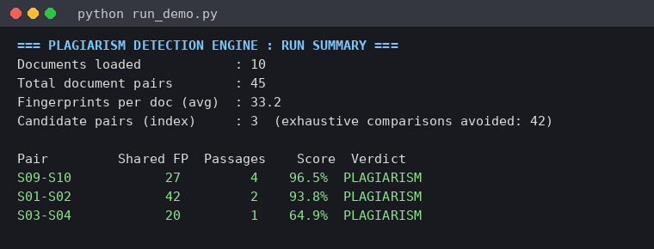
Figure 1: Engine run summary on the 10-document test set
The inverted index shortlisted only 3 of the 45 possible pairs, so 42 exhaustive comparisons were avoided. The three shortlisted pairs are ranked by similarity score and all are flagged as plagiarism.
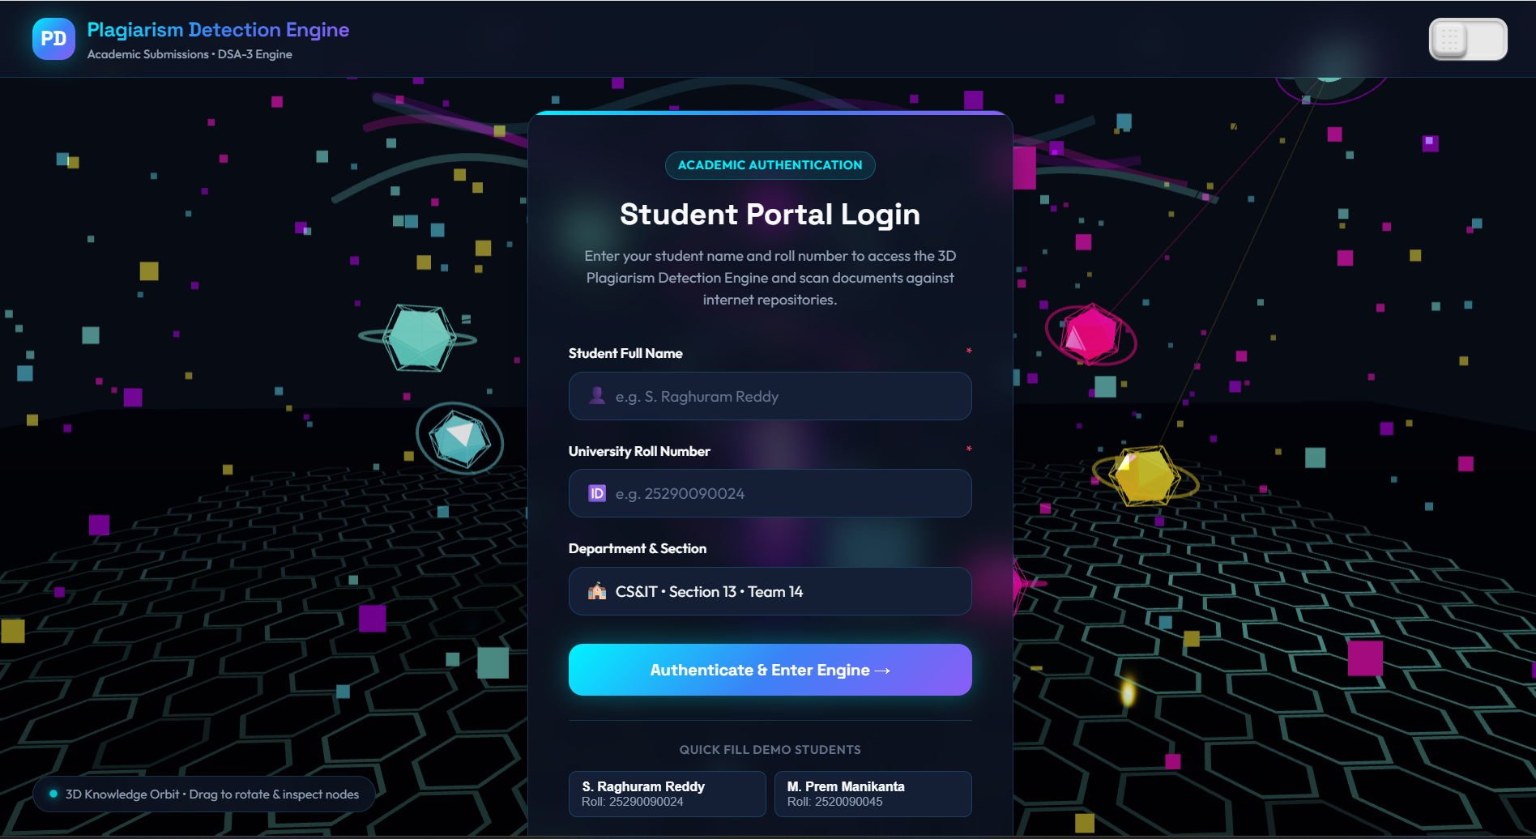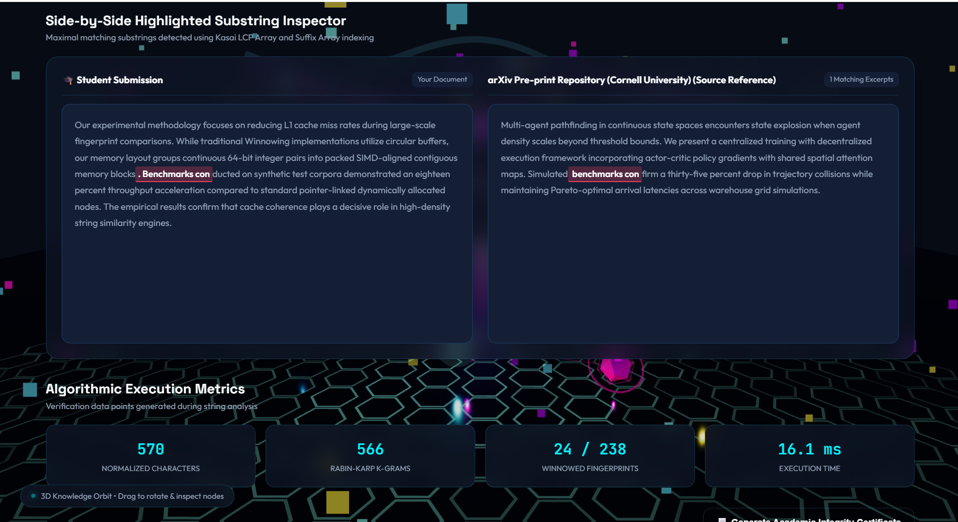
Figure 2: Side-by-side highlighted comparison of submissions S03 and S04
The highlighted 49-token passage was copied word for word, giving an overall similarity of 64.9%, while the student's own sentences stay unhighlighted. The shared cover page was ignored.
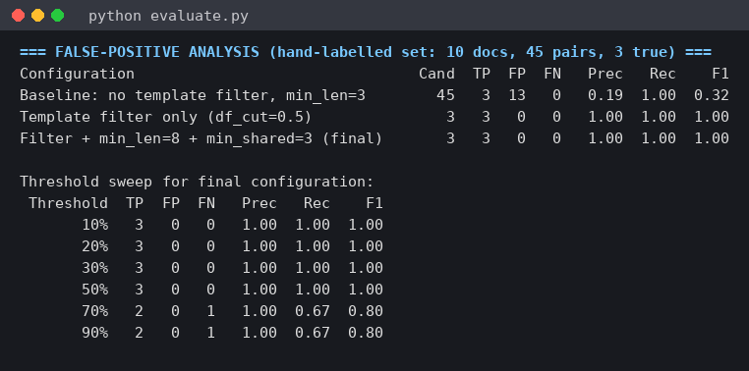
Figure 3: False-positive analysis on the hand-labelled dataset
Without template removal the 13 false positives reduce precision to 0.19; with template removal, precision and recall are both 1.00 at the 30% threshold, and recall falls only when the threshold exceeds about 70%.
Discussion. On the labelled dataset of 10 documents (45 pairs, 3 of them genuinely plagiarised) the final configuration (k = 4, w = 4, template filter df > 0.5, minimum passage length 8, at least 3 shared fingerprints) detected all three plagiarised pairs: a sentence-reordered copy (S01-S02), a partial copy mixed with the student's own text (S03-S04) and a lightly edited copy (S09-S10). Independent essays on the same topic (S05-S06, S07-S08) and documents that only share the cover page and reference list were not flagged. The dataset is small and was prepared by the team, so these numbers show that the pipeline behaves as designed; they should be confirmed on a larger collection of real submissions.
- CONCLUSION & FUTURE SCOPE
Conclusion. The project set out to build a scalable engine that finds copied passages in student submissions and explains where they occur. All objectives were met. Submissions are normalised and tokenised, Rabin-Karp fingerprints are winnowed and stored in an inverted index, and only 3 of 45 pairs in the test set needed detailed comparison. For these pairs the suffix array and the Kasai LCP array located the maximal common passages, which are shown in a side-by-side highlighted report together with a similarity score. Template removal and a minimum passage length raised precision on the hand-labelled set from 0.19 to 1.00 without losing recall. The engine is therefore a transparent, computationally efficient application of rolling hashing, suffix arrays and LCP computation to a real academic problem.
Future Scope
Near term. Add a simple graphical or web front end that accepts PDF and DOCX uploads and exports the comparison report as HTML; make k, w, the template cut-off and the similarity threshold configurable; evaluate on a larger labelled collection of real submissions.
Medium term. Handle paraphrasing by adding stemming, stop-word handling and synonym normalisation; build a generalised suffix array over the whole corpus; process document pairs in parallel to support collections of thousands of submissions.
Long term. Combine fingerprint matching with semantic similarity based on word embeddings, compare submissions with web sources and archives of past batches, and integrate the engine with the university's learning-management system.
- REFERENCES

1. A. Aiken, "MOSS: A System for Detecting Software Similarity," Stanford University. https://theory.stanford.edu/~aiken/moss/
2. S. Schleimer, D. S. Wilkerson and A. Aiken, "Winnowing: Local Algorithms for Document Fingerprinting," Proc. ACM SIGMOD, 2003. https://doi.org/10.1145/872757.872770
3. JPlag: State-of-the-Art Source Code Plagiarism & Collusion Detection, Karlsruhe Institute of Technology. https://github.com/jplag/JPlag
4. Dolos: Source code plagiarism detection, Team Dodona, Ghent University. https://dolos.ugent.be and https://github.com/dodona-edu/dolos
5. Turnitin: Similarity checking and academic integrity service. https://www.turnitin.com
6. PAN: Webis Group evaluation labs on plagiarism detection and text re-use. https://pan.webis.de
7. R. M. Karp and M. O. Rabin, "Efficient randomized pattern-matching algorithms," IBM J. Res. Dev., vol. 31, no. 2, 1987. https://doi.org/10.1147/rd.312.0249
8. U. Manber and G. Myers, "Suffix arrays: a new method for on-line string searches," SIAM J. Comput., vol. 22, no. 5, 1993. https://doi.org/10.1137/0222058
9. T. Kasai, G. Lee, H. Arimura, S. Arikawa and K. Park, "Linear-time longest-common-prefix computation in suffix arrays and its applications," CPM 2001, LNCS 2089. https://doi.org/10.1007/3-540-48194-X_17
10. D. Gusfield, Algorithms on Strings, Trees, and Sequences, Cambridge University Press, 1997.

