Importing libraries

import numpy as np
import pandas as pd
import matplotlib.pyplot as plt
import seaborn as sns
from sklearn.model_selection import train_test_split
from sklearn.ensemble import RandomForestRegressor
from sklearn import metrics

Data collection and processing

#loading csv to pandas data frame
gold_data = pd.read_csv('/content/gld_price_data.csv')

#print first five rows
gold_data.head()

 | Date | SPX | GLD | USO | SLV | EUR/USD
0 | 1/2/2008 | 1447.160034 | 84.860001 | 78.470001 | 15.180 | 1.471692
1 | 1/3/2008 | 1447.160034 | 85.570000 | 78.370003 | 15.285 | 1.474491
2 | 1/4/2008 | 1411.630005 | 85.129997 | 77.309998 | 15.167 | 1.475492
3 | 1/7/2008 | 1416.180054 | 84.769997 | 75.500000 | 15.053 | 1.468299
4 | 1/8/2008 | 1390.189941 | 86.779999 | 76.059998 | 15.590 | 1.557099

#print last five data frame
gold_data.tail()

 | Date | SPX | GLD | USO | SLV | EUR/USD
2285 | 5/8/2018 | 2671.919922 | 124.589996 | 14.0600 | 15.5100 | 1.186789
2286 | 5/9/2018 | 2697.790039 | 124.330002 | 14.3700 | 15.5300 | 1.184722
2287 | 5/10/2018 | 2723.070068 | 125.180000 | 14.4100 | 15.7400 | 1.191753
2288 | 5/14/2018 | 2730.129883 | 124.489998 | 14.3800 | 15.5600 | 1.193118
2289 | 5/16/2018 | 2725.780029 | 122.543800 | 14.4058 | 15.4542 | 1.182033

#number of rows and columns
gold_data.shape

(2290, 6)

#getting some basic info about data
gold_data.info()

<class 'pandas.core.frame.DataFrame'>
RangeIndex: 2290 entries, 0 to 2289
Data columns (total 6 columns):
# Column Non-Null Count Dtype
--- ------ -------------- -----
0 Date 2290 non-null object
1 SPX 2290 non-null float64
2 GLD 2290 non-null float64
3 USO 2290 non-null float64
4 SLV 2290 non-null float64
5 EUR/USD 2290 non-null float64
dtypes: float64(5), object(1)
memory usage: 107.5+ KB
#checking number of missing values
gold_data.isnull().sum()

Date 0
SPX 0
GLD 0
USO 0
SLV 0
EUR/USD 0
dtype: int64

#getting the statistical measures of the data
gold_data.describe()

 | SPX | GLD | USO | SLV | EUR/USD
count | 2290.000000 | 2290.000000 | 2290.000000 | 2290.000000 | 2290.000000
mean | 1654.315776 | 122.732875 | 31.842221 | 20.084997 | 1.283653
std | 519.111540 | 23.283346 | 19.523517 | 7.092566 | 0.131547
min | 676.530029 | 70.000000 | 7.960000 | 8.850000 | 1.039047
25% | 1239.874969 | 109.725000 | 14.380000 | 15.570000 | 1.171313
50% | 1551.434998 | 120.580002 | 33.869999 | 17.268500 | 1.303296
75% | 2073.010070 | 132.840004 | 37.827501 | 22.882499 | 1.369971
max | 2872.870117 | 184.589996 | 117.480003 | 47.259998 | 1.598798

#Converting the date column to the proper format
gold_data['Date'] = pd.to_datetime(gold_data['Date'])
gold_data['Date'] = gold_data['Date'].apply(lambda x:x.date())

#Creating a year column just for some data visualization
gold_data['Year'] =gold_data['Date'].apply(lambda x: x.year)

gold_data['Year'].value_counts()

2009 224
2014 224
2015 223
2011 222
2010 222
2013 221
2016 221
2012 219
2017 218
2008 209
2018 87
Name: Year, dtype: int64

#We can see how the maximum gold value changed from 2008 to 2018
gold_data.groupby('Year').max()['GLD'].plot()

<matplotlib.axes._subplots.AxesSubplot at 0x7fc962dbbc10>

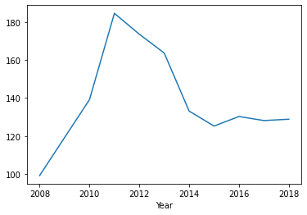

correleation:
1.positive correlation
2.Negative correlation

correlation = gold_data.corr()

#constructing a heatmap to understand the correlation
plt.figure(figsize = (8,8))
sns.heatmap(correlation, cbar=True, square=True, fmt='.1f',annot=True, annot_kws={'size':8}, cmap='Blues')

<matplotlib.axes._subplots.AxesSubplot at 0x7fc9717b6ed0>

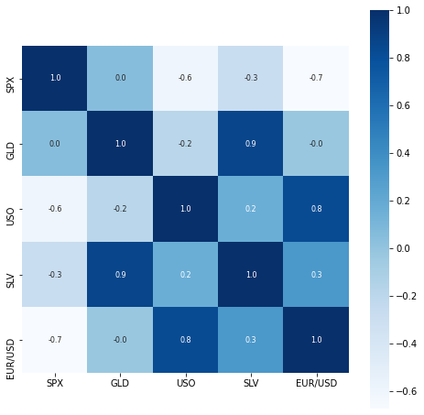

#correlation values of GLD
print(correlation['GLD'])

SPX 0.049345
GLD 1.000000
USO -0.186360
SLV 0.866632
EUR/USD -0.024375
Name: GLD, dtype: float64

#checking the distribution of the GLD price
sns.displot(gold_data['GLD'],color='green')

<seaborn.axisgrid.FacetGrid at 0x7fc96342c750>

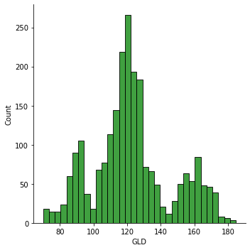

gold_data.hist(figsize=(10,8))

array([[<matplotlib.axes._subplots.AxesSubplot object at 0x7fc962c6fd10>,
<matplotlib.axes._subplots.AxesSubplot object at 0x7fc962c29350>],
[<matplotlib.axes._subplots.AxesSubplot object at 0x7fc962bde9d0>,
<matplotlib.axes._subplots.AxesSubplot object at 0x7fc962c09b90>],
[<matplotlib.axes._subplots.AxesSubplot object at 0x7fc962b57710>,
<matplotlib.axes._subplots.AxesSubplot object at 0x7fc962b118d0>]],
dtype=object)

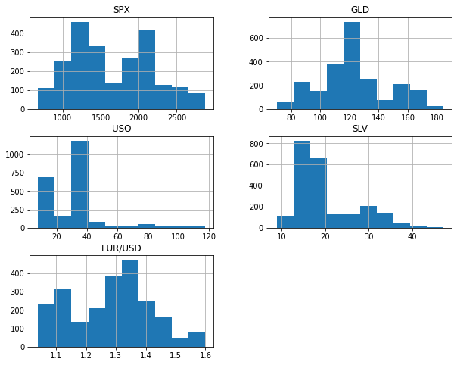

splitting the features and target (gold and date)

X=gold_data.drop(['Date','GLD'],axis=1)
Y=gold_data['GLD']

print(X)

SPX USO SLV EUR/USD
0 1447.160034 78.470001 15.1800 1.471692
1 1447.160034 78.370003 15.2850 1.474491
2 1411.630005 77.309998 15.1670 1.475492
3 1416.180054 75.500000 15.0530 1.468299
4 1390.189941 76.059998 15.5900 1.557099
... ... ... ... ...
2285 2671.919922 14.060000 15.5100 1.186789
2286 2697.790039 14.370000 15.5300 1.184722
2287 2723.070068 14.410000 15.7400 1.191753
2288 2730.129883 14.380000 15.5600 1.193118
2289 2725.780029 14.405800 15.4542 1.182033

[2290 rows x 4 columns]

print(Y)

0 84.860001
1 85.570000
2 85.129997
3 84.769997
4 86.779999
...
2285 124.589996
2286 124.330002
2287 125.180000
2288 124.489998
2289 122.543800
Name: GLD, Length: 2290, dtype: float64

splitting into training data and test data

X_train, X_test, Y_train, Y_test = train_test_split(X,Y, test_size = 0.2, random_state=2)

model Training: Random forest Regressor

regressor = RandomForestRegressor(n_estimators=100)

#training the model
regressor.fit(X_train,Y_train)

RandomForestRegressor(bootstrap=True, ccp_alpha=0.0, criterion='mse',
max_depth=None, max_features='auto', max_leaf_nodes=None,
max_samples=None, min_impurity_decrease=0.0,
min_impurity_split=None, min_samples_leaf=1,
min_samples_split=2, min_weight_fraction_leaf=0.0,
n_estimators=100, n_jobs=None, oob_score=False,
random_state=None, verbose=0, warm_start=False)

Model evaluation

#prediction on Test Data
test_data_prediction=regressor.predict(X_test)

print(test_data_prediction)

[168.68449967 82.02389996 116.17810003 127.66170085 120.82890131
154.74819774 150.15929927 126.16140027 117.41029883 125.87800101
116.76950108 171.5890007 141.95409882 168.19929899 115.20049982
117.73670044 136.97140352 170.11210059 159.4500027 157.45339942
154.89170025 125.39660044 176.23649954 156.45690328 125.15760044
93.9111996 77.66950018 120.59830016 118.9816988 167.45359896
88.27430047 125.25120009 91.15660076 117.75820031 121.0192995
136.67070118 115.47530089 114.43630084 147.97420017 107.13990098
104.36130255 87.19379803 126.56630038 117.81100012 153.80609928
119.77190019 108.33689983 107.87419829 93.25400027 126.90859838
74.60200045 113.55529902 121.35750032 111.32749967 118.78259883
120.56659931 160.07999953 167.69060091 146.90879667 86.03669908
94.46580049 86.77199867 90.62890026 118.96330092 126.43820105
127.61669982 169.79350018 122.20339955 117.3561993 98.27080023
168.61100102 142.87829841 131.9266033 121.18900208 120.70209943
119.81500057 114.59180187 118.62500059 107.20710086 127.95230093
113.76389977 107.06070015 116.98160058 119.65559866 89.1104009
88.34319904 147.17070203 127.16500038 113.74770036 110.25619834
108.41749885 77.43649904 169.87380201 114.17069943 121.6948989
127.99960115 154.8721983 91.7199993 136.3751013 159.18670348
124.47940072 125.16610027 130.15300193 114.99240132 119.79239996
92.09749982 110.62179901 167.55419919 157.94009905 114.42479969
106.75170118 79.61849957 113.3078004 125.80910064 107.32459932
119.68110081 156.13920392 159.49079918 120.19730016 135.02050271
101.44129995 117.56709819 119.24910034 113.06220088 102.76549919
160.18629823 99.02350025 147.89979897 125.65220097 169.70719941
125.76319876 127.31299759 127.43990139 113.85509933 112.60550072
123.643299 102.09989874 89.42039993 124.5853997 101.61509923
107.21979932 113.33880089 117.20840056 99.02449949 121.70770046
163.8007989 87.47029895 106.52219966 116.93770106 127.7486011
124.14610049 80.77819901 120.68200067 158.87759804 87.9658998
110.17469988 118.70489925 172.5307984 103.06559906 105.33810022
122.80670048 158.88769781 87.63849842 93.10080041 112.7066005
177.18359975 114.05389975 119.23850022 94.60920094 125.4568
166.2639006 114.79080043 116.48660139 88.30239884 149.55870083
120.31389971 89.32329984 112.22320006 117.52550016 118.75680106
88.04179935 94.07690013 116.99959999 118.74670211 120.34000094
126.72729835 121.83909961 147.83840026 164.82509981 118.55569972
120.32310175 151.25430102 118.56999921 172.58109838 105.30009928
105.00220059 150.11530103 113.54730116 124.77520086 147.95020051
119.75630129 115.49720053 112.70910013 113.45340173 141.96240134
117.7650977 102.95310047 115.81740104 103.94700204 98.56550042
117.43340099 90.75380014 91.55400059 153.69229955 102.77949977
154.72820079 114.28770122 138.83100151 90.13569812 115.60169971
114.58449933 123.03300034 121.77270013 165.21610137 92.83459979
135.127201 121.43629898 120.90700049 104.77760014 140.45060319
121.83209901 116.64780041 113.58400063 127.01209765 122.82469942
125.80669935 121.26220039 86.76309869 132.51220131 145.9791022
92.6725994 159.18219961 159.50600246 126.35929908 164.97949922
108.86529956 109.54000102 103.90329871 94.38880039 127.80910279
107.09960039 161.64299963 121.75510044 132.20719989 130.2038021
160.27409968 90.18799843 176.20870169 127.47270027 126.67839891
86.36019928 124.4944992 150.60619729 89.55320025 106.85389964
109.02779995 84.41309903 136.06449885 155.10220289 138.41960359
74.34940021 152.71120143 126.10559995 126.66710051 127.4386992
108.7787 156.05550057 114.64670114 116.89190147 125.13259945
154.00800162 121.35999979 156.38809867 92.8839007 125.44870155
125.80250019 87.78760045 92.11269925 126.14029967 128.2608033
113.15450068 117.50339717 120.95770026 127.0249978 119.46350088
136.20270069 93.92699962 119.8627002 113.11250096 94.20219917
108.83729967 87.43079936 109.24799896 89.52729982 92.46910043
131.55180286 162.42430092 89.36010011 119.67450089 133.23010212
123.81200015 128.55180191 101.9247984 88.81919868 131.9426009
119.48450022 108.49739972 168.00390169 115.21480033 86.57979897
118.90470044 91.12759968 161.59240025 116.72700086 121.46429973
160.21869847 119.99419949 112.97789902 108.4471985 126.73079978
76.23460007 103.07889972 127.78200237 121.71699933 92.54040025
131.85820007 118.06260094 115.64499979 154.67770305 158.91480072
110.04509954 154.94009856 119.12830075 160.19540061 118.36670062
158.68899956 115.22079948 116.65840023 150.13219882 114.84530084
125.62619871 165.34479934 117.60930004 125.42099959 153.24060366
153.37140269 132.123 114.78350035 121.19260222 125.06910062
89.71790048 122.99570015 154.97880206 111.70430046 106.61759974
161.75370186 118.37359986 165.54769972 134.27870107 114.62539994
153.08679941 168.77019974 114.40979979 114.0600011 158.95179909
85.4830985 127.07350089 128.04490081 128.87210024 124.31320059
123.94780071 90.42960063 153.45530039 96.97059981 137.74640001
89.05689923 106.96510025 115.15290019 112.29600091 124.22189902
91.4378984 125.38750126 162.53169903 120.08999885 165.07720062
126.80429806 112.14210015 127.63819941 95.00879864 91.14109985
103.06309911 120.92390022 82.8501997 126.27910009 160.38690456
117.37540098 118.45589982 120.04160002 122.72089967 120.18540123
121.45030023 118.2651004 107.15920003 148.5619001 126.32169845
115.69780059 73.8379 127.78490055 155.03130133 121.71380005
125.68200045 88.84430016 103.06019832 124.3260003 120.31860039
73.41430085 151.82830043 121.2630005 104.79519944 86.48039801
115.26769886 172.18109784 120.01790014 160.48839723 113.30049981
120.93490005 118.51890072 95.93889994 118.80289983 125.63480035
118.57079964 95.88830052 153.91560187 121.9668999 147.99440017
159.4456023 113.90340024 122.53789923 149.09579795 127.30950032
165.86100028 135.48709947 120.12099939 167.7284989 108.27039923
121.72449869 139.0859003 107.7708988 ]
#R square error
error_score=metrics.r2_score(Y_test, test_data_prediction)
print("R square error:",error_score)

R square error: 0.9895186991521377

compare the actual value and predicted values in a plot
#Y_test to list convertion so we dont get errors
Y_test=list(Y_test)

plt.plot(Y_test, color='blue', label='Actual value')
#plt.plot(test_data_prediction, color='green',label='predicted value')
plt.title('Actual price vs predicted price')
plt.xlabel('Number of values')
plt.ylabel('GLD price')
plt.legend()
plt.show()

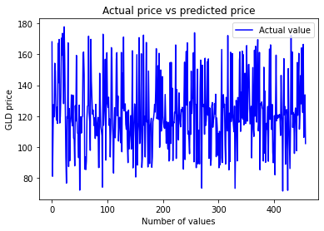

#plt.plot(Y_test, color='blue', label='Actual value')
plt.plot(test_data_prediction, color='green',label='predicted value')
plt.title('Actual price vs predicted price')
plt.xlabel('Number of values')
plt.ylabel('GLD price')
plt.legend()
plt.show()

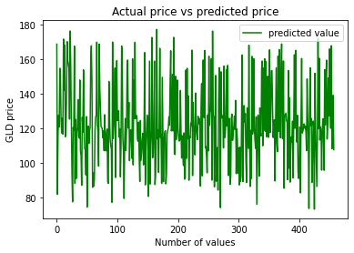

plt.plot(Y_test, color='blue', label='Actual value')
plt.plot(test_data_prediction, color='green',label='predicted value')
plt.title('Actual price vs predicted price')
plt.xlabel('Number of values')
plt.ylabel('GLD price')
plt.legend()
plt.show()

