**Implementation of Chatbot using NLP**

A Project Report

submitted in partial fulfillment of the requirements

of

AICTE Internship on AI: Transformative Learning

with

TechSaksham – A joint CSR initiative of Microsoft & SAP

by

**Raghuvaran Damodaran, raghuvarandamodaran2002@gmail.com**

Under the Guidance of

**Aditya Prashant Ardak**

**ACKNOWLEDGEMENT**

We would like to take this opportunity to express our deep sense of gratitude to all individuals who helped us directly or indirectly during this thesis work.

Firstly, we would like to thank my supervisor, Aditya Prashant Ardak, for being a great mentor and the best adviser I could ever have. His advice, encouragement and the critics are a source of innovative ideas, inspiration and causes behind the successful completion of this project. The confidence shown in me by him was the biggest source of inspiration for me. It has been a privilege working with him for the last one year. He always helped me during my project and many other aspects related to the program. His talks and lessons not only help in project work and other activities of the program but also make me a good and responsible professional. And, I even like to thank Pavan Kumar U, Program Manager, Edunet Foundations for giving me this opportunity and my family for the support.  
Finally, I like to thank AICTE, MICROSOFT and SAP for giving us this program schedule.

#### **ABSTRACT**

BhartAI is an intelligent chatbot designed to provide Anna University students with study materials and syllabi for R2017 and R2021. Leveraging Natural Language Processing (NLP), the chatbot dynamically responds to user queries. It incorporates a responsive UI with Dark, Light, and System themes, ensuring accessibility across devices. Built using Flask, scikit-learn, and Bootstrap, this project demonstrates efficient integration of backend NLP processing and modern frontend design. Key results include accurate intent recognition and user-friendly interfaces.This AI is currentl working under the progress but it will be work within few days.This is very useful for Anna University students.

**I**

**TABLE OF CONTENT**

**Abstract I**

**Chapter 1.**  **Introduction 1**

1.1 Problem Statement 1

1.2 Motivation 1

1.3 Objectives 2

1.4. Scope of the Project 2

**Chapter 2.**  **Literature Survey 3**

**Chapter 3.**  **Proposed Methodology**

**Chapter 4.**  **Implementation and Results**

**Chapter 5. Discussion and Conclusion**

**References**

**LIST OF FIGURES**

|  |  |  |
| --- | --- | --- |
| **Figure No.** | **Figure Caption** | **Page No.** |
|  | Logo | **4** |
|  | Prototype | **4** |
|  | Github Repo | **5** |
|  |  |  |
|  |  |  |
|  |  |  |
|  |  |  |
|  |  |  |
|  |  |  |

**LIST OF TABLES**

|  |  |  |
| --- | --- | --- |
| **Table. No.** | **Table Caption** | **Page No.** |
|  |  |  |
|  |  |  |
|  |  |  |
|  |  |  |
|  |  |  |
|  |  |  |
|  |  |  |
|  |  |  |
|  |  |  |

**CHAPTER 1**

**Introduction**

* 1. **Problem Statement:**

The lack of centralized, accessible, and dynamic platforms for Anna University students to retrieve syllabi and study materials motivated this project. Current systems are often static or outdated, hindering effective learning.

* 1. **Motivation**:

The project was chosen to bridge the gap between academic resources and students' needs. Its applications extend to enhancing e-learning experiences through AI-driven solutions.

* 1. **Objective:**

**The objective of this project is to :**

1. Develop an AI chatbot capable of understanding and responding to academic queries.  
2. Provide a dynamic, responsive user interface for accessing study materials and syllabi.  
3. Ensure compatibility across devices and themes.

* 1. **Scope of the Project:**

The scope includes creating a chatbot for Anna University R2017 and R2021 syllabi and study materials. Limitations include dependency on predefined intents and responses for accuracy.

**CHAPTER 2**

**Literature Survey**Refer from EduChat: An AI-Based Chatbot for University-Related Information Using a Hybrid Approach Hoa Dinh and Thien Khai Tran *Faculty of Information Technology, Ho Chi Minh City University of Foreign Languages and Information Technology, Ho Chi Minh City 700000, Vietnam.We can use the models with DALLE-2 for collecting informations.

Nowadays, like most other artificial intelligent chatbots, Amazon's QnABot makes it easy for educational institutions to add features and functionality and even provides a platform for students to offer feedback.

**CHAPTER 3**

**Proposed Methodology**

* 1. **System Design**

The system integrates a Flask backend with an NLP-based chatbot model and a responsive frontend built using HTML, CSS, and JavaScript. It dynamically fetches user inputs, processes them using Logistic Regression, and returns appropriate responses.

* 1. **Requirement Specification**
     1. **Hardware Requirements:** Any device with internet connection can ne worked well.
     2. **Software Requirements:** Skicit-Learn,Python,SQL,HTML,CSS & JS

**CHAPTER 4**

**Implementation and Result**

* 1. **Snap Shots of Result:**

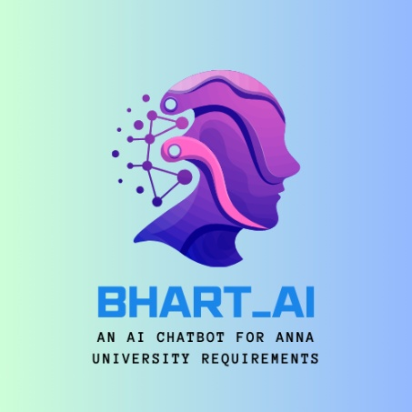

**Figure 1 Logo**

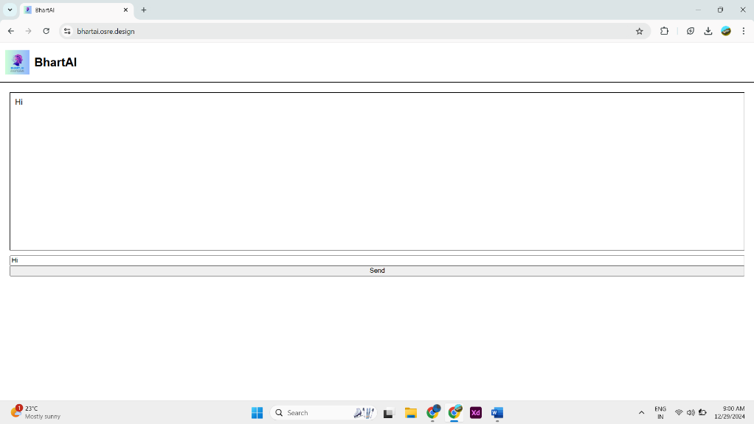

**Figure 2 Prototype**

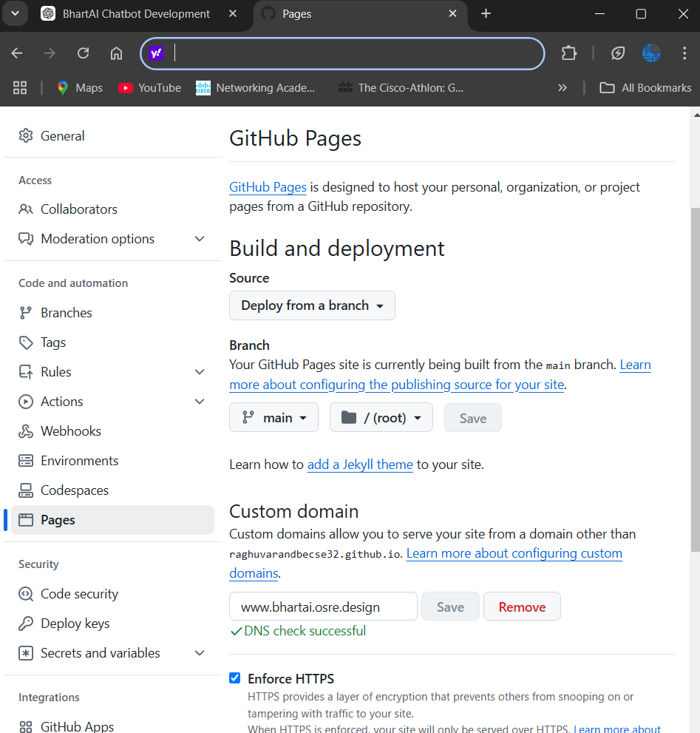

**Figure 3 Github Repository.**

* 1. **GitHub Link for Code:**

<https://github.com/RaghuvaranDBECse32/BhartAI_2>

**CHAPTER 5**

**Discussion and Conclusion**

* 1. **Future Work:**

Future enhancements include adding more intents, integrating deep learning for better intent recognition, and expanding the scope to include more universities.

* 1. **Conclusion:**

BhartAI successfully combines AI and modern UI to address the needs of Anna University students. It demonstrates how NLP and responsive design can enhance academic resource accessibility.

**REFERENCES**

1. Ming-Hsuan Yang, David J. Kriegman, Narendra Ahuja, “Detecting Faces in Images: A Survey”, IEEE Transactions on Pattern Analysis and Machine Intelligence, Volume. 24, No. 1, 2002.
2. EduChat: An AI-Based Chatbot for University-Related Information Using a Hybrid Approach Hoa Dinh and Thien Khai Tran *Faculty of Information Technology, Ho Chi Minh City University of Foreign Languages and Information Technology