

Cloud Computing Fundamentals Lab
LAB PRACTICAL FILE

(B.Tech CSE 2023-27)

Submitted By: Submitted To:
Name-Tanishq Chauhan Mr Satyam Tiwari
Sap Id: 500120139
Roll No: R2142230682
Batch No: 4

Experiment:3

Questions:-
- Write a Java program to count and display the total number of prime numbers between 1 and 1000.
Code:-
package Basics;
import java.util.Scanner;

public class count {
public static void main(String[] args) {
Scanner scanner = new Scanner(System.in);

// Input array size
System.out.print("Enter the size of the array: ");
int size = scanner.nextInt();
int[] arr = new int[size];

// Input array elements
System.out.println("Enter " + size + " elements:");
for (int i = 0; i < size; i++) {
arr[i] = scanner.nextInt();
}

// Input target number
System.out.print("Enter the number to count: ");
int target = scanner.nextInt();

// Count occurrences
int count = 0;
for (int num : arr) {
if (num == target) {
count++;
}
}

// Output the result
System.out.println("The number " + target + " appears " + count + " times in the array.");

scanner.close();
}
}

Output:-
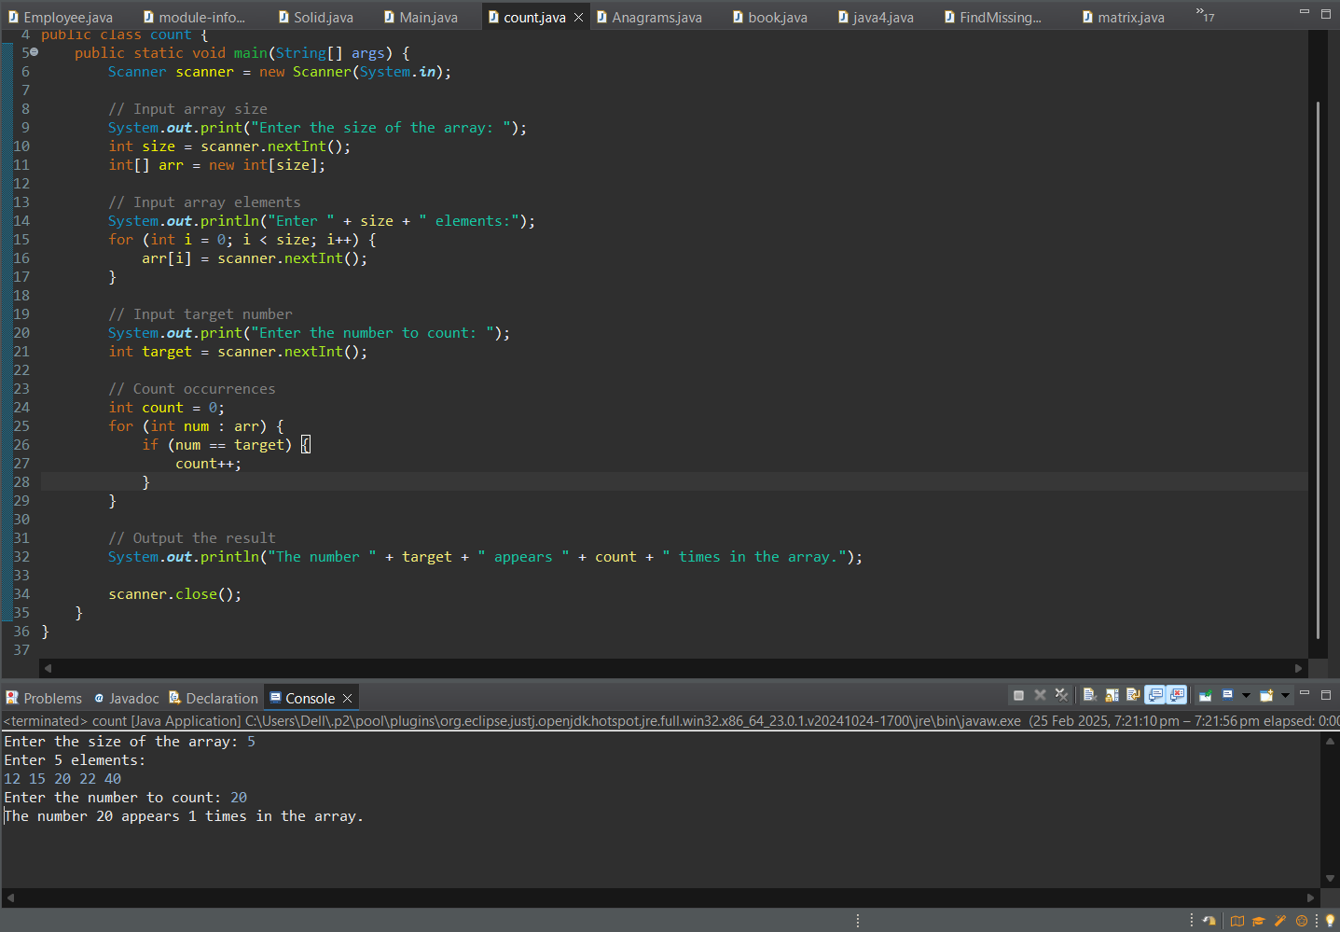

- Given an array containing N-1 unique numbers from 1 to N, write a Java program to find the missing number.
Input: [1, 5, 6, 2, 4]
Output: 3
Code:-
package Basics;

public class FindMissingNumber {
public static void main(String[] args) {
int[] arr = {1,5,6,2,4};
int n = arr.length + 1; // The expected total count of numbers

// Sum of first N natural numbers
int expectedSum = n * (n + 1) / 2;

// Sum of elements in the array
int actualSum = 0;
for (int num : arr) {
actualSum += num;
}

int missingNumber = expectedSum - actualSum;
System.out.println("The missing number is: " + missingNumber);
}
}
Output:-
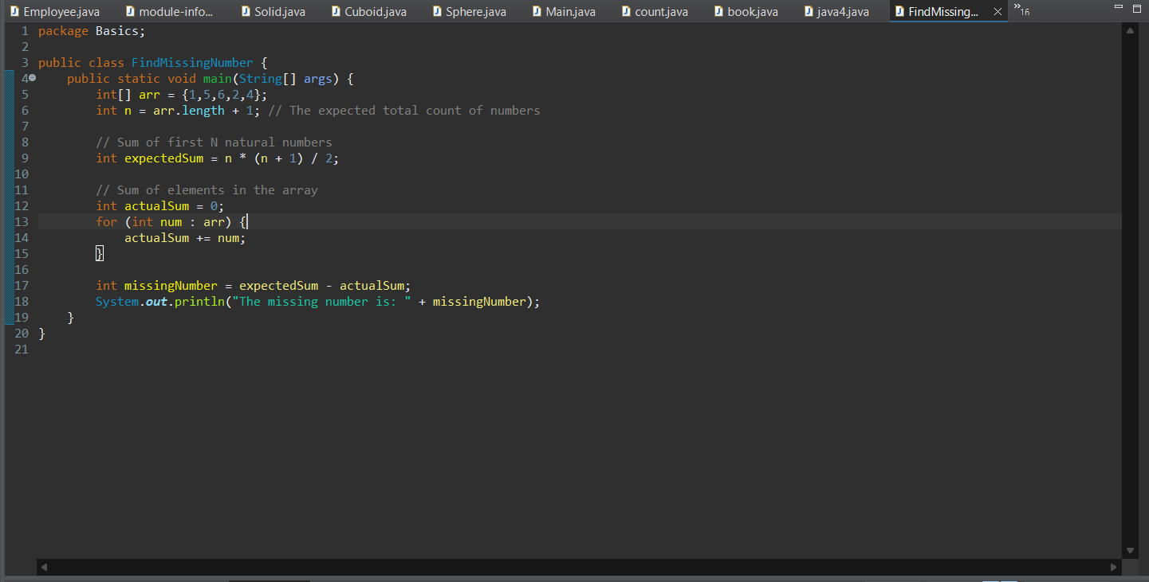

- Given an m x n matrix, return all elements of the matrix in spiral order.

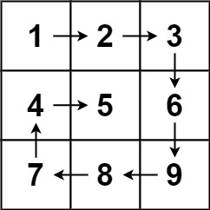

Input: matrix = [[1,2,3],[4,5,6],[7,8,9]]
Output: [1,2,3,6,9,8,7,4,5]
Code:-
package Basics;
import java.util.*;
public class matrix {
public static List<Integer> spiralOrder(int[][] matrix) {
List<Integer> result = new ArrayList<>();
if (matrix == null || matrix.length == 0) return result;

int top = 0, left = 0;
int bottom = matrix.length - 1;
int right = matrix[0].length - 1;

while (top <= bottom && left <= right) {
// Traverse from left to right
for (int i = left; i <= right; i++) {
result.add(matrix[top][i]);
}
top++;

// Traverse from top to bottom
for (int i = top; i <= bottom; i++) {
result.add(matrix[i][right]);
}
right--;

// Traverse from right to left
if (top <= bottom) { // Check to prevent duplicate row traversal
for (int i = right; i >= left; i--) {
result.add(matrix[bottom][i]);
}
bottom--;
}

// Traverse from bottom to top
if (left <= right) { // Check to prevent duplicate column traversal
for (int i = bottom; i >= top; i--) {
result.add(matrix[i][left]);
}
left++;
}
}
return result;
}

public static void main(String[] args) {
int[][] matrix = {
{1, 2, 3},
{4, 5, 6},
{7, 8, 9}
};

System.out.println(spiralOrder(matrix));
}
}

Output:-
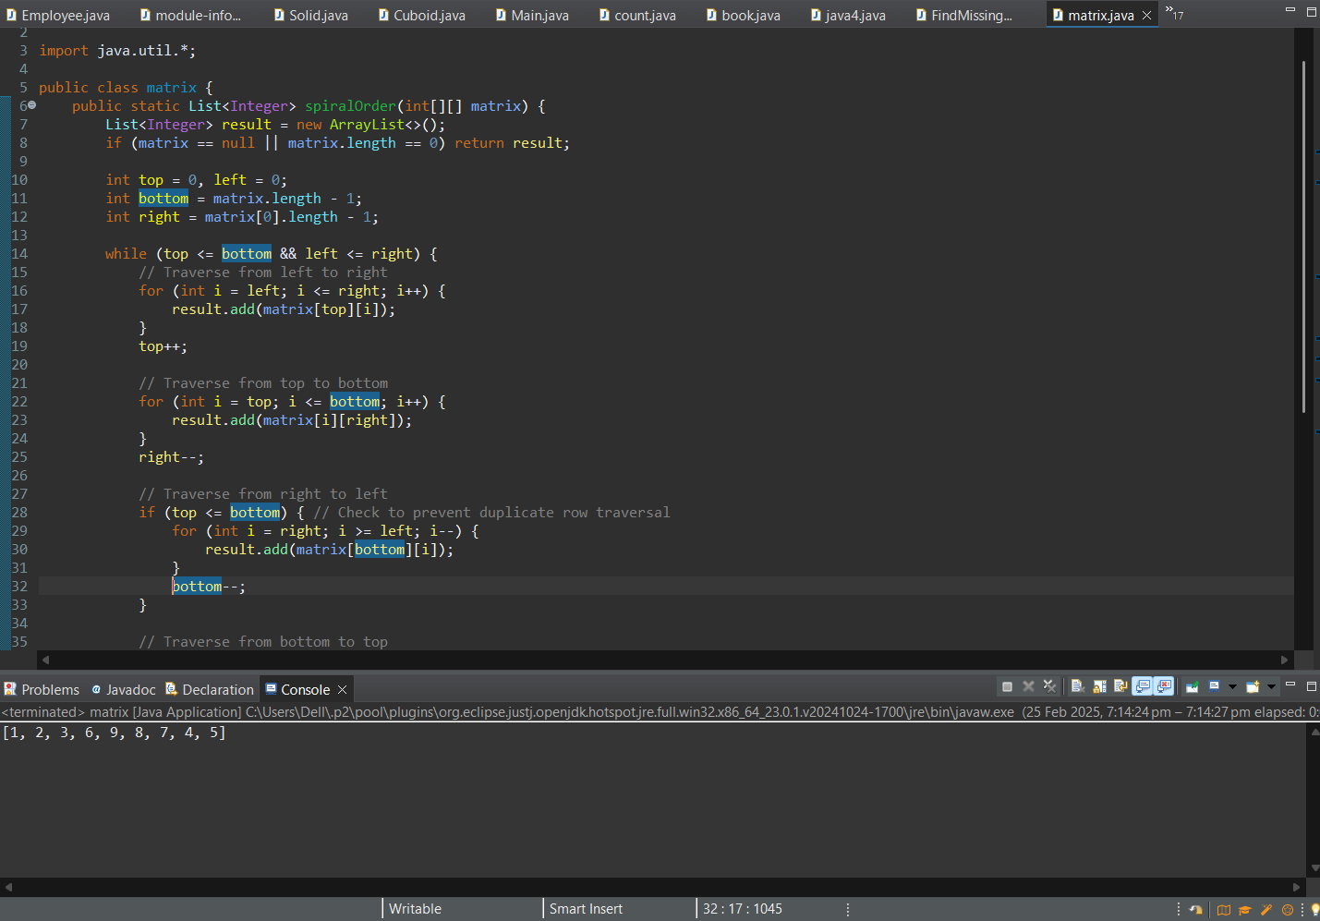

- Given two strings s and t, return true if t is an anagram of s, and false otherwise.
Example 1:
Input: s = "anagram", t = "nagaram"
Output: true

Example 2:

Input: s = "rat", t = "car"
Output: false

Code:-
package Basics;
import java.util.Arrays;

public class Anagrams {
public static boolean isAnagram(String s, String t) {
s=s.toLowerCase();
t = t.toLowerCase();
if (s.length() != t.length()) {
return false;
}

// Convert to char arrays and sort
char[] sArray = s.toCharArray();
char[] tArray = t.toCharArray();

Arrays.sort(sArray);
Arrays.sort(tArray);

return Arrays.equals(sArray, tArray);
}

public static void main(String[] args) {
String s1 = "Yes";
String s2 = "esy";

System.out.println("Are \"" + s1 + "\" and \"" + s2 + "\" anagrams? " + isAnagram(s1, s2));

s1 = "tarr";
s2 = "Ratr";
System.out.println("Are \"" + s1 + "\" and \"" + s2 + "\" anagrams? " + isAnagram(s1, s2));
}
}
Output:-