

Cloud Computing Fundamentals Lab
LAB PRACTICAL FILE

(B.Tech CSE 2023-27)

Submitted By: Submitted To:
Name-Tanishq Chauhan Mr Satyam Tiwari
Sap Id: 500120139
Roll No: R2142230682
Batch No: 4

Experiment:4

Questions:-
1. Create a Book class with attributes title and author.
Assign default values (e.g., "Untitled", "Unknown Author").
Accept user-defined values for title and author.
Add another constructor that also includes an integer parameter for publicationYear.
Objective: Create multiple Book objects using the different constructors and display their details.

Code:-
package Basics;

public class book {
private String title;
private String author;
private int publicationYear;

// Default constructor
public book() {
this.title = "Untitled";
this.author = "Unknown Author";
this.publicationYear = 0; // Explicit initialization for consistency
}

// Constructor with title and author
public book(String title, String author) {
this.title = title != null ? title : "Untitled";
this.author = author != null ? author : "Unknown Author";
this.publicationYear = 0; // Default year when not provided
}

// Constructor with title, author, and publicationYear
public book(String title, String author, int publicationYear) {
this.title = title != null ? title : "Untitled";
this.author = author != null ? author : "Unknown Author";
this.publicationYear = publicationYear > 0 ? publicationYear : 0;
}

public void displayDetails() {
String details = "Title: " + title + ", Author: " + author;
if (publicationYear != 0) {
details += ", Year: " + publicationYear;
}
System.out.println(details);
}

public static void main(String[] args) {
book book1 = new book();
book book2 = new book("1984", "George Orwell");
book book3 = new book("Brave New World", "Aldous Huxley", 1932);

book1.displayDetails();
book2.displayDetails();
book3.displayDetails();
}
}

Output:-
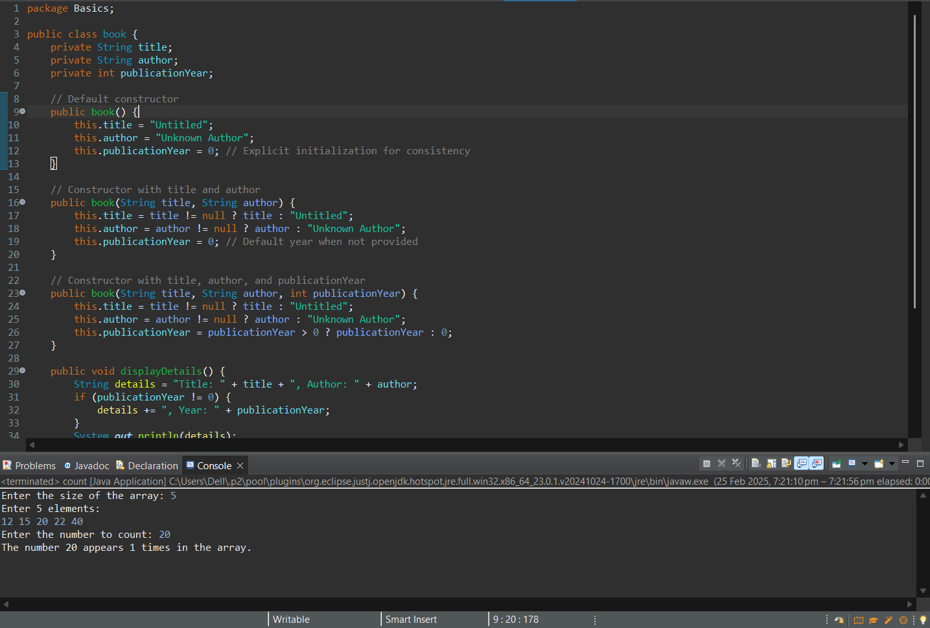

2. Declare a Customer class with a private variable balance.
Implement a public addBalance(double amount) method to add funds.
Implement a protected deductBalance(double amount) method to reduce funds.
Define a default-access (package-private) method showBalance() to display the current balance.
Overload the addBalance(...) method to also accept an int amount for smaller deposits.
Objective: Create an instance of the Customer class Showcase method overloading for different deposit parameters.
Code:-
package base;

import java.util.Scanner;

public class Customer {

private double balance;

// Default constructor to initialize balance
public Customer() {
this.balance = 0.0;
}

// Public method to add balance (double type)
public void addBalance(double amount) {
if (amount > 0) {
balance += amount;
System.out.println("Successfully added " + amount + " to balance.");
} else {
System.out.println("Invalid deposit amount.");
}
}

// Overloaded method to add balance (int type)
public void addBalance(int amount) {
if (amount > 0) {
balance += amount;
System.out.println("Successfully added " + amount + " to balance.");
} else {
System.out.println("Invalid deposit amount.");
}
}

// Protected method to deduct balance
protected void deductBalance(double amount) {
if (amount > 0 && amount <= balance) {
balance -= amount;
System.out.println("Successfully deducted " + amount + " from balance.");
} else {
System.out.println("Invalid deduction amount or insufficient funds.");
}
}

// Package-private method to show the current balance
void showBalance() {
System.out.println("Current Balance: $" + balance);
}

public static void main(String[] args) {
Customer customer = new Customer();
Scanner scanner = new Scanner(System.in);

// Adding balance using double
System.out.print("Enter deposit amount (double): ");
double doubleDeposit = scanner.nextDouble();
customer.addBalance(doubleDeposit);

// Adding balance using int
System.out.print("Enter deposit amount (int): ");
int intDeposit = scanner.nextInt();
customer.addBalance(intDeposit);

// Showing balance after deposits
customer.showBalance();

// Deducting balance
System.out.print("Enter amount to deduct: ");
double deduction = scanner.nextDouble();
customer.deductBalance(deduction);

// Final balance display
customer.showBalance();

scanner.close();
}
}

Output:-
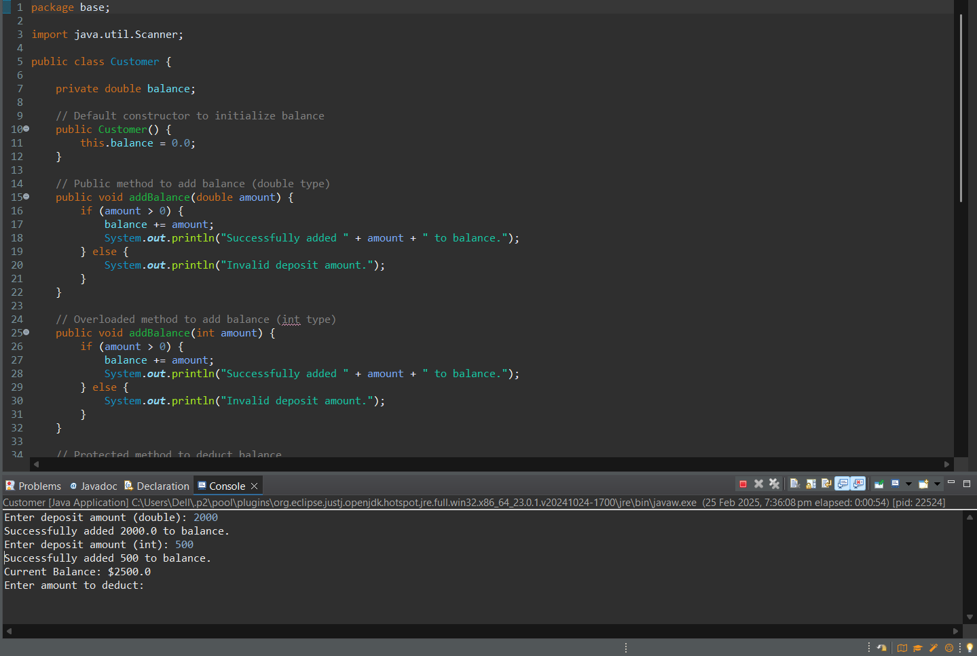

- Create a Club class with a static variable clubName and a non-static variable memberName.
Provide a static method displayClubName() to print the club’s name.Create multiple Club objects and assign different member names to each.
Objective: Show how the static variable clubName is shared across all instances, while memberName remains unique to each object. Prove this by displaying each member’s name alongside the shared club name.
Code:-
package base;

class Club {
// Static variable shared by all instances
private static String clubName = "Elite Programmers Club";

// Non-static variable unique to each instance
private String memberName;

// Constructor to initialize memberName
public Club(String memberName) {
this.memberName = memberName;
}

// Static method to display the club's name
public static void displayClubName() {
System.out.println("Club Name: " + clubName);
}

// Method to display member details
public void displayMemberInfo() {
System.out.println("Member Name: " + memberName + " | Club: " + clubName);
}

public static void main(String[] args) {
// Static method call
Club.displayClubName();

// Creating multiple Club objects with unique member names
Club member1 = new Club("Alice");
Club member2 = new Club("Bob");
Club member3 = new Club("Charlie");

// Displaying each member's information
member1.displayMemberInfo();
member2.displayMemberInfo();
member3.displayMemberInfo();

// Changing the static variable to demonstrate shared nature
Club.clubName = "Global Developers League";

System.out.println("\nAfter changing club name:");

// Display updated club name with each member
member1.displayMemberInfo();
member2.displayMemberInfo();
member3.displayMemberInfo();
}
}

Output:-
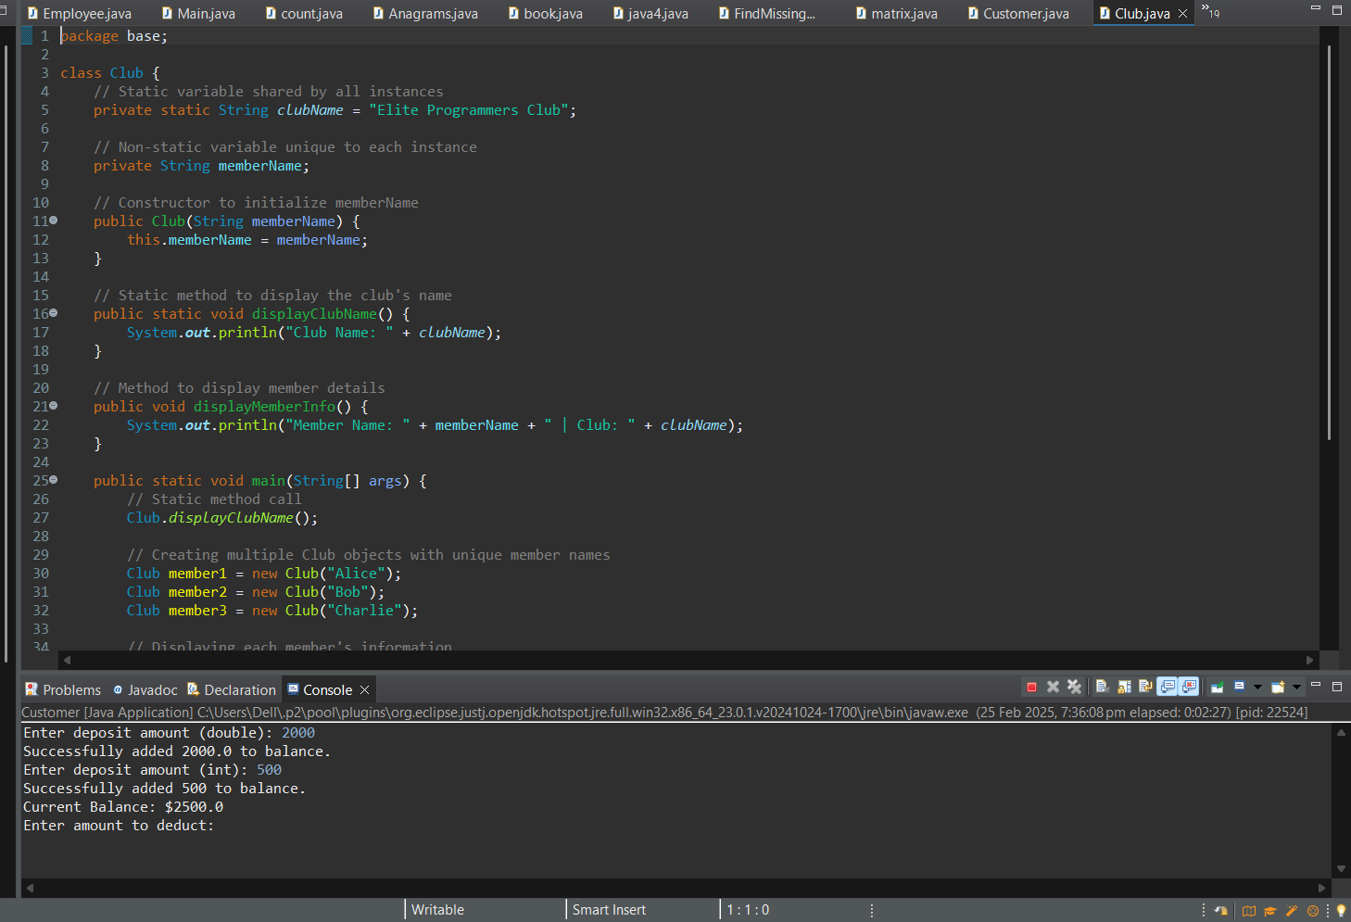

4. Define a Car class with attributes make, model, and year.
Create a parameterized constructor that uses the this keyword to distinguish constructor parameters from the class fields (e.g., this.make = make;). Instantiate a Car object with specific values (e.g., "Tesla", "Model 3", 2025) and display its details, ensuring the correct assignment of attributes using this.
Code:-
package base;

class Car {
// Attributes of the Car class
private String make;
private String model;
private int year;

// Parameterized constructor using `this` keyword
public Car(String make, String model, int year) {
this.make = make;
this.model = model;
this.year = year;
}

// Method to display car details
public void displayCarDetails() {
System.out.println("Car Make: " + make);
System.out.println("Car Model: " + model);
System.out.println("Car Year: " + year);
}

public static void main(String[] args) {
// Instantiate a Car object with specific values
Car myCar = new Car("Hyundai", "Model 3", 2012);

// Display the car's details
myCar.displayCarDetails();
}
}

Output:-
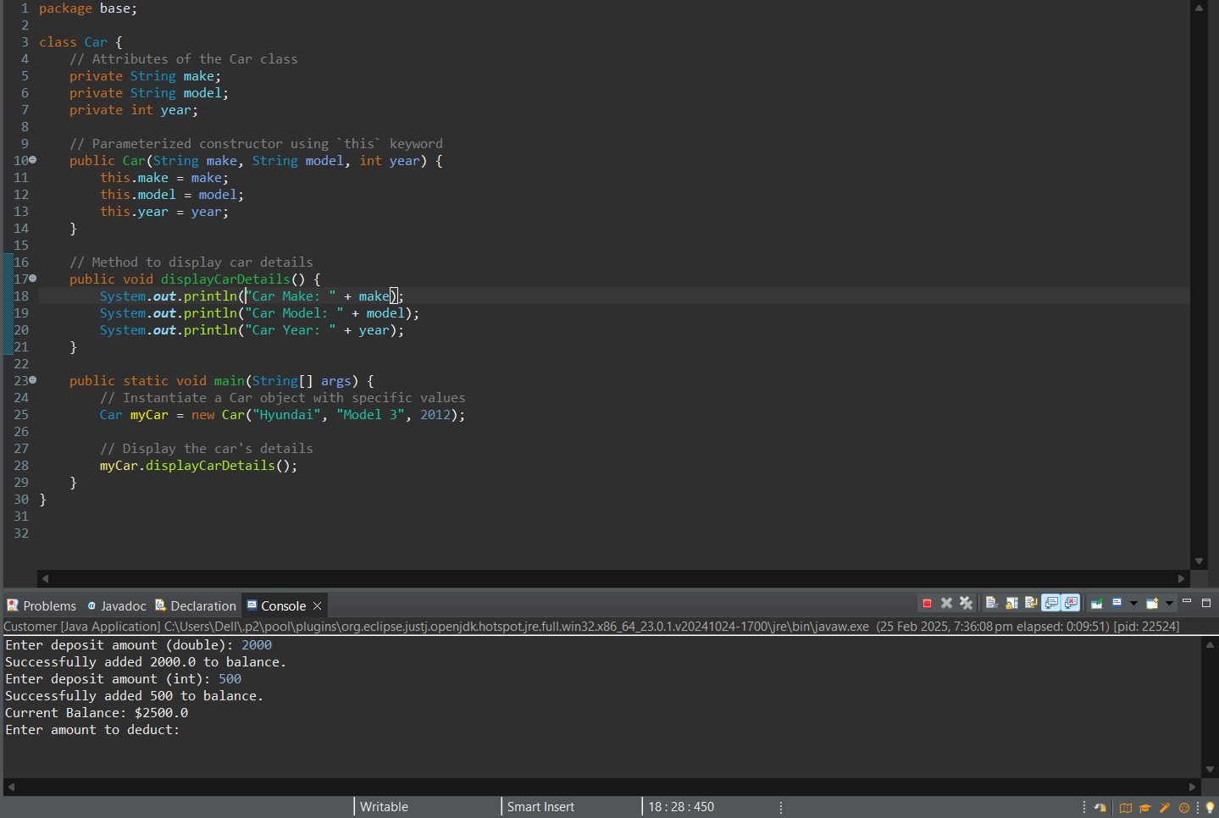
5. A company wants to manage a list of products with details such as product ID, name, price, and category. They also want to keep track of the total number of products and calculate the overall stock value.
Product Class:
Instance variables: productId, productName, category.
A private variable price.
A default constructor setting some default values.
A parameterized constructor that initializes product details using this to differentiate parameters from class fields.
A public method getPrice() to access the private price.
A public method displayProductInfo() to show all details.
Static Members:
A static variable totalProducts to count how many Product objects are created.
A static method displayTotalProducts() to print the total count.
Method to Calculate Stock Value:
A method (e.g., calculateStockValue()) to multiply the price by a given quantity (demonstrate method overloading by adding an optional parameter for a discount rate).
In the main method:
Create multiple Product objects using both the default and parameterized constructors.
Call the static method to display the total number of products.
Display each product’s details, including the price and the calculated stock value for a given quantity.

Code:-
package base;

class Product {
// Instance variables
private String productId;
private String productName;
private String category;
private double price;

// Static variable to count total products
private static int totalProducts = 0;

// Default constructor
public Product() {
this.productId = "P000";
this.productName = "Unknown Product";
this.category = "Miscellaneous";
this.price = 0.0;
totalProducts++;
}

// Parameterized constructor
public Product(String productId, String productName, String category, double price) {
this.productId = productId;
this.productName = productName;
this.category = category;
this.price = price;
totalProducts++;
}

// Getter for price (access private variable)
public double getPrice() {
return price;
}

// Method to display product information
public void displayProductInfo() {
System.out.println("Product ID: " + productId);
System.out.println("Product Name: " + productName);
System.out.println("Category: " + category);
System.out.println("Price: $" + price);
System.out.println("--------------------------");
}

// Static method to display total products
public static void displayTotalProducts() {
System.out.println("Total Products: " + totalProducts);
}

// Method to calculate stock value
public double calculateStockValue(int quantity) {
return price * quantity;
}

// Overloaded method to calculate stock value with a discount
public double calculateStockValue(int quantity, double discountRate) {
double discountedPrice = price * (1 - discountRate / 100);
return discountedPrice * quantity;
}

public static void main(String[] args) {
// Creating multiple Product objects
Product product1 = new Product();
Product product2 = new Product("P101", "Laptop", "Electronics", 1500.0);
Product product3 = new Product("P102", "Smartphone", "Electronics", 800.0);

// Display total products created
Product.displayTotalProducts();

// Display product details and stock value
product1.displayProductInfo();
System.out.println("Stock Value (10 units): $" + product1.calculateStockValue(10));

product2.displayProductInfo();
System.out.println("Stock Value (5 units): $" + product2.calculateStockValue(5));
System.out.println("Stock Value (5 units with 10% discount): $" + product2.calculateStockValue(5, 10));

product3.displayProductInfo();
System.out.println("Stock Value (8 units): $" + product3.calculateStockValue(8));
System.out.println("Stock Value (8 units with 15% discount): $" + product3.calculateStockValue(8, 15));
}
}

Output:-
