

Cloud Computing Fundamentals Lab
LAB PRACTICAL FILE

(B.Tech CSE 2023-27)

Submitted By: Submitted To:
Name-Tanishq Chauhan Mr Satyam Tiwari
Sap Id: 500120139
Roll No: R2142230682
Batch No: 4

Experiment:5

Questions:-
- Write a Java program to demonstrate that a private member of a superclass cannot be accessed directly from a derived class.
Code:-
package Basics;
class SuperClass {
private String privateMessage = "This is a private member of SuperClass";

// Public method to access private data (Encapsulation)
public String getPrivateMessage() {
return privateMessage;
}
}

// Subclass attempting to access the private member
class SubClass extends SuperClass {
public void showPrivateMessage() {
// System.out.println(privateMessage); // ❌ Compilation Error: privateMessage is not accessible
System.out.println("Cannot access private member directly!");

// Correct way: Access through a public method
System.out.println("Accessing via public method: " + getPrivateMessage());
}
}

class Main_s {
public static void main(String[] args) {
SubClass obj = new SubClass();
obj.showPrivateMessage();
}
}

Output:-
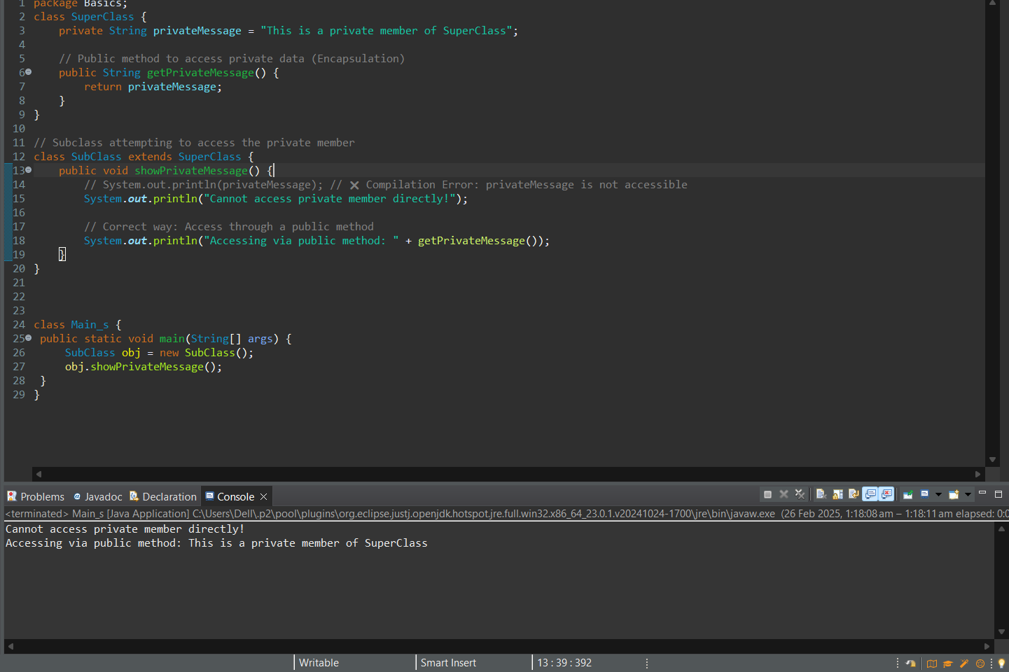

- Design a Java class Employee with attributes name, empid, and salary. Implement a default
constructor, a parameterized constructor, and methods to return the employee’s name and salary. Add a method increaseSalary(double percentage) to raise the salary by a userspecified percentage. Create a subclass Manager with an additional instance variable department. Develop a test program to validate these functionalities.
Code:-
package Basics;

// Employee class (Superclass)
class Employee {
private String name;
private int empId;
private double salary; // Changed from protected to private

// Default constructor
public Employee() {
this.name = "Unknown";
this.empId = 0;
this.salary = 0.0;
}

// Parameterized constructor
public Employee(String name, int empId, double salary) {
this.name = name;
this.empId = empId;
this.salary = salary;
}

// Getters
public String getName() {
return name;
}

public int getEmpId() {
return empId;
}

public double getSalary() {
return salary;
}

// Increase salary by a percentage
public void increaseSalary(double percentage) {
if (percentage > 0) {
salary += salary * (percentage / 100);
} else {
System.out.println("Invalid percentage. Salary remains unchanged.");
}
}

// toString() method for Employee
@Override
public String toString() {
return String.format("Employee{name='%s', empId=%d, salary=%.2f}", name, empId, salary);
}
}

// Manager class (Subclass)
class Manager extends Employee {
private String department;

// Default constructor
public Manager() {
super(); // Calls Employee's default constructor
this.department = "Unknown";
}

// Parameterized constructor
public Manager(String name, int empId, double salary, String department) {
super(name, empId, salary);
this.department = department;
}

// Getter for department
public String getDepartment() {
return department;
}

// Setter for department
public void setDepartment(String department) {
this.department = department;
}

// toString() method for Manager
@Override
public String toString() {
return String.format("Manager{name='%s', empId=%d, salary=%.2f, department='%s'}",
getName(), getEmpId(), getSalary(), department);
}
}

class Emp_M {
public static void main(String[] args) {
// Creating Employee instance
Employee emp1 = new Employee("John Doe", 101, 50000);
System.out.println(emp1);

// Increasing salary
emp1.increaseSalary(10);
System.out.println("After 10% raise: " + emp1);

// Creating Manager instance
Manager mgr1 = new Manager("Jane Smith", 201, 80000, "IT");
System.out.println(mgr1);

// Increasing salary for manager
mgr1.increaseSalary(15);
System.out.println("After 15% raise: " + mgr1);

// Changing department
mgr1.setDepartment("HR");
System.out.println("After changing department: " + mgr1);
}
}

Output:-
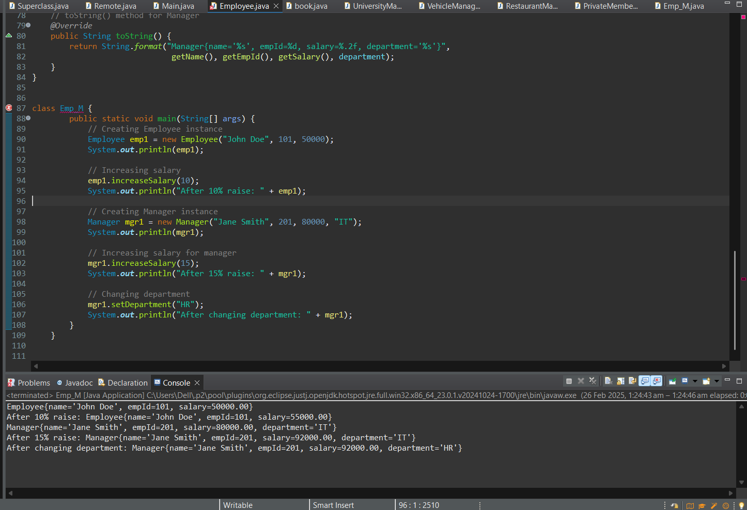

- A university has different types of people associated with it, including staff members and students. The base class Person contains common attributes such as name, age, and address.The class Staff extends Person and adds attributes like staffId and department. Further, a subclass Professor extends Staff by introducing an additional attribute, specialization, and a method conductLecture(). Similarly, the Student class extends Person and adds studentId and course. Finally, the subclassGraduateStudent extends Student, adding researchTopic and a method submitThesis(). Implement this university management system in Java using multilevel inheritance andmethodoverriding.Demonstrate polymorphism by creating an array of Person objects containing instances of Professor and GraduateStudent, and call their respective methods.
Code:-
package Basics;

//Base class Person
class Person {
protected String name;
protected int age;
protected String address;

public Person(String name, int age, String address) {
this.name = name;
this.age = age;
this.address = address;
}

public void displayInfo() {
System.out.println("Name: " + name);
System.out.println("Age: " + age);
System.out.println("Address: " + address);
}
}

//Staff class extending Person
class Staff extends Person {
protected String staffId;
protected String department;

public Staff(String name, int age, String address, String staffId, String department) {
super(name, age, address);
this.staffId = staffId;
this.department = department;
}

@Override
public void displayInfo() {
super.displayInfo();
System.out.println("Staff ID: " + staffId);
System.out.println("Department: " + department);
}
}

//Professor class extending Staff
class Professor extends Staff {
private String specialization;

public Professor(String name, int age, String address, String staffId, String department, String specialization) {
super(name, age, address, staffId, department);
this.specialization = specialization;
}

public void conductLecture() {
System.out.println(name + " is conducting a lecture on " + specialization);
}

@Override
public void displayInfo() {
super.displayInfo();
System.out.println("Specialization: " + specialization);
}
}

//Student class extending Person
class Student extends Person {
protected String studentId;
protected String course;

public Student(String name, int age, String address, String studentId, String course) {
super(name, age, address);
this.studentId = studentId;
this.course = course;
}

@Override
public void displayInfo() {
super.displayInfo();
System.out.println("Student ID: " + studentId);
System.out.println("Course: " + course);
}
}

//GraduateStudent class extending Student
class GraduateStudent extends Student {
private String researchTopic;

public GraduateStudent(String name, int age, String address, String studentId, String course, String researchTopic) {
super(name, age, address, studentId, course);
this.researchTopic = researchTopic;
}

public void submitThesis() {
System.out.println(name + " has submitted a thesis on: " + researchTopic);
}

@Override
public void displayInfo() {
super.displayInfo();
System.out.println("Research Topic: " + researchTopic);
}
}

public class UniversityManagementSystem {
public static void main(String[] args) {
// Create instances of Professor and GraduateStudent
Professor professor = new Professor("Dr. John Doe", 45, "123 University St.", "P123", "Computer Science", "Artificial Intelligence");
GraduateStudent gradStudent = new GraduateStudent("Jane Smith", 25, "456 College Ave.", "S456", "MSc Physics", "Quantum Computing");

// Array of Person objects to demonstrate polymorphism
Person[] people = {professor, gradStudent};

for (Person person : people) {
person.displayInfo();
System.out.println();

// Polymorphic method calls
if (person instanceof Professor) {
((Professor) person).conductLecture();
} else if (person instanceof GraduateStudent) {
((GraduateStudent) person).submitThesis();
}

System.out.println("----------------------");
}
}
}

Output:-
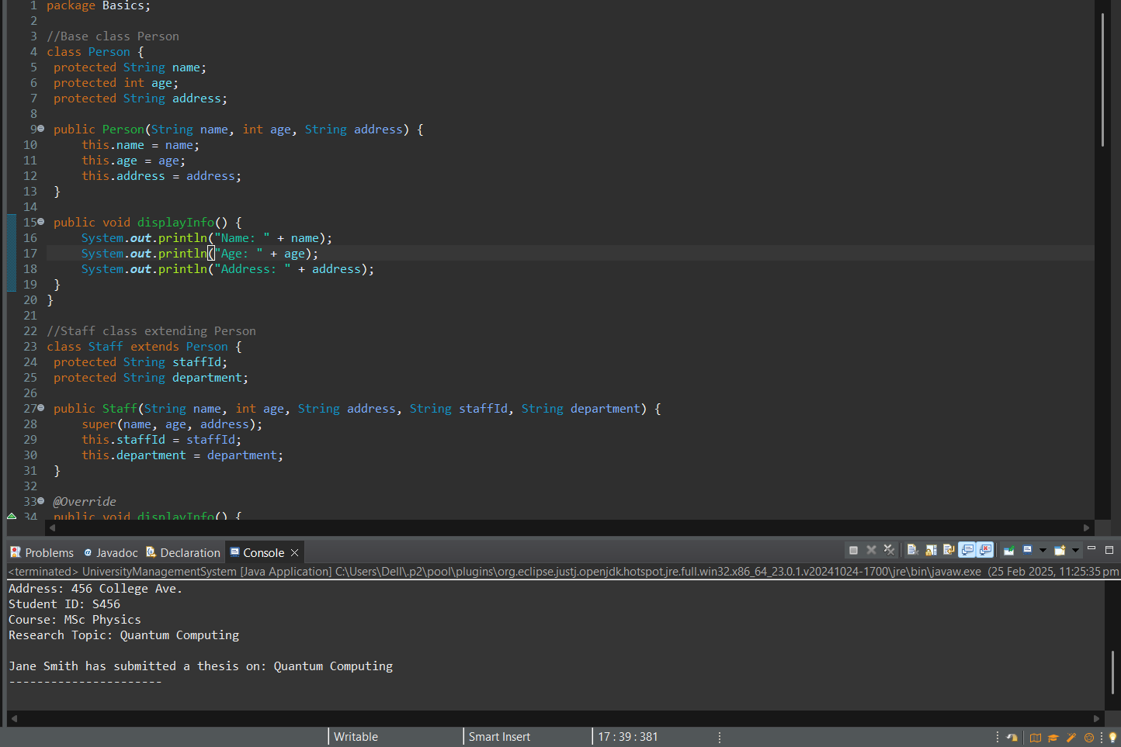

- Design an abstract class named Vehicle with abstract methods such as startEngine() and stopEngine(), as well as a non-abstract method serviceInfo() that prints basic servicing instructions. Include a couple of protected or private fields (e.g., make, model) and a constructor for Vehicle that initializes those fields.Create a concrete class Car that extends Vehicle and provides implementations for startEngine() and stopEngine(). Within these methods, include print statements or logic that simulates starting and stopping a car engine. Finally, instantiate a Car object in the main method, call all available methods (including the inherited non-abstract method), and verify that your abstraction works as intended.
Code:-
package Basics;

//Abstract Vehicle class
abstract class Vehicle {
protected String make;
protected String model;

// Constructor to initialize make and model
public Vehicle(String make, String model) {
this.make = make;
this.model = model;
}

// Abstract methods to be implemented by subclasses
public abstract void startEngine();
public abstract void stopEngine();

// Non-abstract method providing service information
public void serviceInfo() {
System.out.println("Regular servicing is recommended every 10,000 miles.");
}
}

//Concrete class Car extending Vehicle
class Car extends Vehicle {

public Car(String make, String model) {
super(make, model);
}

@Override
public void startEngine() {
System.out.println("Starting the engine of the " + make + " " + model + ".");
}

@Override
public void stopEngine() {
System.out.println("Stopping the engine of the " + make + " " + model + ".");
}
}

public class VehicleManagementSystem {
public static void main(String[] args) {
// Instantiate a Car object
Car myCar = new Car("Toyota", "Camry");

// Call all available methods
myCar.startEngine();
myCar.stopEngine();
myCar.serviceInfo();
}
}

Output:-
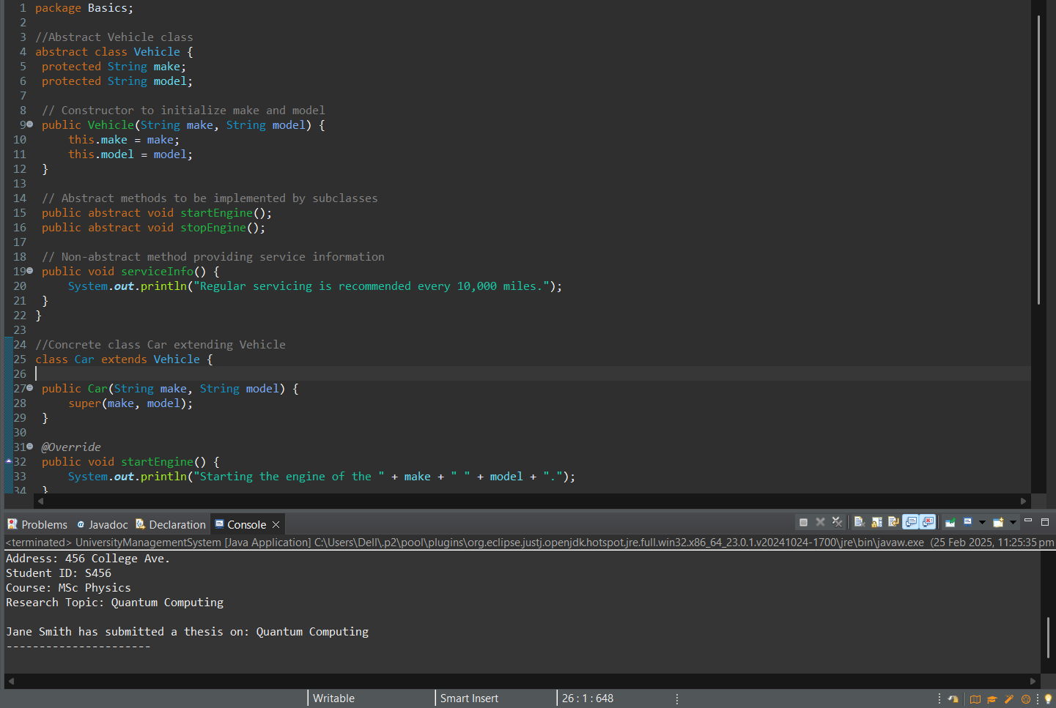

- Imagine you’re designing a restaurant management system where you have a base class called Chef with a method makeSpecialDish(). This method simply prints a generic message indicating that the chef is making a special dish. Next, create three subclasses called ItalianChef, ChineseChef, and MexicanChef—each overrides makeSpecialDish() with a distinct print statement, such as "Making pasta", "Making dumplings", or "Making tacos".
In your main method, declare an array or list of Chef references, but assign each element to a different subclass (ItalianChef, ChineseChef, MexicanChef). Use a loop to call the makeSpecialDish() method on each array element and observe how runtime polymorphism ensures that the correct subclass version of makeSpecialDish() is invoked.
Code:-
package Basics;

//Base class Chef
class Chef {
public void makeSpecialDish() {
System.out.println("The chef is making a special dish.");
}
}

//Subclass ItalianChef
class ItalianChef extends Chef {
@Override
public void makeSpecialDish() {
System.out.println("Making pasta.");
}
}

//Subclass ChineseChef
class ChineseChef extends Chef {
@Override
public void makeSpecialDish() {
System.out.println("Making dumplings.");
}
}

//Subclass MexicanChef
class MexicanChef extends Chef {
@Override
public void makeSpecialDish() {
System.out.println("Making tacos.");
}
}

public class RestaurantManagementSystem {
public static void main(String[] args) {
// Array of Chef references
Chef[] chefs = {new ItalianChef(), new ChineseChef(), new MexicanChef()};

// Loop to call makeSpecialDish on each chef
for (Chef chef : chefs) {
chef.makeSpecialDish();
}
}
}

Output:-
