

Cloud Computing Fundamentals Lab
LAB PRACTICAL FILE

(B.Tech CSE 2023-27)

Submitted By: Submitted To:
Name-Tanishq Chauhan Mr Satyam Tiwari
Sap Id: 500120139
Roll No: R2142230682
Batch No: 4

Experiment:6

Questions:-
- Imagine you are developing an Employee Management System, where employee details need to be maintained securely. Create a package named EmployeeManagement that contains a class Employee with attributes such as name, id, and salary. The class should also have a method displayDetails() that prints employee information. Then, create another program outside the EmployeeManagement package that imports the package and utilizes the Employee class to create an employee object and display their details. Ensure that the package maintains encapsulation while allowing controlled access to employee information.
Code:-
package Basics;

// Employee class (Superclass)
class Employee {
private String name;
private int empId;
private double salary; // Changed from protected to private

// Default constructor
public Employee() {
this.name = "Unknown";
this.empId = 0;
this.salary = 0.0;
}

// Parameterized constructor
public Employee(String name, int empId, double salary) {
this.name = name;
this.empId = empId;
this.salary = salary;
}

// Getters
public String getName() {
return name;
}

public int getEmpId() {
return empId;
}

public double getSalary() {
return salary;
}

// Increase salary by a percentage
public void increaseSalary(double percentage) {
if (percentage > 0) {
salary += salary * (percentage / 100);
} else {
System.out.println("Invalid percentage. Salary remains unchanged.");
}
}

// toString() method for Employee
@Override
public String toString() {
return String.format("Employee{name='%s', empId=%d, salary=%.2f}", name, empId, salary);
}
}

// Manager class (Subclass)
class Manager extends Employee {
private String department;

// Default constructor
public Manager() {
super(); // Calls Employee's default constructor
this.department = "Unknown";
}

// Parameterized constructor
public Manager(String name, int empId, double salary, String department) {
super(name, empId, salary);
this.department = department;
}

// Getter for department
public String getDepartment() {
return department;
}

// Setter for department
public void setDepartment(String department) {
this.department = department;
}

// toString() method for Manager
@Override
public String toString() {
return String.format("Manager{name='%s', empId=%d, salary=%.2f, department='%s'}",
getName(), getEmpId(), getSalary(), department);
}
}

class Emp_M {
public static void main(String[] args) {
// Creating Employee instance
Employee emp1 = new Employee("John Doe", 101, 50000);
System.out.println(emp1);

// Increasing salary
emp1.increaseSalary(10);
System.out.println("After 10% raise: " + emp1);

// Creating Manager instance
Manager mgr1 = new Manager("Jane Smith", 201, 80000, "IT");
System.out.println(mgr1);

// Increasing salary for manager
mgr1.increaseSalary(15);
System.out.println("After 15% raise: " + mgr1);

// Changing department
mgr1.setDepartment("HR");
System.out.println("After changing department: " + mgr1);
}
}

Output:- 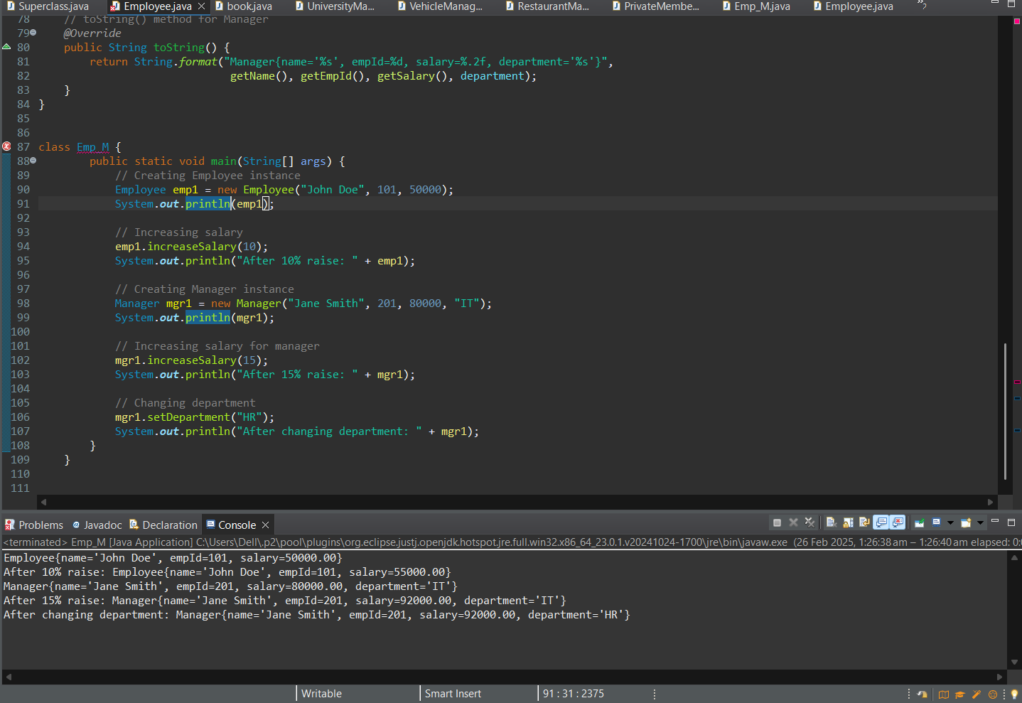

- In a Banking System, different types of users, such as bank employees and customers, need access to account operations with varying permissions. Create a package named BankingSystem containing a class BankAccount that has four methods with different access modifiers: a public method deposit() for adding money, a protected method withdraw() for authorized transactions, a default-access method checkBalance() to be accessed within the same package, and a private method calculateInterest() to compute interest internally. Then, create another package named UserAccount with a class Customer that tries to access these methods from an instance of BankAccount. Demonstrate which methods are accessible and explain why some cannot be accessed based on Java’s access modifier rules.
Code:-

package base;

public class BankAccount {
private double balance;

// Constructor
public BankAccount(double initialBalance) {
this.balance = initialBalance;
}

// Public method: Can be accessed from anywhere
public void deposit(double amount) {
if (amount > 0) {
balance += amount;
System.out.println("Deposited: $" + amount);
} else {
System.out.println("Invalid deposit amount.");
}
}

// Protected method: Can be accessed within the same package and by subclasses in other packages
protected void withdraw(double amount) {
if (amount > 0 && amount <= balance) {
balance -= amount;
System.out.println("Withdrawn: $" + amount);
} else {
System.out.println("Invalid withdrawal amount or insufficient funds.");
}
}

// Default-access method: Can be accessed only within the same package
void checkBalance() {
System.out.println("Current Balance: $" + balance);
}

// Private method: Can be accessed only within this class
private void calculateInterest() {
double interest = balance * 0.05; // 5% interest
System.out.println("Interest calculated: $" + interest);
}

// Public method to indirectly access private method
public void showInterest() {
calculateInterest();
}
}

import base.BankAccount;

public class Customer1 {
public static void main(String[] args) {

BankAccount account = new BankAccount(1000);

account.deposit(10000);

account.showInterest();
}
}

Output:- 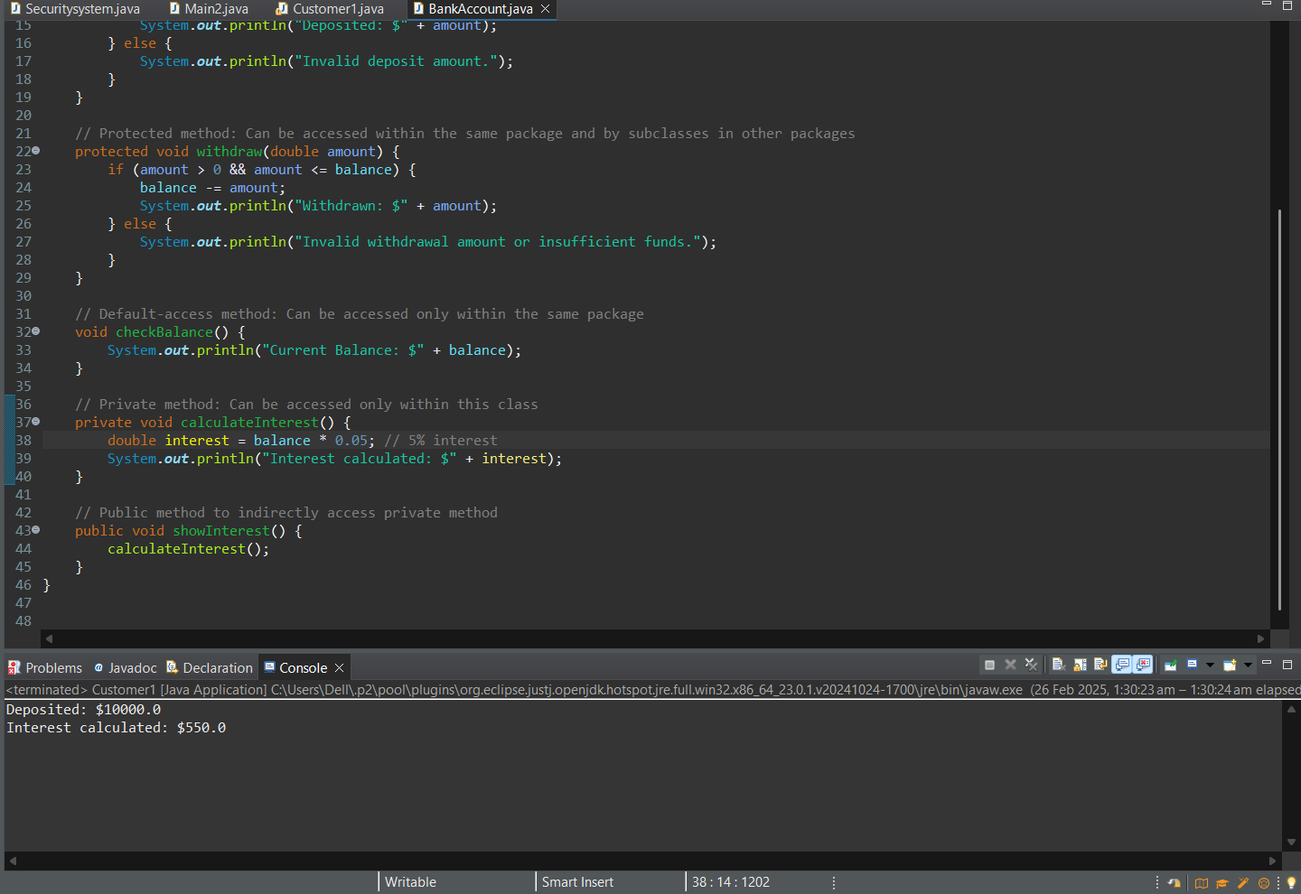
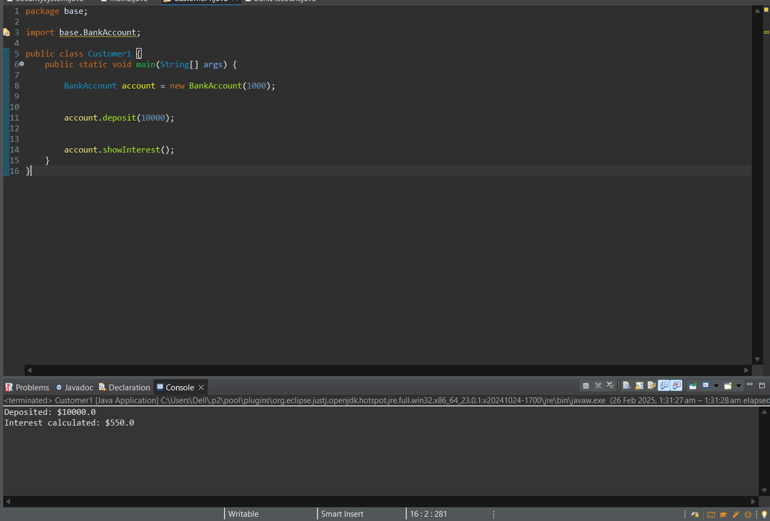

- In a Student Records Management System, personal and academic details of students need to be stored securely while providing controlled access to their data. Create a package named StudentRecords containing a class Student with private attributes studentId, name, and grade. Provide a public constructor to initialize these attributes and a method displayStudentInfo() to print student details. Then, write another program outside the package that imports StudentRecords, creates Student objects, and displays their details. This exercise will illustrate how encapsulation is maintained in Java, allowing data to be accessed only through well-defined public methods while preventing direct modification of private fields.
Code:-
package base;

public class Student {
// Private attributes for encapsulation
private int studentId;
private String name;
private char grade;

// Public constructor to initialize the attributes
public Student(int studentId, String name, char grade) {
this.studentId = studentId;
this.name = name;
this.grade = grade;
}

// Public method to display student details
public void displayStudentInfo() {
System.out.println("Student ID: " + studentId);
System.out.println("Name: " + name);
System.out.println("Grade: " + grade);
}
}

public class Main1 {
public static void main(String[] args) {
// Creating Student objects
Student student1 = new Student(101, "Alice Johnson", 'A');
Student student2 = new Student(102, "Bob Williams", 'B');

// Displaying student details
System.out.println("Student Details:");
student1.displayStudentInfo();
System.out.println("-----------------");
student2.displayStudentInfo();
}
}

Output:- 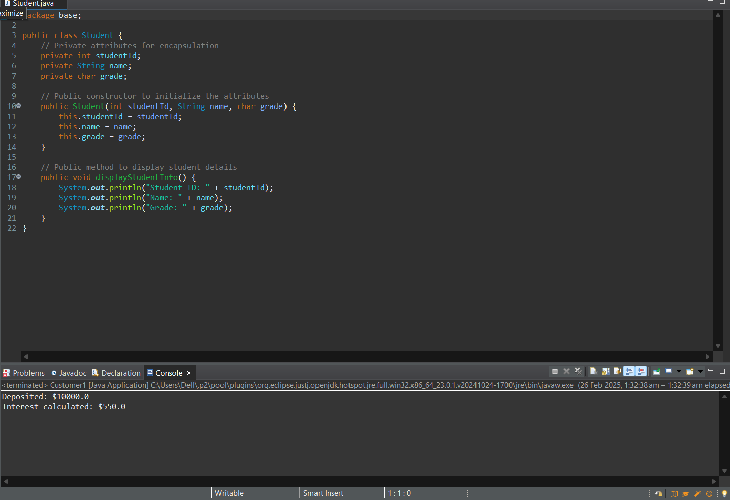 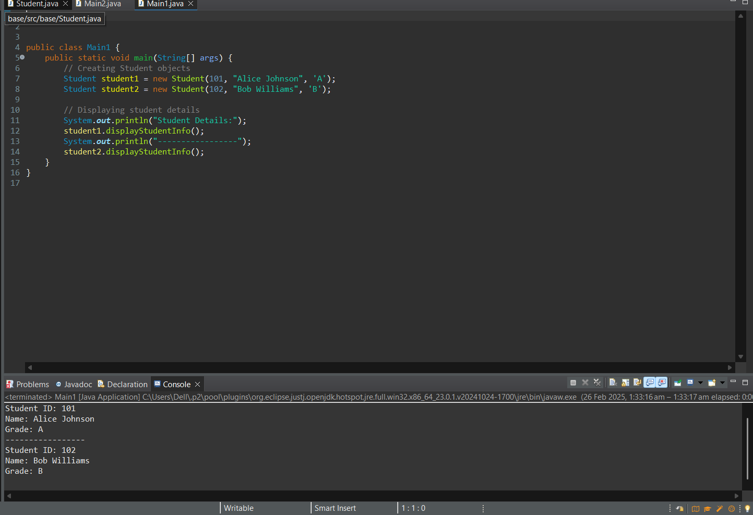

- A security system needs to protect its authentication mechanism to prevent tampering. Implement a final class named SecuritySystem that includes a method authenticateUser(String username, String password), which verifies user credentials. Then, attempt to create a subclass AdvancedSecurity that tries to extend SecuritySystem and override authenticateUser(). Observe the compilation error and explain why a final class cannot be inherited. In the main() method, create an instance of SecuritySystem and use the authenticateUser() method to validate login credentials. This will demonstrate how the final keyword enforces security by preventing unauthorized modifications to authentication logic.
Code:-
package base;

public final class Securitysystem {

// Method to authenticate user credentials
public void authenticateUser(String username, String password) {
// Hardcoded credentials for demonstration
String validUsername = "admin";
String validPassword = "secure123";

if (username.equals(validUsername) && password.equals(validPassword)) {
System.out.println("Authentication successful! Access granted.");
} else {
System.out.println("Authentication failed! Invalid credentials.");
}
}
}
public class Main2 {
public static void main(String[] args) {
Securitysystem security = new Securitysystem()
System.out.println("Test Case 1: Valid Credentials");
security.authenticateUser("admin", "secure123");
System.out.println("\nTest Case 2: Invalid Credentials");
security.authenticateUser("user", "wrongpass");
}
}
Output:- 