 | BMS INSTITUTE OF TECHNOLOGY AND MANAGEMENT  Yelahanka, Bengaluru. 560064  DEPARTMENT OF INFORMATION SCIENCE AND ENGINEERING

PROJECT BASED LEARNING SYNOPSIS

Name of Guide: Prof. S Mahalakshmi Batch No: B3 Date of Submission: 10-06-2021

NAME OF STUDENT (Block Letters) | USN (Block Letters) | Email-Id/Group Mail-Id | Contact No.
PRAJWAL R | 1BY18IS084 | 1by18is084@bmsit.in | 9901816104
PRASHANTH R | 1BY18IS089 | 1by18is089@bmsit.in | 9108289865
RAGHAVENDRA K M | 1BY18IS093 | 1by18is093@bmsit.in | 9446829868
SUGANDHA SINHA | 1BY18IS119 | 1by18is119@bmsit.in | 8804908735

Project Title: | SMART PARKING APP
Project Execution Place (Inhouse /Industry (Details of The Industry and External Guide (Name, Designation, Mail-Id, Contact No, Acceptance Letter to be enclosed )) | Inhouse
Project Category/Area( Research, Environmental and Societal, Product development , Industrial Live Project, Application Project, Case Study) | Product Development

Abstract
It is very common waiting outside a parking lot and looking if any space available in there, this overtime will be irritating and time consuming especially in traffic rich cities like Bangalore, Delhi etc.
Everyone would have frequently experienced that they park their vehicle somewhere beside the road and by the time they return the vehicle is gone, this would have been the worst day for a person having plans for the day. Thus, knowing the availability of parking space in advance would help people to plan for the same and save the time which would have been spent in looking for a spot in the lot. The parking fee is also a major concern of people, wherein many of them would not know the cost of parking per hour basis and which would cause them to pay more than the actual fee for it.
Our application would solve the above problems by providing the user with the available space in the lot and calculate the amount accurately with the parameters of entry time and exit time.

Introduction
With the increase in use of private vehicle in recent years, the problem of car parking has raised in busy and big cities of the world. In crowded cities of the world, mostly a person must spend a lot of time in finding the vacant parking lot.
As an important component of traffic system, parking management system is playing an important role and affecting people’s daily life. By detecting and processing the information from parking lots, smart parking systems allows driver to obtain real-time parking information and alleviates parking contentions.
A Smart Parking system is a parking solution which is embedded into parking spots to detect whether parking bays are free or occupied through real-time data collection.

Existing System
People traveling in cities many a times find difficulty in parking their vehicles. Few of the reasons are:
1. People who are strangers to a city
2. Lack of available parking slots
3. Manual searching of parking spaces
4. Google maps displays parking slots, but it does not show the available parking slot.
Causes of this are:
1. People will get exhausted in finding the perfect place for their vehicles
2. Fuels which are the national resources will also get wasted in this process of searching

Objectives
- To develop an intelligent, user friendly automated car parking system which reduces the manpower and traffic congestion.
- To improve the performance and satisfy the need of free parking lot.
- To reduces the time wastage in finding the vacant parking lot.

Problem Statement
With the increasing number of vehicles and the decreasing efficiency of modern busy parking lots, major problems which we people are facing is:
- Valuable time wasted from inconvenient and inefficient parking lots.
- More fuel consumed while driving around parking lots, leading to CO2 emissions.
- Potential accidents caused by abundance of moving vehicles in disorganized parking lots.
Therefore, there is a need to develop an affordable system which solve the problem and obtain the information about the parking lot on real time.

Proposed System
The proposed system is mostly targeted to the drivers who wants to park his vehicle in a city. The system will act as his/her assistant in finding a nearest parking space for him. And in addition to this, the system(app) will also help in generation of the bills.

The proposed system will be designed to tackle most of the problems which are being faced by the society in the existing system discussed above.

Few of the features of the proposed model are:
1. Provide users with information related to parking spaces near him/her.
2. Also details about available parking slots in the parking area/space.
3. The parking fee of the parking space.
4. Generating parking bills according to the duration of parking.
Methodology
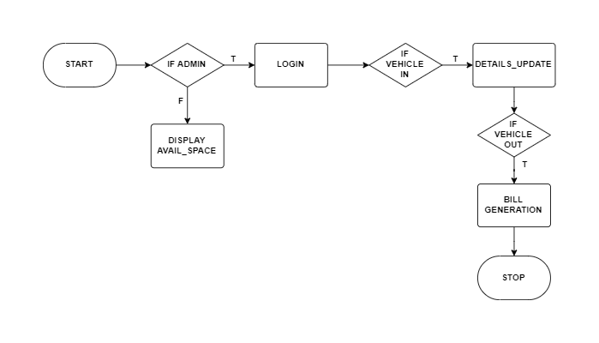
Fig 1.0

Users will be able to know the parking space available once they open the application.
The admin will have to login and then goes to the home page.
If vehicle enters, the admin will have to take the details of it and update the same.
If the vehicle leaves, the bill must be calculated and displayed.

System Requirement Specifications
Android device (android version>7.0)
RAM - 2gb
Faster CPU(>1GHz)
Disk storage >10 mb

References: (IEEE format)
M. Owayjan, B. Sleem, E. Saad and A. Maroun, "Parking management system using mobile application," 2017 Sensors Networks Smart and Emerging Technologies (SENSET), 2017, pp. 1-4, doi: 10.1109/SENSET.2017.8125048.
https://ieeexplore.ieee.org/document/8125048

C. Ng, S. Cheong, E. Hajimohammadhosseinmemar and W. Yap, "Mobile outdoor parking space detection application," 2017 IEEE 8th Control and System Graduate Research Colloquium (ICSGRC), 2017, pp. 81-86, doi: 10.1109/ICSGRC.2017.8070573.
https://ieeexplore.ieee.org/document/8070573

B. K. Patil, A. Deshpande, S. Suryavanshi, R. Magdum and B. Manjunath, "Smart Parking System for Cars," 2018 International Conference on Recent Innovations in Electrical, Electronics & Communication Engineering (ICRIEECE), 2018, pp. 1118-1121, doi: 10.1109/ICRIEECE44171.2018.9008662.
https://ieeexplore.ieee.org/document/9008662

Signature of Guide Signature of Coordinator Signature of HOD

