Abstract
It is very common waiting outside a parking lot and looking if any space available in there, this overtime will be irritating and time consuming especially in traffic-rich cities like Bangalore, Delhi etc.
Thus, knowing the availability of parking space in advance would help people to plan for the same and save the time which would have been spent in looking for a spot in the lot.
The parking fee is also a major concern of people, wherein many of them would not know the cost of parking per hour basis and which would cause them to pay more than the actual fee for it.
The application would solve the above problems by providing the user with the available space in the lot and calculate the amount accurately with the parameters of entry time and exit time.

Methodology
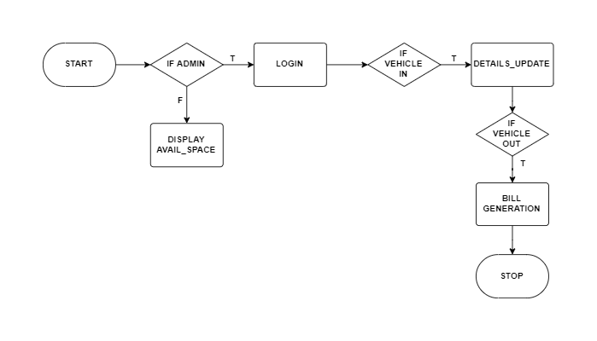
Fig 2.1

Users will be able to know the parking space available once they open the application.
The admin will have to login and then directed to the home page.
If vehicle enters, the admin will have to take the details of it and update the same.
If the vehicle leaves, the bill must be calculated and displayed.

