PARKING MANAGEMENT APP FOR ANDROID

Prof. S Mahalakshmi   
*Department of ISE*  
*BMS Institute of Technology and Management*Bengaluru, India  
maha.shanmugan@bmsit.in

Sugandha Sinha   
*Department of ISE*  
*BMS Institute of Technology and Management*Bengaluru, India  
sugandha.sinha2000@gmail.com

Prashanth R  
*Department of ISE*  
*BMS Institute of Technology and Management*Bengaluru, India  
prashanthr8050@gmail.com

Raghavendra K M  
*Department of ISE*  
*BMS Institute of Technology and Management*Bengaluru, India raghavendrakm300@gmail.com

Prajwal R   
*Department of ISE*  
*BMS Institute of Technology and Management*Bengaluru, India  
prajwalbhat30@gmail.com

*Abstract*— It is very common waiting outside a parking lot and looking if any space available in there, this overtime will be irritating and time consuming especially in traffic rich cities like Bangalore, Delhi etc.

Everyone would have frequently experienced that they park their vehicle somewhere beside the road and by the time they return the vehicle is gone, this would have been the worst day for a person having plans for the day. Thus, knowing the availability of parking space in advance would help people to plan for the same and save the time which would have been spent in looking for a spot in the lot. The parking fee is also a major concern of people, wherein many of them would not know the cost of parking per hour basis and which would cause them to pay more than the actual fee for it.

This Parking Management App is a parking solution which to solve the above problems by providing the user with the available space in the lot and calculate the amount accurately with the parameters of entry time and exit time. It will also keep history of all the vehicles parked at any parking spot with specific date and time.

Keywords—Parking Management, Smart City, Automatic Billing, Android app

# Introduction

With the increase in the use of the private vehicle in recent years, the problem of car parking has raised in busy and big cities of the world. In crowded cities of the world, mostly a person must spend a lot of time in finding a vacant parking lot.

Currently, most of the parking lots follow the traditional way of maintaining records - through books, which makes the data storage and maintenance inefficient, thus the app is developed to give an easier interface to the parking manager where they can check the available slots, enter the vehicle number of incoming vehicles, mark the existing vehicle as exiting, generate a bill and keep track of all the vehicles visited. In addition to these general users can view the available space in the parking bays.

# Related works

*A. Mobbypark operator:*

This is a parking management app where the admin or the parking manager has to create an account and later will be directed to dashboards having options to enter the details of the vehicle. The user can book the particular parking slot through the app and a QR will be generated for the booking, which scanned by admin would result in the parking of the vehicle. The admin will be in charge of manually selecting the type of vehicle and the amount to be charged. The owner will be given the option to view the statistics of the parking lot in the web dashboard designed.

*B. GCC Smart Parking:*

This is a smart parking app where the user will have to first signup and then will be directed home page where the app is integrated with maps which will help them search for a location or premises and select the type of vehicle which they would like to park. This would result in the display of details like, route to the location, information of available slots, the amount which is charged, and the option of booking the slot. On booked the user will be given information regarding the lot number and slot number along with an option to choose the duration, After entering the duration user will be asked to pay for the selected hours and will be led to the payment gateway which on success would confirm his reservation for parking.

*C. Smart Parking:*

The app is developed with the integration of maps and sensors, where the user will initially know the parking spots available near them with the help of a map view, they can even search for a destination, and all available parking spots in and around the location will be displayed with the amount charged, on selecting a spot, it will display the details of the spot with available space and the direction how to reach it.

# Proposed system

The app's functionality is divided into two:

1. User

2. Parking manager

The user can view the details of a particular parking slot, which contains the name of the parking slot, location, total slots, available slots.

The admin (i.e parking manager) will have to first register himself with the slot details, after that, they will have to log in and on successful authentication, they will be moved to the dashboard which contains the parking manager name, parking lot name, location, available slots in the lot and two options namely: Parked vehicles and History.

When clicked on the parked vehicle card, the details of vehicles already parked will be displayed in the form of lists, which contain a vehicle number, date, and time of entry. The page also contains a floating icon to add a new vehicle that enters the parking lot, when clicked on the icon, the app will navigate to the vehicle entry page where the vehicle number is validated and after entering user will be prompted with a confirmation dialog box, on clicking *Yes* the details of the vehicle with the current time and date are added to the firebase.   
  
If the vehicle exits the parking lot, the admin can just click on the list of parked vehicles, after which a confirmation dialog box will be prompted whether the vehicle should be marked as out, on clicking *Yes* the control flows to the billing page, where the amount will be displayed along with vehicle number, entry date and time, exit date and time.

The history page will contain all details of vehicles visited the parking lot.

*Algorithm:*

1. The HomeActivity will be the first activity triggered on opening of app, here there will be two options i.e., the users can view the parking spaces and the admin can login.
2. If it is user then the control flows to AvailableSlotsActivity where the details of all the parking slots i.e., the name of the slot, location, available and total slots will be displayed in a list view.
3. If the admin has already registered, they click on login then the LoginActivity will be invoked where they will have to provide their credentials to login, else the admin can register by clicking on register.
4. After login, the admin will be displayed with the AdminHomeActivity where the details of the admin will be displayed, and he will be given an option to enter vehicle or view history.
5. If the admin clicks on parked vehicles, he will be directed to ParkedvehicleActivity where the vehicles present in the lot will be displayed in a list view and he will be given an option to enter a vehicle, after entering vehicle, the details are validated with help of regular expression and saved to the database.
6. If the admin clicks on a list containing a vehicle present in the lot, then the control flows to BillActivity where the amount will be calculated and displayed to the admin.
7. If the admin clicks on history, he will be directed to ParkedHistoryActivity where the details of previously parked vehicles will be displayed in a list view.

*Fig 1: Algorithm*

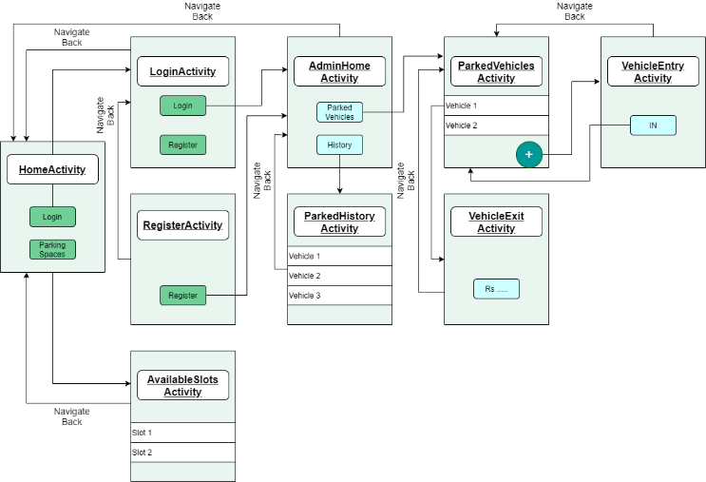 Fig 2: The design of Application

The user interface (UI) for an Android app is built as a hierarchy of layouts and widgets. The layouts are View Group objects, containers that control how their child views are positioned on the screen. Widgets are View objects, UI components such as buttons and text boxes.

The Application is designed using the components of android such as, Layouts, Buttons, Text Views, Edit Texts, Card Layouts etc.

The above figure gives a brief design of the application and its flow. The app is designed using Constraint Layout which is a View Group containing many Views such as Edit Texts, Buttons etc.

The Constraint Layout gives the option of constraining the views with respect to the parent i.e., View Group or other Views in the layout.

The List View is designed using a Recycler View, which is been loaded with data with the help of adapters which acts as a bridge between the View and the underlying data.

|  |  |  |
| --- | --- | --- |
|  |  |  |
| *Fig. 3: Home Activity* |  | *Fig. 4: Admin Home Activity* |
|  |  |  |
|  |  |  |
| *Fig. 5: Available Slots Activity* |  | *Fig. 6: Parked Vehicles Activity* |
|  |  |  |
| *Fig. 7: Parked History Activity* |  | *Fig. 8: Add Vehicle Activity* |
|  |  |  |
| *Fig. 9: Remove Vehicle Alert Dialog* |  | *Fig. 10: Vehicle Exit Activity* |
|  |  |  |

# Conclusion

* The parking management system app is effective in detecting the available parking slots through real-time data collection.
* In addition to that, the app can be a part of a bigger revolution by reducing the traffic in a city by informing the user about the parking spaces.
* The manual process of entering the vehicles in the vehicle register book is eliminated.
* A further enhancement is required to make the user view his or her nearby parking areas.
* The overall system can handle all the requests from the User to give a fresh digital look to the current parking management system.

# Future Scope

These are the few improvements,

* Online booking of parking slots in a parking space/area so that users can reserve the parking slot for his/her vehicle.
* Redesigning the user interface of the app.
* Creating a profile page for the admin of the parking space so that he/she can update not just his/her profile but also details regarding the parking space/area.
* Integrating the app with Google maps to easily locate or navigate to the parking area.
* A feature to view the nearby parking areas

##### References

1. M. Owayjan, B. Sleem, E. Saad and A. Maroun, "Parking management system using mobile application," 2017 Sensors Networks Smart and Emerging Technologies (SENSET), 2017, pp. 1-4, doi: 10.1109/SENSET.2017.8125048.
2. C. Ng, S. Cheong, E. Hajimohammadhosseinmemar and W. Yap, "Mobile outdoor parking space detection application," 2017 IEEE 8th Control and System Graduate Research Colloquium (ICSGRC), 2017, pp. 81-86, doi: 10.1109/ICSGRC.2017.8070573.
3. T. Kiliç and T. Tuncer, "Smart city application: Android based smart parking system," 2017 International Artificial Intelligence and Data Processing Symposium (IDAP), 2017, pp. 1-4, doi: 10.1109/IDAP.2017.8090284.
4. Hina C. Parmar,Nisha N. Shirvi, "Development of an Android Application for Smart Parking System", International Journal of Engineering Development and Research (IJEDR), ISSN:2321-9939, Vol.6, Issue 2, pp.30-34, April 2018, Available :http://www.ijedr.org/papers/IJEDR1802005.pdf
5. L. H. Chowdhury, Z. N. M. Z. Mahmud, I. Islam, I. Jahan and S. Islam, "Smart Car Parking Management System," 2019 IEEE International Conference on Robotics, Automation, Artificial-intelligence and Internet-of-Things (RAAICON), 2019, pp. 122-126, doi: 10.1109/RAAICON48939.2019.49.
6. P. M. Ebin, P. Akhil Dev, P. Mishab, C. Sreejith and U. K. Srudhil, "An Andriod Application for Smart Parking With Efficient Space Management," 2018 International Conference on Emerging Trends and Innovations In Engineering And Technological Research (ICETIETR), 2018, pp. 1-5, doi: 10.1109/ICETIETR.2018.8529084.
7. B. K. Patil, A. Deshpande, S. Suryavanshi, R. Magdum and B. Manjunath, "Smart Parking System for Cars," 2018 International Conference on Recent Innovations in Electrical, Electronics & Communication Engineering (ICRIEECE), 2018, pp. 1118-1121, doi: 10.1109/ICRIEECE44171.2018.9008662.