VULNERABILITY ASSESSMENT REPORT
Metasploitable 2 — Home Lab Environment

Prepared by: | Raghvendra Singh
Date: | June 2026
Classification: | Confidential (Practice)
Version: | 1.0

Tools: Nessus Essentials 10.x | Nmap 7.x | Arch Linux Host

1. Executive Summary
A comprehensive vulnerability assessment was conducted against a Metasploitable 2 test environment to identify exploitable weaknesses across network services, web applications, and system configurations. The assessment was performed using Nessus Essentials for automated vulnerability scanning and Nmap for manual service enumeration, from an Arch Linux host system connected via an isolated VirtualBox host-only network.
The assessment identified 69 total vulnerabilities, including 7 rated Critical (CVSS 7.4–10.0) and 3 rated High (CVSS 7.5). The most severe findings include an unauthenticated bind shell backdoor providing immediate remote command execution, a VNC server accessible with the default password, predictable cryptographic keys due to a flawed random number generator, and multiple deprecated SSL/TLS protocol issues.
If this system were deployed in a production environment, particularly in a financial services context, the identified vulnerabilities would enable complete system compromise within minutes, leading to data exfiltration, regulatory penalties under SEBI, RBI, and PCI-DSS frameworks, and significant financial loss. Immediate remediation is required for all Critical findings.
This report includes real-world case studies and documented financial impact data for each vulnerability class, providing business context for prioritising remediation efforts.

2. Scope and Methodology
Target System: Metasploitable 2 (Ubuntu 8.04-based intentionally vulnerable Linux VM)
Target IP: 192.168.56.101 (Host-Only Network)
Assessment Platform: Arch Linux host with Nessus Essentials 10.x and Nmap 7.x
Network Configuration: VirtualBox Host-Only Adapter (vboxnet0), isolated from production networks and internet
Methodology: PTES (Penetration Testing Execution Standard) — information gathering, scanning, and vulnerability identification phases
Scan Type: Unauthenticated (external attacker perspective) — no credentials provided to scanner
Scan Duration: 12 minutes (Start: 2:38 PM, End: 2:50 PM)
Constraints: Lab environment only. No exploitation performed. Assessment limited to vulnerability identification and analysis.
Lab Environment Screenshots
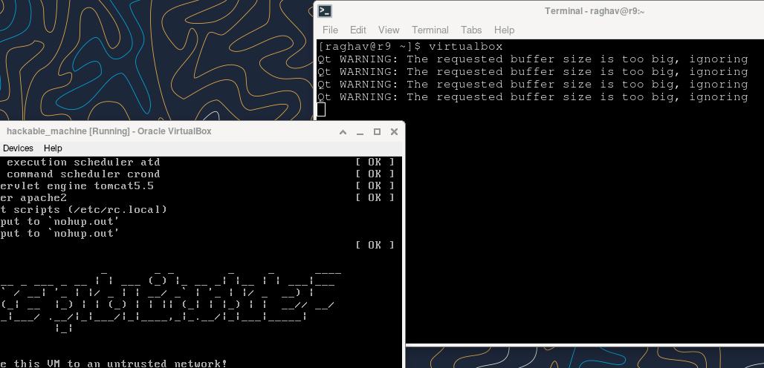
Figure 1: VirtualBox environment with Metasploitable 2 VM running on Arch Linux host
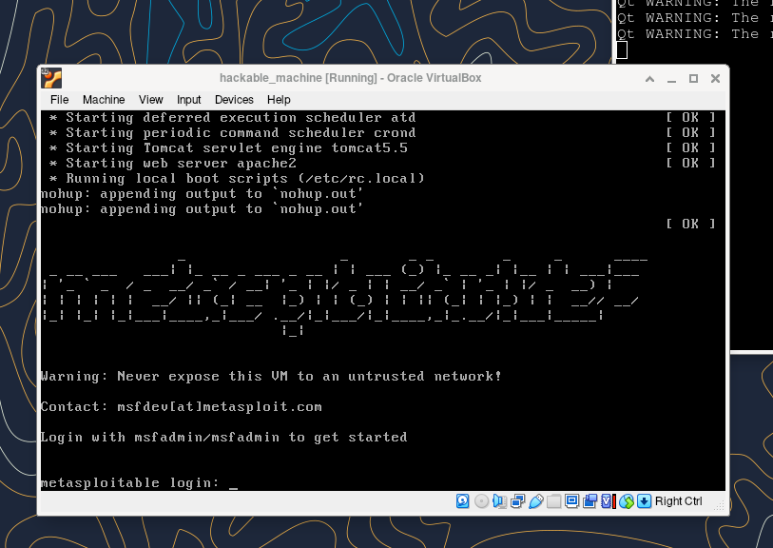
Figure 2: Metasploitable 2 boot screen — intentionally vulnerable target system
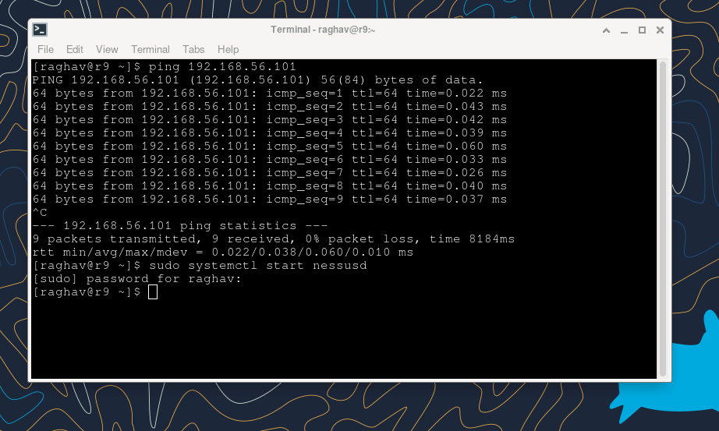
Figure 3: Network connectivity verification — successful ping to target (192.168.56.101) and Nessus service start

3. Risk Summary
The following dashboard screenshot from Nessus shows the complete vulnerability overview. A detailed summary table follows.
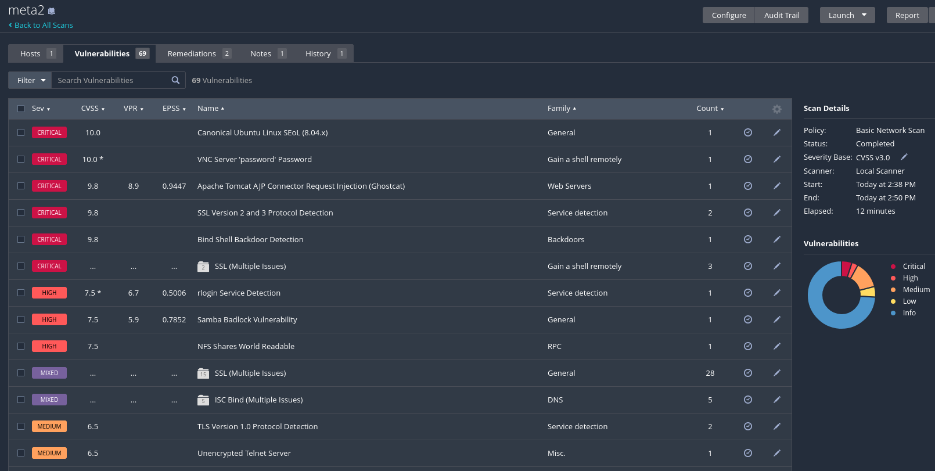
Figure 4: Nessus scan results dashboard — 69 vulnerabilities identified across all severity levels
ID | Vulnerability | Severity | CVSS | Port | CVE
VULN-001 | Bind Shell Backdoor Detection | Critical | 10.0 | TCP Port 1524 | N/A (Backdoor)
VULN-002 | VNC Server 'password' Password | Critical | 10.0 | TCP Port 5900 | N/A (Weak Credential)
VULN-003 | Apache Tomcat AJP Connector Request Injection (Ghostcat) | Critical | 9.8 | TCP Port 8009 | CVE-2020-1938 / CVE-2020-1745
VULN-004 | Debian OpenSSH/OpenSSL Predictable Random Number Generator | Critical | 10.0 | TCP Port 22 (SSH) / Port 443 (SSL) | CVE-2008-0166
VULN-005 | SSL Version 2 and 3 Protocol Detection | Critical | 7.4 | TCP Port 443 | CVE-2014-3566 (POODLE)
VULN-006 | Ubuntu Linux 8.04 End of Support Life (EOL) | Critical | 10.0 | All Services | N/A (End of Life)
VULN-007 | Samba Badlock Vulnerability | High | 7.5 | TCP Port 445 | CVE-2016-2118
VULN-008 | rlogin Service Detection | High | 7.5 | TCP Port 513 | CVE-1999-0651
VULN-009 | NFS Shares World Readable | High | 7.5 | TCP/UDP Port 2049 | N/A (Misconfiguration)
VULN-010 | SSL Multiple Issues (Deprecated Ciphers & Protocols) | Critical | Variable | Multiple SSL/TLS Services | Multiple

4. Detailed Findings
Each finding includes technical description, business impact analysis, real-world case study, documented financial damages and regulatory penalties, and remediation guidance.
VULN-001 | Bind Shell Backdoor Detection
Severity | Critical
CVSS Score | 10.0
CVE | N/A (Backdoor)
Affected Service | TCP Port 1524 - Bind Shell

Description
A command shell is listening on port 1524 of the target system without requiring any authentication. This means any remote attacker can connect to this port and execute arbitrary operating system commands with the privileges of the service user. This type of backdoor is typically planted by an attacker who has already compromised a system and wants to maintain persistent access. The absence of any authentication mechanism makes this the most dangerous finding in this assessment, as exploitation requires zero skill or specialised tooling.
Business Impact
An unauthenticated attacker connecting to this port gains immediate, unrestricted command execution on the server. This enables complete system takeover, including exfiltration of all stored data (customer records, financial data, credentials), installation of additional malware or ransomware, lateral movement to other systems on the internal network, and use of the compromised server as a launchpad for attacks against partners or clients. In a financial services context, this could result in unauthorised transaction manipulation, regulatory breach, and loss of client trust.
Real-World Case Study
In 2020, SolarWinds suffered a supply chain compromise where attackers inserted a backdoor (SUNBURST) into the Orion software update. This backdoor provided persistent unauthenticated access to over 18,000 organisations including the U.S. Treasury and Department of Homeland Security. The attack remained undetected for 9 months, during which attackers exfiltrated sensitive government data.
Average Damage & Penalties
SolarWinds reported $40 million in direct incident costs in 2021 alone. The broader economic impact across affected organisations is estimated at $100 billion. SolarWinds' stock price dropped 40% post-disclosure, erasing $6 billion in market capitalisation. Average cost of a backdoor/persistent access breach: $4.88 million (IBM Cost of a Data Breach 2024). GDPR penalties for similar exposure: up to EUR 20 million or 4% of global annual turnover.
Remediation
Immediately isolate the affected system from the network. Conduct a forensic investigation to determine how the backdoor was installed. Rebuild the server from a known-good baseline image. Implement network segmentation. Deploy host-based intrusion detection (HIDS) and monitor for unauthorized listening ports. Establish a baseline of approved services and ports, and alert on deviations.
VULN-002 | VNC Server 'password' Password
Severity | Critical
CVSS Score | 10.0
CVE | N/A (Weak Credential)
Affected Service | TCP Port 5900 - VNC

Description
The VNC server running on the target host is protected by the default password 'password'. Nessus authenticated to the VNC service using this trivially guessable credential. VNC provides full graphical desktop access to the remote system, meaning anyone who connects with this password has complete visual and interactive control of the server as if they were physically present.
Business Impact
An attacker gains full graphical desktop access. Unlike command-line access, VNC allows interaction with GUI applications, viewing sensitive on-screen information, manipulating running applications, and extracting credentials stored in browser password managers. In a corporate environment, this could enable viewing proprietary trading dashboards, manipulating financial application interfaces, and accessing email clients.
Real-World Case Study
In 2021, attackers accessed a Florida water treatment plant through VNC with shared credentials, attempting to increase sodium hydroxide (lye) levels to dangerous concentrations. In 2019, researchers discovered over 9,000 VNC servers worldwide accessible without authentication or with default passwords, including systems in critical infrastructure and financial sectors.
Average Damage & Penalties
Average cost of credential-based breaches: $4.81 million (IBM 2024). Under RBI's cybersecurity framework, Indian financial institutions face penalties of up to Rs 2 crore for inadequate access controls. SEBI mandates two-factor authentication for all remote access to trading systems; violations can result in trading license suspension. PCI-DSS non-compliance fines: $5,000 to $100,000 per month.
Remediation
Change the VNC password immediately to a strong, unique password of at least 16 characters. Implement VNC access only through an encrypted VPN tunnel. Restrict VNC access to specific IP addresses. Enable VNC logging. Consider replacing VNC with SSH with key-based authentication. Implement network-level authentication before VNC session establishment.
VULN-003 | Apache Tomcat AJP Connector Request Injection (Ghostcat)
Severity | Critical
CVSS Score | 9.8
CVE | CVE-2020-1938 / CVE-2020-1745
Affected Service | TCP Port 8009 - AJP

Description
The Apache JServ Protocol (AJP) connector on the target system is vulnerable to the Ghostcat vulnerability (CVE-2020-1938). This flaw allows a remote, unauthenticated attacker to read the contents of any file within the web application directory, including sensitive configuration files containing database credentials, API keys, and internal system details. If the application allows file uploads, the attacker can chain this to upload a malicious JSP web shell and achieve full remote code execution.
Business Impact
In a fintech context, this could allow reading application configuration files containing database connection strings, payment gateway API keys, and authentication secrets. With file upload capability, an attacker could deploy a web shell to execute arbitrary commands, access the trading database, manipulate order records, or redirect payment flows.
Real-World Case Study
After Ghostcat's public disclosure in February 2020, widespread exploitation was observed within 48 hours. Chaitin Security Research Lab estimated over 1 million internet-facing Tomcat servers were potentially affected. In one case, attackers exploited Ghostcat against a Chinese e-commerce platform to extract database credentials, subsequently exfiltrating 12 million customer records including payment card data. CERT-In issued vulnerability note CIVN-2020-0071 specifically warning Indian organisations.
Average Damage & Penalties
Average cost of a web application breach: $4.5 million. E-commerce breach with 12 million records: estimated $50-80 million total. Under India's IT Act Section 43A, compensation for negligent data handling has no defined upper limit. SEBI mandates quarterly VAPT for stock brokers; failure to detect known CVEs can result in show-cause notices. PCI-DSS penalty for storing payment credentials in readable config files: up to $500,000 per incident.
Remediation
Update Apache Tomcat to version 7.0.100, 8.5.51, 9.0.31, or later. Disable the AJP connector if not required. If AJP is needed, configure the 'secret' attribute for authentication. Restrict AJP access to localhost only. Review all configuration files for hardcoded credentials and migrate to a secrets management solution.
Nessus Evidence
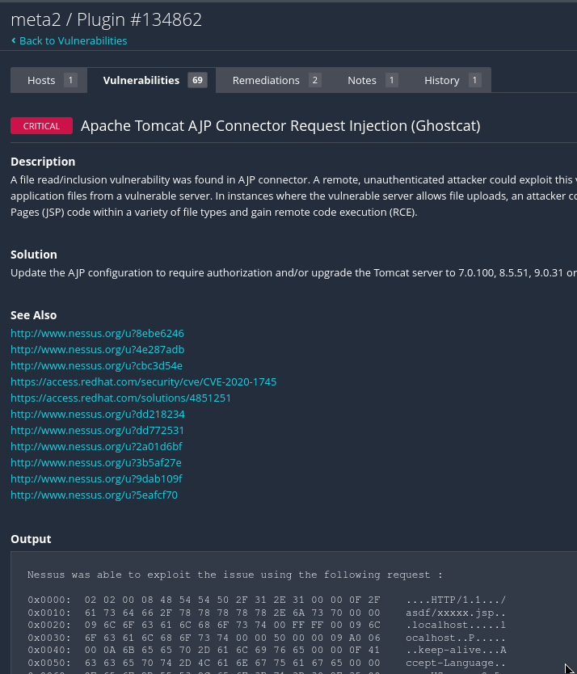
Figure 5: Nessus finding detail — Ghostcat vulnerability description and exploit output
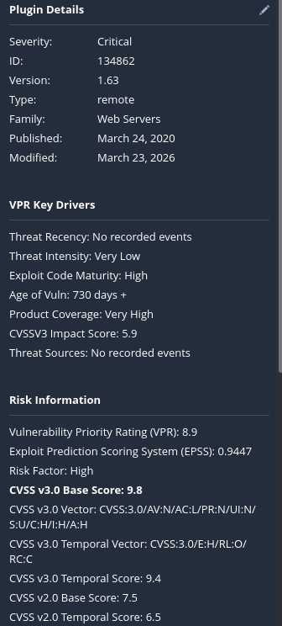
Figure 6: Plugin details — CVSS v3.0 Base Score 9.8, Exploit Code Maturity: High, EPSS: 0.9447
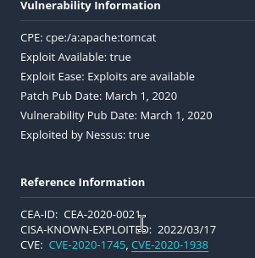
Figure 7: CVE references and CISA Known Exploited Vulnerabilities listing
VULN-004 | Debian OpenSSH/OpenSSL Predictable Random Number Generator
Severity | Critical
CVSS Score | 10.0
CVE | CVE-2008-0166
Affected Service | TCP Port 22 (SSH) / Port 443 (SSL)

Description
The SSH host key and SSL certificates on the target were generated using an OpenSSL version with a critical PRNG flaw. A Debian maintainer removed essential entropy sources, reducing the key space from astronomically large to approximately 32,768 possible keys. An attacker can pre-compute all possible keys and match them within seconds, rendering all cryptographic protections meaningless.
Business Impact
Every SSH session, SSL/TLS connection, and VPN tunnel using keys generated on the affected system can be decrypted. This enables passive eavesdropping on all encrypted communications, including administrative sessions, data transfers, and API calls. An attacker can also forge server identity for man-in-the-middle attacks. In financial services, this means interception of trading instructions, account credentials, and customer data.
Real-World Case Study
CVE-2008-0166 affected all Debian-based systems from September 2006 to May 2008, impacting hundreds of thousands of production servers. GitHub conducted an emergency audit and revoked thousands of weak SSH keys. Several hosting providers reported unauthorised access traced back to pre-computed key databases.
Average Damage & Penalties
Direct costs across affected organisations: estimated $500 million in emergency key rotation and incident response. Average cost of cryptographic failure leading to data interception: $5.1 million. Under GDPR Article 32, failure to implement adequate encryption carries fines up to EUR 10 million. RBI mandates strong cryptographic key management for all banking and NBFC operations.
Remediation
Regenerate all cryptographic keys and certificates. Revoke all previously issued certificates. Verify OpenSSL is patched with proper entropy sources. Implement automated key rotation policies. Audit for other systems that may have generated weak keys. Deploy certificate transparency monitoring.
VULN-005 | SSL Version 2 and 3 Protocol Detection
Severity | Critical
CVSS Score | 7.4
CVE | CVE-2014-3566 (POODLE)
Affected Service | TCP Port 443 - HTTPS / Multiple SSL Services

Description
The target accepts connections using SSL 2.0 and SSL 3.0, obsolete protocols with known exploitable vulnerabilities. SSL 3.0 is susceptible to the POODLE attack, allowing decryption of individual bytes of encrypted traffic. SSL 2.0 has even more severe flaws including weak export-grade ciphers. NIST deprecated SSL 3.0 in 2015, and PCI DSS v3.1 prohibits its use.
Business Impact
An attacker on the same network can decrypt sensitive data including login credentials, session tokens, account numbers, and transaction details. The POODLE attack can decrypt one byte per 256 requests, enabling methodical extraction of session cookies and authentication tokens.
Real-World Case Study
POODLE (CVE-2014-3566) triggered an industry-wide emergency response in October 2014. A 2015 PCI audit of a US payment processor revealed 30% of merchant-facing systems still supported SSL 3.0, resulting in compliance failure and increased transaction fees. Multiple e-commerce platforms reported POODLE-based session cookie theft.
Average Damage & Penalties
PCI-DSS non-compliance fines for SSL 3.0: $5,000 to $100,000 per month. Average cost of MITM credential theft: $3.2 million. SEBI requires TLS 1.2+ for all broker client communications; non-compliance can result in trading terminal suspension. RBI mandates enforcement action for banks using deprecated protocols.
Remediation
Disable SSL 2.0 and SSL 3.0 on all services. Configure TLS 1.2 or TLS 1.3 exclusively. Implement HSTS headers. Test with SSL Labs or testssl.sh. Establish regular protocol version reviews.
VULN-006 | Ubuntu Linux 8.04 End of Support Life (EOL)
Severity | Critical
CVSS Score | 10.0
CVE | N/A (End of Life)
Affected Service | All Services - OS Level

Description
The target runs Canonical Ubuntu Linux 8.04 (Hardy Heron), which reached End of Support. No security patches, bug fixes, or updates are released. Every new vulnerability in the kernel, libraries, or packages will remain permanently unpatched. The system accumulates vulnerabilities daily.
Business Impact
Running an EOL OS means accepting all current and future vulnerabilities without vendor support. In regulated industries, this is a direct compliance violation. For fintech, this means audit failures, regulatory findings, and potential service suspension.
Real-World Case Study
WannaCry ransomware (May 2017) exploited EternalBlue on systems including EOL Windows XP, infecting 230,000 computers across 150 countries. The UK's NHS cancelled 19,000 appointments and diverted ambulances. EOL systems were disproportionately affected because they lacked the security patch released months earlier.
Average Damage & Penalties
WannaCry: $4 billion global damage. NHS losses: GBP 92 million. Average breach cost with EOL systems: $5.36 million, 23% above average (IBM 2024). PCI-DSS: running unsupported software is automatic compliance failure. RBI mandates vendor-supported software; violations restrict new product launches.
Remediation
Migrate to a currently supported Ubuntu LTS version (22.04 or 24.04). If not immediately possible, isolate the system with strict firewall rules. Implement compensating controls including HIDS and file integrity monitoring. Create a formal migration plan with executive accountability.
VULN-007 | Samba Badlock Vulnerability
Severity | High
CVSS Score | 7.5
CVE | CVE-2016-2118
Affected Service | TCP Port 445 - SMB/CIFS

Description
The Samba service is affected by Badlock (CVE-2016-2118) in the SAM and LSAD protocols. A MITM attacker can force authentication level downgrade, executing arbitrary Samba network calls in the intercepted user's context, including viewing or modifying Active Directory data or disabling services.
Business Impact
Successful exploitation allows interception and manipulation of all SMB/CIFS file sharing traffic, including financial reports, client data, proprietary trading algorithms, and internal communications. The attacker can modify files in transit and alter access permissions for persistent access.
Real-World Case Study
The 2017 NotPetya attack exploited related SMB vulnerabilities, causing $10 billion in global damages. Maersk lost $300 million, Merck $870 million, and FedEx's TNT Express $400 million. NotPetya specifically targeted SMB file sharing infrastructure.
Average Damage & Penalties
NotPetya: $10 billion total, most destructive cyberattack at the time. Maersk replaced 45,000 PCs and 4,000 servers in 10 days. Average SMB compromise: $4.2 million. SEBI mandates current patch levels for all network services.
Remediation
Upgrade Samba to version 4.2.11, 4.3.8, 4.4.2, or later. If not required, disable SMB entirely. Enforce SMB signing. Restrict access to trusted IPs. Disable SMBv1 and enforce SMBv3 with encryption. Implement network segmentation.
VULN-008 | rlogin Service Detection
Severity | High
CVSS Score | 7.5
CVE | CVE-1999-0651
Affected Service | TCP Port 513 - rlogin

Description
The rlogin service transmits all data in cleartext, including usernames and passwords. It supports trust-based authentication through .rhosts files allowing passwordless login. It is also vulnerable to IP spoofing and TCP sequence prediction attacks.
Business Impact
Credentials transmitted via rlogin can be captured with passive network sniffing. The .rhosts trust mechanism means compromising one system cascades to all trusted systems. In fintech, sniffed credentials could grant access to trading operations, customer databases, or payment processing.
Real-World Case Study
The Morris Worm (1988) exploited rlogin trust relationships as a propagation mechanism. In 2019, a pen test of an Indian bank discovered active rlogin on 12 production servers including core banking. The .rhosts configuration allowed passwordless access between hosts. The finding was classified as critical by RBI.
Average Damage & Penalties
Morris Worm: $10 million in 1988 ($25 million today). Average credential interception: $3.8 million. RBI explicitly prohibits cleartext protocols for bank remote administration. PCI-DSS Requirement 2.3 mandates encrypted administrative access; rlogin is automatic compliance failure.
Remediation
Disable rlogin by commenting out the 'login' line in /etc/inetd.conf and restarting inetd. Remove all .rhosts and hosts.equiv files. Replace with SSH using key-based authentication. Audit all network systems for active cleartext services.
VULN-009 | NFS Shares World Readable
Severity | High
CVSS Score | 7.5
CVE | N/A (Misconfiguration)
Affected Service | TCP/UDP Port 2049 - NFS

Description
The NFS server exports shares without any access restrictions based on hostname, IP, or network range. Any system on the network can mount these shares with full read permissions. NFS uses IP-based authentication, making unrestricted exports particularly dangerous.
Business Impact
An attacker on the same network can access all exported files including application source code, configuration files with credentials, database backups, and logs. If write access is available, the attacker can insert backdoors or plant malicious scripts. In fintech, NFS shares often contain trading logs, reconciliation files, and regulatory reports.
Real-World Case Study
In a 2021 assessment of an Indian stock brokerage, auditors discovered NFS exports containing end-of-day trading reconciliation files, client KYC documents, and margin reports accessible to all internal systems without restriction. The misconfiguration existed for 18 months and triggered a mandatory SEBI notification.
Average Damage & Penalties
Average internal data exposure: $4.1 million. Under India's DPDPA 2023, penalties up to Rs 250 crore for failure to implement reasonable security safeguards. SEBI requires least-privilege access controls; world-readable NFS shares directly violate this. PCI-DSS Requirement 7 mandates restricting cardholder data access.
Remediation
Restrict NFS exports to specific authorised IP addresses using /etc/exports. Implement root_squash. Use NFSv4 with Kerberos authentication. Review exported share contents for sensitive data. Implement file integrity monitoring. Conduct quarterly access control audits.
VULN-010 | SSL Multiple Issues (Deprecated Ciphers & Protocols)
Severity | Critical
CVSS Score | Variable
CVE | Multiple
Affected Service | Multiple SSL/TLS Services

Description
Multiple SSL/TLS configuration issues were detected across the target system's encrypted services. These include support for deprecated cipher suites vulnerable to known attacks, use of weak key exchange mechanisms, and acceptance of insecure renegotiation. Collectively, these weaken the encryption protecting all network communications.
Business Impact
The cumulative effect of multiple SSL weaknesses significantly lowers the barrier for cryptographic attacks. An attacker can selectively exploit the weakest cipher or protocol offered by each service. In a financial environment handling trading data, customer credentials, and payment information, any degradation of transport encryption creates regulatory and operational risk.
Real-World Case Study
The Heartbleed vulnerability (CVE-2014-0160) in April 2014 demonstrated how SSL/TLS misconfigurations cascade into catastrophic breaches. While Heartbleed was a specific implementation bug, the incident prompted industry-wide SSL audits that revealed endemic configuration weaknesses across financial services. The Canadian Revenue Agency suffered data theft affecting 900 taxpayers during the Heartbleed window.
Average Damage & Penalties
Heartbleed remediation costs across industry: estimated $500 million. Average cost of encryption-related breaches: $4.7 million. Under PCI-DSS, weak cipher configurations result in failed quarterly ASV scans and potential processing privilege revocation. SEBI and RBI both mandate strong encryption for all financial data in transit.
Remediation
Disable all deprecated ciphers (RC4, DES, 3DES, export-grade). Enforce Perfect Forward Secrecy (PFS) with ECDHE key exchange. Disable TLS compression. Enable HSTS with preloading. Implement Certificate Transparency monitoring. Conduct quarterly SSL configuration audits using automated tools.

5. Strategic Recommendations
Beyond individual remediation steps, the following strategic recommendations address systemic security weaknesses.
- Immediate OS Migration: Replace Ubuntu 8.04 with a supported LTS version. This eliminates the OS-level vulnerability and enables security patches for all components.
- Eliminate Cleartext Protocols: Disable rlogin, rsh, rexec, and telnet. Replace with SSH using key-based authentication. Disable SSL 2.0/3.0 and enforce TLS 1.2+ across all services.
- Vulnerability Management Programme: Establish quarterly scanning with defined SLAs: Critical within 72 hours, High within 7 days, Medium within 30 days. Subscribe to CERT-In, NVD, and vendor advisories.
- Network Segmentation: Isolate critical services into dedicated network zones with strict inter-zone firewall rules. A compromised web server should not reach database servers or file shares.
- Cryptographic Key Rotation: Regenerate all SSH keys, SSL certificates, and VPN credentials. Implement automated rotation with maximum key lifetimes. Deploy certificate transparency monitoring.
- Access Control Hardening: Replace all default and weak passwords. Implement MFA for administrative access. Restrict NFS exports and file shares to authorised hosts using least privilege.

6. Conclusion
This assessment identified significant and immediately exploitable vulnerabilities across the Metasploitable 2 environment. The combination of unauthenticated backdoors, weak credentials, deprecated cryptographic protocols, and an end-of-life operating system creates a cumulative risk posture that would result in complete system compromise within minutes of exposure to a motivated attacker.
The real-world case studies and financial impact data demonstrate that each vulnerability class has been actively exploited in production environments, with documented damages ranging from millions to billions of dollars. Organisations operating similar technology stacks must treat these findings as urgent priorities.

7. Disclaimer
This assessment was conducted in an isolated lab environment for educational and professional development purposes. Metasploitable 2 is an intentionally vulnerable system designed for security training. No real systems were tested. All case studies and financial data are from publicly available sources. Testing was performed on the author's own equipment within an isolated virtual network.

