ASSIGNMENT – 3 (JAVA PROGRAMMING)

GITHUB LINK: https://github.com/RaghviSood/assignment3/new/main

- Create a thread by extending the Thread class: Create a thread by extending the Thread class that prints even numbers from 2 to 20 with a 500ms delay between each number.

package apps;

public class EvenNumberThread extends Thread {
public void run() {
for (int i = 2; i <= 20; i += 2) {
System.out.println(i);
try {
Thread.sleep(500);
} catch (InterruptedException e) {
e.printStackTrace();
}
}
}
public static void main(String[] args) {
EvenNumberThread thread = new EvenNumberThread();
thread.start();
}
}
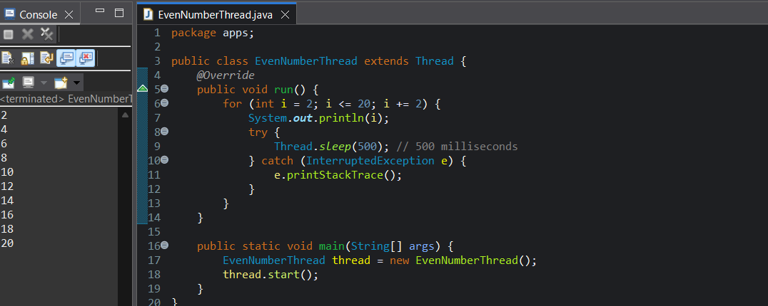

- Create a thread by implementing the Runnable interface: Create a thread by implementing the Runnable interface that takes a string "MULTITHREADING" and prints its characters in reverse order one by one.

package apps;

public class ReverseStringRunnable implements Runnable {
public void run() {
String str = "MULTITHREADING";
for (int i = str.length() - 1; i >= 0; i--) {
System.out.println(str.charAt(i));
try {
Thread.sleep(300);
} catch (InterruptedException e) {
e.printStackTrace();
}
}
}
public static void main(String[] args) {
Thread thread = new Thread(new ReverseStringRunnable());
thread.start();
}
}

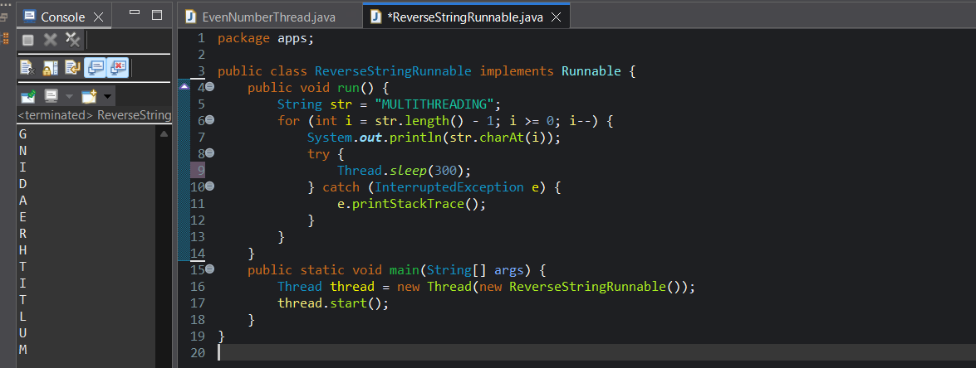

3.Thread Sleep Method: Create a program that creates two threads. The first thread should print "Thread 1" every 1 second, and the second thread should print "Thread 2" every 2 seconds.
package apps;
public class TwoThreadsSleep {
public static void main(String[] args) { Thread thread1 = new Thread(() -> {
while (true) {
System.out.println("Thread 1");
try {
Thread.sleep(1000); // 1 second delay
} catch (InterruptedException e) {
e.printStackTrace();
}
}
});
Thread thread2 = new Thread(() -> {
while (true) {
System.out.println("Thread 2");
try {
Thread.sleep(2000); // 2 second delay
} catch (InterruptedException e) {
e.printStackTrace();
}
}
});
thread1.start();
thread2.start();
}
}
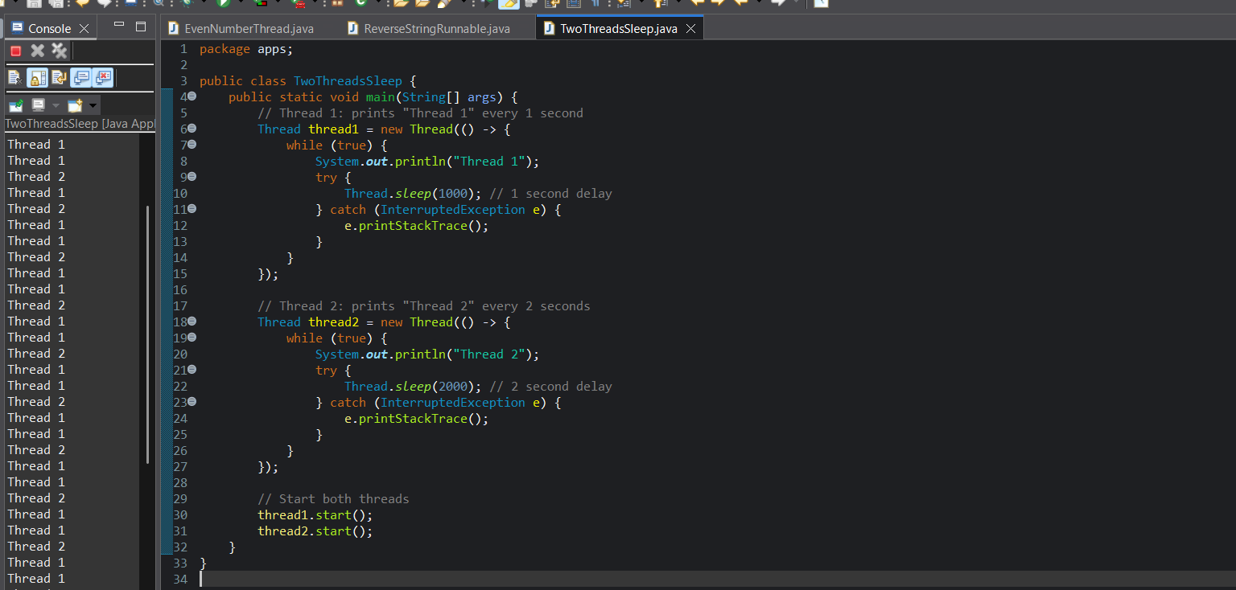

4.Thread Sleep with Multiple Threads (Countdown Timer): Write a program where one thread prints a countdown from 10 to 1 (1-second delay), while another thread simultaneously prints "Tick..." every half a second.

package apps;

public class CountdownAndTick {
public static void main(String[] args) {
Thread countdownThread = new Thread(() -> {
for (int i = 10; i >= 1; i--) {
System.out.println("Countdown: " + i);
try {
Thread.sleep(1000);
} catch (InterruptedException e) {
e.printStackTrace();
}
}
});
Thread tickThread = new Thread(() -> {
for (int i = 0; i < 20; i++) {
System.out.println("Tick...");
try {
Thread.sleep(500);
} catch (InterruptedException e) {
e.printStackTrace();
}
}
});
countdownThread.start();
tickThread.start();
}
}

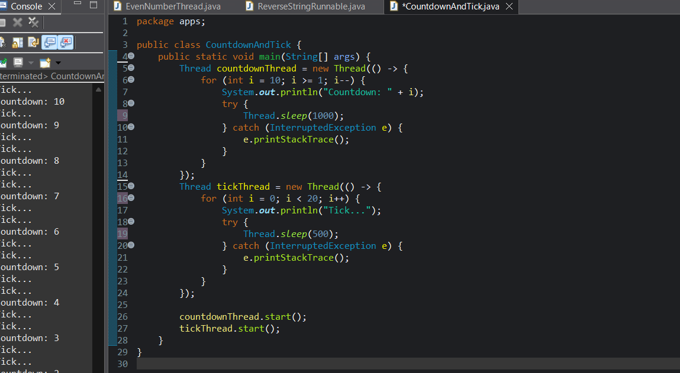
5.Thread Naming and Priority: Write a Java program that creates three threads: "Worker-1", "Worker-2", and "Worker-3". Assign different priorities and print messages from each thread showing their execution order.
package apps;

public class ThreadPriorityDemo {
public static void main(String[] args) {
Thread worker1 = new Thread(() -> {
System.out.println(Thread.currentThread().getName() + " is running with priority " + Thread.currentThread().getPriority());
}, "Worker-1");
Thread worker2 = new Thread(() -> {
System.out.println(Thread.currentThread().getName() + " is running with priority " + Thread.currentThread().getPriority());
}, "Worker-2");

Thread worker3 = new Thread(() -> {
System.out.println(Thread.currentThread().getName() + " is running with priority " + Thread.currentThread().getPriority());
}, "Worker-3");
worker1.setPriority(Thread.MIN_PRIORITY);
worker2.setPriority(Thread.NORM_PRIORITY);
worker3.setPriority(Thread.MAX_PRIORITY);

worker1.start();
worker2.start();
worker3.start();
}
}

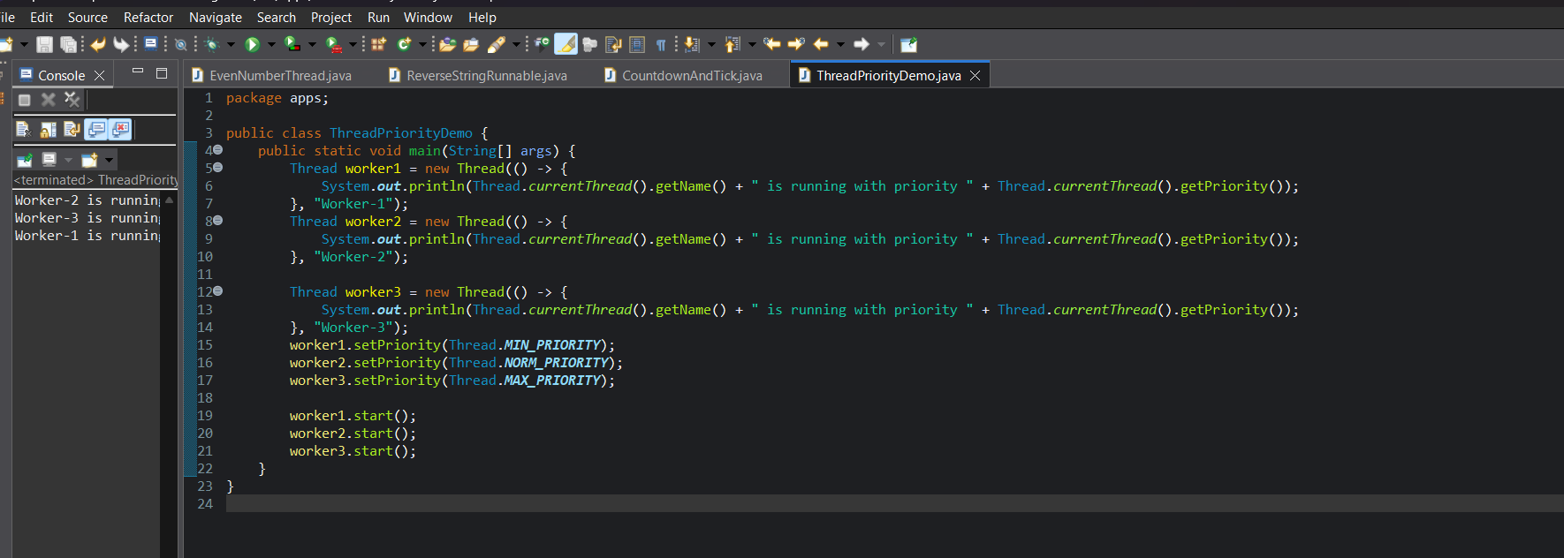
6.Daemon Threads: Write a Java program where a daemon thread continuously writes "Auto-Save in progress..." every 3 seconds, while the main thread performs a file processing task.

public class AutoSaveDemo {
public static void main(String[] args) {
Thread autoSaveThread = new Thread(() -> {
while (true) {
try {
Thread.sleep(3000); // Sleep for 3 seconds
System.out.println("Auto-Save in progress...");
} catch (InterruptedException e) {
System.out.println("Auto-save thread interrupted.");
break;
}
}
});
autoSaveThread.setDaemon(true);
autoSaveThread.start();
for (int i = 1; i <= 5; i++) {
System.out.println("Main thread processing file line " + i);
try {
Thread.sleep(2000); // Simulate processing time (2 seconds per line)
} catch (InterruptedException e) {
System.out.println("Main thread interrupted.");
}
}
System.out.println("Main thread finished file processing.");
}
}
6. Synchronized Method: Create a ticket booking system where multiple users (threads) attempt to book tickets simultaneously. Use synchronization to prevent overselling of tickets.

package apps;
class TicketCounter {
private int availableTickets = 5; // total available tickets
public synchronized void bookTicket(String userName, int numberOfTickets) {
System.out.println(userName + " is trying to book " + numberOfTickets + " ticket(s).");

if (numberOfTickets <= availableTickets) {
System.out.println("Booking successful for " + userName);
availableTickets -= numberOfTickets;
System.out.println("Tickets left: " + availableTickets);
} else {
System.out.println("Sorry " + userName + ", not enough tickets available.");
}
}
}
class UserThread extends Thread {
private TicketCounter counter;
private String userName;
private int ticketsToBook;

public UserThread(TicketCounter counter, String userName, int ticketsToBook) {
this.counter = counter;
this.userName = userName;
this.ticketsToBook = ticketsToBook;
}
public void run() {
counter.bookTicket(userName, ticketsToBook);
}
}
public class TicketBookingSystem {
public static void main(String[] args) {
TicketCounter counter = new TicketCounter();
UserThread user1 = new UserThread(counter, "A", 2);
UserThread user2 = new UserThread(counter, "B", 3);
UserThread user3 = new UserThread(counter, "C", 1);
user1.start();
user2.start();
user3.start();
}
}
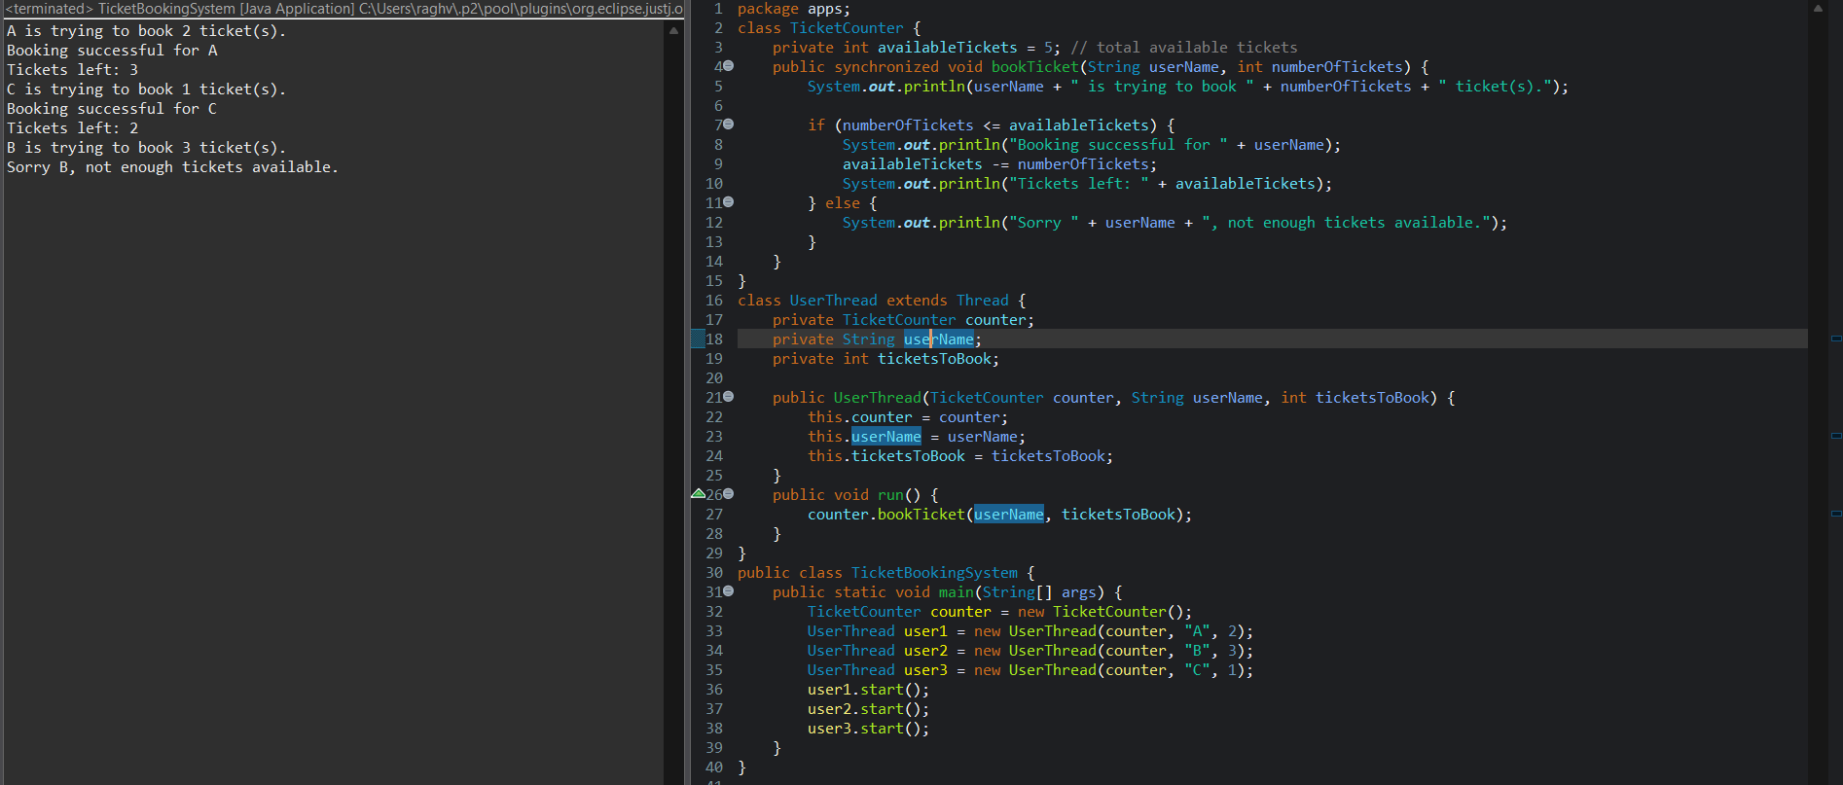

7. Synchronized Block: Create an inventory management program where multiple threads decrease the stock count of a product. Use a synchronized block to ensure stock updates are thread-safe.

package apps;

class Inventory {
private int stock = 10;
public void decreaseStock(String threadName, int quantity) {
System.out.println(threadName + " is trying to buy " + quantity + " item(s).");

synchronized (this) {
if (quantity <= stock) {
System.out.println(threadName + " purchase successful.");
stock -= quantity;
System.out.println("Stock remaining: " + stock);
} else {
System.out.println("Sorry " + threadName + ", not enough stock available.");
}
}
}
}
class StockThread extends Thread {
private Inventory inventory;
private String threadName;
private int quantity;

public StockThread(Inventory inventory, String threadName, int quantity) {
this.inventory = inventory;
this.threadName = threadName;
this.quantity = quantity;
}
public void run() {
inventory.decreaseStock(threadName, quantity);
}
}
public class InventoryManagement {
public static void main(String[] args) {
Inventory inventory = new Inventory();
StockThread t1 = new StockThread(inventory, "User1", 3);
StockThread t2 = new StockThread(inventory, "User2", 4);
StockThread t3 = new StockThread(inventory, "User3", 5);
t1.start();
t2.start();
t3.start();
}
}
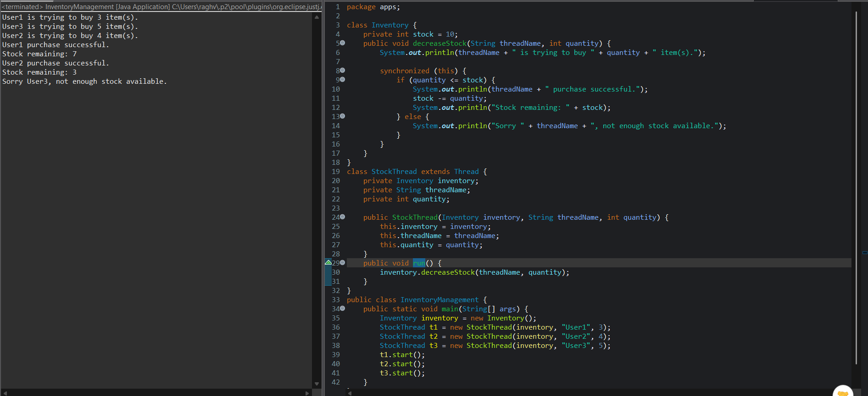

- Deadlock Example with Dining Philosophers: Simulate a simple Dining Philosophers problem where two philosophers try to pick up chopsticks (resources) and create a deadlock situation.

package apps;
class Chopstick {
private final String name;

public Chopstick(String name) {
this.name = name;
}

public String getName() {
return name;
}
}
class Philosopher extends Thread {
private Chopstick leftChopstick;
private Chopstick rightChopstick;
public Philosopher(String name, Chopstick left, Chopstick right) {
super(name);
this.leftChopstick = left;
this.rightChopstick = right;
}

@Override
public void run() {
synchronized (leftChopstick) {
System.out.println(getName() + " picked up left chopstick: " + leftChopstick.getName());
try {
Thread.sleep(100);
} catch (InterruptedException e) {
e.printStackTrace();
}
synchronized (rightChopstick) {
System.out.println(getName() + " picked up right chopstick: " + rightChopstick.getName());
System.out.println(getName() + " is eating.");
}
}
}
}
public class DiningPhilosophersDeadlock {
public static void main(String[] args) {
Chopstick c1 = new Chopstick("Chopstick-1");
Chopstick c2 = new Chopstick("Chopstick-2");
Philosopher p1 = new Philosopher("Philosopher-1", c1, c2);
Philosopher p2 = new Philosopher("Philosopher-2", c2, c1);
p1.start();
p2.start();
}
}

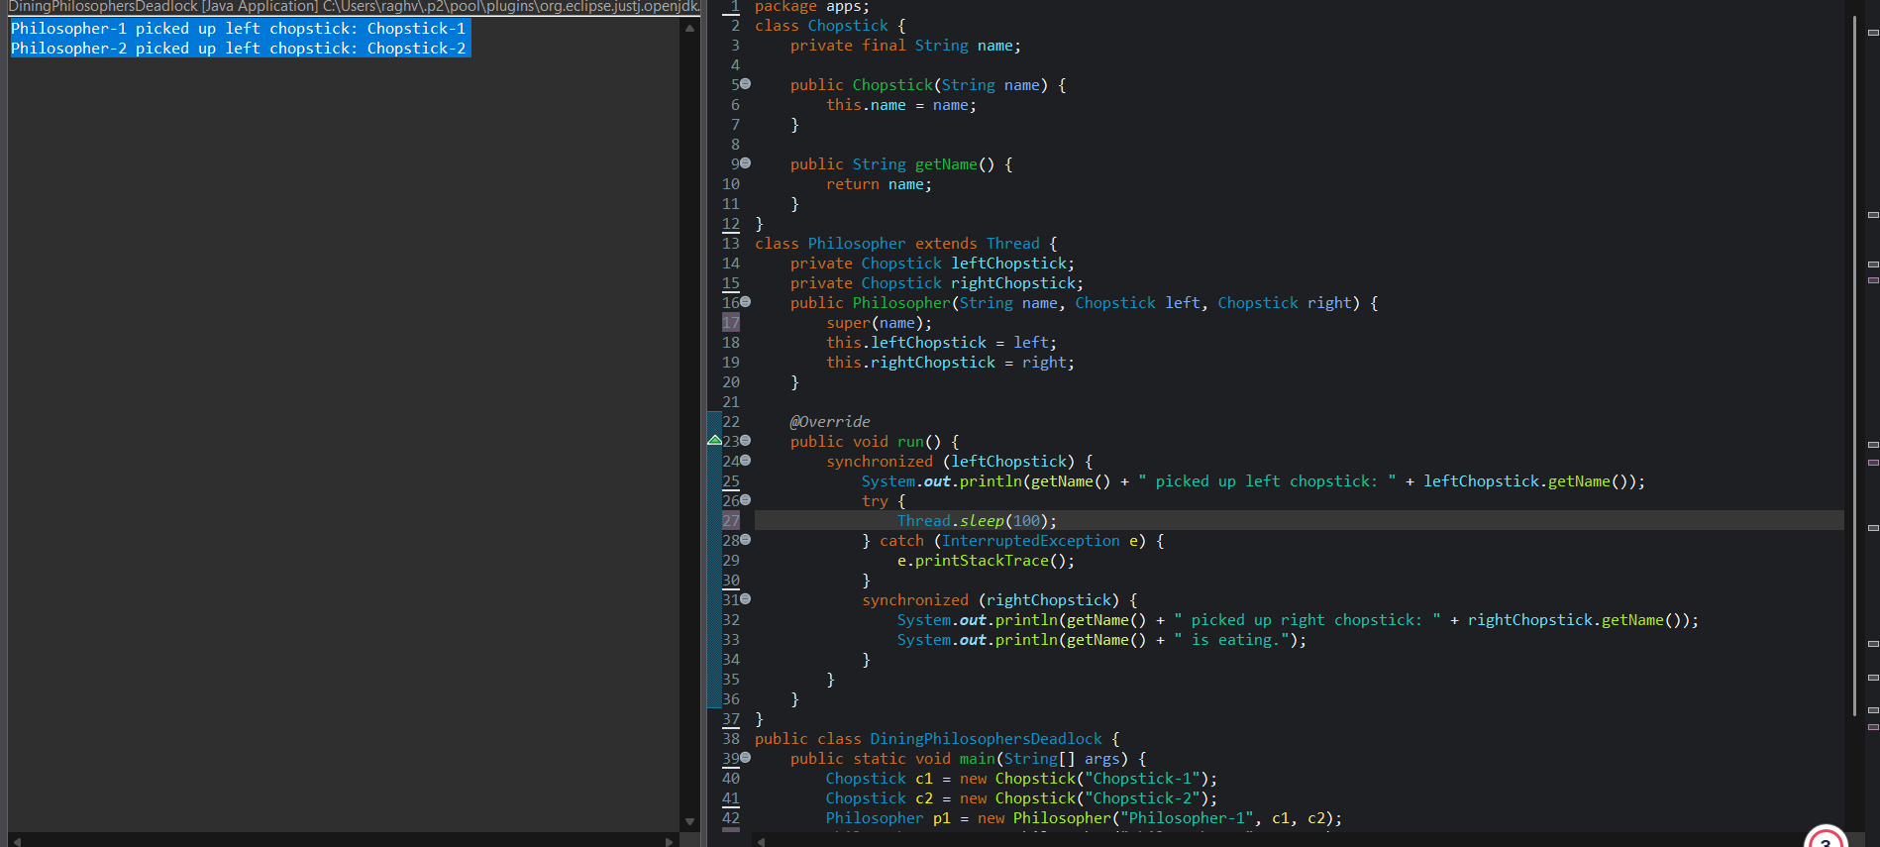

9.Using wait(), notify(), and notifyAll():
  - Implement a producer-consumer scenario where one thread (producer) produces data and another thread (consumer) consumes it. Use the wait() and notify() methods for synchronization.
  - Write a program where two threads print numbers from 1 to 20 alternately: one prints odd numbers, and the other prints even numbers. Use wait() and notify() for synchronization.

package apps;
class SharedBuffer {
private int data;
private boolean hasData = false;
public synchronized void produce(int value) {
while (hasData) {
try {
wait();
} catch (InterruptedException e) {
e.printStackTrace();
}
}
data = value;
hasData = true;
System.out.println("Produced: " + value);
notify();
}
public synchronized void consume() {
while (!hasData) {
try {
wait();
} catch (InterruptedException e) {
e.printStackTrace();
}
}
System.out.println("Consumed: " + data);
hasData = false;
notify();
}
}
class Producer extends Thread {
private SharedBuffer buffer;
public Producer(SharedBuffer buffer) {
this.buffer = buffer;
}
public void run() {
for (int i = 1; i <= 5; i++) {
buffer.produce(i);
try {
Thread.sleep(500);
} catch (InterruptedException e) {
e.printStackTrace();
}
}
}
}
class Consumer extends Thread {
private SharedBuffer buffer;
public Consumer(SharedBuffer buffer) {
this.buffer = buffer;
}
public void run() {
for (int i = 1; i <= 5; i++) {
buffer.consume();
try {
Thread.sleep(500);
} catch (InterruptedException e) {
e.printStackTrace();
}
}
}
}
public class ProducerConsumer {
public static void main(String[] args) {
SharedBuffer buffer = new SharedBuffer();
Producer producer = new Producer(buffer);
Consumer consumer = new Consumer(buffer);

producer.start();
consumer.start();
}
}
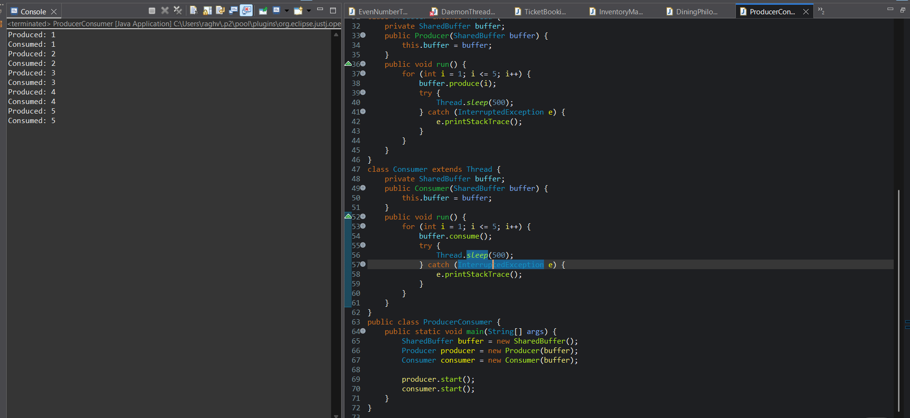

9) b Stopping a Thread: Write a program that simulates a file download in a thread (printing "Downloading chunk X"). Allow the download to stop gracefully when a stop flag is set to false.

package apps;
class NumberPrinter {
private int number = 1;
private final int MAX = 20;
public synchronized void printOdd() {
while (number <= MAX) {
if (number % 2 == 0) {
try {
wait();
} catch (InterruptedException e) {
e.printStackTrace();
}
} else {
System.out.println("Odd: " + number);
number++;
notify();
}
}
}
public synchronized void printEven() {
while (number <= MAX) {
if (number % 2 == 1) {
try {
wait();
} catch (InterruptedException e) {
e.printStackTrace();
}
} else {
System.out.println("Even: " + number);
number++;
notify();
}
}
}
}
class OddThread extends Thread {
private NumberPrinter printer;
public OddThread(NumberPrinter printer) {
this.printer = printer;
}
public void run() {
printer.printOdd();
}
}

class EvenThread extends Thread {
private NumberPrinter printer;
public EvenThread(NumberPrinter printer) {
this.printer = printer;
}
public void run() {
printer.printEven();
}
}
public class OddEvenPrinter {
public static void main(String[] args) {
NumberPrinter printer = new NumberPrinter();
Thread odd = new OddThread(printer);
Thread even = new EvenThread(printer);
odd.start();
even.start();
}
}

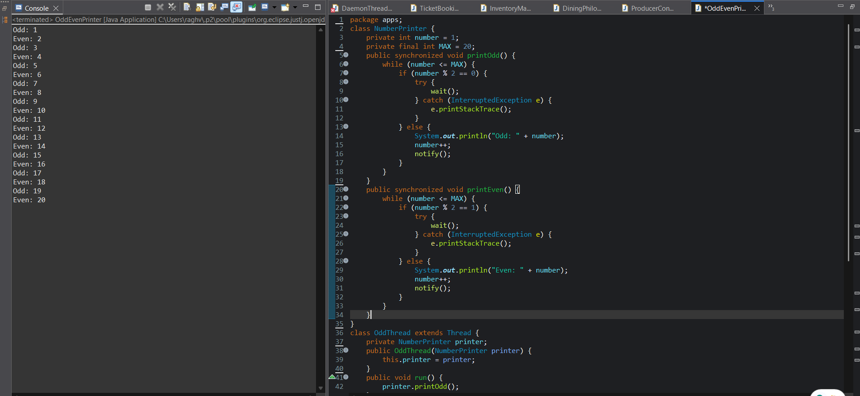

10.Stopping a Thread: Write a program that simulates a file download in a thread (printing "Downloading chunk X"). Allow the download to stop gracefully when a stop flag is set to false.
package apps;
public class FileDownloadSimulator implements Runnable {
private volatile boolean running = true;
public void run() {
int chunk = 1;
while (running) {
System.out.println("Downloading chunk " + chunk);
chunk++;
try {
Thread.sleep(500);
} catch (InterruptedException e) {
System.out.println("Thread interrupted");
Thread.currentThread().interrupt();
break;
}
}
System.out.println("Download stopped gracefully.");
}
public void stop() {
running = false;
}
public static void main(String[] args) {
FileDownloadSimulator downloader = new FileDownloadSimulator();
Thread downloadThread = new Thread(downloader);
downloadThread.start();
try {
Thread.sleep(5000);
} catch (InterruptedException e) {
e.printStackTrace();
}
System.out.println("Requesting download to stop...");
downloader.stop();
}
}

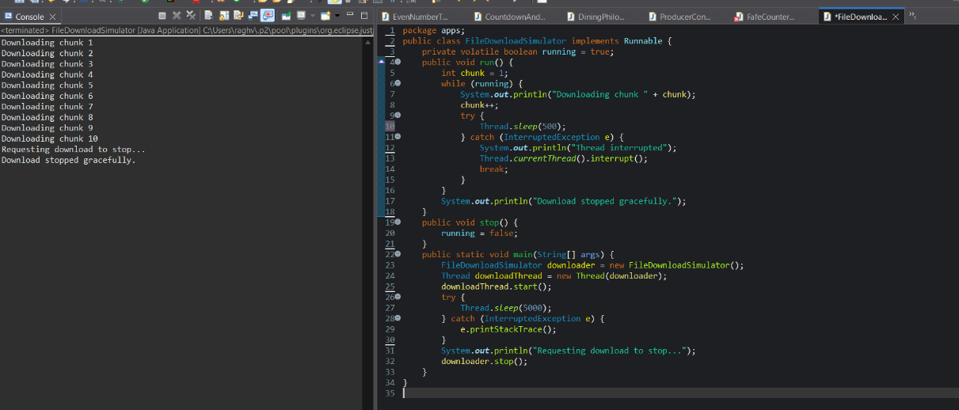

11.Write a Java program using the ReentrantLock class to create a simple counter that can be safely incremented by multiple threads. Compare the result with the version that does not use a lock.

package apps;
import java.util.concurrent.locks.ReentrantLock;
public class CounterExamplee {
static class SafeCounter {
private int count = 0;
private final ReentrantLock lock = new ReentrantLock();
public void increment() {
lock.lock();
try {
count++;
} finally {
lock.unlock();
}
}
public int getCount() {
return count;
}
}
static class UnsafeCounter {
private int count = 0;
public void increment() {
count++;
}
public int getCount() {
return count;
}
}
public static void main(String[] args) throws InterruptedException {
final int NUM_THREADS = 100;
final int INCREMENTS_PER_THREAD = 1000;
SafeCounter safeCounter = new SafeCounter();
Thread[] safeThreads = new Thread[NUM_THREADS];
for (int i = 0; i < NUM_THREADS; i++) {
safeThreads[i] = new Thread(() -> {
for (int j = 0; j < INCREMENTS_PER_THREAD; j++) {
safeCounter.increment();
}
});
safeThreads[i].start();
}
for (Thread t : safeThreads) {
t.join();
}
System.out.println("SafeCounter final count: " + safeCounter.getCount());
UnsafeCounter unsafeCounter = new UnsafeCounter();
Thread[] unsafeThreads = new Thread[NUM_THREADS];
for (int i = 0; i < NUM_THREADS; i++) {
unsafeThreads[i] = new Thread(() -> {
for (int j = 0; j < INCREMENTS_PER_THREAD; j++) {
unsafeCounter.increment();
}
});
unsafeThreads[i].start();
}
for (Thread t : unsafeThreads) {
t.join();
}
System.out.println("UnsafeCounter final count: " + unsafeCounter.getCount());
}
}

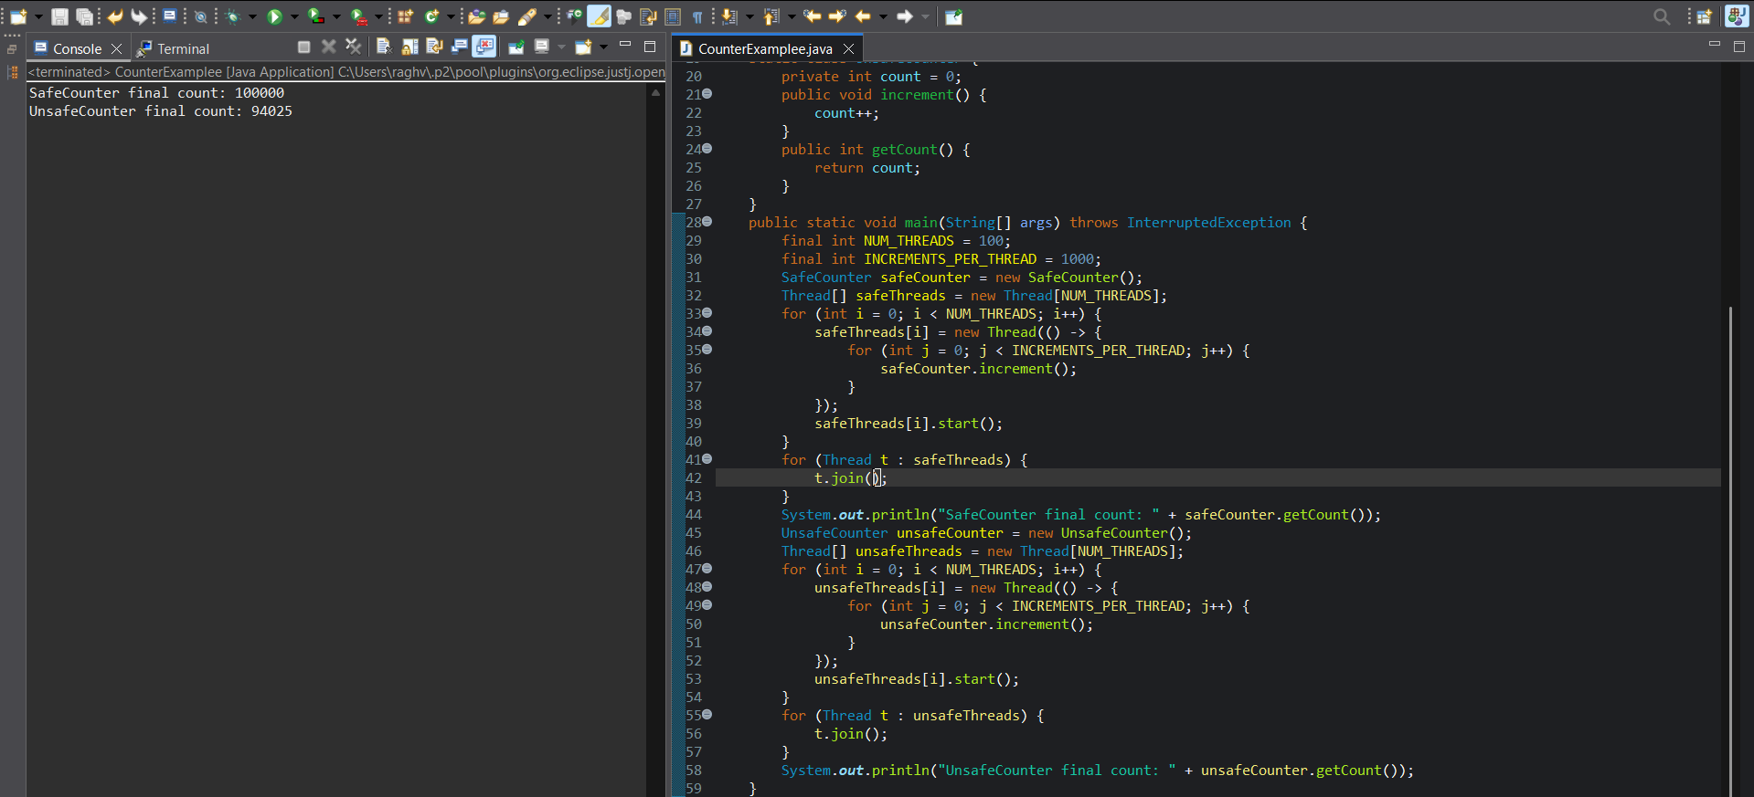

12. Write a program where two threads acquire two locks (lock1 and lock2) in opposite order, causing a deadlock. Then, fix the deadlock by using tryLock() with timeout.

package apps;

import java.util.concurrent.locks.Lock;
import java.util.concurrent.locks.ReentrantLock;
import java.util.concurrent.TimeUnit;

public class DeadlockDemo {

private final Lock lock1 = new ReentrantLock();
private final Lock lock2 = new ReentrantLock();

public void deadlockThread1() {
lock1.lock();
System.out.println("Thread 1 acquired lock1");

try {
Thread.sleep(100);
System.out.println("Thread 1 waiting for lock2");
lock2.lock();
System.out.println("Thread 1 acquired lock2");
} catch (InterruptedException e) {
e.printStackTrace();
} finally {
if (lock2.tryLock()) { // careful to avoid unlocking if not held, or just check
lock2.unlock();
}
lock1.unlock();
}
}

public void deadlockThread2() {
lock2.lock();
System.out.println("Thread 2 acquired lock2");

try {
Thread.sleep(100);
System.out.println("Thread 2 waiting for lock1");
lock1.lock();
System.out.println("Thread 2 acquired lock1");
} catch (InterruptedException e) {
e.printStackTrace();
} finally {
if (lock1.tryLock()) {
lock1.unlock();
}
lock2.unlock();
}
}

public void fixedThread1() {
try {
if (lock1.tryLock(500, TimeUnit.MILLISECONDS)) {
System.out.println("Fixed Thread 1 acquired lock1");
try {
Thread.sleep(100);
if (lock2.tryLock(500, TimeUnit.MILLISECONDS)) {
try {
System.out.println("Fixed Thread 1 acquired lock2");
} finally {
lock2.unlock();
}
} else {
System.out.println("Fixed Thread 1 could not acquire lock2, releasing lock1");
}
} finally {
lock1.unlock();
}
} else {
System.out.println("Fixed Thread 1 could not acquire lock1");
}
} catch (InterruptedException e) {
e.printStackTrace();
}
}

public void fixedThread2() {
try {
if (lock2.tryLock(500, TimeUnit.MILLISECONDS)) {
System.out.println("Fixed Thread 2 acquired lock2");
try {
Thread.sleep(100);
if (lock1.tryLock(500, TimeUnit.MILLISECONDS)) {
try {
System.out.println("Fixed Thread 2 acquired lock1");
} finally {
lock1.unlock();
}
} else {
System.out.println("Fixed Thread 2 could not acquire lock1, releasing lock2");
}
} finally {
lock2.unlock();
}
} else {
System.out.println("Fixed Thread 2 could not acquire lock2");
}
} catch (InterruptedException e) {
e.printStackTrace();
}
}

public static void main(String[] args) throws InterruptedException {
DeadlockDemo demo = new DeadlockDemo();

System.out.println("Starting deadlock demonstration...");
Thread t1 = new Thread(demo::deadlockThread1);
Thread t2 = new Thread(demo::deadlockThread2);

t1.start();
t2.start();

t1.join(2000);
t2.join(2000);

System.out.println("\nDeadlock demo may be stuck. Now running fixed version...\n");

Thread f1 = new Thread(demo::fixedThread1);
Thread f2 = new Thread(demo::fixedThread2);

f1.start();
f2.start();

f1.join();
f2.join();

System.out.println("Fixed version finished without deadlock.");
}
}

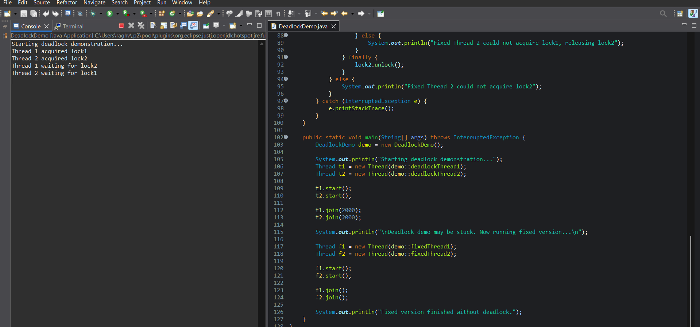

13. Reading File Using Byte Stream: Write a program that reads a text file using the FileInputStream and prints the contents to the console
package app
import java.io.FileInputStream;
import java.io.IOException;
public class FileByteReader {
public static void main(String[] args) {
String filePath = "example.txt";
try (FileInputStream fis = new FileInputStream(filePath)) {
int byteRead;
while ((byteRead = fis.read()) != -1) {
System.out.print((char) byteRead);
}
} catch (IOException e) {
System.err.println("Error reading file: " + e.getMessage());
}
}
}

14.Writing to a File Using Byte Stream: Create a program that writes a string into a file using the FileOutputStream. Ensure that the program writes the string "Java I/O Streams Example" to a file named output.txt.

package apps;
import java.io.FileOutputStream;
import java.io.IOException;
public class FileByteWriter {
public static void main(String[] args) {
String data = "Java I/O Streams Example";
String filePath = "output.txt";
try (FileOutputStream fos = new FileOutputStream(filePath)) {
byte[] bytes = data.getBytes();
fos.write(bytes);
System.out.println("Data written to " + filePath);
} catch (IOException e) {
System.err.println("Error writing file: " + e.getMessage());
}
}
}
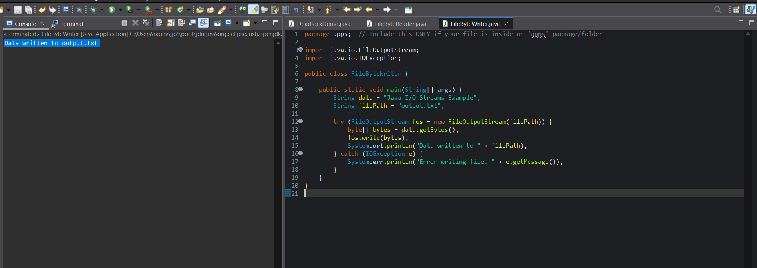

15.Reading a File Using Character Stream: Write a program that reads a file using the FileReader class and prints the contents of the file to the console.
package apps;

import java.io.FileReader;
import java.io.FileWriter;
import java.io.IOException;
public class FileCharacterReader {
public static void main(String[] args) {
String filePath = "input.txt";

try (FileWriter fw = new FileWriter(filePath)) {
fw.write("Hello, this is a sample file.\nThis text will be printed by the program.");
} catch (IOException e) {
System.err.println("Error writing file: " + e.getMessage());
return;
}

try (FileReader fr = new FileReader(filePath)) {
int ch;
while ((ch = fr.read()) != -1) {
System.out.print((char) ch);
}
} catch (IOException e) {
System.err.println("Error reading file: " + e.getMessage());
}
}
}
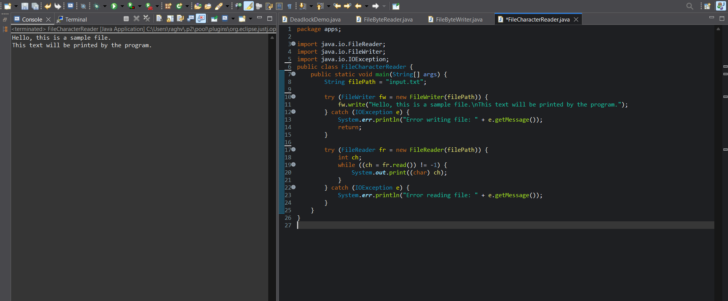

- Writing to a File Using Character Stream: Write a program that writes a string to a file using the FileWriter class. The string should be written to a file named example.txt.

package apps;
import java.io.FileWriter;
import java.io.IOException;
public class FileCharacterWriter {
public static void main(String[] args) {
String data = "This is an example string written using FileWriter.";
String filePath = "example.txt";
try (FileWriter fw = new FileWriter(filePath)) {
fw.write(data);
System.out.println("Data written to " + filePath);
} catch (IOException e) {
System.err.println("Error writing file: " + e.getMessage());
}
}
}

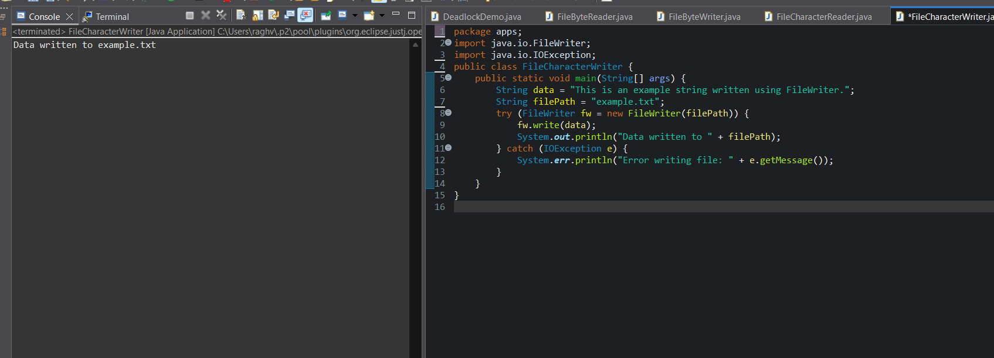

- Buffered I/O: Modify the previous FileReader and FileWriter examples to use BufferedReader and BufferedWriter respectively to read from and write to the file, improving performance.
- package apps;

- import java.io.BufferedReader;
- import java.io.FileReader;
- import java.io.IOException;
- public class BufferedFileReader {
- public static void main(String[] args) {
- String filePath = "example.txt";
- try (BufferedReader br = new BufferedReader(new FileReader(filePath))) {
- String line;
- while ((line = br.readLine()) != null) {
- System.out.println(line);
- }
- } catch (IOException e) {
- System.err.println("Error reading file: " + e.getMessage());
- }
- }
- }

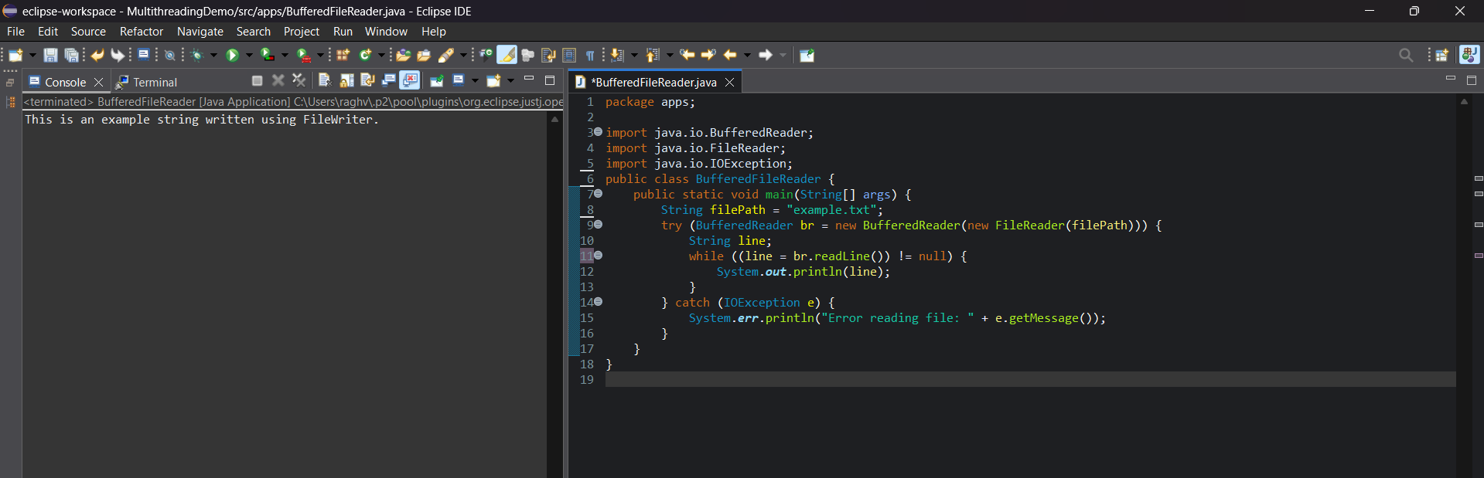

File Handling
- File Existence Check: Write a program that checks if a file exists in the system. If the file does not exist, create the file using the File class.
- package apps;

- import java.io.File;
- import java.io.IOException;

- public class FileExistenceCheck {

- public static void main(String[] args) {
- String filePath = "testfile.txt";
- File file = new File(filePath);

- if (file.exists()) {
- System.out.println("File already exists: " + filePath);
- } else {
- try {
- boolean created = file.createNewFile();
- if (created) {
- System.out.println("File created successfully: " + filePath);
- } else {
- System.out.println("Failed to create the file: " + filePath);
- }
- } catch (IOException e) {
- System.err.println("An error occurred while creating the file: " + e.getMessage());
- }
- }
- }
- }

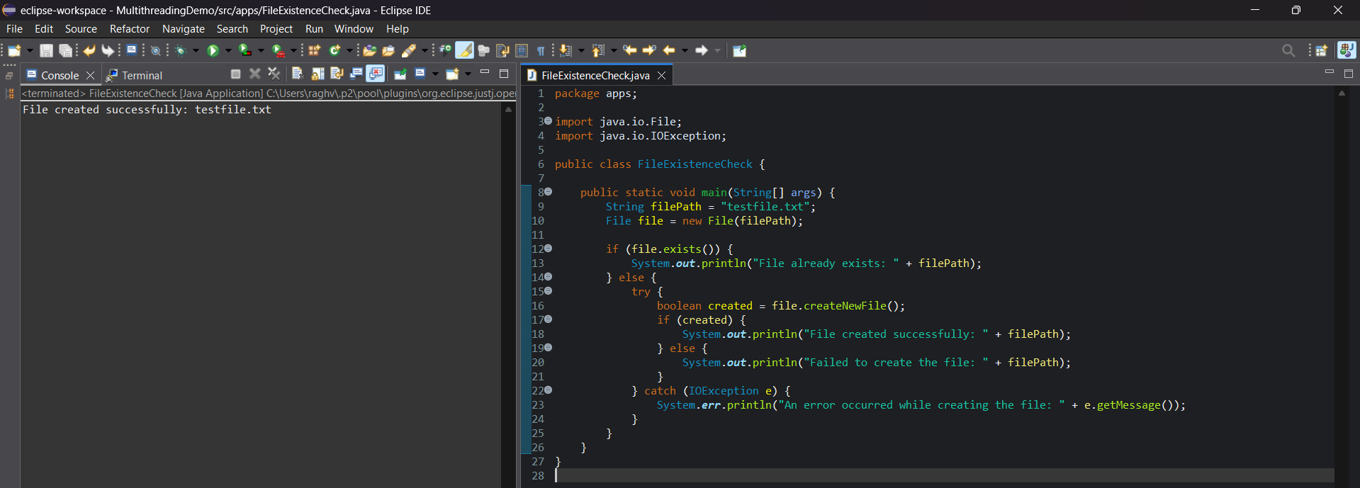

- Listing All Files in a Directory: Write a Java program that lists all files in a directory specified by the user. The program should handle exceptions appropriately.

package apps;
import java.io.File;
import java.util.Scanner;
public class ListFilesInDict {
public static void main(String[] args) {
Scanner scanner = new Scanner(System.in);
System.out.print("Enter directory path: ");
String dirPath = scanner.nextLine();
File directory = new File(dirPath);
if (!directory.exists()) {
System.out.println("The specified directory does not exist.");
} else if (!directory.isDirectory()) {
System.out.println("The specified path is not a directory.");
} else {
File[] files = directory.listFiles();
if (files == null || files.length == 0) {
System.out.println("The directory is empty.");
} else {
System.out.println("Files in directory '" + dirPath + "':");
for (File file : files) {
if (file.isFile()) {
System.out.println("File: " + file.getName());
} else if (file.isDirectory()) {
System.out.println("Directory: " + file.getName());
}
}
}
}
scanner.close();
}
}
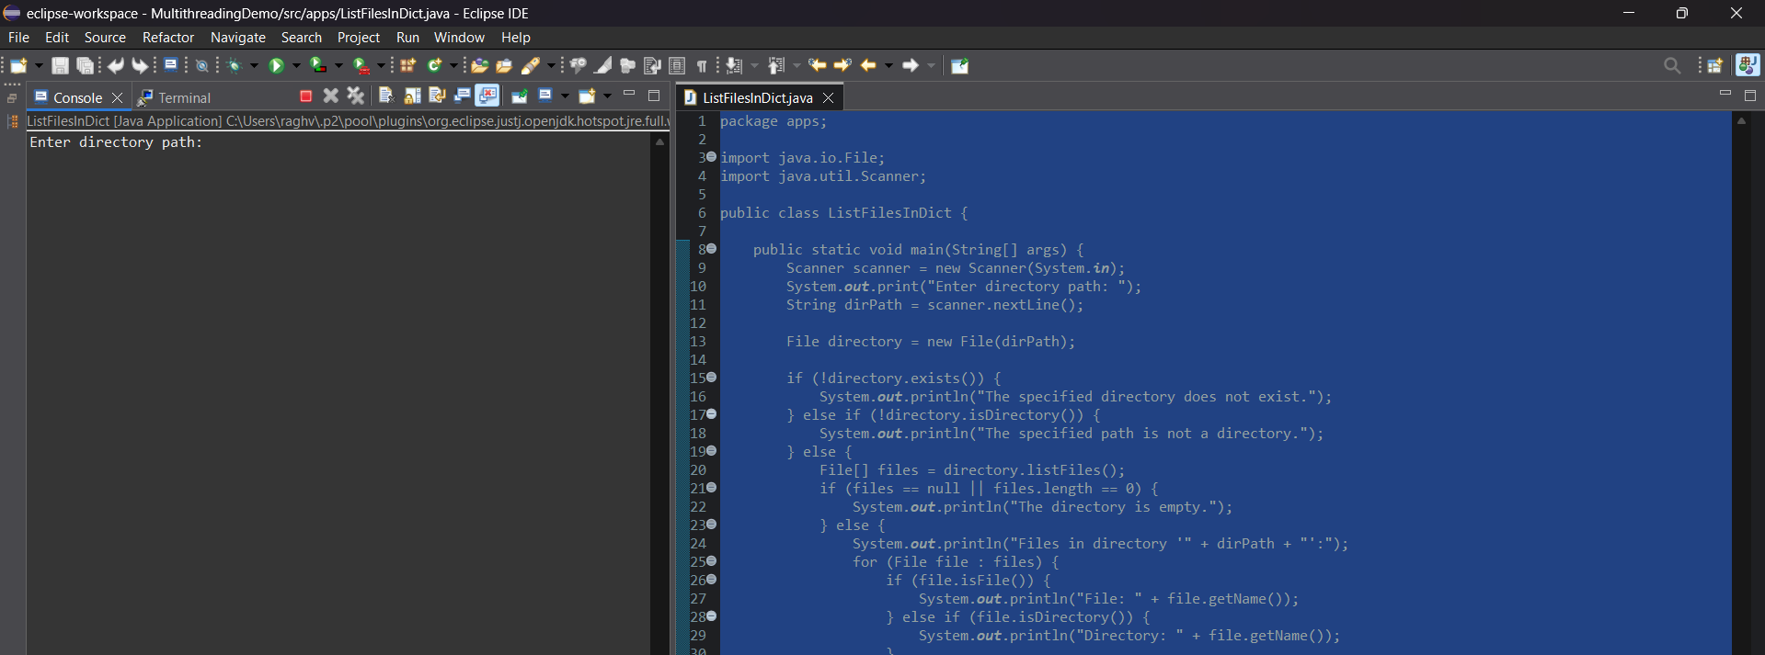

- Copying a File: Create a program that copies the contents of one file to another using byte streams (FileInputStream and FileOutputStream).

import java.io.FileInputStream;
import java.io.FileOutputStream;
import java.io.IOException;

public class FileCopy {

public static void main(String[] args) {
String sourceFile = "source.txt";
String destinationFile = "dest.txt";

try (FileInputStream fis = new FileInputStream(sourceFile);
FileOutputStream fos = new FileOutputStream(destinationFile)) {

byte[] buffer = new byte[1024];
int bytesRead;

while ((bytesRead = fis.read(buffer)) != -1) {
fos.write(buffer, 0, bytesRead);
}

System.out.println("File copied successfully!");

} catch (IOException e) {
System.err.println("Error during file copy: " + e.getMessage());
}
}
}

- Deleting a File: Write a Java program that deletes a file from the system using the File class.package apps;

import java.io.File;
import java.io.IOException;

public class FileToDelete {
public static void main(String[] args) {
File file = new File("file_to_delete.txt");
try {
if (file.createNewFile()) {
System.out.println("File created: " + file.getAbsolutePath());
} else {
System.out.println("File already exists at: " + file.getAbsolutePath());
}
} catch (IOException e) {
System.err.println("Error creating file: " + e.getMessage());
}
}
}
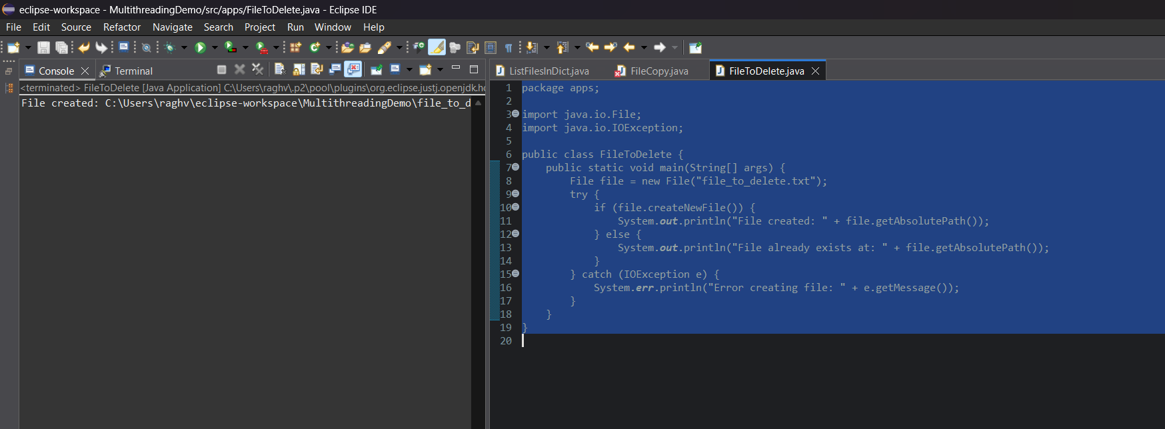

package apps;

import java.io.File;

public class FileDelete {
public static void main(String[] args) {
String filePath = "file_to_delete.txt";
File file = new File(filePath);

if (file.exists()) {
boolean deleted = file.delete();
if (deleted) {
System.out.println("File deleted successfully: " + filePath);
} else {
System.out.println("Failed to delete the file: " + filePath);
}
} else {
System.out.println("File does not exist: " + filePath);
}
}
}

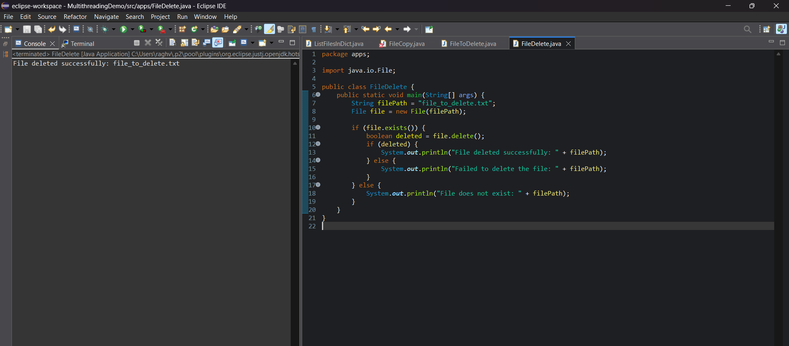

- Random Access File: Create a program that uses the RandomAccessFile class to read and write to specific positions within a file. The program should write some data at the beginning of the file, then overwrite part of it later.
- package apps;

- import java.io.IOException;
- import java.io.RandomAccessFile;

- public class RandomAccessFileExample {
- public static void main(String[] args) {
- System.out.println("Working Directory = " + System.getProperty("user.dir"));
- String filename = "random_access_file.txt";
- try (RandomAccessFile raf = new RandomAccessFile(filename, "rw")) {
- String initialData = "Hello, this is the original file content.";
- raf.write(initialData.getBytes());
- System.out.println("Initial data written: " + initialData);

- raf.seek(7);

- String overwriteData = "WORLD";
- raf.write(overwriteData.getBytes());
- System.out.println("Overwritten data at position 7 with: " + overwriteData);

- raf.seek(0); // reset pointer to beginning
- byte[] buffer = new byte[(int) raf.length()];
- raf.readFully(buffer);
- System.out.println("Final file content: " + new String(buffer));
- } catch (IOException e) {
- System.err.println("IO Error: " + e.getMessage());
- }
- }
- }

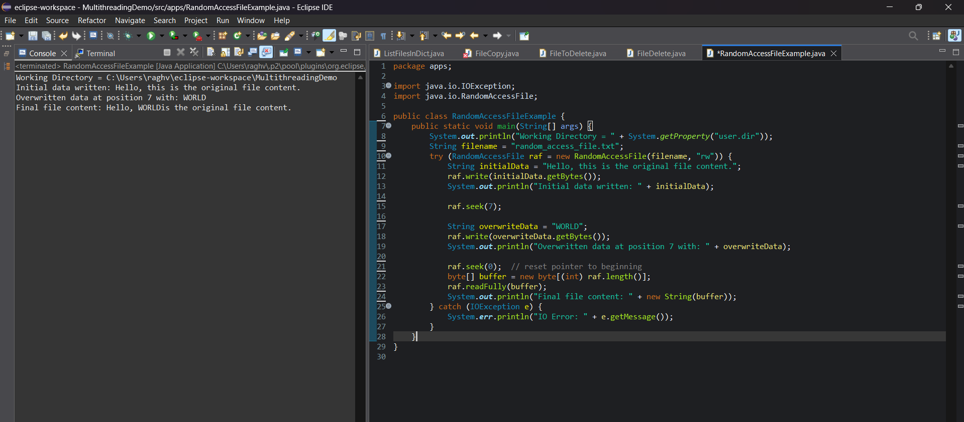

Exploring Java Packages
- Using java.lang Package: Write a program that demonstrates the use of Math.random(), Math.abs(), and Math.pow() from the java.lang package.
- package apps;
- public class MathDemo {

- public static void main(String[] args) {
- double randomValue = Math.random();
- System.out.println("Random value between 0.0 and 1.0: " + randomValue);
- int negativeNumber = -42;
- int absoluteValue = Math.abs(negativeNumber);
- System.out.println("Absolute value of " + negativeNumber + " is: " + absoluteValue);
- double base = 3;
- double exponent = 4;
- double powerResult = Math.pow(base, exponent);
- System.out.println(base + " raised to the power of " + exponent + " is: " + powerResult);
- }
- }

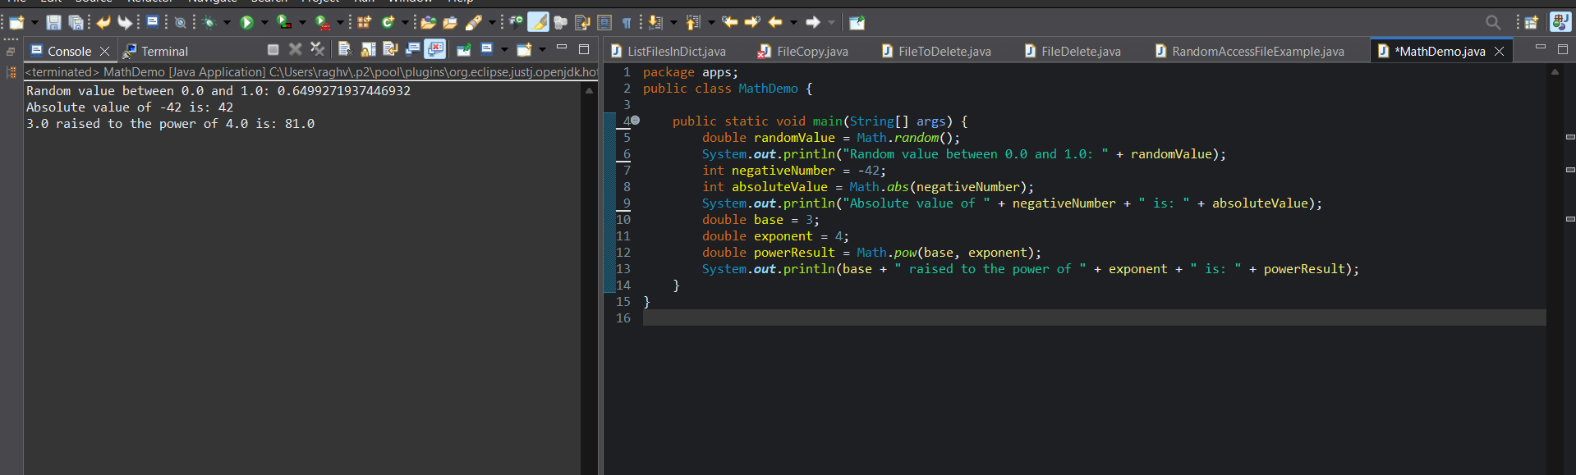

- Using java.util Package (Date and Calendar Example): Write a program that uses the Date and Calendar classes to display the current date and time.

package apps;
import java.util.Date;
import java.util.Calendar;
import java.text.SimpleDateFormat;

public class DateCalendar{

public static void main(String[] args) {
Date currentDate = new Date();
System.out.println("Current date and time using Date: " + currentDate);

Calendar calendar = Calendar.getInstance();
SimpleDateFormat sdf = new SimpleDateFormat("yyyy-MM-dd HH:mm:ss");
System.out.println("Current date and time using Calendar: " + sdf.format(calendar.getTime()));
}
}

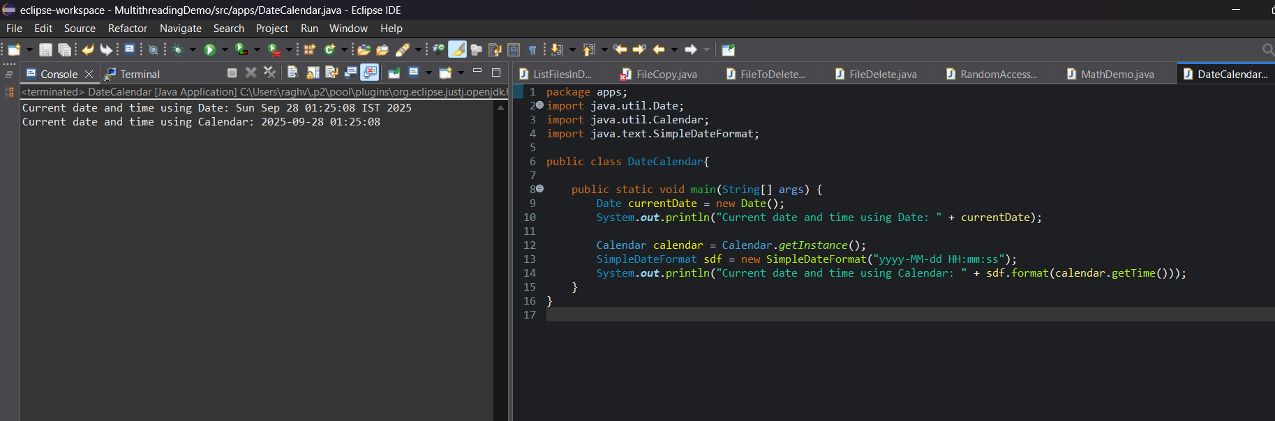

- Regular Expressions in java.util.regex: Create a program that uses the Pattern and Matcher classes from the java.util.regex package to check if a given string is a valid email address.

package apps;
import java.util.regex.Pattern;
import java.util.regex.Matcher;
import java.util.Scanner;

public class EmailValidator {

public static void main(String[] args) {
String emailRegex = "^[A-Za-z0-9+_.-]+@[A-Za-z0-9.-]+$";
Pattern pattern = Pattern.compile(emailRegex);
Scanner scanner = new Scanner(System.in);
System.out.print("Enter an email address to validate: ");
String email = scanner.nextLine();
Matcher matcher = pattern.matcher(email);
if (matcher.matches()) {
System.out.println(email + " is a valid email address.");
} else {
System.out.println(email + " is NOT a valid email address.");
}

scanner.close();
}
}
