Azure VM Created below

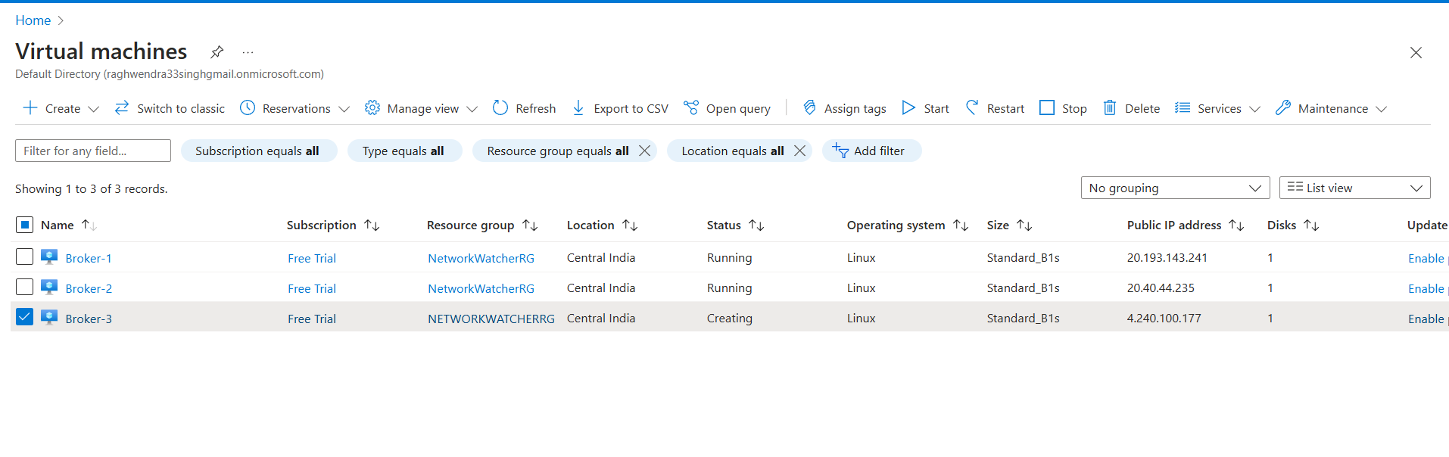

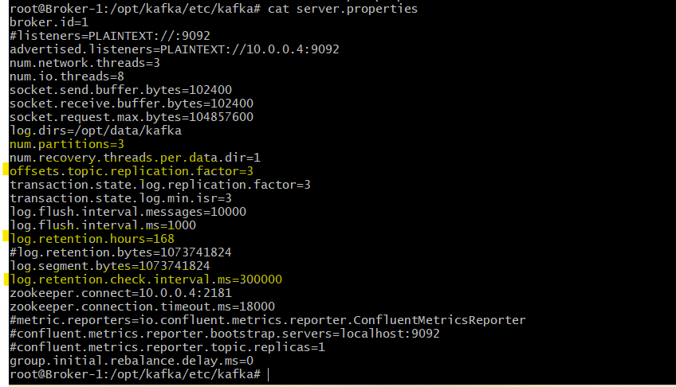

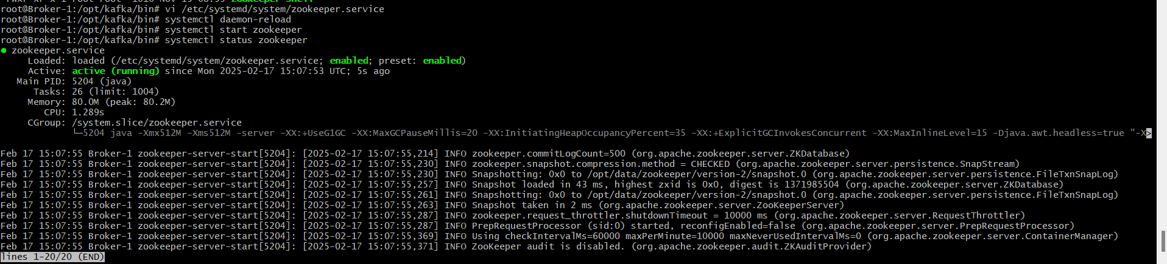

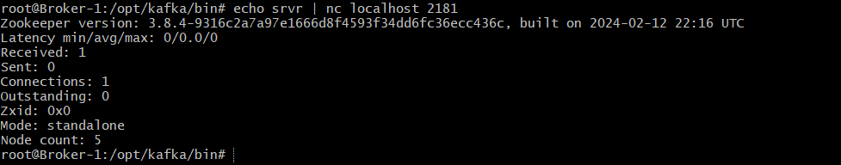

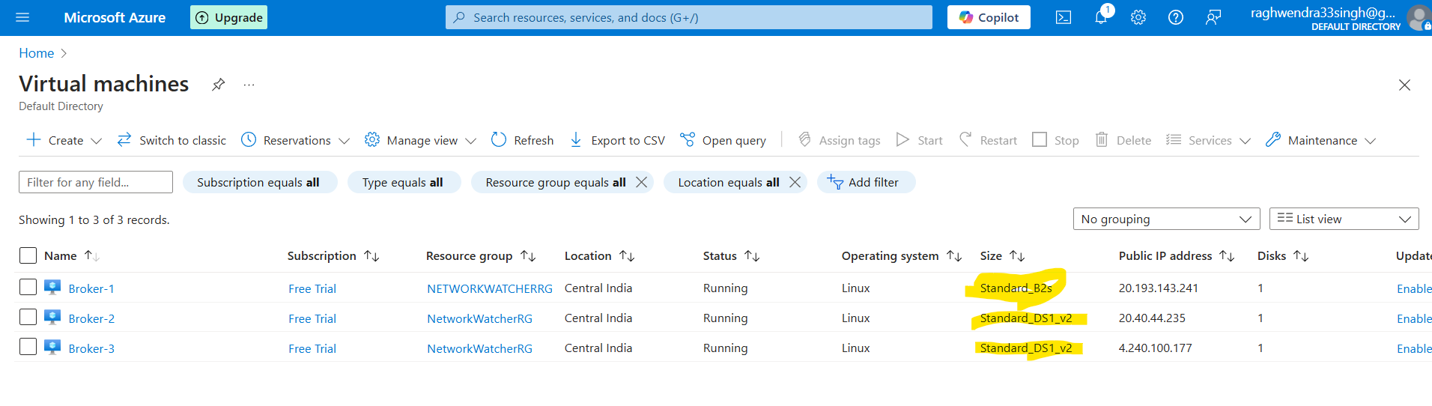

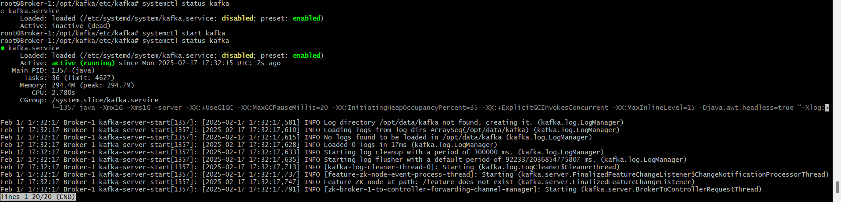

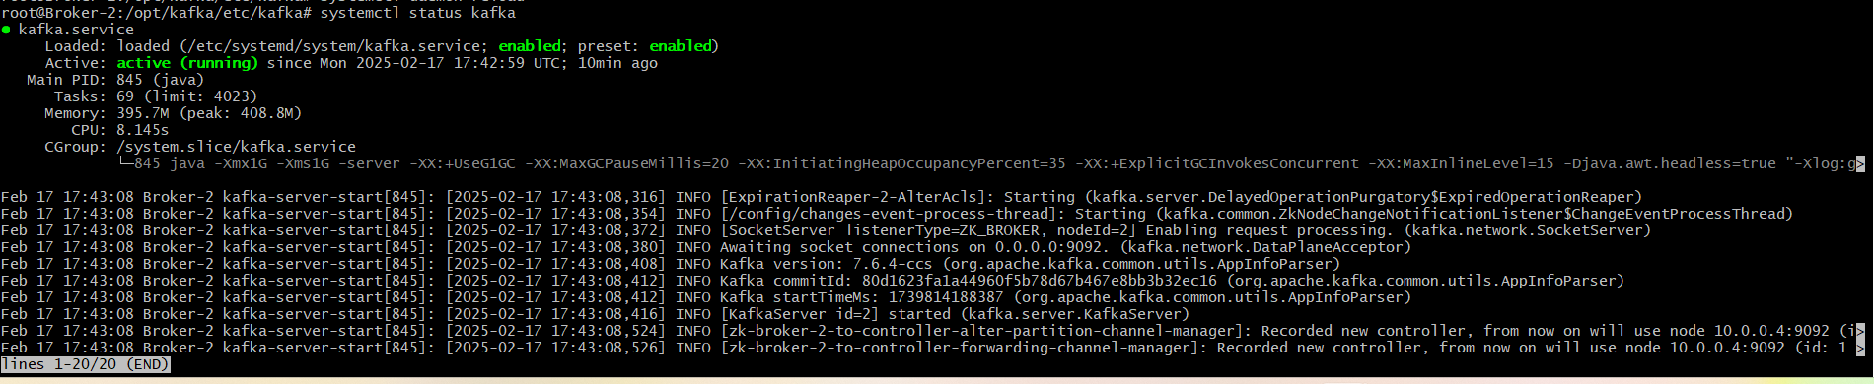



**Task2: Kafka Topic Configuration and Data Flow**

Topic A creation:

/opt/kafka/bin/kafka-topics --bootstrap-server localhost:9092 -create -topic A -partitions 6 -replication-factor 3



Topic B creation:

/opt/kafka/bin/kafka-topics --bootstrap-server localhost:9092 -create -topic B -partitions 2 -replication-factor 1



