**STEP1: Create a new repo on GitHub (web)**

1. Sign in to GitHub → **New repository**.
2. **Repository name**
3. Visibility: **Public** (simplest for Pages).
4. **Create repository**.
5. Clone the Repository in your local system.
6. Inside of folder we have to create html
7. clone the empty repo (copy the HTTPS URL from your repo page if you prefer)
8. git clone https://github.com/$GITHUB_USER/$REPO_NAME.git
9. cd "$REPO_NAME"

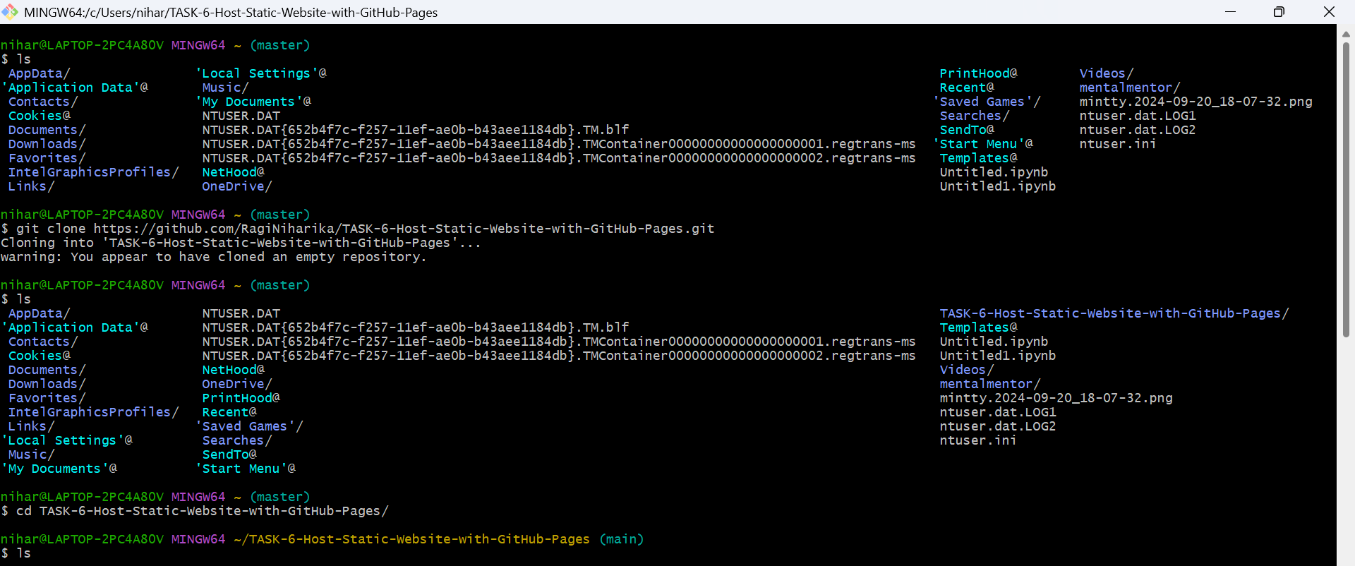

**STEP2: Create Website Files** (index.html , style.cs)

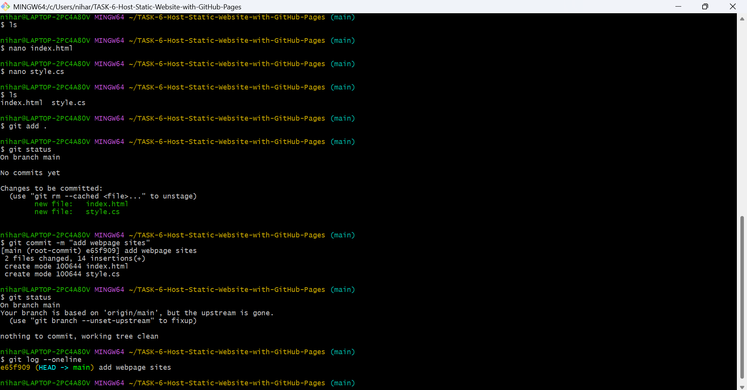

**STEP3: commit and push to Github**

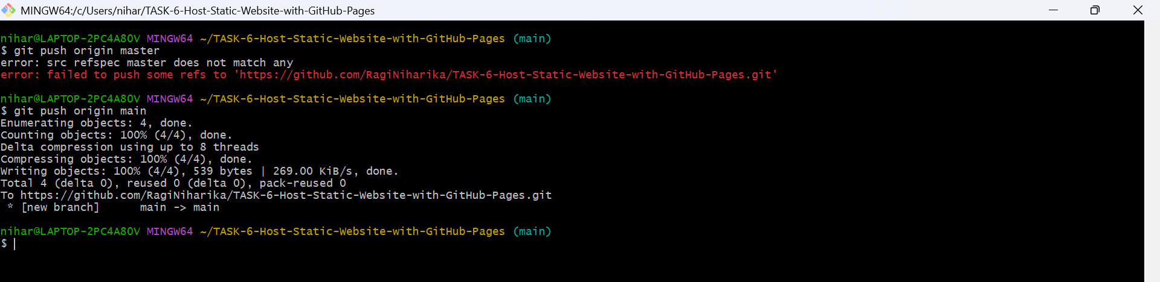

**STEP4: GitHub**

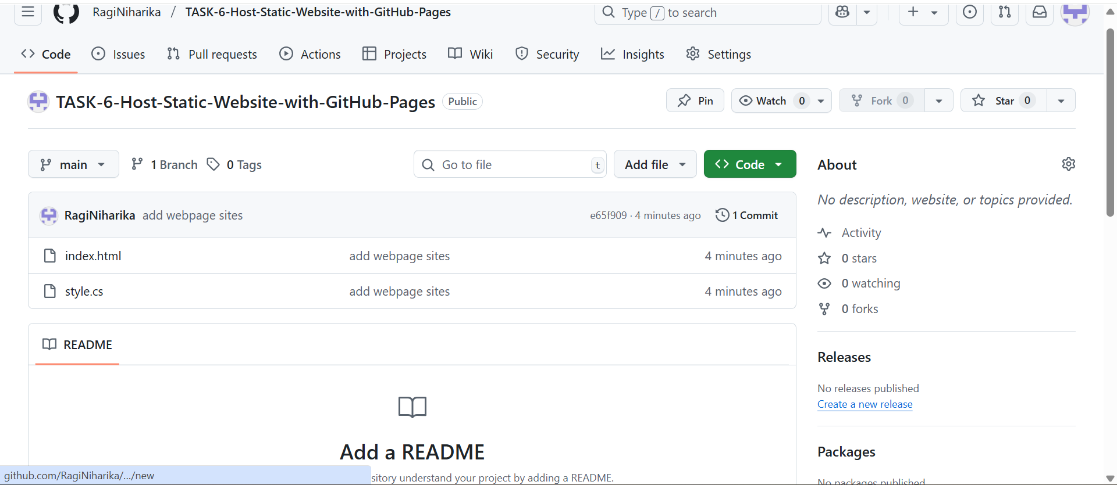

STEP5: **Enable GitHub Pages (web)**

1. Open your repo on GitHub → **Settings** → **Pages** (left sidebar).
2. In **Build and deployment**, set:
   * **Source / Deploy from a branch**
   * **Branch:** main
   * **Folder:** / (root)
3. Click **Save**.

GitHub will start publishing.

**STEP6: Get your live link**

* On the same **Settings → Pages** screen, a green banner will show the site URL
* The link will be:  
  https://<your-username>.github.io/<repo-name>/

**STEP7: Update your site any time**

Edit files locally → commit → push. GitHub Pages auto-rebuilds.

