**Step 1: Connect to your Ubuntu EC2 instance**

* Go to your **AWS Console → EC2 → Instances**.
* Copy the **Public IP**.
* From your local terminal/command prompt, connect via SSH:
* ssh -i your-key.pem ubuntu@<your-ec2-public-ip>

**Step 2: Install Docker**

Update system and install & verify Docker:

* sudo apt update -y
* sudo apt install docker.io -y
* sudo systemctl start docker
* sudo systemctl enable docker
* docker --version

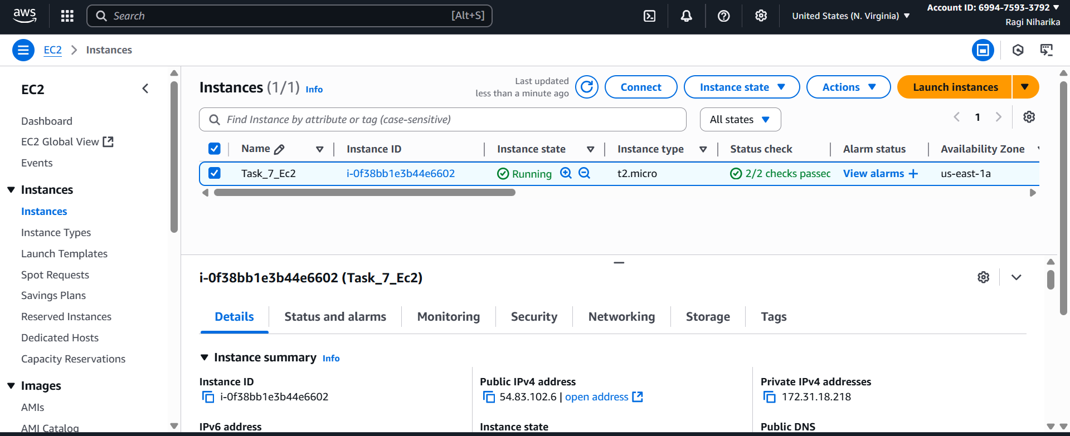

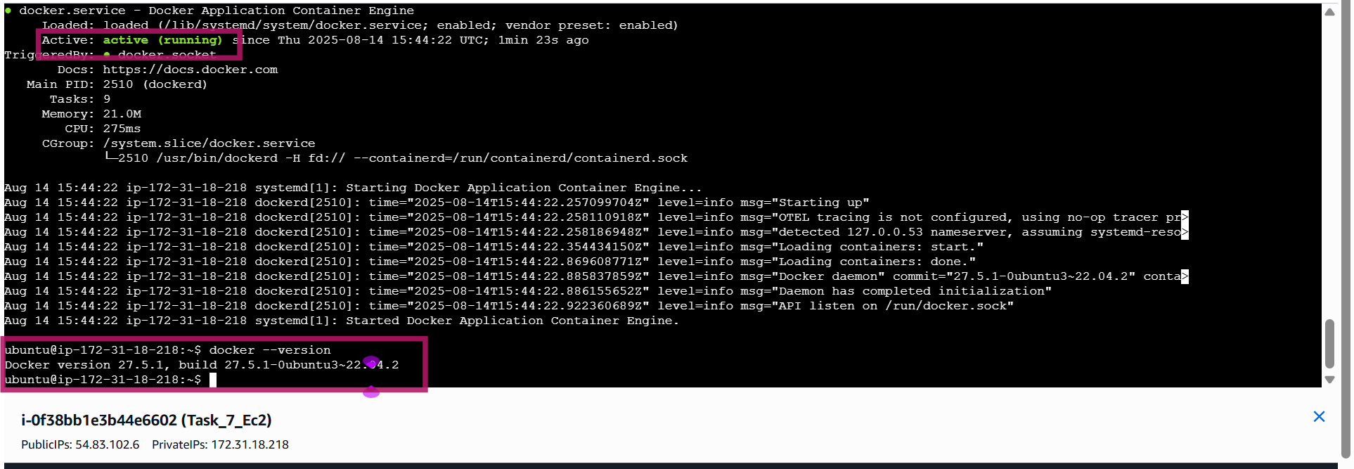

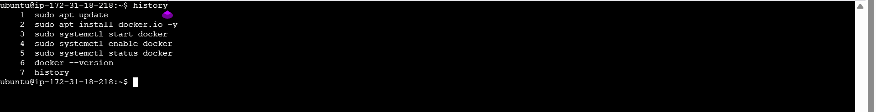

**Step 3: Run Netdata in Docker**

Now run Netdata container:

sudo docker run -d --name=netdata \

-p 19999:19999 \

--cap-add SYS_PTRACE \

--security-opt apparmor=unconfined \

netdata/netdata

Check if the container is running:

sudo docker ps

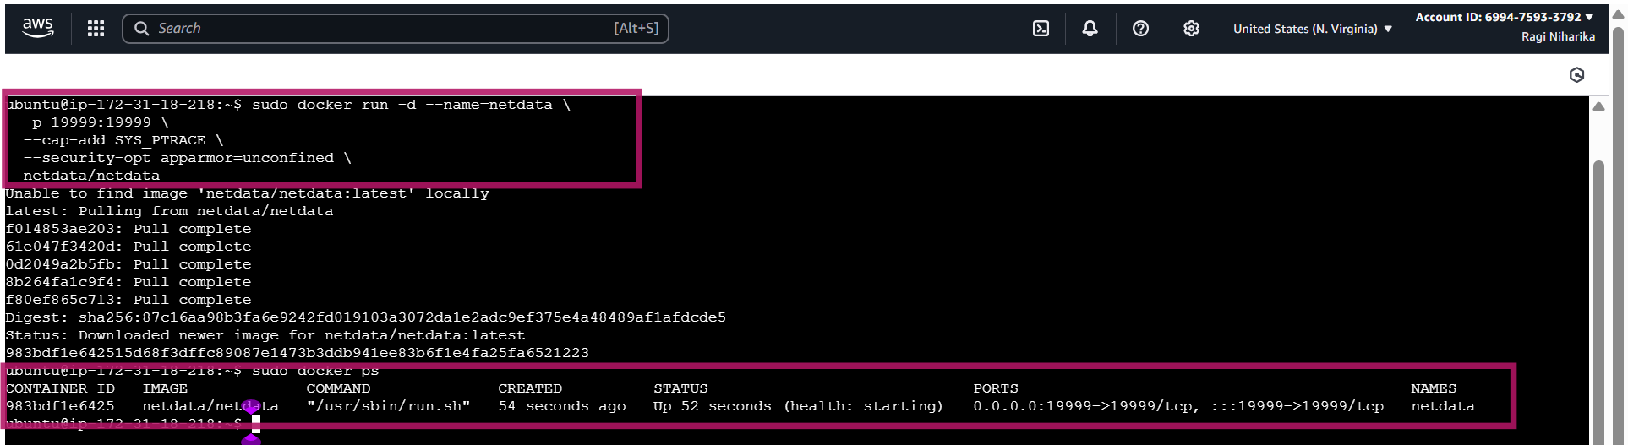

**Step 4: Open Port in AWS Security Group**

* By default, AWS blocks external access. You need to **allow port 19999**:
* Go to **AWS Console → EC2 → Security Groups**.
* Edit inbound rules → **Add Rule**:
  1. Type: Custom TCP
  2. Port: 19999
  3. Source: 0.0.0.0/0 (or your IP for security).

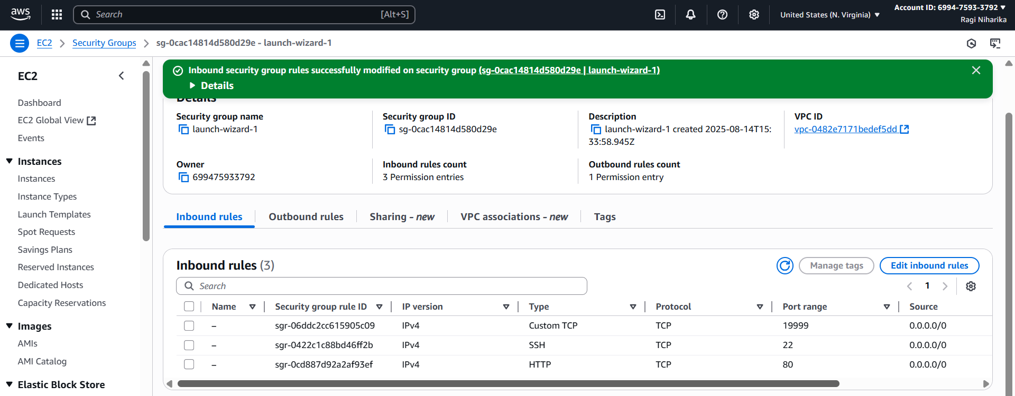

**Step 5: Access Netdata Dashboard**

* Now open your browser and visit:
* http://<your-ec2-public-ip>:19999
* we should see the **Netdata Dashboard** with CPU, memory, disk, Docker, and alerts.

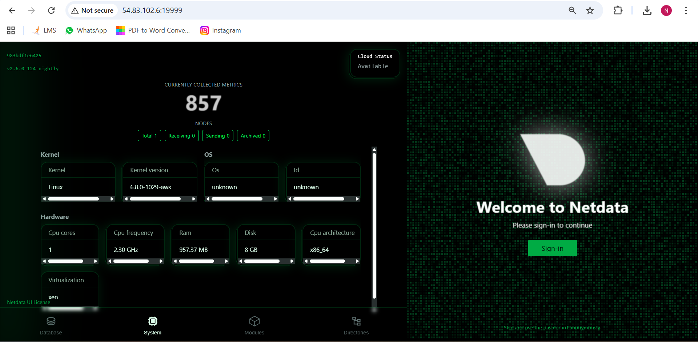

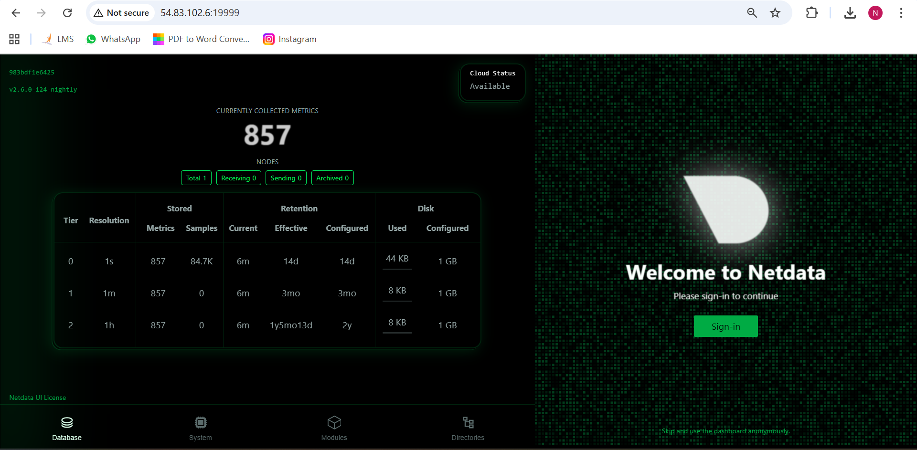

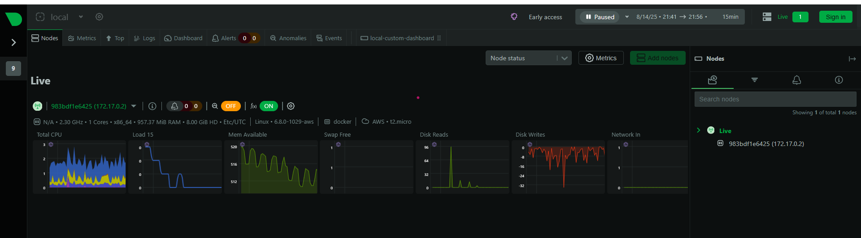

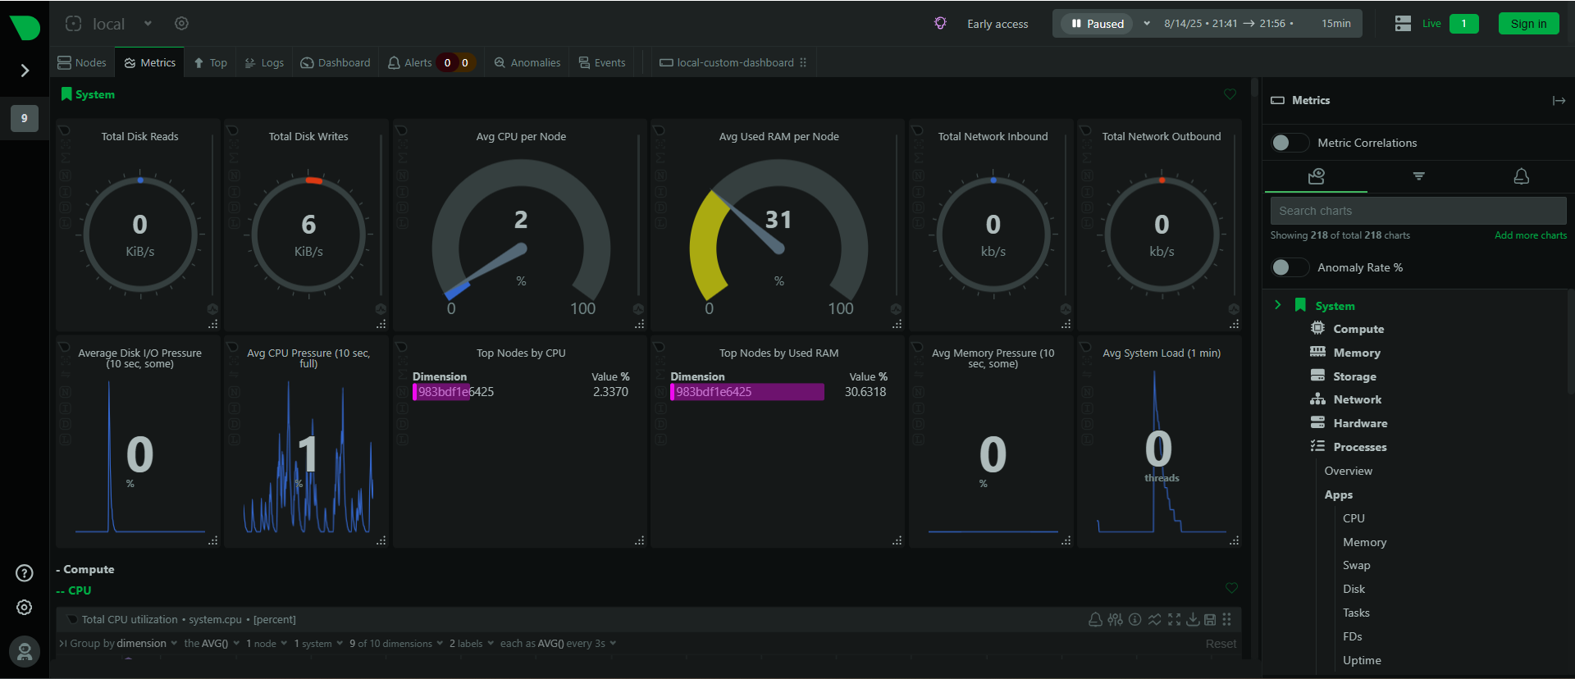

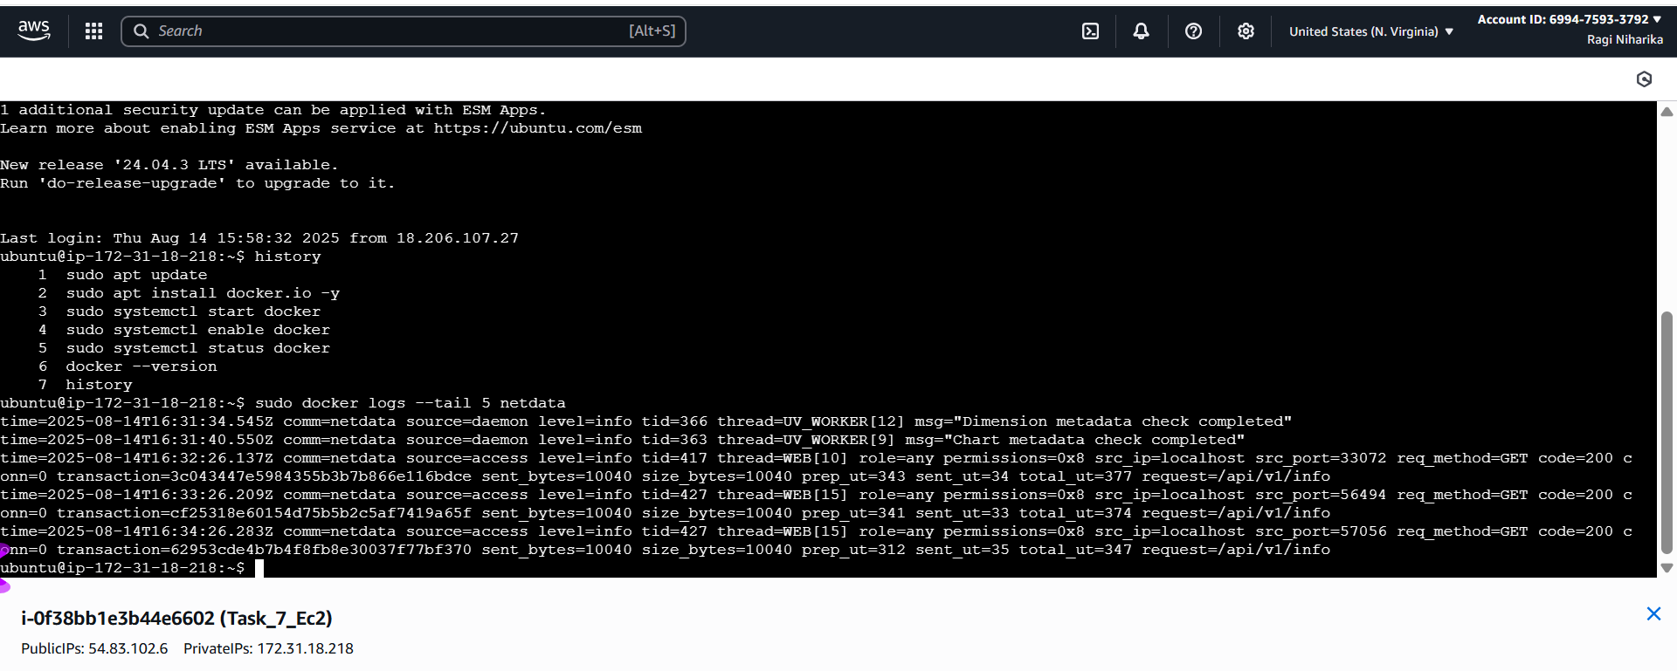

**Explore Logs in /var/log/netdata**

* Since you are running Netdata in Docker:
* sudo docker exec -it netdata bash
* Go to logs folder:
* cd /var/log/netdata
* ls

we will see files like:

* + error.log → Netdata errors
  + access.log → API/dashboard access logs
  + health.log → alarms/alerts logs

View logs (example):

* tail -n 20 health.log

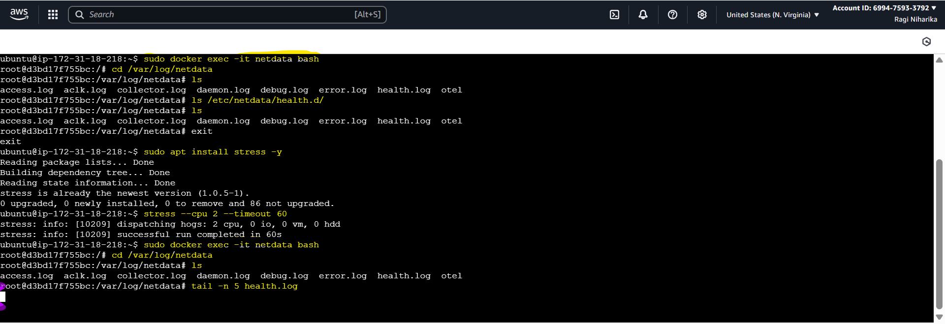

* You’ve opened the **Metrics → System → Compute → CPU** section.
* The charts show:
* **Total CPU utilization (%)** (top graph).
* **Pressure Stall Information (PSI)** (middle graph).
* **CPU stall time (ms)** (bottom graph).

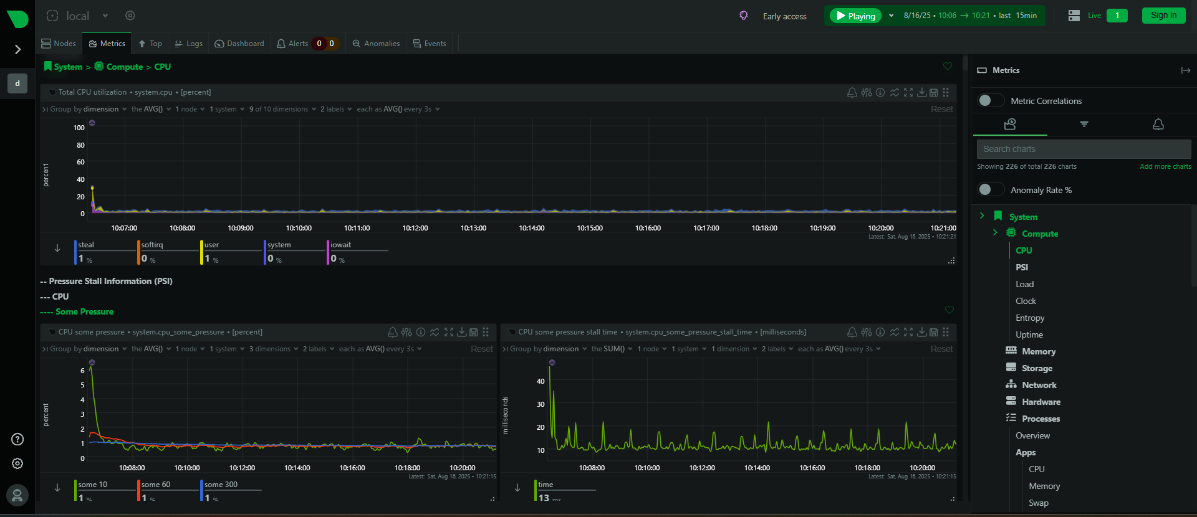

it shows the **System → Memory** section:

* **Top left (gauge):** Available RAM → ~507 MiB free.
* **Top middle (gauge):** Total committed memory → ~2 GiB.
* **Top right:** Node dimension (your container/VM ID → d3bd17f755bc).
* **Bottom graph:** Memory availability trend (in MiB) over time.

