Module 08 [Advanced Topics: Java Programming]:
(for Week 11:28-1/3/2026)

Topic 01 [java Programming: Anonymous object]
Problem Statement: Write a Java program that creates a Point object using anonymous object using the following getPoint() method.
Point pt=getPoint();

Code:
class Point
{
int x;
int y;
Point(int x, int y)
{
this.x=x;
this.y=y;
}
public static Point getPoint(int x, int y)
{

return new Point(x, y);

}
public void display()
{
System.out.println("Point("+x+","+y+")");
}
}
public class Topic01 {
public static void main(String[] args) {
Point pt = Point.getPoint(5,10);
pt.display();

}

}

Topic 02 [java Programming: ArrayList<> object]
Problem Statement: Write a Java program performs the following operations using ArrayList Object
- Declare a ArrayList object ax to store flowers
- Add three flowers: Rose, Lilie, Carnation, Daisie, and Tulip
- Insert a new flower Peonie in the second position of ax
- Delete the flower Lilie
- Find any flower in ax
- Sort the list
- Delete the list

Code:

import java.util.*;
public class Topic2
{
public static void main(String[] args)
{
ArrayList<String> ax = new ArrayList<>();
ax.add("Rose");
ax.add("Lilie");
ax.add("Carnation");
ax.add("Daisie");
ax.add("Tulip");

System.out.println("Initial Array: "+ax);

ax.add(1,"Peonie");
System.out.println("After Insertion: "+ ax);

ax.remove("Lilie");
System.out.println("After Deletion: "+ ax);

String search = "Tulip";
if(ax.contains(search))
{
System.out.println(search+"found in the list");
}
else
{
System.out.println(search + "not found");
}

Collections.sort(ax);
System.out.println("Sorted list"+ ax);

ax.clear();
System.out.println("After Clearing: "+ ax);
}

}

Topic 03 [inheritance: use of super keyword]
Problem Statement: For the following Java program write
- to display x of class A in class B
- statement to call getX() of class A in class B
- to call parameterized constructor of in class B

class A{ int x;
public A(){ x=0;
}
public A(int x){ this.x=x;
}
public int getX(){ return(x+10);
}
class B extends A{ int x=20;
public int getX(){ return(x+10);
}
}
public class First{
public static void main(String[] args) {

}
}

Code:
class A
{
int x;
public A()
{
x=0;
}
public A(int x)
{
this.x=x;
}
public int getX()
{
return(x+10);
}
}
class B extends A
{
int x=20;
public int getX()
{
return(x+10);
}
public int getXa()
{
return super.x;

}
public void show()
{
System.out.println(super.getX());
}
B(int x)
{
super(x);
System.out.println("Super Parameterized Constructor");

}
}
public class First
{
public static void main(String[] args)
{

B b = new B(10);
System.out.println(b.getXa());
System.out.println(b.getX());
b.show();
}
}

Topic 04 [inheritance]
Problem Statement: Implement the following relation diagram into java program
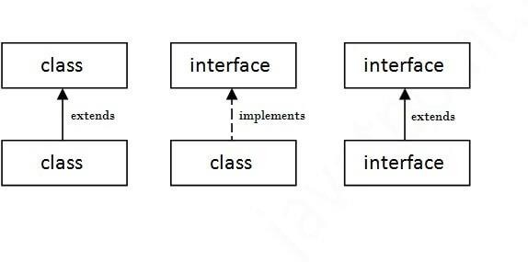 | 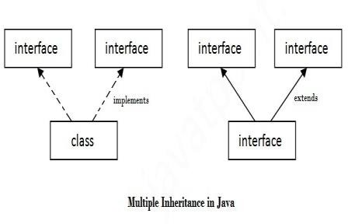

Code:
class A
{
A()
{
System.out.println("A created");
}

}
class B extends A
{
//super(A);

}
public class Topic41 {
public static void main(String[] args)
{
A b = new B();

}

}

interface A
{
void show();

}
class B implements A
{
@Override
public void show()
{
System.out.println("Implemnetd from A");
}

}

public class Topic42 {
public static void main(String[] args) {
B a = new B();
a.show();
}

}

interface a
{
void show();
}
interface b extends a {
@Override
default void show()
{
System.out.println("extened from a");

}
}
public class Topic43 {
public static void main(String[] args) {
b obj = new b() {};
obj.show();
}

}

interface A{
void show();
}
interface B{
void display();
}
class C implements A,B
{
@Override
public void show()
{
System.out.println("From a");

}
@Override
public void display()
{
System.out.println("From b");
}
}
public class topic44 {
public static void main(String[] args)
{
C c = new C();
c.show();
c.display();

}

}

interface A
{
void showA();
}
interface B
{
void showB();
}
interface C extends A,B
{
@Override
default void showA()
{
System.out.println("From A");

}
@Override
default void showB()
{
System.out.println("From B");
}
}
public class topic45 {
public static void main(String[] args)
{
C c = new C(){};
c.showA();
c.showB();
}

}

Topic 05 [Singleton class]
Problem Statement: Write a Java program to create and operate a singleton class.

class Singleton
{
public static int count=0;
private static Singleton[] instance= new Singleton[2];
private Singleton()
{
count++;

}
public static Singleton getInstance()
{
if(count < 2)
{
instance[count] = new Singleton();
}
return instance[count];
}
public void show()
{
System.out.println("Singleton instance");
}
}
public class Topic5
{
public static void main(String[] args)
{
Singleton single1 = Singleton.getInstance();
Singleton single2 = Singleton.getInstance();

System.out.println(Singleton.count);
System.out.println(single2.count);
single1.show();

}

}

Topic 06 [Java Multithreading]
Problem Statement: Write a program to run three applications i) Word Processor ii) Music Player and iii) Real-time clock simultaneously. Use run() method of Thread class or implements runnable interface.

class Wordprocessor extends Thread
{
public void run()
{
for(int i=0; i<10; i++)
{
System.out.println("Word processor is running");
}
}
}
class Musicplayer extends Thread
{
public void run()
{
for(int i=0; i<10; i++)
{
System.out.println("Musicplayer is running");
}
}
}
class Realtimeclock extends Thread
{
public void run()
{
for(int i=0; i<10; i++)
{
System.out.println("Timer is on");
}
}
}
public class Topic6 {
public static void main(String[] args)
{
Wordprocessor word = new Wordprocessor();
Musicplayer music = new Musicplayer();
Realtimeclock timer = new Realtimeclock();
word.start();
music.start();
timer.start();

}

}

class words implements Runnable
{
public void run()
{
for(int i=0; i<10; i++)
System.out.println("Ms Word is running");
}
}
class music implements Runnable
{
public void run()
{
for(int i=0; i<10; i++)
System.out.println("Music is playing");
}

}
class timer implements Runnable
{
public void run()
{
for(int i=0; i<10; i++)
System.out.println("Time is ticking");
}
}
public class Topic6runnable
{
public static void main(String[] args)
{
words w = new words();
Thread w1= new Thread(w);
music m = new music();
Thread m1 = new Thread(m);
timer t = new timer();
Thread t1 = new Thread(t);
w1.start();
m1.start();
t1.start();
}

}

