Task (a):
A single MOD-10 counter must represent 10 different states: 0, 1, 2, 3, 4, 5, 6, 7, 8, and 9. To represent 10 states we need enough flip-flops so that 2^{n} ≥ 10. With n=4, 2⁴ = 16 > 10, which is sufficient. So, each decade counter uses 4 JK flip-flops.
A MOD-100 counter counts from 00 to 99 which can be built from two MOD-10 counter.
Each digit is counted by 4 flipflops.
So, total flip-flops = 4+4 = 8 JK flip-flops is necessary for the MOD-100 counter.
In the existing asynchronous design, the tens-digit stage is clocked by the carry-out of the units-digit stage. The units stage counts from 0 to 9 on each falling edge of the clock. When the units counter transitions from 9 (1001₂) back to 0 (0000₂), it is detected and used as the clock of the first flip-flop of the tens-digit counter. Thus, the tens-counter increments by 1 every time the units stage completes a full count cycle, producing the correct two-digit output.
Task (b):
i) Each J-K flip-flop has a propagation delay of 10 ns. In a ripple counter, each flip-flop is clocked by the output of the previous one. So the maximum number of flip-flop stages a transtion must ripple through from the first flip-flop of units stage to the last flip-flop of the tens stage. Meaning, There will be a propagation delay for 8 flip-flops.
So, T_{worst} = 8 × 10 ns = 80 ns
ii) Here, T_{min} = T_{worst}
So, T_{min} = 80 ns
F_{max} = 1/T_{min} = 1/80 ns = 12.5MHz
iii) During rush periods, we get rapid bursts of pulses at up to 500KHz.
For this value,
T=1/(500× 10³) s = 2µs = 2000ns
Now, T_{operational} (2000ns) >> T_{min} (80ns)
Meaning, at 500KHz, the clock period is 25 times longer than the worst case ripple delay. So, the counter has enough time to settle before the next pulse arrives. Theoretically, there should be no incorrect counts. But due to being an asynchronous counterm, there can be some faults present that can explain this problem.
As in asynchronous counter, flip-flops do not change simultaneously, during change, outputs can pass through intermediate states before settling down to the correct states. This transient states can appear as short flicker or incorrect intermediate value at a display interface. In addition to that, under crowded conditions, electrical noise on the turnstile line can also cause incorrect transtions. In brief, These flickers are caused due to the inherent structural faults of an asynchronous cascaded counter, independent of operating frequency.
Task (c):
The design of one synchronous MOD-10 decade counter using J-K flip-flops is given below-
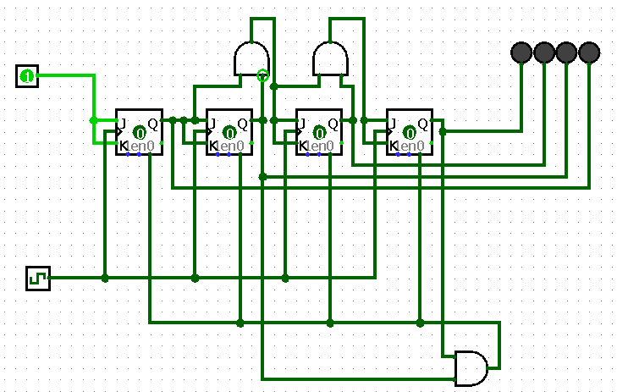
The state transition diagram would be-
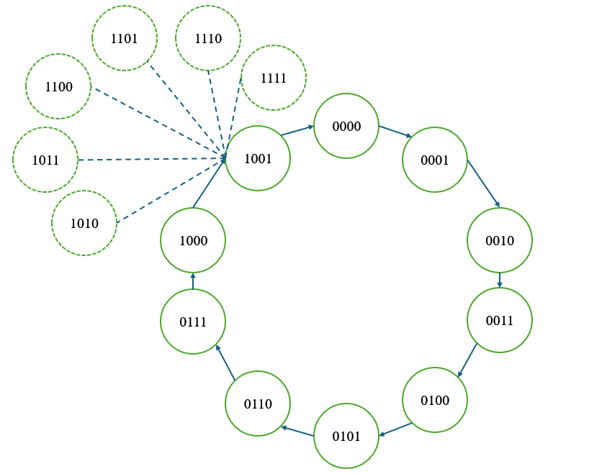

Excitation table for 0 to 15-
State | Q3 | Q2 | Q1 | Q0 | Q3⁺ | Q2⁺ | Q1⁺ | Q0⁺ | J3 | K3 | J2 | K2 | J1 | K1 | J0 | K0
0 | 0 | 0 | 0 | 0 | 0 | 0 | 0 | 1 | 0 | x | 0 | x | 0 | x | 1 | x
1 | 0 | 0 | 0 | 1 | 0 | 0 | 1 | 0 | 0 | x | 0 | x | 1 | x | x | 1
2 | 0 | 0 | 1 | 0 | 0 | 0 | 1 | 1 | 0 | x | 0 | x | x | 0 | 1 | x
3 | 0 | 0 | 1 | 1 | 0 | 1 | 0 | 0 | 0 | x | 1 | x | x | 1 | x | 1
4 | 0 | 1 | 0 | 0 | 0 | 1 | 0 | 1 | 0 | x | x | 0 | 0 | x | 1 | x
5 | 0 | 1 | 0 | 1 | 0 | 1 | 1 | 0 | 0 | x | x | 0 | 1 | x | x | 1
6 | 0 | 1 | 1 | 0 | 0 | 1 | 1 | 1 | 0 | x | x | 0 | x | 0 | 1 | x
7 | 0 | 1 | 1 | 1 | 1 | 0 | 0 | 0 | 1 | x | x | 1 | x | 1 | x | 1
8 | 1 | 0 | 0 | 0 | 1 | 0 | 0 | 1 | x | 0 | 0 | x | 0 | x | 1 | x
9 | 1 | 0 | 0 | 1 | 0 | 0 | 0 | 0 | x | 1 | 0 | x | 0 | x | x | 1
10 | 1 | 0 | 1 | 0 | 0 | 0 | 0 | 0 | x | 1 | 0 | x | x | 1 | 0 | x
11 | 1 | 0 | 1 | 1 | 0 | 0 | 0 | 0 | x | 1 | 0 | x | x | 1 | x | 1
12 | 1 | 1 | 0 | 0 | 0 | 0 | 0 | 0 | x | 1 | x | 1 | 0 | x | 0 | x
13 | 1 | 1 | 0 | 1 | 0 | 0 | 0 | 0 | x | 1 | x | 1 | 0 | x | x | 1
14 | 1 | 1 | 1 | 0 | 0 | 0 | 0 | 0 | x | 1 | x | 1 | x | 1 | 0 | x
15 | 1 | 1 | 1 | 1 | 0 | 0 | 0 | 0 | x | 1 | x | 1 | x | 1 | x | 1

Equations for J-K-
J0=Q₀Q₁Q₂
K0=1
J1=Q₀Q₁Q₃`
K1=Q₀+Q₃
J2=Q₀Q₁Q₃`
K2=Q₀Q₁+Q₃
J3=Q₀Q₁Q₂
K3=Q₀+Q₁+Q₂

Task (d):
i) In a fully synchronous design, both decade share the same clock. But in this case, the tens-stage counter does not receive its clock like so. In stead, it is enabled via a terminal count signal derived from the units-stage counter.
Here the terminal count signal would be equivalent to TC = Q₃.Q₀
This signal is connected to the clocks of the tens-stage flip-flops. When TC=1, tens-stage is clocked normally and increments by 1 and when TC=0, it holds its existing value.
Using it, all flip-flops in both stages simultaneously on the same clock edge, eliminating all ripple delays and glitch states between stages.
Figure for MOD-100 synchronous counter where tens-stage uses terminal count signal as clock-
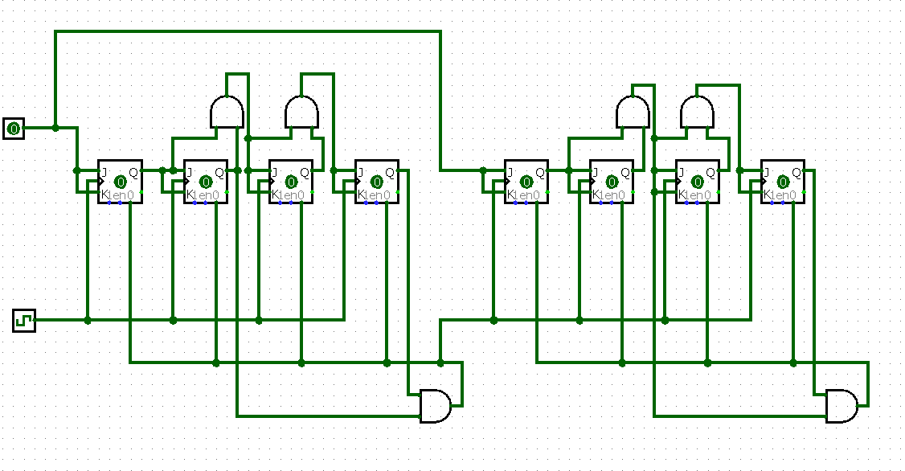
ii) We know from task (b) that each J-K flip-flop has a propagation delay of 10ns. In synchronous design, every flip-flop is operating simultaneously. So, the propagation delay of flip-flops would be- T_{FF}=10ns.
Assuming combinational logic gate delay for terminal count signal generation is T_{TC}=10ns and setup time is T_{S}=5ns,
Total time is = T_{FF}+T_{TC}+T_{S} = (10+10+5) ns = 25ns
Then, F_{max} in synchronous counter is = 1/(500× 10⁻⁹) Hz = 40MHz
This is around 3.2 times higher than the asynchronous design from part (b). Additionally, there are no glitch states.

Part (e):
A fully asynchronous ripple counter has the lowest hardware complexity but its cumulative propagation delay and intermediate states can cause visible glitches during rapid counting. A fully synchronous design uses more combinational logic but all flip-flops change with the same clock, giving better timing control and reducing ripple-related display errors. A hybrid design, with synchronous counting inside each decade and ripple carry between decades, reduces some logic complexity but still retains an inter-stage propagation delay and possible transient behavior. For the hall application, the fully synchronous architecture provides a cleaner timing structure and is better suited to high-speed sensor bursts. Therefore, I would deploy the fully synchronous MOD-100 design because it offers a substantial timing margin while eliminating the asynchronous inter-stage ripple path.

