|  |
| --- |
|  |
| Regression and Time Series Model |
| Group 6 |
|  |
|  |
|  |

|  |
| --- |
|  |

|  |  |
| --- | --- |
| **Yash Parakh** | **13HS20041** |
| **Vinayak Mahbubani** | **13HS20039** |
| **Sunil Yadav** | **13HS20035** |
| **Shubhankar Gupta** | **13HS20034** |
| **Tarang Khairkar** | **13HS20015** |
| **Deepak Sharma** | **13HS20009** |

**Abstract**

One of the major concerns of Central Banks around the world is to understand the dynamics of the inflation process and to forecast it as accurately as possible so that the policies could be implemented accordingly. In 1958, William Philips, a New Zealand born economist tried to establish a relationship between unemployment and inflation in the United Kingdom using the data from 1861-1957, thus establishing the famous Philips Curve. Now in today’s world, trade has increased many fold and all the countries are highly inter-linked. Hence inflation not just depends on unemployment but various other factors too, like currency exchange rates, world growth, oil prices. So in this project, we try to establish as to what factors affect inflation in the United States of America for 1970-2014. Our independent variables are: Broad Money (in percentage of GDP),Broad Money to Total Reserve Ratio, Broad Money Growth (Annual Percentage),Real Interest Rate(in Percent) ,Lending Interest Rate(in Percent),Total Central Government Debt (in Percentage of GDP), Crude Oil Price (per Barrel in Dollars),Growth Rate of GDP.

**Inflation**

Inflation is defined to be a condition of persistent rise in the general level of prices. Of course, it does not mean that all prices are rising without exceptions. This is statistically captured by the persistent upward movement of some aggregate price index, usually WPI or CPI or GDP deflator.

When inflation is measured by some index that uses all prices, it is called head-line inflation. Prices of food and fuel items are considered to be particularly vulnerable to sectoral supply shocks and hence more volatile on average than the rest. Core inflation is measured by subtracting food and fuel inflation from headline inflation.

**Causes of Inflation**

The major explanations of inflation are broadly classified into: Demand – pull factors and Cost – push factors

1. **Demand-pull factors:** Demand-pull inflation occurs when there is an increase in aggregate demand, categorized by the four sections of the macro economy: households, businesses, governments and foreign buyers. When these four sectors concurrently want to purchase more output than the economy can produce, they compete to purchase limited amounts of goods and services. Buyers in essence "bid prices up", again, are causing inflation. This excessive demand, also referred to as "too much money chasing too few goods", usually occurs in an expanding economy. Demand-pull inflation is a product of an increase in aggregate demands that faster than the corresponding increase in aggregate supply. When aggregate demand increases without a change in aggregate supply, the ‘quantity supplied' will increase (given production is *not* at full capacity).

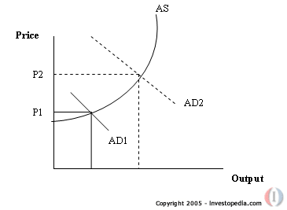

**Figure 1: Demand-Pull Inflation**

Looking again at the price-quantity graph, we can see the relationship between aggregate supply and demand. If aggregate demand increases from AD1 to AD2, in the short run, this will *not* change (shift) aggregate supply, but cause a change in the quantity supplied as represented by a movement along the AS curve. The rationale behind this lack of shift in aggregate supply is that aggregate demand tends to react faster to changes in economic conditions than aggregate supply.

1. **Cost – push factors:** Aggregate supply is the total volume of goods and services produced by an economy at a given price level. When there is a decrease in the aggregate supply of goods and services stemming from an increase in the cost of production, we have cost-push inflation provided the demand remains the same. Cost-push inflation basically means that prices have been "pushed up" by increases in costs of any of the four factors of production (labor, capital, land or entrepreneurship) when companies are already running at full production capacity. With higher production costs and productivity maximized, companies cannot maintain profit margins by producing the same amounts of goods and services. As a result, the increased costs are passed on to consumers, causing a rise in the general price level (inflation).

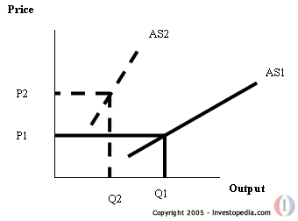

**Figure 2: Cost-Push Inflation**

To visualize how cost-push inflation works, we can use a simple price-quantity graph showing what happens to shifts in aggregate supply. The graph below shows the level of output that can be achieved at each price level. As production costs increase, aggregate supply decreases from AS1 to AS2 (given production is at full capacity), causing an increase in the price level from P1 to P2. The rationale behind this increase is that, for companies to maintain (or increase) profit margins, they will need to raise the retail price paid by consumers, thereby causing inflation.

**Quantity theory of Money**

The quantity theory of money states that there is a direct relationship between the quantity of money in an economy and the level of prices of goods and services sold. According to QTM, if the amount of money in an economy doubles, price levels also double, causing inflation (the percentage rate at which the level of prices is rising in an economy). The consumer therefore pays twice as much for the same amount of the good or service.

***P = Ms / (k* Y)***

**P: General level of Prices**

**Ms: Money Supply**

**Y: Real Income**

**Modern Quantity theory of Money**

Over longer periods of time, the value of Y rises with the growth of labor force, capital accumulation, and technological innovations that raise the productivity of factors. If Y is changing, the QTM equation predicts,

***Gp = Gm - GY***

In the modern version of the quantity theory, money is treated as a luxury good in the sense that an increase in income leads to a more proportionate increase in the demand for money, that is, the income elasticity of money demand is greater than one. Therefore,

***Gp = Gm - BGY***

Where B>1 is the income elasticity of money demand. This approach was the basis for the Chakravarty Committee (1985) rule for monetary targeting in India.

The Modern Quantity theory of Money in its hard form states that:

*“Inflation rate equals the growth rate of nominal money stock minus the growth rate of real money demand”.*

**The Philips Curve**

Controlling inflation is one of the core aspects of monetary policy making. And hence, central bankers have a great deal of interest in forecasting inflation accurately. Inflation also affects the day to day prices and hence the expenses of common man. Thus, forecasting the value of inflation has interested researchers over the years.

In 1958, William Phillips, a New Zealand born economist established a relationship between unemployment and inflation in the United Kingdom using the data from 1861-1957. Phillips found a consistent inverse relationship between unemployment and inflation. When unemployment was high, wages increased slowly; when unemployment was low, wages rose rapidly. Phillips conjectured that the lower the unemployment rate, the tighter the labor market would be and, therefore, the faster firms must raise wages to attract scarce labor. At higher rates of unemployment, the pressure abated. Phillips curve represented the average relationship between unemployment and wage behavior over the business cycle. It showed the rate of wage inflation that would result if a particular level of unemployment persisted for some time. Monetarists exploited the idea of Phillips Curve. They assumed that they could use the tradeoff to reduce unemployment at a small cost of additional inflation.

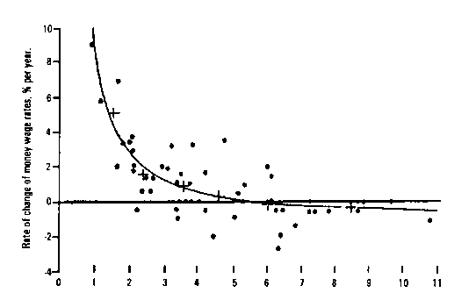

**Figure 3: Philips Curve**

But, twenty years down the road, the inverse relationship between inflation and unemployment as described by Philips started to crumble in the wake of OPEC oil crisis. High inflation rates along with high unemployment rates were observed. The Federal Reserve Bank of Boston in its paper published in June 1978 titled “After the Phillips Curve: Persistence of High Inflation and High Unemployment” noted that in some countries, such as France, Italy, the United Kingdom and Canada, the unemployment rate in 1977 was as high as or higher than in 1973, the last year of general prosperity; but the inflation rate was higher also. Similarly, in the United States, the unemployment rate also was higher in 1977 than in 1973, and the rate of inflation was only slightly lower. Phelps and Friedman, in separate researches, argued that the effect of low rates would eventually wear off and unemployment would rise back to the non-accelerating inflation rate of unemployment or NAIRU for short, leaving behind a higher inflation rate. Lucas and Sargent (1979) in the wake of these events concluded that the prediction of Keynesian models were wildly incorrect and the doctrine on which they were based were fundamentally flawed. They also called these developments as "the spectacular failure of the Keynesian models in the 1970s”. In the post oil crisis period, monetary policy frameworks have been set out to target various factors like exchange rate, different measures of money supply etc. Stock and Watson in their paper titled Forecasting Inflation (1999) noted that “the unemployment rate Phillips curve can play a useful role in forecasting inflation, but that relying on it to the exclusion of other forecasts is a mistake.” Various researchers like Kydland, Prescott, Sargent are often attributed as the creators of the New‐ Keynesian Phillips Curve. It emphasizes forward‐looking expectations that can jump in response to anticipated policy changes. Clearly, if researches are anything to go by, we can observe that unemployment is not the only factor to be considered in evaluating the inflation. The inflation depends on various other factors too.

**Initial Linear Regression**

The impact of all the factors affecting inflation will be studied in the first place with a multiple linear regression models. If they have significant influence to inflation, it will be included in the final multiple regression model or inflation rate.

The factors included in the initial study are:

* Broad Money to Total Reserves
* Broad Money(% of GDP)
* Broad Money Growth
* Real Interest Rate
* Lending Interest Rate
* Central Government Debt(% of GDP)
* Crude oil price per barrel(in dollars)
* Real GDP growth

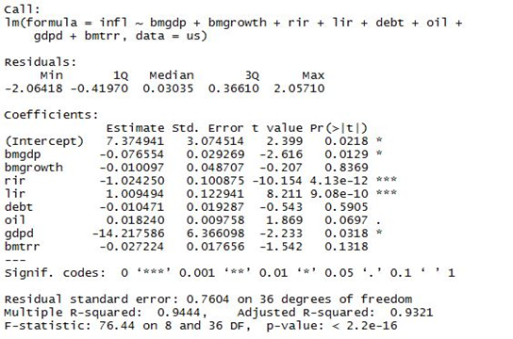

**Model 1**

Multiple R-squared in model 1 is 0.94 which might be the result of multi-collinearity in the model. Correlation between factors will be studied to determine the extent of multi-collinearity which will be determined by variance inflation factor (VIF).

**Multi-collinearity**

The variance inflation factor quantifies the severity of multicollinearity in an ordinary least squares regression analysis. A rule of thumb is that if VIF > 5 then multicollinearity is high.

The square root of the variance inflation factor tells you how large the standard error is, compared with what it would be if that variable were uncorrelated with the other predictor variables in the model.

**Step -1**



**Step - 2**



**Step - 3**



VIF of Lending Interest Rate in Step-1 is much higher than 5 leading to its exclusion in Step-2. Similarly the variable for crude oil prices is excluded in Step-3 resulting in 6 factors with no correlation with each other.

**Regression Model 2.0**

There is a correlation between Lending Interest Rate and Real Interest Rate and between Broad Money (% of GDP) and Crude oil price per barrel (in dollars) and also between Central Government Debt (% of GDP) and Crude oil price per barrel (in dollars).We try to removing multicollinearity from the model .After removing multicollinearity from the model there are six factors remaining .By remaining six factors calculating the linear regression model but is this model adequate?

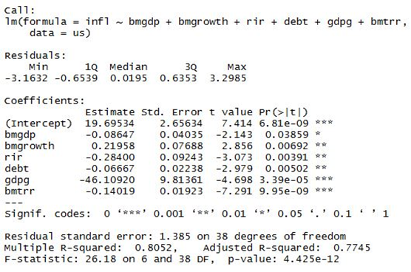

**Model 2.0**

To check adequacy of the model we plot the Normal Probability plot and residuals versus fitted values.

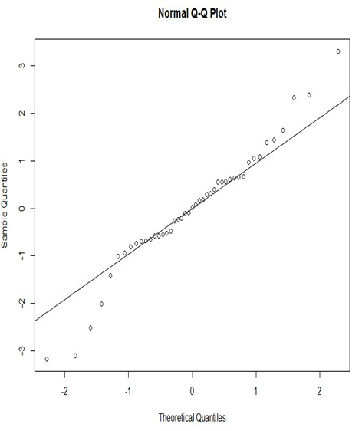 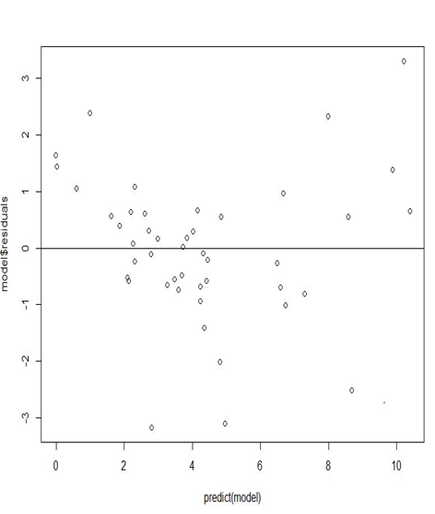

**Figure 4: Normal Probability Plot Figure 5: Residuals vs. Fitted Values**

In the normal probability plot some values are deviating from the straight line, also in years 1980, 1986 and 2010 the error terms have a magnitude of 3.2. Considering these points as outliers and again finding the linear regression model.

**Final Regression Model**

Model 3 is determined after removing the outliers obtained above. The multiple R-squared is considerably increased in this model. Broad Money (% of GDP) is no longer significant in the model having p-value greater than 0.05.

Hence, excluding Broad Money (% of GDP) Model 4 is obtained with no significant change in multiple R-squared. This Model is the final regression model with broad money growth, broad money to total reserve ratio, real interest rate, government debt and GDP growth as the independent variables.

The linear regression equation is:

*infl* = 14.14439 + 0.15712*(*bmgrowth*) -0.22072*(*rir*) - 0.08678*(*debt*) - 40.52219*(*gdpg*) - 0.12324*(*bmtrr*)

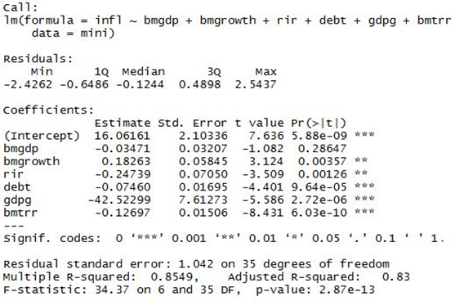**Model 3**

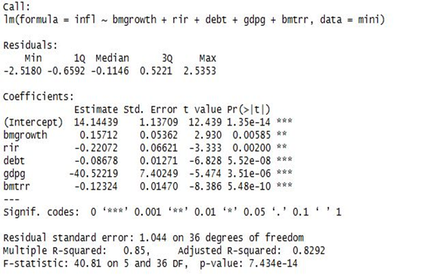

**Model 4**

Considering all the influence factors included in the multiple regression model, the actual inflation and predicted inflation are presented in the figure:

**Figure 6: Actual Inflation vs. Predicted Inflation**

**Conclusion**

This model explains 85% of regression model as significant as we found R squared value is 0.85.

Inflation depends on Broad Money Growth, Broad Money to Total Reserves, Real Interest Rate Lending Interest Rate, Central Government Debt (% of GDP), and Real GDP growth.

Correlation between Lending Interest Rate and Real Interest Rate and between Broad Money(% of GDP) and Crude oil price per barrel(in dollars)and also between Central Government Debt(% of GDP) and Crude oil price per barrel(in dollars).

After removing multicollinearity Broad Money as a percentage of GDP comes out to be insignificant.

**References**

Phillips Curve Inflation Forecasts - *James H. Stock and Mark W. Watson* (1999)

Real-Time Inflation Forecasting in a Changing World – *Groen, Paap, Ravazzalo* (2009)

After the Phillips Curve: Persistence of High Inflation and High Unemployment – *Federal Reserve Bank of Boston* (1978)

UK Phillips Curves and Monetary Policy - *Andrew* *Haldane and Danny Quah* (October 1999)

Forecasting Inflation - *Jon Faust and Jonathan H. Wright* (2011)

The History of Philips Curve: *Consensus and Bifurcation - Robert Gordon* (2009)

The Historical Place of the ‘Friedman - Phelps’ Expectations Critique - *James Forder* (2009)

Is Philips Curve useful for Forecasting Inflation? - *Atkenson, Ohanian* (2001)

Why Has U.S. Inflation Become Harder to Forecast? - *Stock, Watson* (2006)

The Phillips Curve and Long Term Unemployment - *Ricardo Llaudes* (2005)

Understanding Inflation and controlling it - *Kaushik Basu* (Chief Economic Advisor, Ministry of Finance, Government of India) (2011)

Modeling Inflation Dynamics: A Critical Review of Recent Research - *Rudd, Whelan* (2006)

**Appendix 1**

|  |  |
| --- | --- |
| **Key** | **Description** |
| bmgdp | Broad Money as a percentage of GDP |
| bmgrowth | Broad Money Growth |
| rir | Real Interest Rate |
| lir | Lending Interest Rate |
| debt | Central Government Debt as a % of GDP |
| oil | Crude Oil Price per barrel |
| gdpd | Real GDP Growth Rate |
| bmtrr | Ratio of Broad Money to Total Reserves |

**Appendix 2**

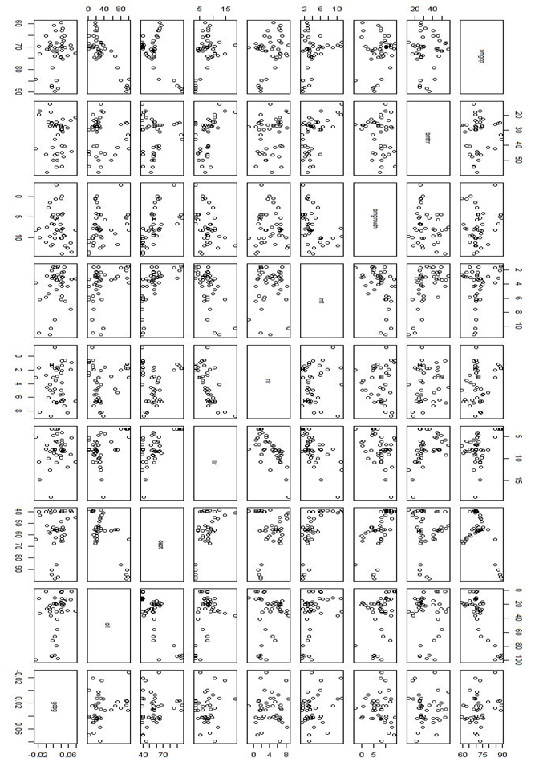

**Figure 7: Scatter Plot Matrix**