**//bubble sort:**

import java.util.Scanner;

class bubblesort

{

public static void main(String[] args)

{

int n,i,j,temp;

Scanner ob= new Scanner(System.in);

System.out.println("Input number of integers to sort:");

n=ob.nextInt();

int array[]=new int[n];

System.out.println("Enter" + n + "Integers:");

for(i=0;i<n;i++)

{

array[i]=ob.nextInt();

}

for(i=0;i<n-1;i++)

{

for(j=i+1;j<n;j++)

{

if(array[i]>array[i+1])

{

temp=array[i];

array[i]=array[i+1];

array[i+1]=temp;

}

}

}

System.out.println("your sorted array is:");

for(i=0;i<n;i++)

{

System.out.println(array[i]);

}

}

}

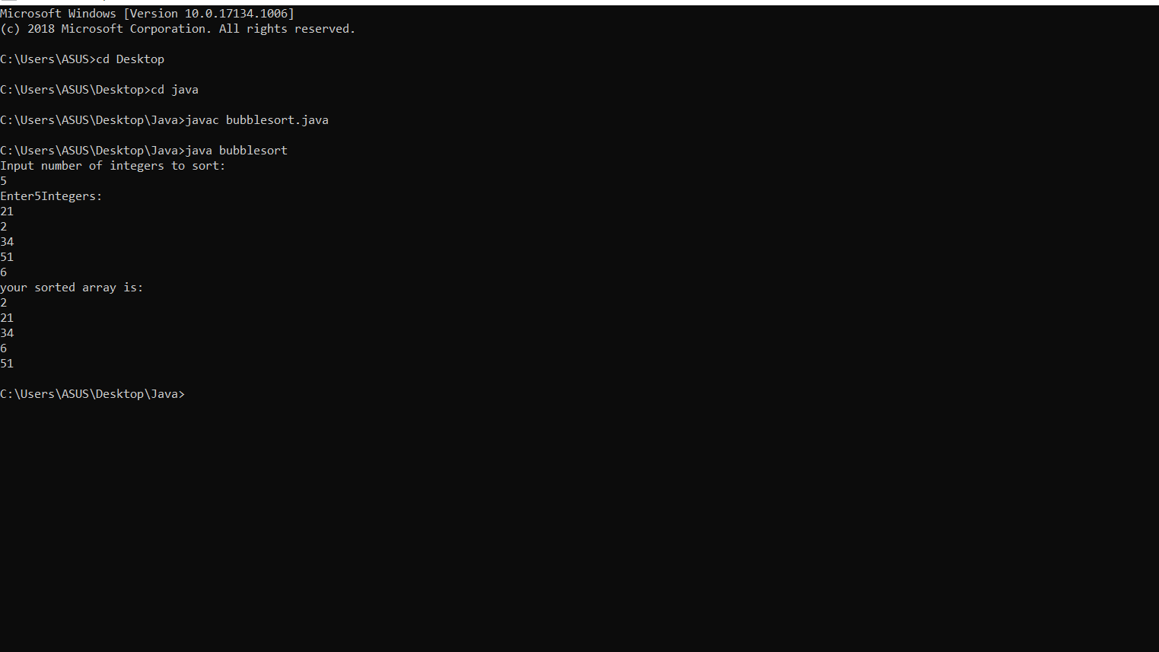

**//selection sort:**

import java.util.Scanner;

class selectionsort

{

public static void main(String[] args)

{

int min,n,i,j,temp;

Scanner ob=new Scanner(System.in);

System.out.println("Input number of integers to sort:");

n=ob.nextInt();

int array[]=new int[n];

System.out.println("Enter" + n + "Integers:");

for(i=0;i<n;i++)

{

array[i]=ob.nextInt();

}

for(i=0;i<n-1;i++)

{ min=i;

for(j=i+1;j<n;j++)

{

if(array[j]<array[min])

{

min=j;

}

}

temp=array[min];

array[min]=array[i];

array[i]=temp;

}

System.out.println("your sorted array is:");

for(i=0;i<n;i++)

{

System.out.println(array[i]);

}

}

}

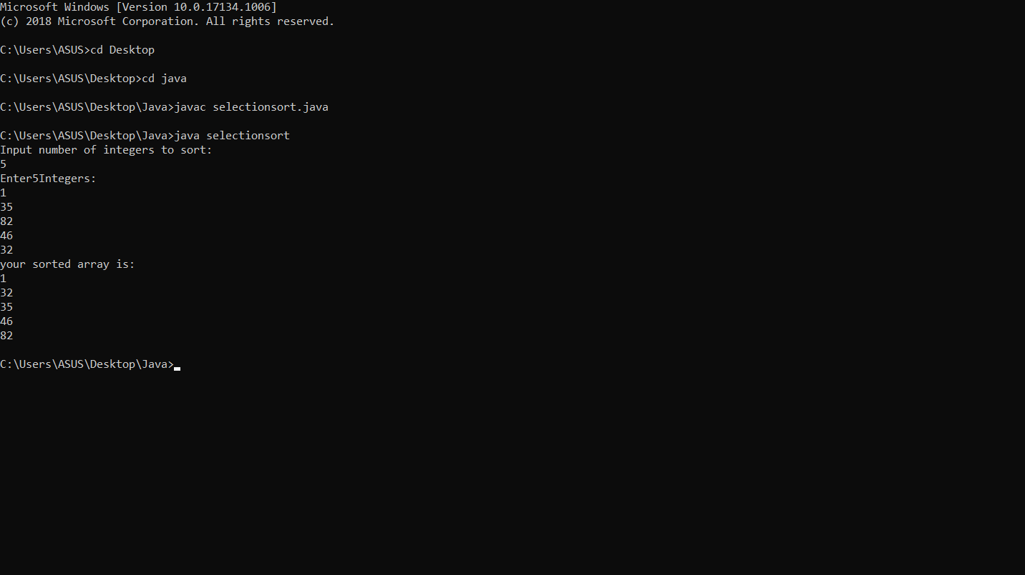

**//insertion sort:**

import java.util.Scanner;

class insertionsort

{

public static void main(String[] args)

{

int n,key,i,j,temp;

Scanner ob=new Scanner(System.in);

System.out.println("Input number of integers to sort:");

n=ob.nextInt();

int array[]=new int[n];

System.out.println("Enter" + n + "Integers:");

for(i=0;i<n;i++)

{

array[i]=ob.nextInt();

}

for(i=1;i<n;i++)

{ key=array[i];

j=i-1;

while(j>=0 && array[j]>key)

{

array[j+1]=array[j];

j=j-1;

}

array[j+1]=key;

}

System.out.println("your sorted array is:");

for(i=0;i<n;i++)

{

System.out.println(array[i]);

}

}

}

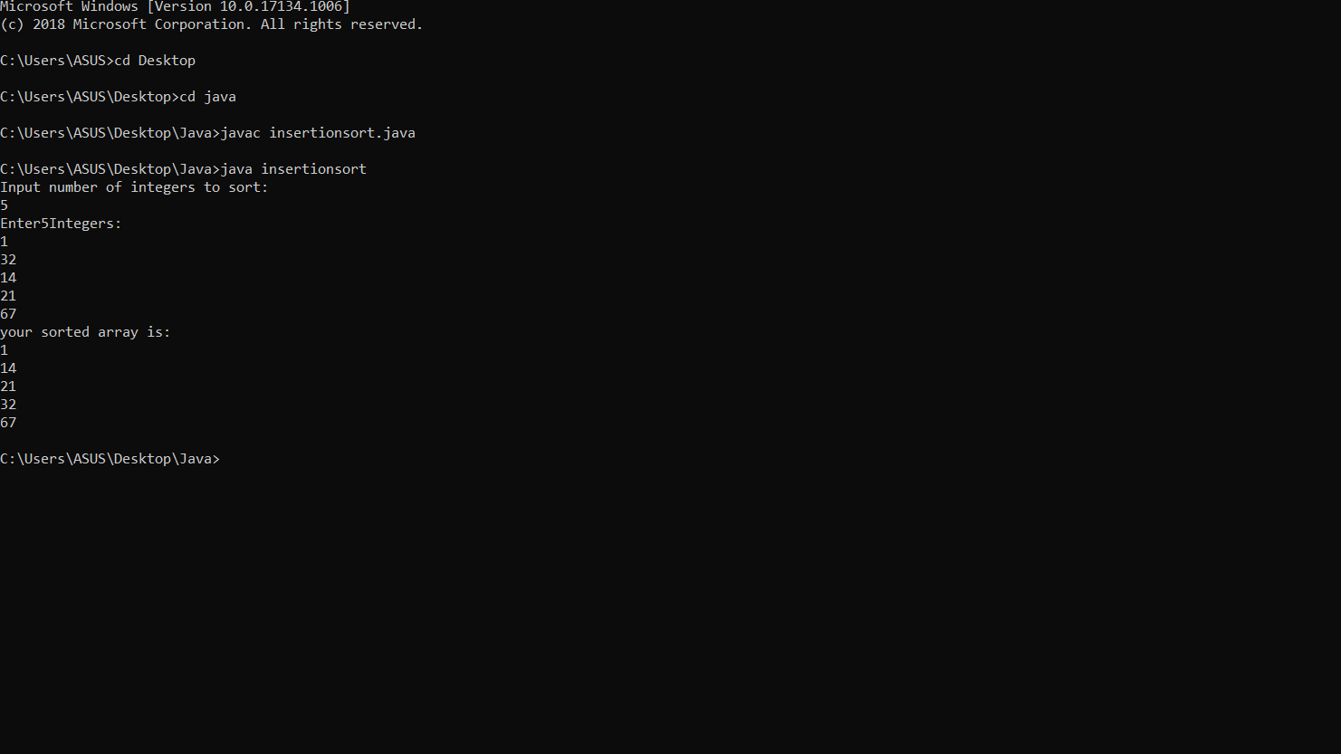

**//binary search:**

import java.util.Scanner;

class binary

{

public static void main(String[] args)

{

int n,first,last,middle,s,i;

Scanner ob=new Scanner(System.in);

System.out.println("Input number of integers to sort:");

n=ob.nextInt();

int array[]=new int[n];

System.out.println("Enter" + n + "Integers:");

for(i=0;i<n;i++)

{

array[i]=ob.nextInt();

}

System.out.println("Enter search value:");

s=ob.nextInt();

first=0;

last=n-1;

middle=(first + last)/2;

while(first<=last)

{

if(array[middle]<s)

{

first=middle + 1;

}

else if(array[middle]==s)

{

System.out.println(s +"found at location" + (middle + 1) + ".");

break;

}

else

{

last=middle - 1;

}

middle= (first + last)/2;

}

if(first>last)

System.out.println(s +"is not found.\n");

}

}

