Title:
Insurance Policy Management System using GraphQL
Name : Ragini Singh
Cohort : Jensen Huang
Roll No : 150096724023
Problem Statement No : 023
Subject : GraphQL + GraphDB Internal Mini Project
Date: 27/02/2026

​​2️⃣ Introduction:
This project is a backend-based Insurance Policy Management System developed using GraphQL and MongoDB Atlas. The system allows users to create customers, assign insurance policies, and fetch customer data dynamically using GraphQL queries and mutations.

3️⃣ Objective
The main objective of this project is:
- To understand GraphQL concepts
- To implement queries and mutations
- To connect FastAPI with MongoDB Atlas
- To handle nested relationships between customers and policies

4️⃣ Technology Stack
- FastAPI – Backend Framework
- Strawberry GraphQL – GraphQL implementation in Python
- MongoDB Atlas – Cloud Database
- PyMongo – MongoDB driver

5️⃣ System Architecture
The client sends GraphQL queries and mutations through a single endpoint (/graphql).
The FastAPI server processes the request using resolvers.
The data is stored and retrieved from MongoDB Atlas.

6️⃣ Project Structure
insurance_system/
│
├── main.py
├── schema.py
├── database.py
├── .env

7️⃣ GraphQL Operations

Query Example
{
customers {
id
name
email
policies {
policyName
premium
}
}
}

Explain:
This query fetches customer data along with their policies.

Mutation Example – Create Customer
mutation {
createCustomer(name: "DemoUser", email: "demo@email.com")
}
Explain:
This mutation inserts a new customer into the database.

Mutation Example – Add Policy
mutation {
addPolicy(
customerId: "ID"
policyName: "Health Insurance"
premium: 5000
)
}
Explain:
This mutation attaches a policy to an existing customer.

8️⃣ Difference Between GraphQL and GraphDB
GraphQL is a query language for APIs.
Graph Database stores data as nodes and relationships.

9️⃣ Output Screenshots:

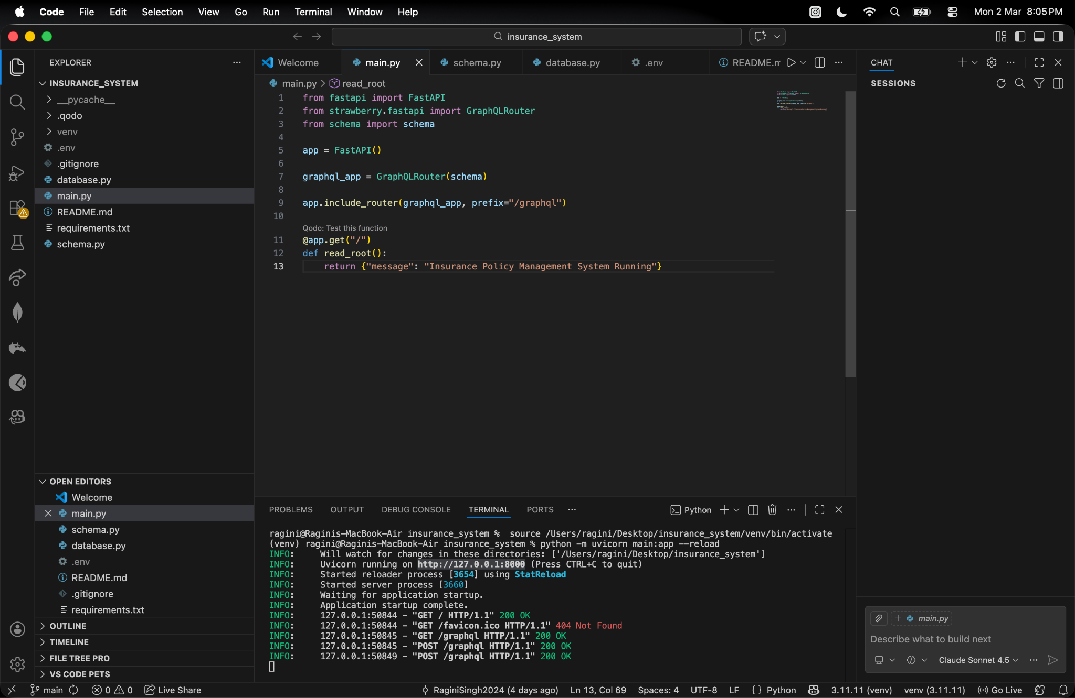

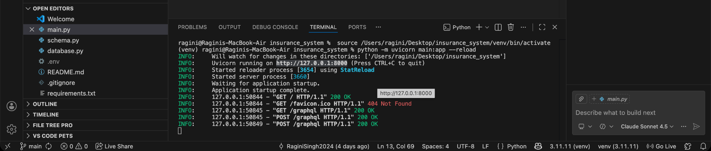

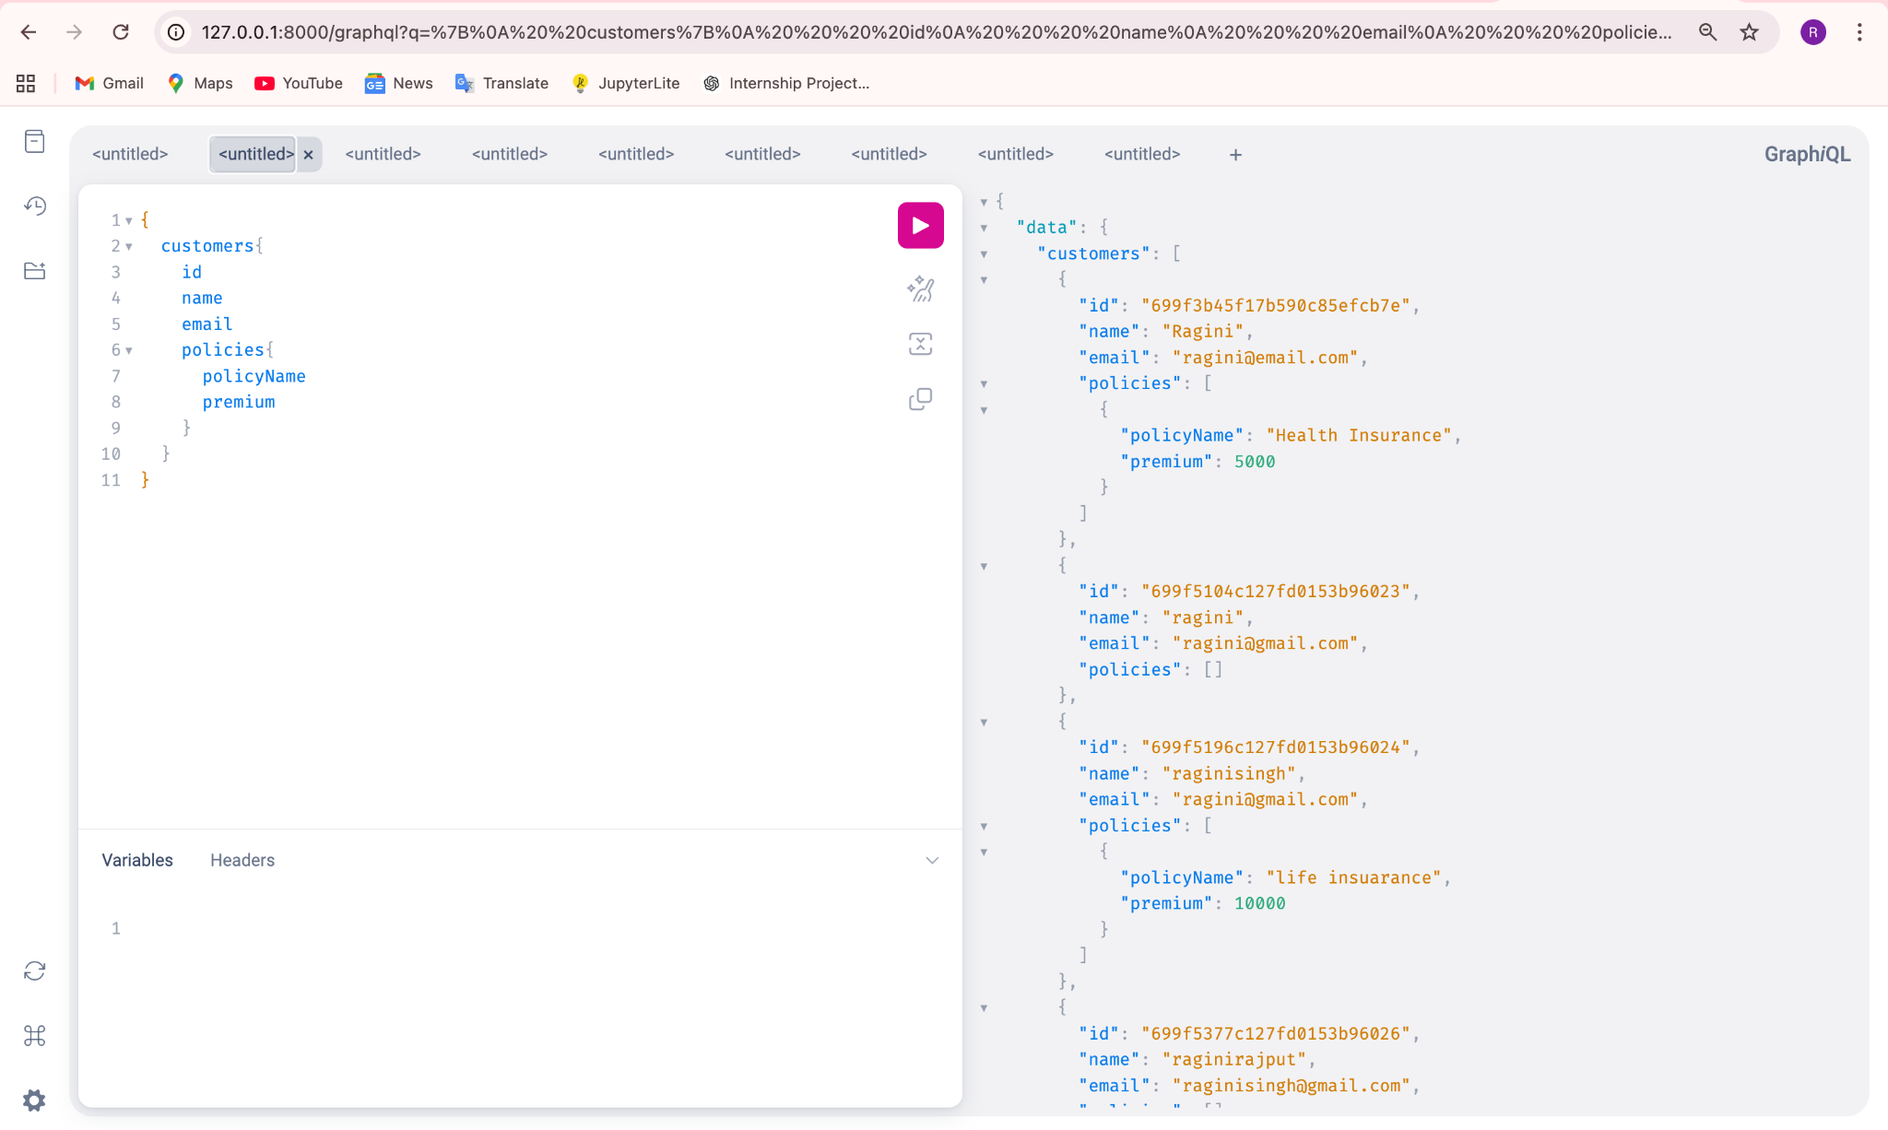

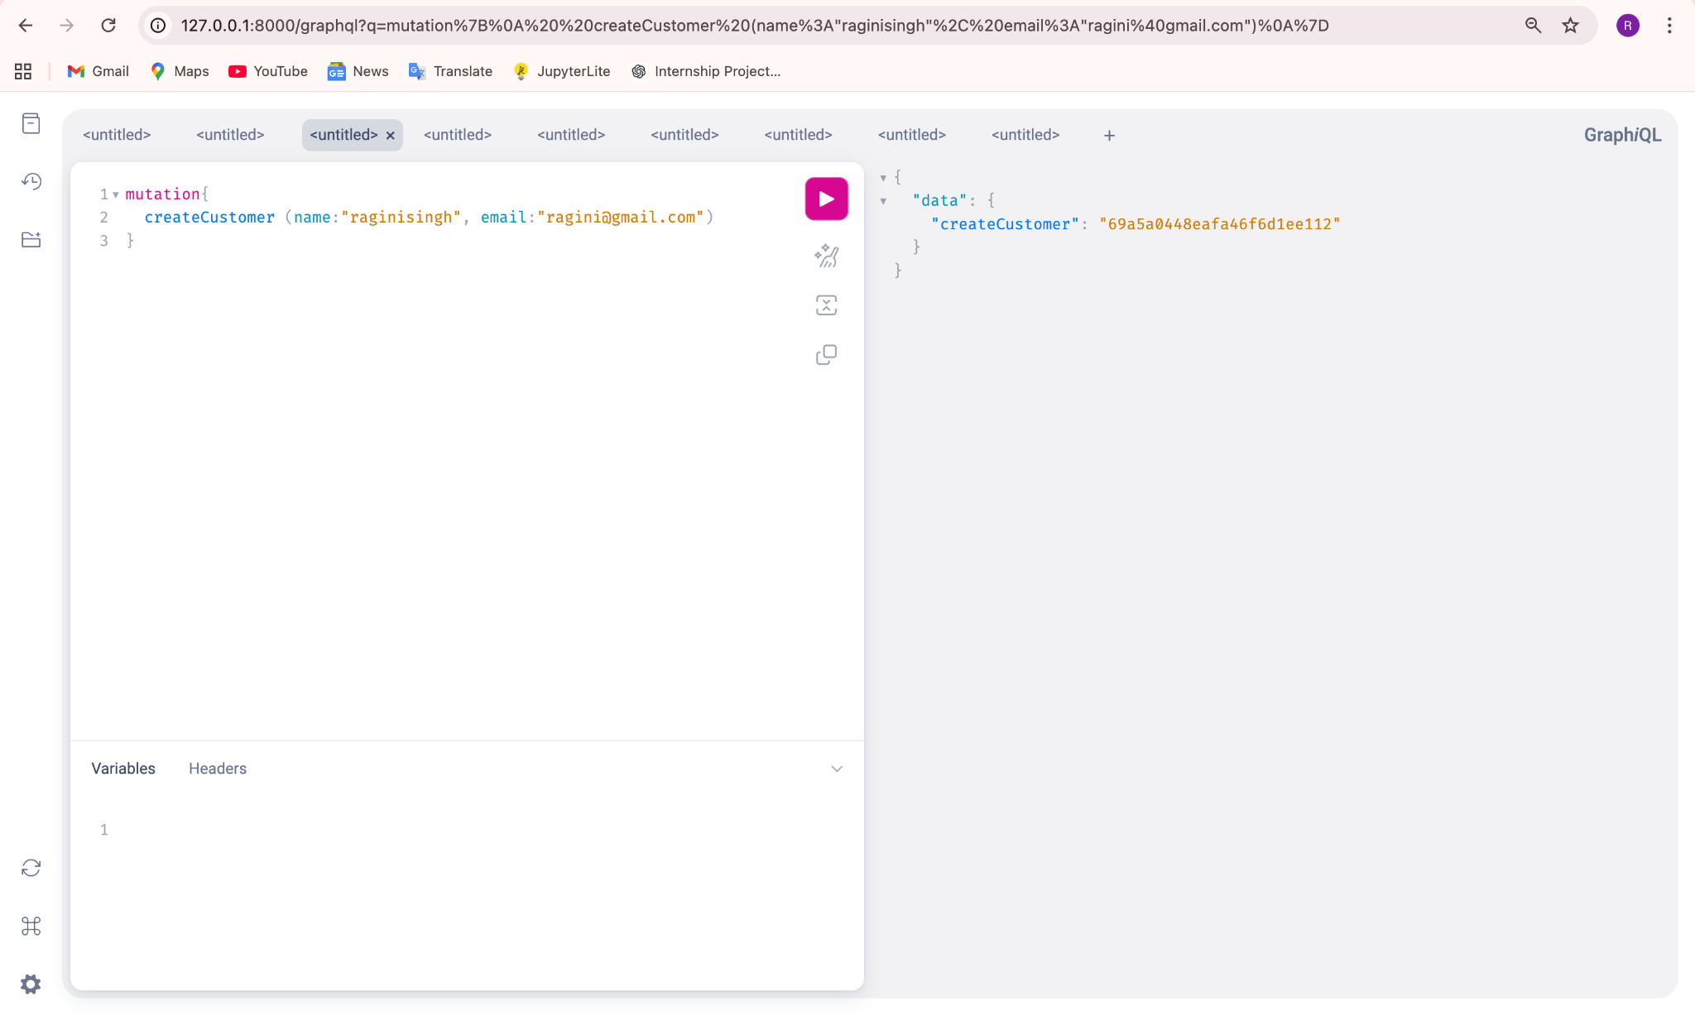

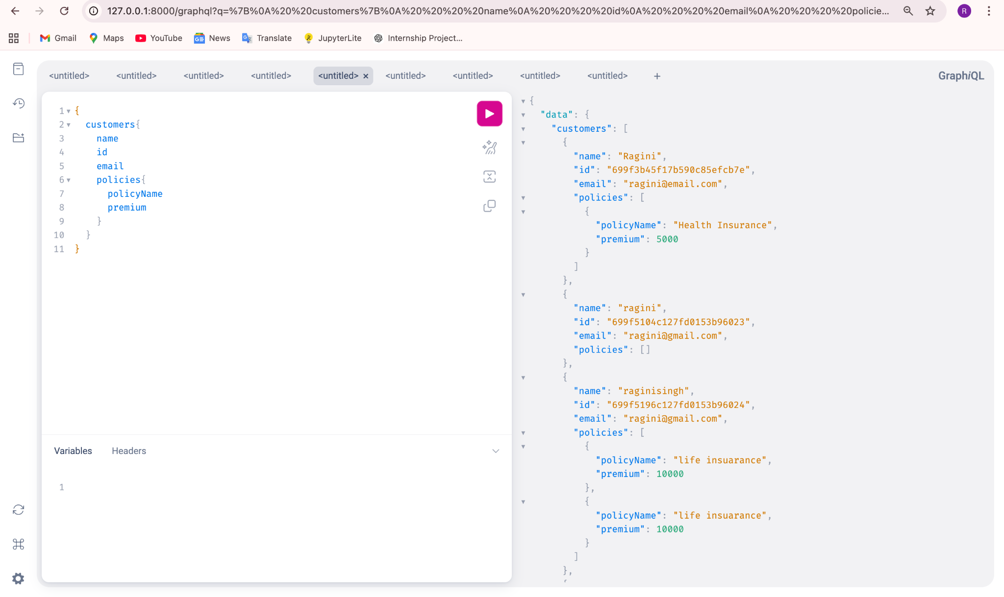
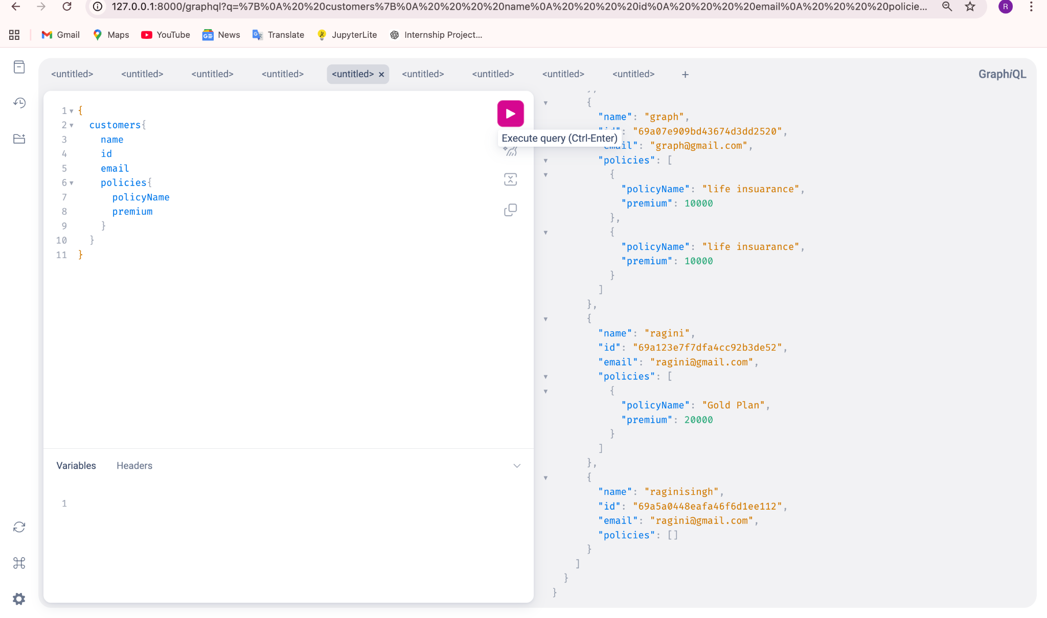

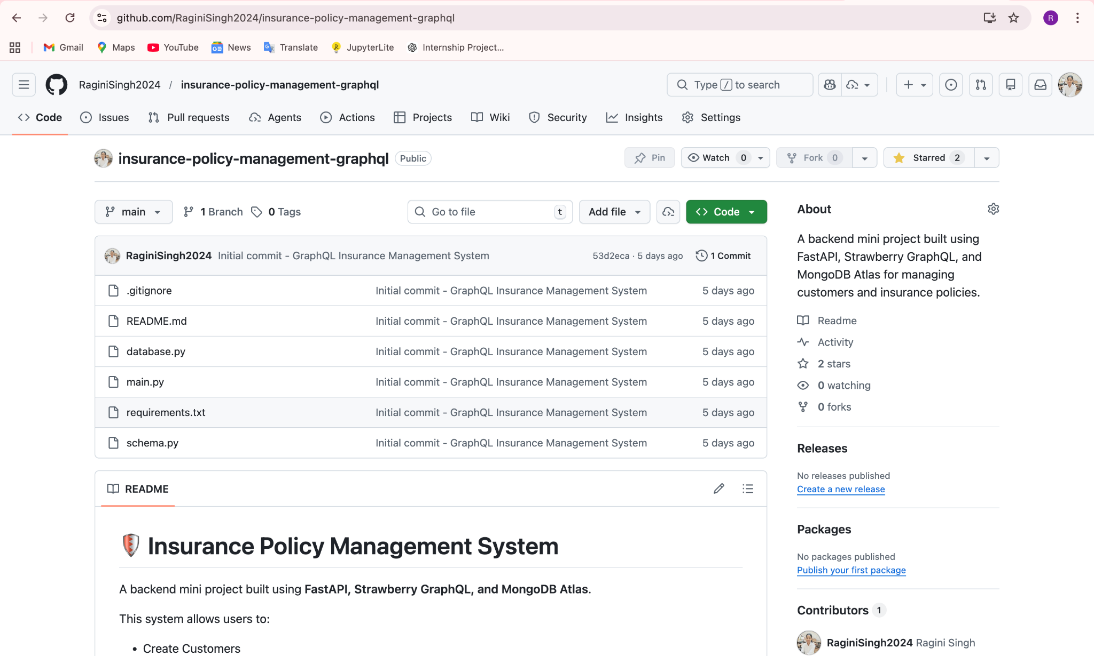

🔟 Conclusion
This project helped me understand the practical implementation of GraphQL, schema design, resolvers, and database integration. It improved my backend development skills and knowledge of API architecture.

Github Repo Link :

https://github.com/RaginiSingh2024/insurance-policy-management-graphql

