ITM SKILLS UNIVERSITY
B.Tech – Computer Science & Engineering

MACHINE LEARNING FUNDAMENTALS
SEMESTER V – SPRINT 1 EXAM

PROJECT REPORT
Farm Production Cost Prediction Using Machine Learning

Student Name | Ragini Singh
Roll Number | 150096724023
Problem Statement No. | PS 146
Problem Statement Title | Farm Production Cost Prediction
Subject | Machine Learning Fundamentals
Semester | V
Assessment | Sprint 1 Exam

Github Repo Link : https://github.com/RaginiSingh2024/ML-PS146-Farm-Production-Cost-Prediction
Deployment Link : https://ml-ps146-farm-appuction-cost-prediction-nwquxvdesgufqsuj4uqgsm.streamlit.app/

Academic Project Report

Table of Contents
- 1. Project Overview
- 2. Problem Statement
- 3. Objectives
- 4. Proposed Solution
- 5. Dataset Description
- 6. Input Features and Target Variable
- 7. Data Processing and Methodology
- 8. Regression Algorithms Implemented
- 9. Evaluation Metrics
- 10. Model Comparison Results
- 11. Selected Model
- 12. Cost Driver / Feature Importance Analysis
- 13. Farm Area and Production Cost Relationship
- 14. Prediction Demonstration
- 15. Web Application and Deployment
- 16. Project Structure
- 17. Case Study Questions and Answers
- 18. Limitations
- 19. Future Scope
- 20. Conclusion
- 21. Project Deliverables

1. Project Overview
This project implements a machine learning regression system for predicting total farm production cost. The solution analyzes agricultural expenditure variables, compares five regression algorithms, evaluates their prediction performance, identifies important cost drivers, and provides a web-based prediction interface.
The project was developed for Machine Learning Fundamentals, Semester V, Sprint 1 Exam, under Problem Statement 146. The implementation includes a dataset, executed Jupyter Notebook, preprocessing and training modules, evaluation outputs, a serialized best-model pipeline, and a web application.

2. Problem Statement
Agricultural profitability depends on several production expenses such as seeds, fertilizer, labor, irrigation, machinery, pesticides, and transportation. Accurate estimation of total production cost can help in planning budgets and estimating financial requirements before or during a farming cycle.
The objective of this case study is to use historical farm expenditure information to develop a regression model that can estimate expected total production cost for a new farming scenario.

3. Objectives
- Analyze historical farm expenditure data.
- Identify major contributors to total production cost.
- Develop a machine learning model for production-cost prediction.
- Compare Linear, Polynomial, Decision Tree, Random Forest, and Gradient Boosting regression.
- Evaluate models using MAE, MSE, RMSE, and R².
- Study the relationship between farm area and total production cost.
- Estimate expected production cost for a new farm.
- Provide a web application for interactive cost prediction.

4. Proposed Solution
The solution follows a complete machine learning workflow: data preparation → exploratory analysis → preprocessing → model training → evaluation → model selection → feature analysis → prediction → deployment.
Stage | Implementation
Data | 1,000 agricultural farm records in CSV format
Preprocessing | Pipeline-based preprocessing with column transformation and encoding
Models | Five regression algorithms
Evaluation | MAE, MSE, RMSE and R² on a hold-out test set
Model artifact | Scikit-learn pipeline saved as models/best_model.pkl
Application | Interactive web-based cost prediction

5. Dataset Description
The project dataset contains 1,000 agricultural records. A reproducible data-generation module is included with seed=42. The dataset is stored as:
dataset/farm_production_cost.csv
The model-training workflow uses 800 records for training and 200 hold-out records for evaluation, with the five regression models evaluated under the same conditions.

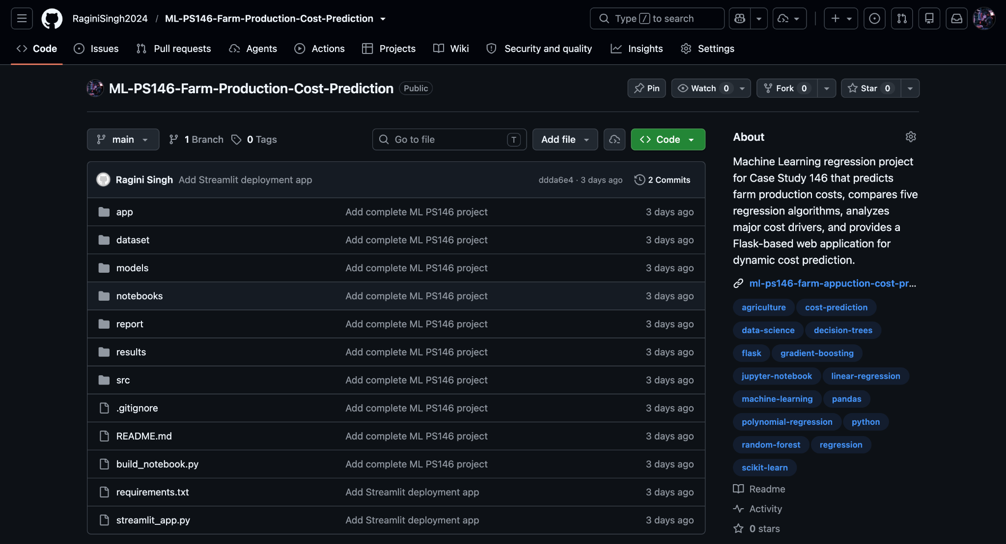

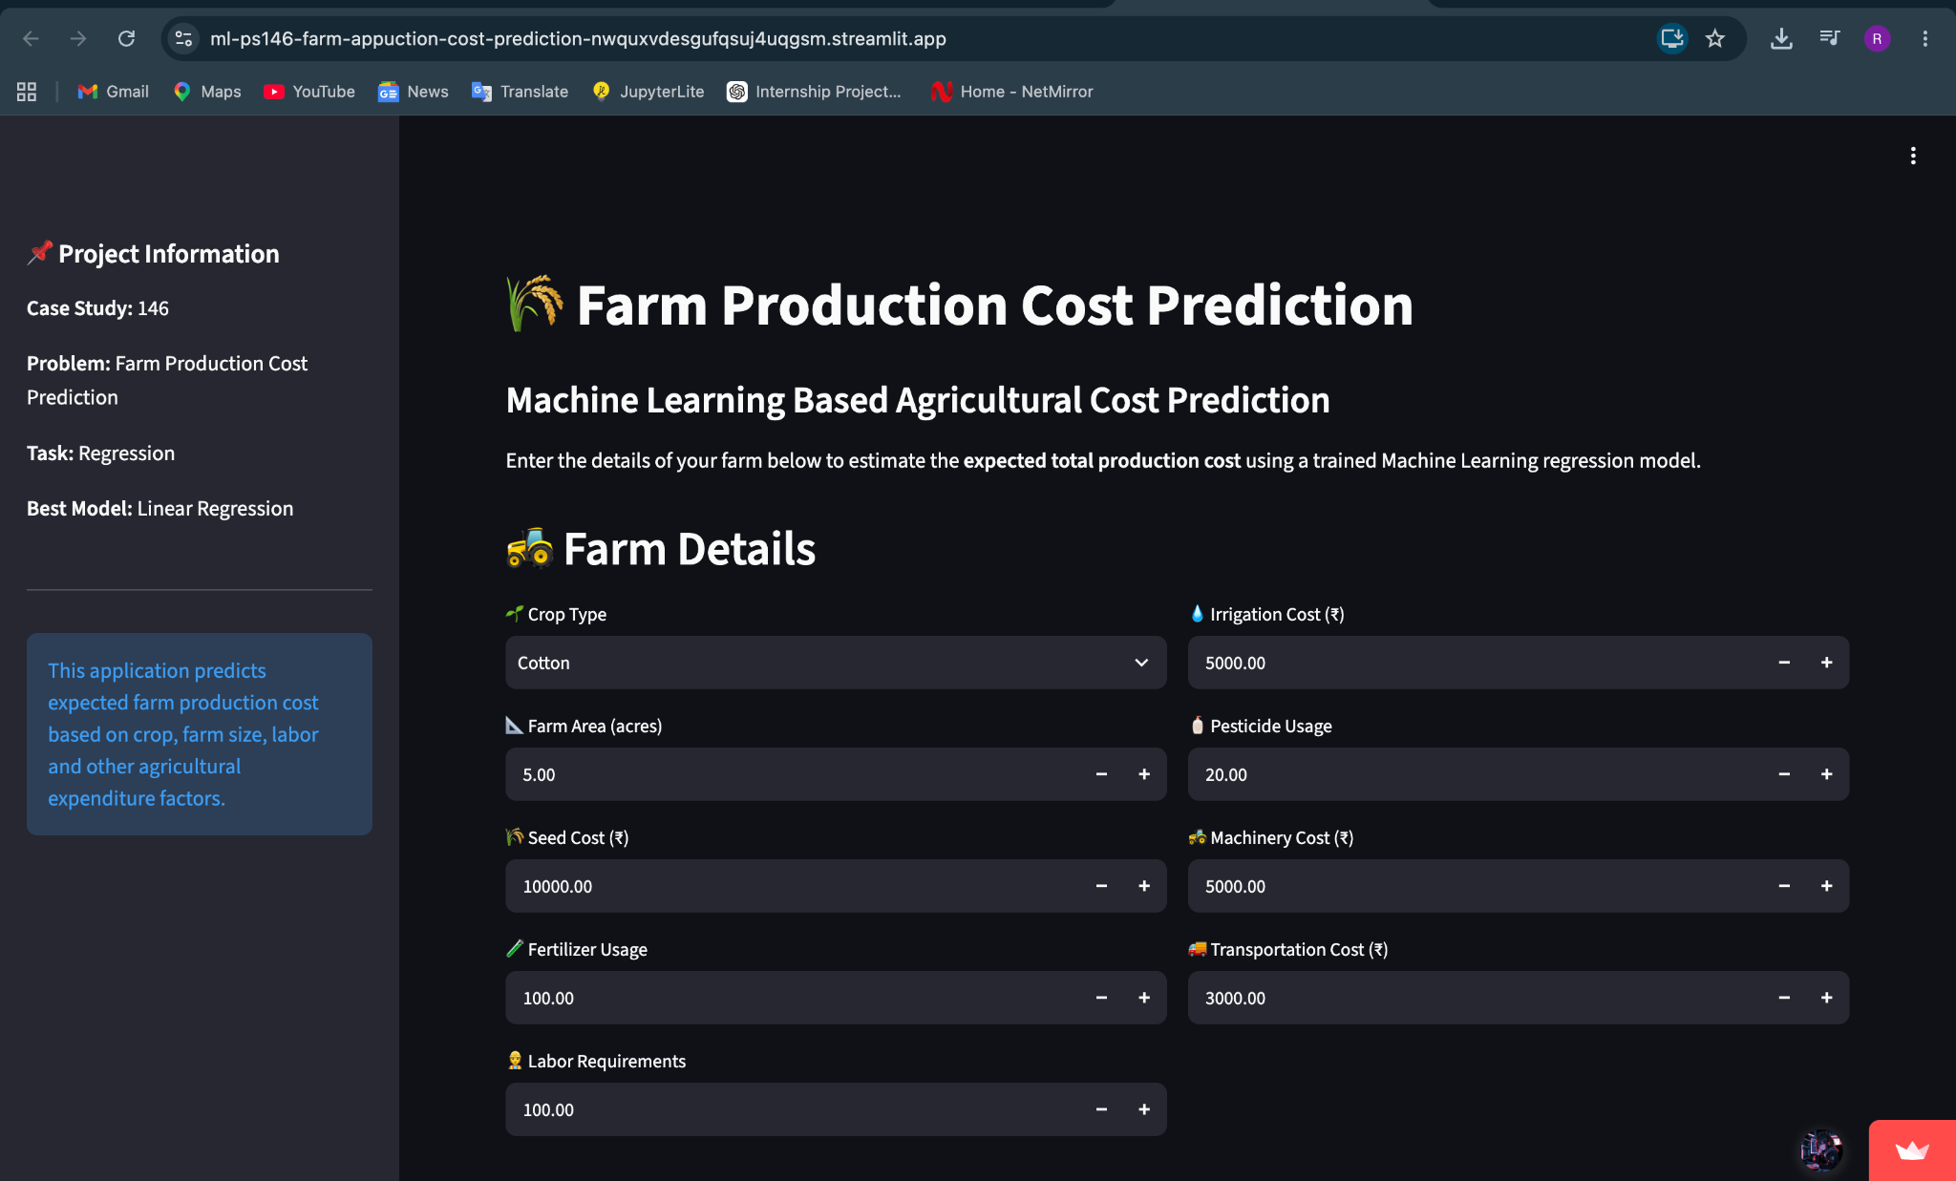

6. Input Features and Target Variable
Feature | Description
Crop_Type | Type of crop being cultivated
Farm_Area | Farm size in acres
Seed_Cost | Cost associated with seeds
Fertilizer_Usage | Fertilizer usage
Labor_Requirements | Labor requirement / person-days
Irrigation_Cost | Irrigation expenditure
Pesticide_Usage | Pesticide usage
Machinery_Cost | Machinery-related expenditure
Transportation_Cost | Transportation expenditure
Total_Production_Cost | Target variable: total production cost

7. Data Processing and Methodology
- Load and inspect the farm production-cost dataset.
- Separate input variables from the target variable Total_Production_Cost.
- Apply the project preprocessing pipeline, including categorical encoding for Crop_Type and transformation of numerical variables.
- Split the dataset into training and hold-out test data.
- Train five regression algorithms under the same evaluation setup.
- Calculate MAE, MSE, RMSE and R² for every model.
- Compare the results and select the model using the observed evaluation metrics.
- Analyze cost-driver importance and farm-area relationship.
- Serialize the selected model pipeline for dynamic prediction.

8. Regression Algorithms Implemented
Linear Regression: Models the relationship between input variables and production cost using a linear combination of features.
Polynomial Regression: Extends linear regression by adding polynomial terms; degree 2 was evaluated.
Decision Tree Regression: Uses recursive feature-based splits to estimate a continuous target.
Random Forest Regression: Combines multiple decision trees to produce an ensemble regression prediction.
Gradient Boosting Regression: Builds an ensemble sequentially, where later learners focus on reducing previous prediction errors.

9. Evaluation Metrics
Metric | Full Form | Interpretation
MAE | Mean Absolute Error | Average absolute difference between actual and predicted values. Lower is better.
MSE | Mean Squared Error | Average squared prediction error. Lower is better.
RMSE | Root Mean Squared Error | Square root of MSE; expressed in the same unit as production cost. Lower is better.
R² | Coefficient of Determination | Measures the proportion of target variance explained by the model. Higher is better.

10. Model Comparison Results
The following are the actual model-comparison results recorded in the project report. All five models were trained on 800 farms and evaluated on 200 hold-out test farms.
Algorithm | MAE (₹) | MSE | RMSE (₹) | R²
Linear Regression | ₹5,981.27 | 84,258,630.48 | ₹9,179.25 | 0.9952
Polynomial Regression (Degree 2) | ₹6,284.07 | 89,528,310.49 | ₹9,461.94 | 0.9949
Gradient Boosting Regression | ₹8,724.88 | 223,733,408.03 | ₹14,957.72 | 0.9872
Random Forest Regression | ₹8,752.42 | 338,179,348.72 | ₹18,389.65 | 0.9807
Decision Tree Regression | ₹14,936.46 | 684,898,125.06 | ₹26,170.56 | 0.9608

11. Selected Model
Based on the recorded evaluation results, Linear Regression was selected for the final prediction pipeline. It recorded the lowest MAE and RMSE and the highest R² among the five evaluated models.
Criterion | Linear Regression Result
MAE | ₹5,981.27
RMSE | ₹9,179.25
R² | 0.9952
Interpretation | 99.52% of total cost variance explained in the reported test evaluation

The project report also notes that agricultural production expenditure is an additive accumulation of several physical inputs, which is consistent with the strong performance of a linear model on this dataset.

12. Cost Driver / Feature Importance Analysis
Tree-based feature importance analysis was used to examine the relative contribution of input variables to the observed prediction variance.
Feature | Importance Score | Relative Share
Labor_Requirements | 0.8560 | 85.60%
Seed_Cost | 0.0444 | 4.44%
Fertilizer_Usage | 0.0405 | 4.05%
Farm_Area | 0.0362 | 3.62%
Pesticide_Usage | 0.0086 | 0.86%
Irrigation_Cost | 0.0070 | 0.70%
Machinery_Cost | 0.0050 | 0.50%
Transportation_Cost | 0.0023 | 0.23%
Crop_Type | 0.0000 | 0.00%

The project analysis identifies Labor_Requirements as the dominant cost driver in the trained tree-based importance analysis, followed by Seed_Cost, Fertilizer_Usage, and Farm_Area.

13. Farm Area and Production Cost Relationship
The project analysis reports a strong positive correlation between farm area and total production cost, with r approximately 0.98. This indicates that larger farms generally have higher total production costs. The project analysis also reports slight economies of scale in per-acre operational and mechanization overhead.
A dedicated visualization, farm_area_vs_cost.png, is included in the results directory to support this analysis.

14. Prediction Demonstration
The serialized model pipeline can accept a new farm scenario and return an estimated total production cost. The project documentation records the following example predictions:
Crop | Farm Area | Predicted Total Production Cost
Wheat | 5 acres | ₹1,06,291.64
Sugarcane | 10 acres | ₹4,37,175.80
Cotton | 7.5 acres | ₹2,75,348.12

15. Web Application and Deployment
A web application was implemented to allow users to enter farming parameters and obtain a production-cost prediction. The final deployment uses Streamlit Community Cloud, while the project also retains the original Flask application in the app directory.
- Interactive input form for crop type, farm area, seed cost, fertilizer usage, labor requirements, irrigation cost, pesticide usage, machinery cost, and transportation cost.
- Loads the saved best-model pipeline from models/best_model.pkl.
- Generates a production-cost prediction for the entered scenario.
- Provides a deployable web interface through Streamlit Community Cloud.
- The GitHub repository contains the complete project implementation.
GitHub Repository: https://github.com/RaginiSingh2024/ML-PS146-Farm-Production-Cost-Prediction

16. Project Structure
Path | Purpose
dataset/ | farm_production_cost.csv – 1,000 agricultural records
notebooks/ | Farm_Production_Cost_Prediction.ipynb – executed notebook with code, outputs and plots
src/ | Data generation, preprocessing, training, evaluation and prediction modules
models/ | best_model.pkl – saved scikit-learn preprocessing + model pipeline
results/ | Model metrics, feature importance and analytical plots
app/ | Flask web application, HTML template, CSS and JavaScript
streamlit_app.py | Streamlit deployment application
report/ | Formal project report
README.md | Project documentation and execution guide
requirements.txt | Project dependencies
VIVA_QUESTIONS.md | Viva questions and preparation material

17. Case Study Questions and Answers
1. Can farm production costs be predicted? Yes. The reported test evaluation achieved R² = 0.9952 with MAE = ₹5,981.27.
2. Which cost component has the greatest influence? Labor_Requirements, with a reported feature-importance share of 85.60%, followed by Seed_Cost (4.44%) and Fertilizer_Usage (4.05%).
3. Which regression model performs best? Linear Regression, based on the recorded comparison: MAE ₹5,981.27, RMSE ₹9,179.25 and R² 0.9952.
4. How does farm size affect total cost? The project reports a strong positive correlation (r ≈ 0.98) between farm area and total cost, with slight economies of scale in per-acre overhead.
5. Can production costs be estimated for a new farm? Yes. The saved best-model pipeline accepts the required farm inputs and returns a prediction.
6. Can ML-based cost prediction support farm budget planning? Yes. The project identifies predictive budgeting as a potential way to estimate working-capital requirements before a farming season.

18. Limitations
- The reported dataset contains 1,000 records; performance can change with larger or independently collected agricultural datasets.
- Predictions depend on the quality and representativeness of the input data.
- The reported feature importance is model- and dataset-dependent and should not be interpreted as a universal causal effect.
- Real-world production costs can also be affected by factors not represented in the project dataset, such as local market prices, weather, seasonal shocks, and regional wage differences.

19. Future Scope
- Integrate larger real-world farm datasets from multiple regions and seasons.
- Add weather, soil, market-price and seasonal variables.
- Perform systematic hyperparameter tuning and cross-validation.
- Add confidence or prediction intervals for budget-risk estimation.
- Add user authentication and persistent farm-history storage.
- Extend the application with dashboards for historical costs and scenario comparison.

20. Conclusion
The Farm Production Cost Prediction project demonstrates an end-to-end machine learning regression workflow for agricultural cost estimation. Five regression algorithms were implemented and compared using MAE, MSE, RMSE and R². In the recorded evaluation, Linear Regression produced the strongest metric values and was saved as the final model pipeline. The analysis also identified Labor_Requirements as the dominant feature in the tree-based feature-importance analysis and showed a strong positive relationship between farm area and total production cost.
The project further converts the trained model into an interactive web application, enabling a user to enter a new farm scenario and obtain an estimated production cost. The completed implementation is organized as a reproducible academic project with a notebook, dataset, source modules, evaluation outputs, saved model, report, GitHub repository, and Streamlit deployment.

21. Project Deliverables
- Dataset: farm_production_cost.csv
- Executed Jupyter Notebook: Farm_Production_Cost_Prediction.ipynb
- Source modules for data generation, preprocessing, training, evaluation and prediction
- Saved model pipeline: best_model.pkl
- Model comparison and visualization results
- Flask application retained in app/
- Streamlit application: streamlit_app.py
- Streamlit Community Cloud deployment
- GitHub repository
- README.md and formal report
- Viva preparation resource

Student Declaration
I, Ragini Singh (Roll No. 150096724023), submit this report for the Semester V Sprint 1 Examination of Machine Learning Fundamentals under Problem Statement 146: Farm Production Cost Prediction. This document summarizes the implemented project, recorded model evaluation, analysis, prediction workflow, and deployment.

Student Name: Ragini Singh
Roll Number: 150096724023
PS Number: 146
Semester / Assessment: Semester V – Sprint 1 Exam

