SOFTWARE DESIGN & UML
PropTax – Online Property Tax Self-Assessment and Payment Portal

Field | Details
Student Name | Ragini Singh
Roll No. | 150096724023
Case Study No. | 141
Case Study Title | PropTax – Online Property Tax Self-Assessment and Payment Portal
Subject | Software Engineering & Project Management
Semester | V
Examination | Sprint 1 Examination
Programme | B.Tech Computer Science & Engineering
Batch | 2025–29
Document | UML Package

1. Purpose
This UML package models the main structure and workflows of the PropTax portal described in Case Study 141. It covers the required use case, class, sequence, activity and state diagrams, followed by a short cohesion and coupling justification.
2. System Scope Used for UML
- Property search and property-detail access.
- Online property-tax self-assessment and tax calculation.
- Online payment and receipt generation.
- Objection submission/tracking workflow, with the release-one scope decision handled separately in the project scope document.
- Validation of assessment inputs such as built-up area and property age.
3. Use Case Diagram
The use case model identifies the Property Owner as the main portal user and shows the portal interactions needed for search, assessment, calculation, payment, receipt access and objections. The payment gateway is represented as an external supporting actor.
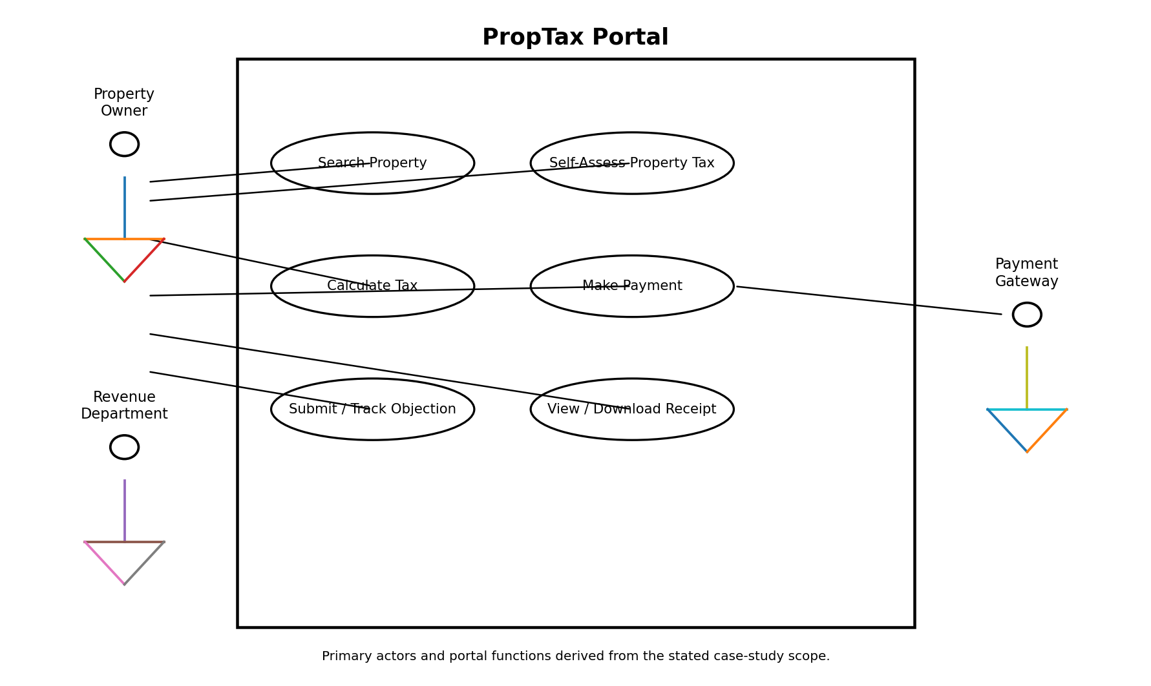
4. Class Diagram
The class model separates property information, assessment/calculation data, payment information and objections. This keeps the tax-calculation responsibility separate from payment processing and receipt generation.
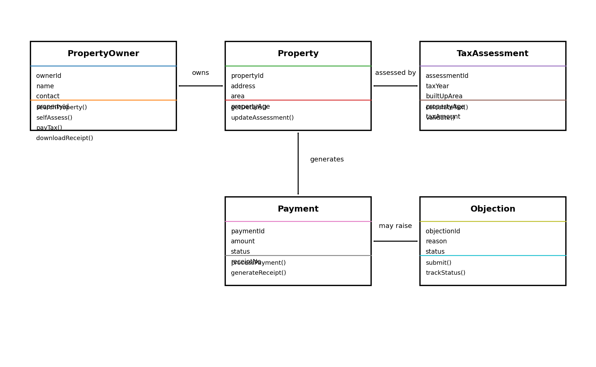
5. Sequence Diagram – Self-Assess Property Tax and Pay
The sequence follows the required flow: search the property, enter assessment data, validate it, calculate the tax, confirm payment, process the payment and generate the receipt.
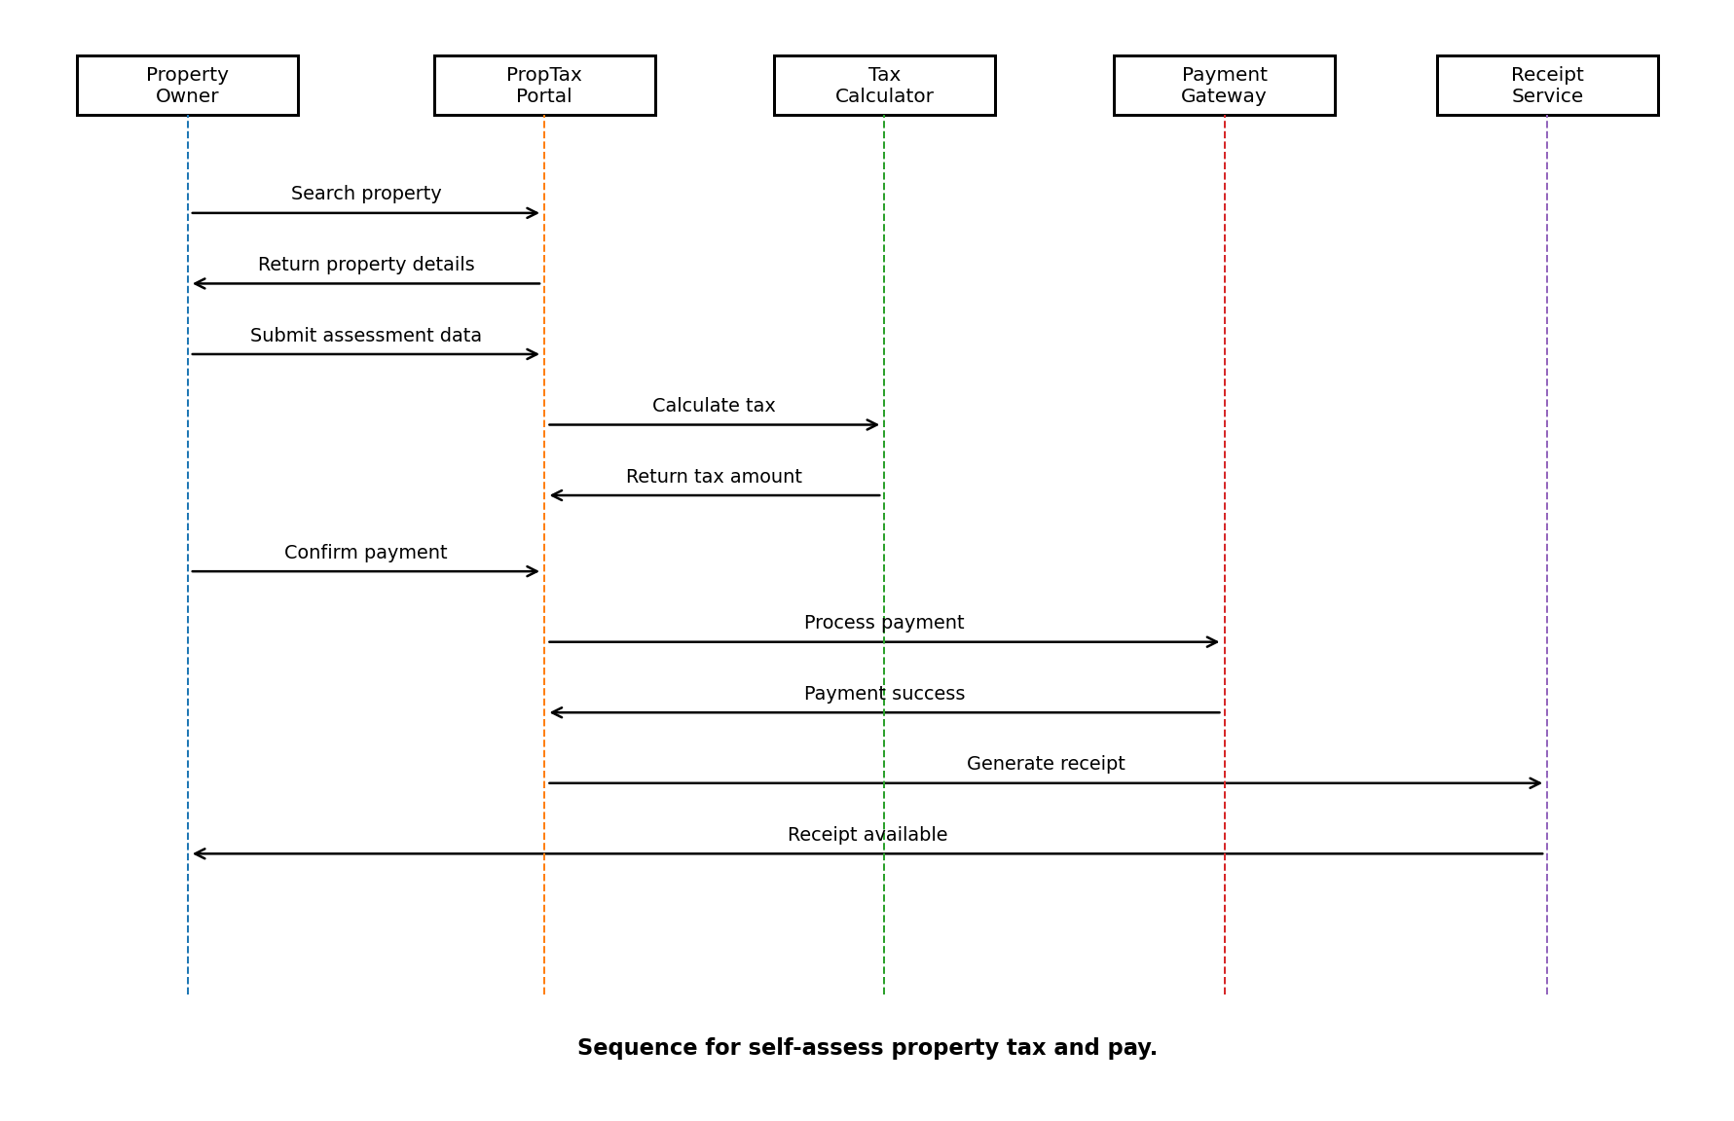
6. Activity Diagram
The activity flow shows the assessment and payment process from start to completion, including input validation and the validation-error path.
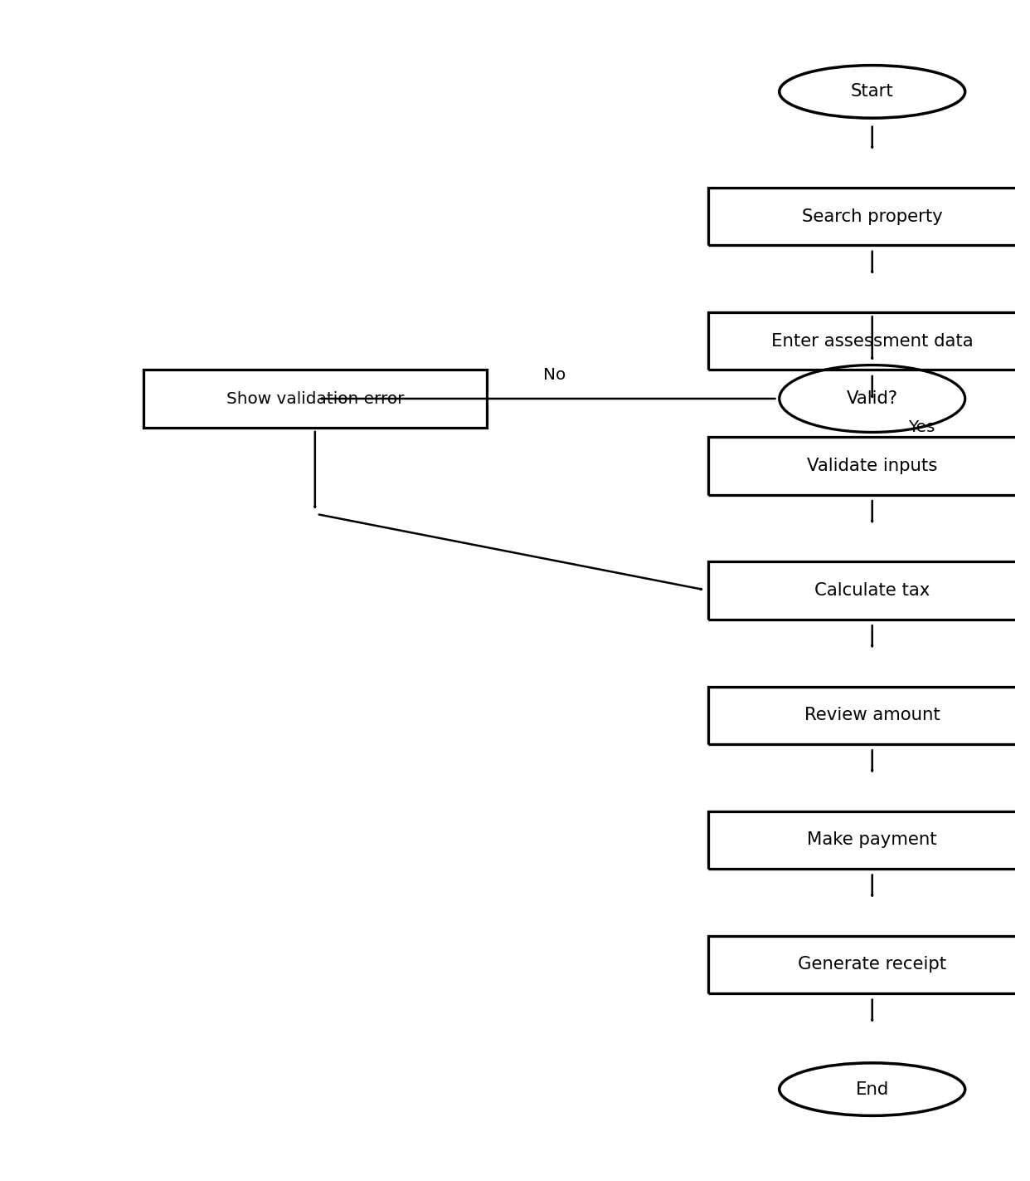
7. State Diagram – Assessment
The assessment moves through draft, submission, validation, calculation, payment and receipt issuance. An objection workflow is represented separately because the case study explicitly identifies objections as a scope decision.
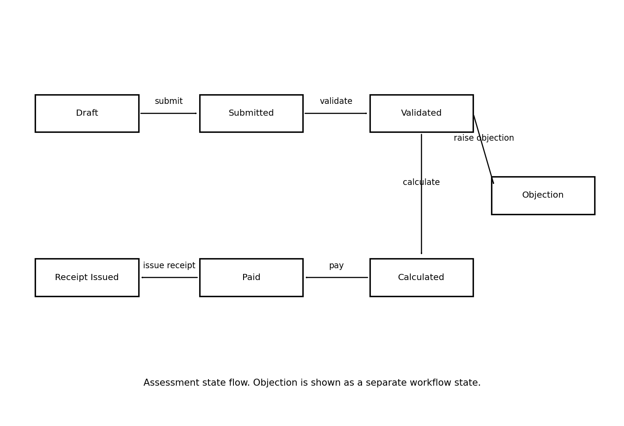
8. Cohesion and Coupling Justification
Module | Responsibility | Cohesion / Coupling Approach
Property Search | Find and display property information | High cohesion; exposes property data without owning payment logic.
Tax Assessment & Calculator | Validate assessment inputs and calculate tax | High cohesion; calculation rules remain within the assessment/calculator responsibility.
Payment | Process payment and maintain payment status | Separate from tax calculation; interacts through the calculated payable amount.
Receipt | Generate and provide payment receipt | Focused on receipt generation rather than calculation or payment rules.
Objection | Capture and track an objection | Separate workflow so legal/administrative handling does not tightly couple with calculation.

The design aims for high cohesion by keeping each module focused on one major responsibility. Coupling is kept low by passing only the required information between modules, such as property/assessment data to the calculator and the final payable amount to payment processing.
9. UML Consistency Notes
- The same core concepts—Property, Assessment, Payment, Receipt and Objection—are used consistently across the diagrams.
- The sequence diagram specifically models the 'self-assess property tax and pay' flow required by the case study.
- Validation is represented in both the activity flow and the assessment state flow.
- The objection workflow is kept separate from the core payment flow because the case study identifies it as a scope decision.
- The diagrams are intended as a clean design model for the individual case study; implementation-specific APIs or technologies are not assumed here.

