PROJECT PLAN
PropTax – Online Property Tax Self-Assessment and Payment Portal

Field | Details
Student Name | Ragini Singh
Roll No. | 150096724023
Case Study No. | 141
Case Study Title | PropTax – Online Property Tax Self-Assessment and Payment Portal
Subject | Software Engineering & Project Management
Semester | V
Examination | Sprint 1 Examination
Programme | B.Tech Computer Science & Engineering
Batch | 2025–29
Document | Project Plan

1. Purpose
This project plan defines the work breakdown structure, dependency network, critical path, release schedule, milestones and role-based resource allocation for the PropTax case study. The plan uses the project data supplied in the case study.
2. Planning Basis
Given Project Data | Value
Search & Calculator backlog | 34 story points
Payment & Receipts backlog | 21 story points
Objections workflow backlog | 29 story points
Velocity | 11 points per 2-week sprint
Tax year starts | 16 weeks
Online target | 35% of payments online in Year 1

For Release 1, the objection workflow is excluded based on the scope decision. Therefore, the planned Release 1 workload is 34 + 21 = 55 story points. At 11 points per 2-week sprint, the forecast is 55 / 11 = 5 sprints = 10 weeks.
3. Work Breakdown Structure (WBS)
WBS ID | Work Package | Main Activities
1.0 | Project & Requirements | Understand problem, stakeholders, scope, requirements and acceptance needs.
1.1 | Requirements & Scope | Define functional requirements, NFRs, MoSCoW and Release 1 boundary.
2.0 | Search & Self-Assessment | Property search, property details, assessment input and validation.
2.1 | Property Search | Search and retrieve property information.
2.2 | Self-Assessment | Capture built-up area, property age and other assessment inputs.
2.3 | Tax Calculator | Apply rate-table and rebate rules and calculate tax.
3.0 | Payment & Receipts | Online payment, transaction recording and receipt generation.
3.1 | Payment | Initiate and confirm online payment.
3.2 | Receipt | Generate payment receipt after successful payment.
4.0 | Quality & Integration | Integration, validation, test evidence and defect handling.
4.1 | Testing | Boundary-value, equivalence-class and decision-table testing.
4.2 | Release Validation | Validate critical workflows and release readiness.
5.0 | Release 1 | Deploy the core search, assessment, calculation, payment and receipt scope.

4. Network Diagram and Critical Path
The main sequential dependency for Release 1 is requirements and scope → property search and data → self-assessment validation → tax calculation and rebate → payment integration → receipt and acceptance. This is treated as the critical path for the release because each stage depends on the preceding stage.
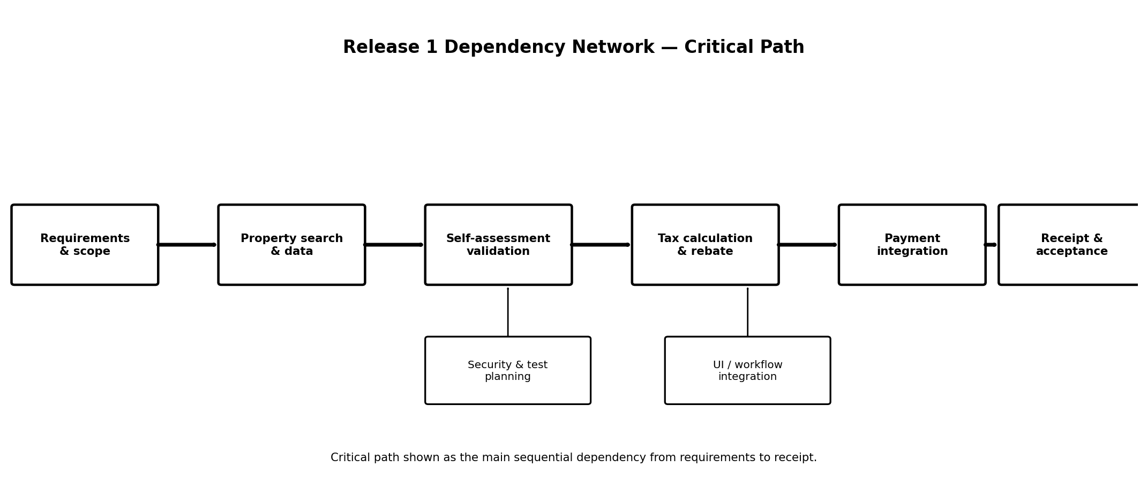
5. Critical Path
Sequence | Dependency
1 | Requirements and scope must be defined before detailed implementation.
2 | Property search/data must be available before self-assessment can use property information.
3 | Validated assessment data is required before reliable tax calculation.
4 | Calculated payable tax is required before payment.
5 | Successful payment is required before the receipt is issued.

Note: The case study provides story points and velocity, but it does not provide separate calendar durations for each individual activity. Therefore, the critical path is presented as a dependency path rather than as an independently calculated activity-duration CPM.
6. Gantt Chart
The Release 1 forecast is 5 two-week sprints, giving a 10-week schedule. The chart below shows the planned sequence using project weeks because the case study does not provide a project start date.
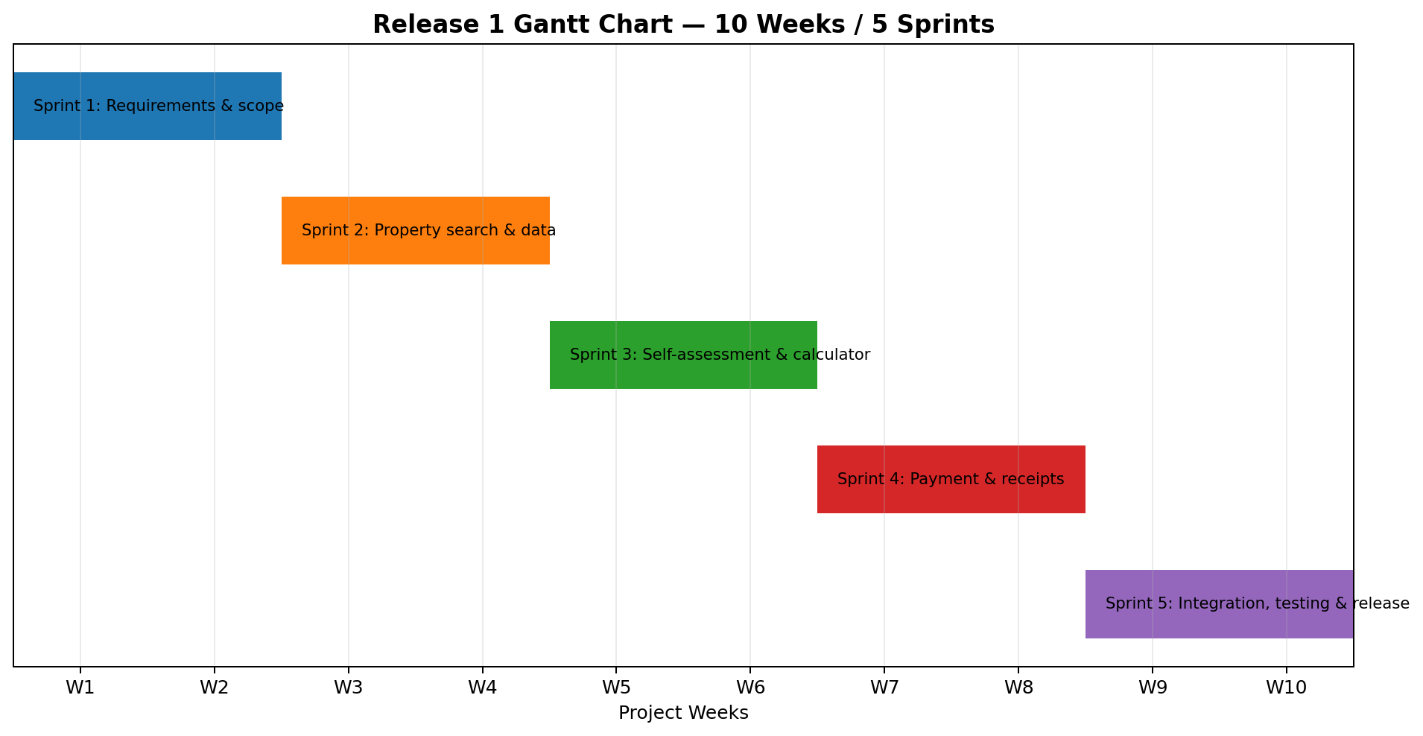
7. Sprint Plan
Sprint | Weeks | Planned Focus | Output
Sprint 1 | 1–2 | Requirements, scope, SRS/UML planning | Approved requirements and Release 1 boundary
Sprint 2 | 3–4 | Property search and property data | Search workflow and property information flow
Sprint 3 | 5–6 | Self-assessment and tax calculation | Validated assessment and calculation flow
Sprint 4 | 7–8 | Online payment and receipts | Payment and receipt workflow
Sprint 5 | 9–10 | Integration, testing and release validation | Test evidence, fixes and Release 1 readiness

8. Milestones
Milestone | Target
M1 – Requirements & scope baseline | End of Sprint 1 / Week 2
M2 – Property search flow complete | End of Sprint 2 / Week 4
M3 – Self-assessment & calculator complete | End of Sprint 3 / Week 6
M4 – Payment & receipt flow complete | End of Sprint 4 / Week 8
M5 – Release 1 validation complete | End of Sprint 5 / Week 10

9. Resource Allocation
The case study does not specify a team size or individual resource names. Therefore, resources are allocated by project role rather than by invented headcount.
Work Area | Primary Role | Supporting Role(s)
Requirements & scope | Business / Project Management | Solution / Technical Design
SRS & UML | Solution / Technical Design | Business / Project Management, Development
Property search & assessment | Development | Solution / Technical Design, QA
Tax calculation & rules | Solution / Technical Design | Development, Revenue Department
Payment & receipts | Development | QA, Payment/Gateway stakeholder
Testing & evidence | QA / Testing | Development, Solution / Technical Design
Release validation | Project Management | Solution / Technical Design, Development, QA

10. Release 1 Scope Decision
The full case-study backlog including objections is 34 + 21 + 29 = 84 points. At 11 points per two-week sprint, 84 / 11 = 7.64, which requires 8 sprints or 16 weeks. This consumes the entire period before the tax year starts. The case study also states that the objections workflow involves legal procedures requiring more time. Therefore, Release 1 is planned around the 55-point core scope, forecast at 5 sprints or 10 weeks.
11. Schedule and Resource Assumptions
- The supplied velocity of 11 points per 2-week sprint is used for forecasting.
- Release 1 excludes the full objections workflow.
- Project weeks are used because no calendar start date is given in the case study.
- Resource allocation is role-based because no team size or named resources are provided.
- The 10-week forecast is an estimate based on the supplied velocity, not a delivery guarantee.
12. Conclusion
The project plan converts the PropTax case study into a structured Release 1 delivery plan. The core search, self-assessment, calculation, payment and receipt scope is forecast at 55 points, which equals 5 two-week sprints at the supplied velocity. The plan includes the required WBS, dependency network, critical path, Gantt schedule, milestones and role-based resource allocation.

