FLUTTER FINAL PROJECT DOCUMENTATION
Smart Hospital Appointment & Queue Management
MediQueue

Name | Ragini Singh
Roll No. | 150096724023
Subject | Flutter Final Project
PS No. | PS 147
PS Title | Smart Hospital Appointment & Queue Management
Semester / Sprint | Semester 5 – Sprint 1
Examination | Final Project Examination
Exam Date | 03/10/2026

Project Links
Figma / UI Design: https://stitch.withgoogle.com/projects/6637076470176643694
GitHub Repository: https://github.com/RaginiSingh2024/smart-hospital-appointment-queue-flutter

1. Problem Understanding
PS 147 addresses the need for a digital hospital appointment and queue-management system. The application is designed for a multi-specialty hospital where patients can discover doctors, book and manage appointments, receive queue/token information and use QR-based check-in. Doctors require a focused operational dashboard for appointments, patient lists, queue handling and consultations, while administrators require hospital-wide monitoring and management capabilities.

Project Objective
- Provide a Flutter-based cross-platform healthcare application.
- Support separate Patient, Doctor and Admin experiences through role-based access.
- Reduce manual appointment and OPD queue handling through digital workflows.
- Provide appointment tokens, estimated waiting information and QR check-in.
- Provide doctor-side queue/consultation operations and admin-side hospital monitoring.
- Use Firebase services as the backend foundation for authentication and application data.

Key User Roles
Role | Primary Responsibilities | Major Screens / Functions
Patient | Find doctors, book appointments, track queue, check in, view notifications and profile. | Dashboard, Doctor Search, Booking, Confirmation, Appointments, Notifications, Profile
Doctor | Manage daily appointments, patient list, queue and consultation workflow. | Doctor Dashboard, Appointments, Patients, Queue & Consult, Doctor Profile
Admin | Monitor hospital operations and manage doctors and administrative activities. | Admin Dashboard, Doctor Management, Admin Profile

2. Application Design

UI Design
The application follows a clean healthcare-oriented interface with clear role-specific navigation, large touch targets, appointment cards, status indicators and quick-action sections. The final documentation is presented in black and white for formal academic submission.

Navigation & Workflow
- Patient flow: Login / Registration → Patient Dashboard → Find Doctor → Doctor Details → Appointment Booking → Booking Confirmation → My Appointments / QR Check-in / Live Queue / Notifications.
- Doctor flow: Doctor Login → Doctor Dashboard → Queue & Consultation / Today's Appointments / Patients List → Consultation or patient operations → Doctor Profile.
- Admin flow: Admin Login → Admin Dashboard → Doctors / Patients / Appointments / Queue monitoring and administrative actions → Admin Profile.

3. Implementation

Technology Stack
- Flutter and Dart for cross-platform application development.
- Firebase Authentication for user authentication.
- Cloud Firestore / Firebase backend services for application data.
- Role-based application routing for Patient, Doctor and Admin experiences.
- QR-based appointment check-in workflow.
- Repository/state-management architecture used by the Flutter project.

Implemented Functional Areas
Area | Implemented Scope
Patient | Registration, login, doctor discovery, specialty filtering, doctor details, appointment booking, confirmation/token, appointment details, notifications and patient profile.
Queue & Check-in | Queue position, estimated wait information, token display and QR check-in flow.
Doctor | Doctor dashboard, today's appointments, queue & consultation view, registered patient list and doctor profile.
Admin | Hospital operations dashboard, doctor management, operational statistics and admin profile.
Backend | Firebase project integration and authentication evidence are included in the screenshots section.

4. Screenshots / Demonstration
The following screenshots document the implemented application workflow across Patient, Doctor, Admin and Firebase/GitHub project setup. Screenshots are converted to grayscale in this report to maintain a formal black-and-white submission format.

1. Patient Registration
Patient registration screen with account creation fields and validation flow.
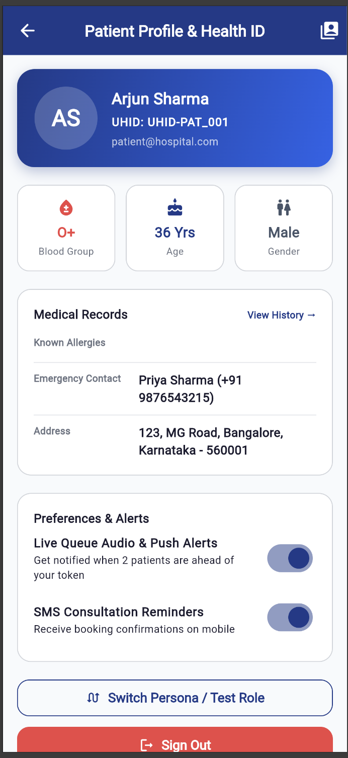

2. Staff / Admin Login
Role-based login entry point for administrative access.
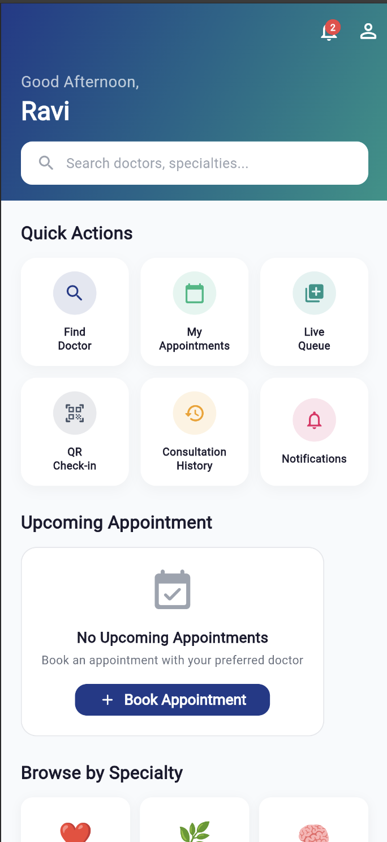

3. Patient Dashboard
Patient home dashboard with quick actions, appointments and queue access.
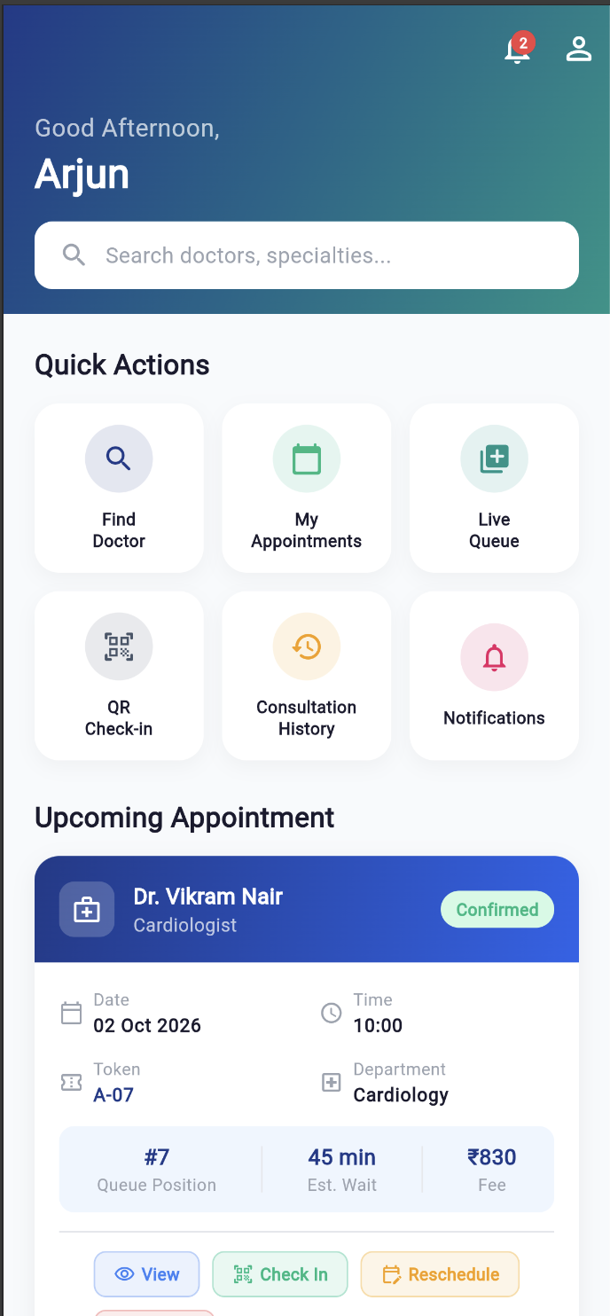

4. Doctor Search
Doctor discovery screen with specialty filters, availability and booking actions.
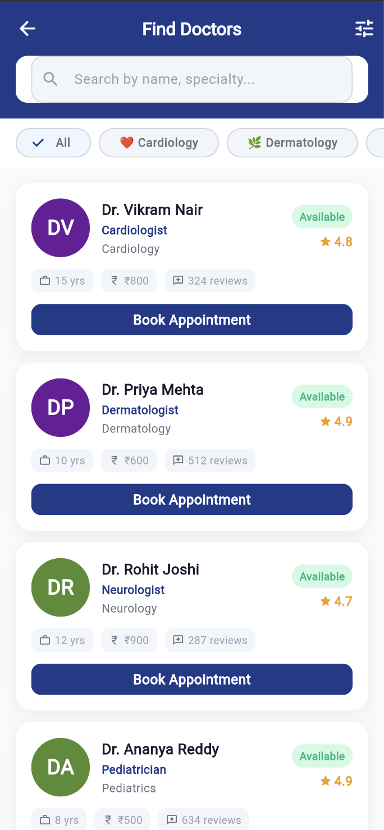

5. Appointment Booking
Appointment booking workflow for selecting doctor, date and slot.
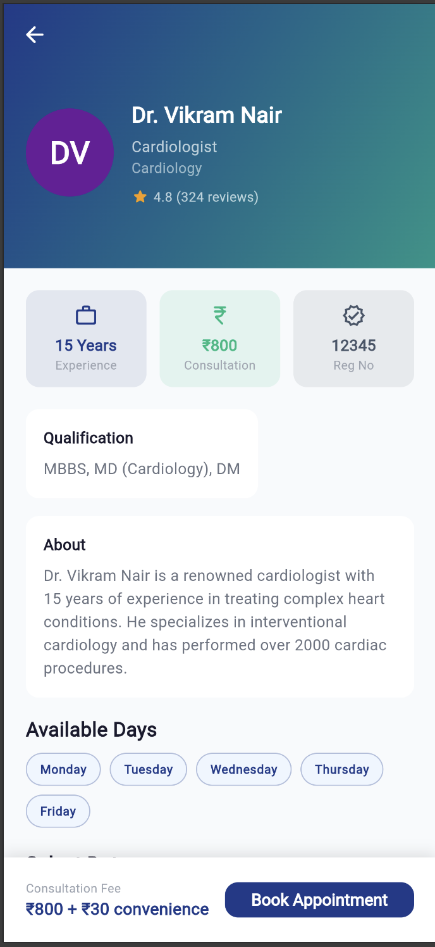

6. Booking Confirmation
Confirmed appointment with token, doctor, department and QR check-in information.
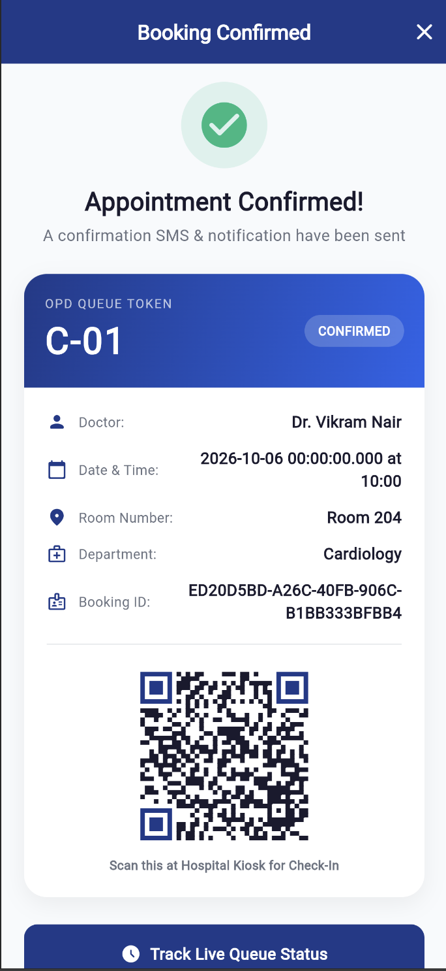

7. Admin Dashboard
Hospital administration command center with operational statistics and management actions.
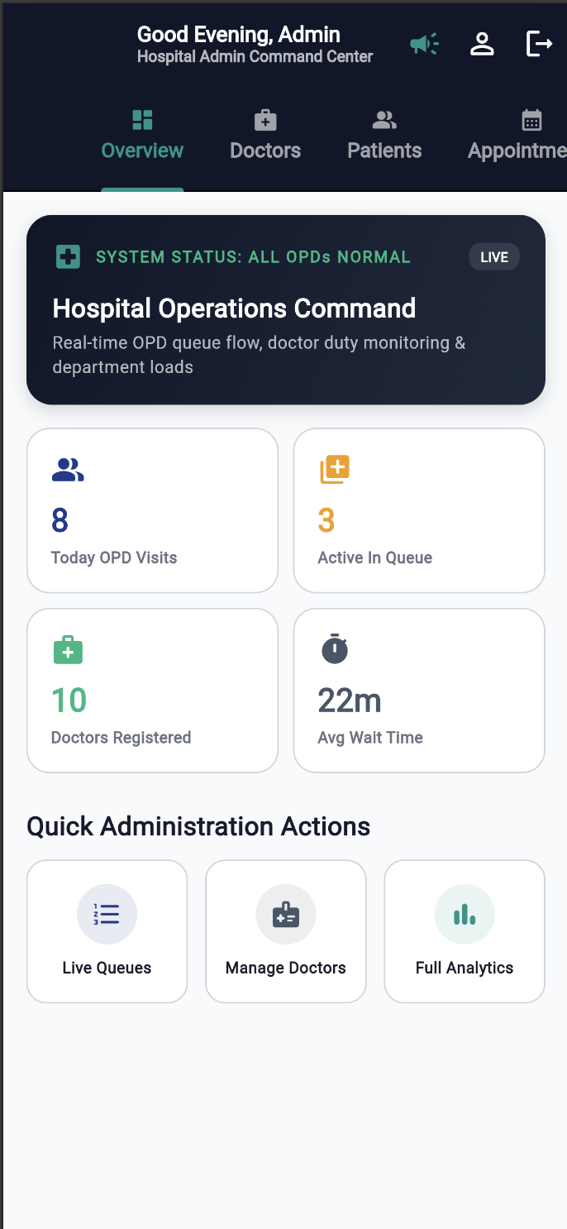

8. Admin Profile
Administrator profile and hospital command-center information.
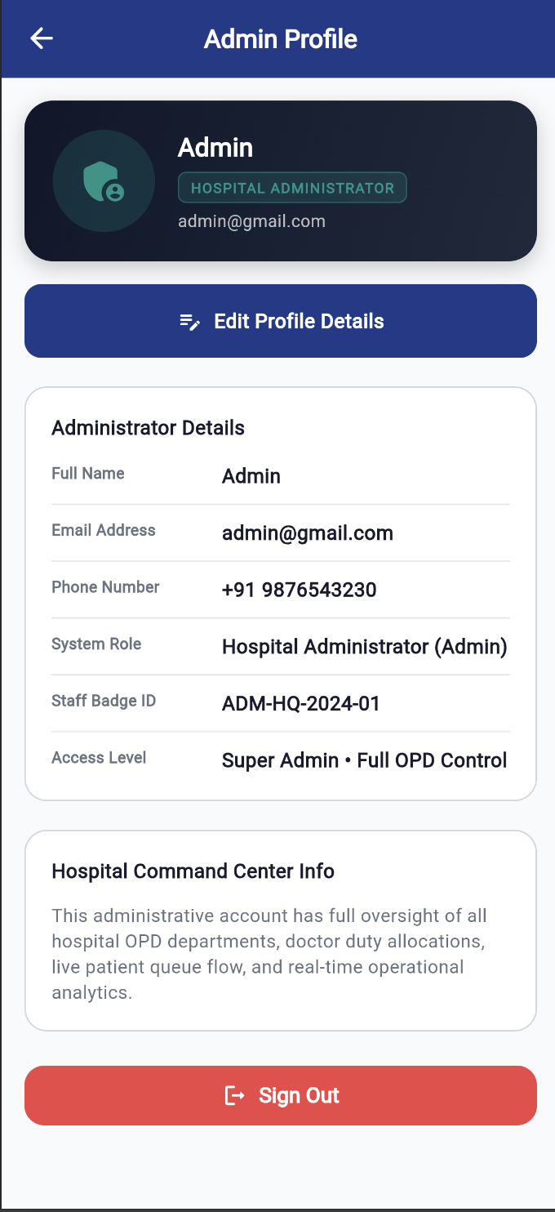

9. Appointment Detail
Detailed appointment information including date, time, token, queue and fee.
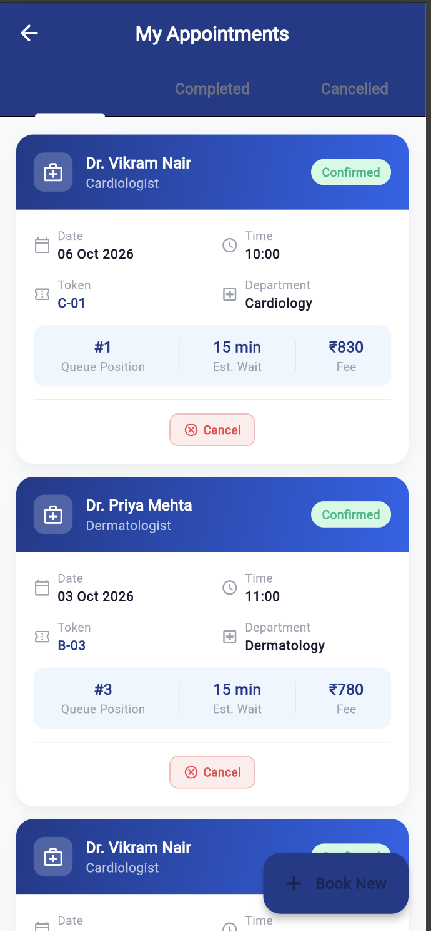

10. Doctor Dashboard / Queue
Doctor queue and consultation dashboard with active consultation and waiting queue.
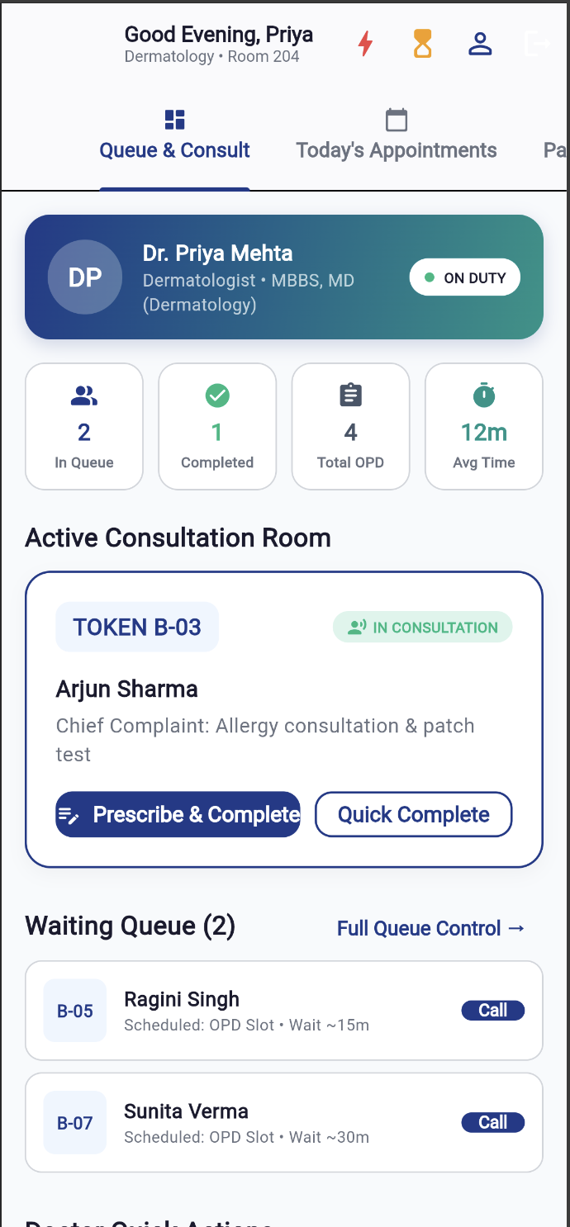

11. Doctor Profile
Doctor professional profile, department, qualification, contact and availability details.
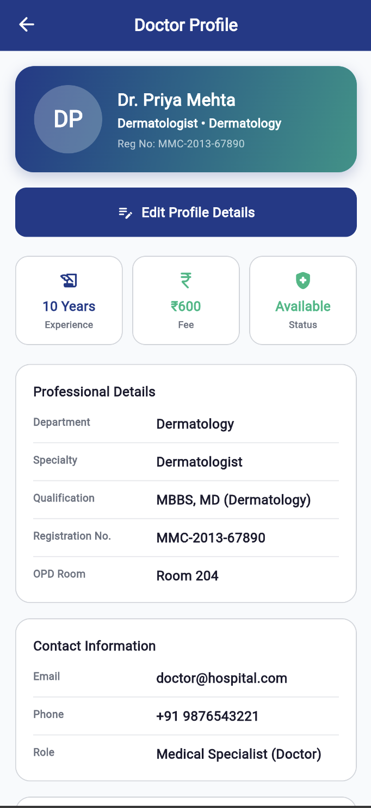

12. Doctor's Appointments
Doctor's appointment list with status, check-in and consultation actions.
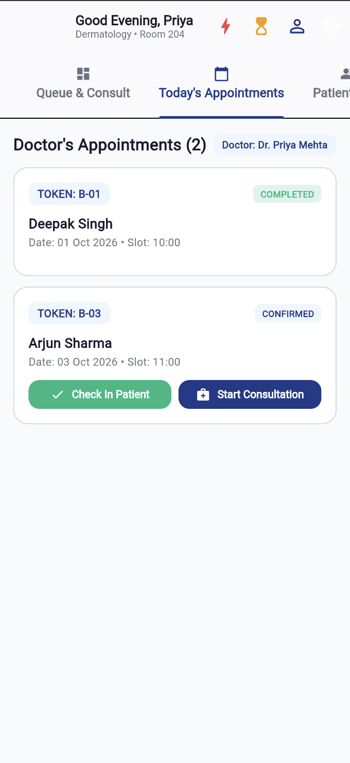

13. Admin Doctor Management
Administrative doctor-management screen showing registered doctors and availability.
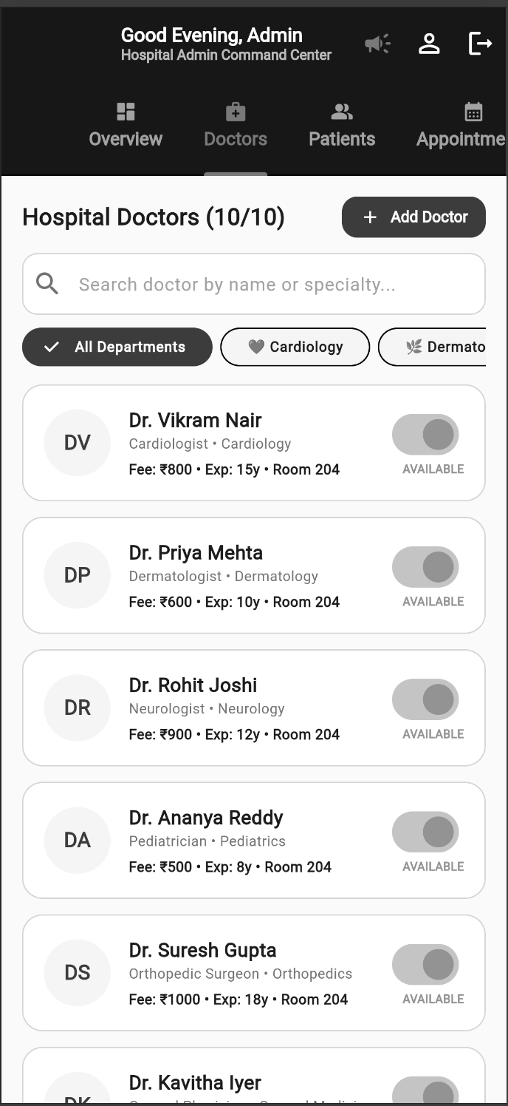

14. Firebase Project Connected
Firebase project connection/configuration evidence for the Flutter application.
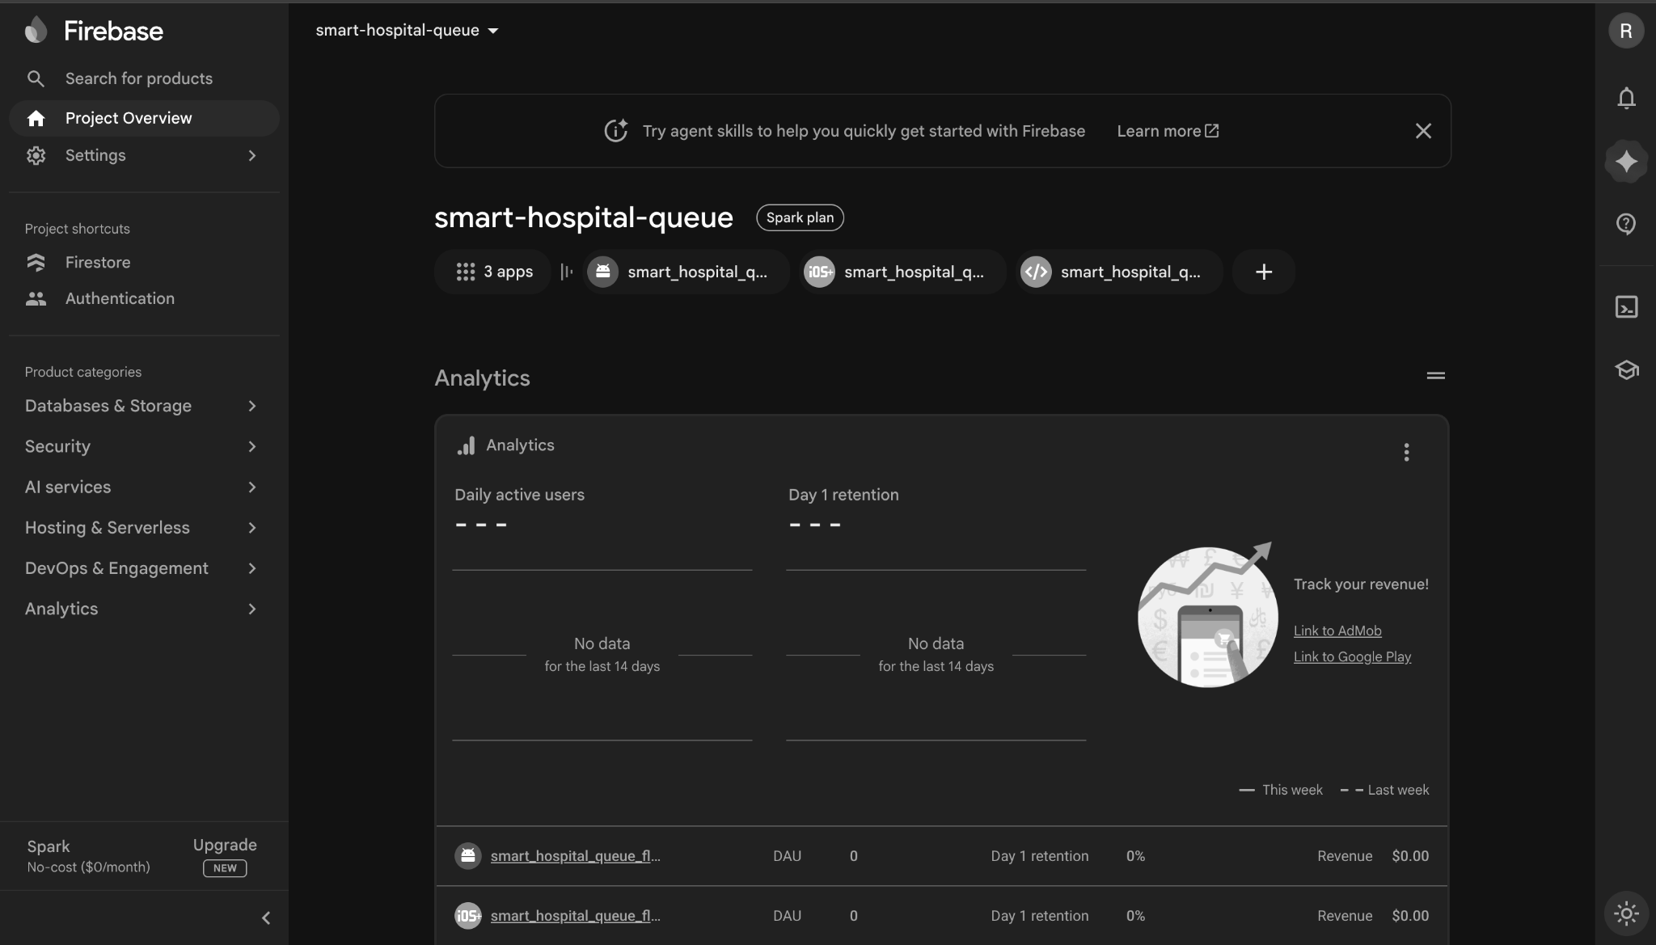

15. Firebase Backend
Firebase console evidence for the project backend.
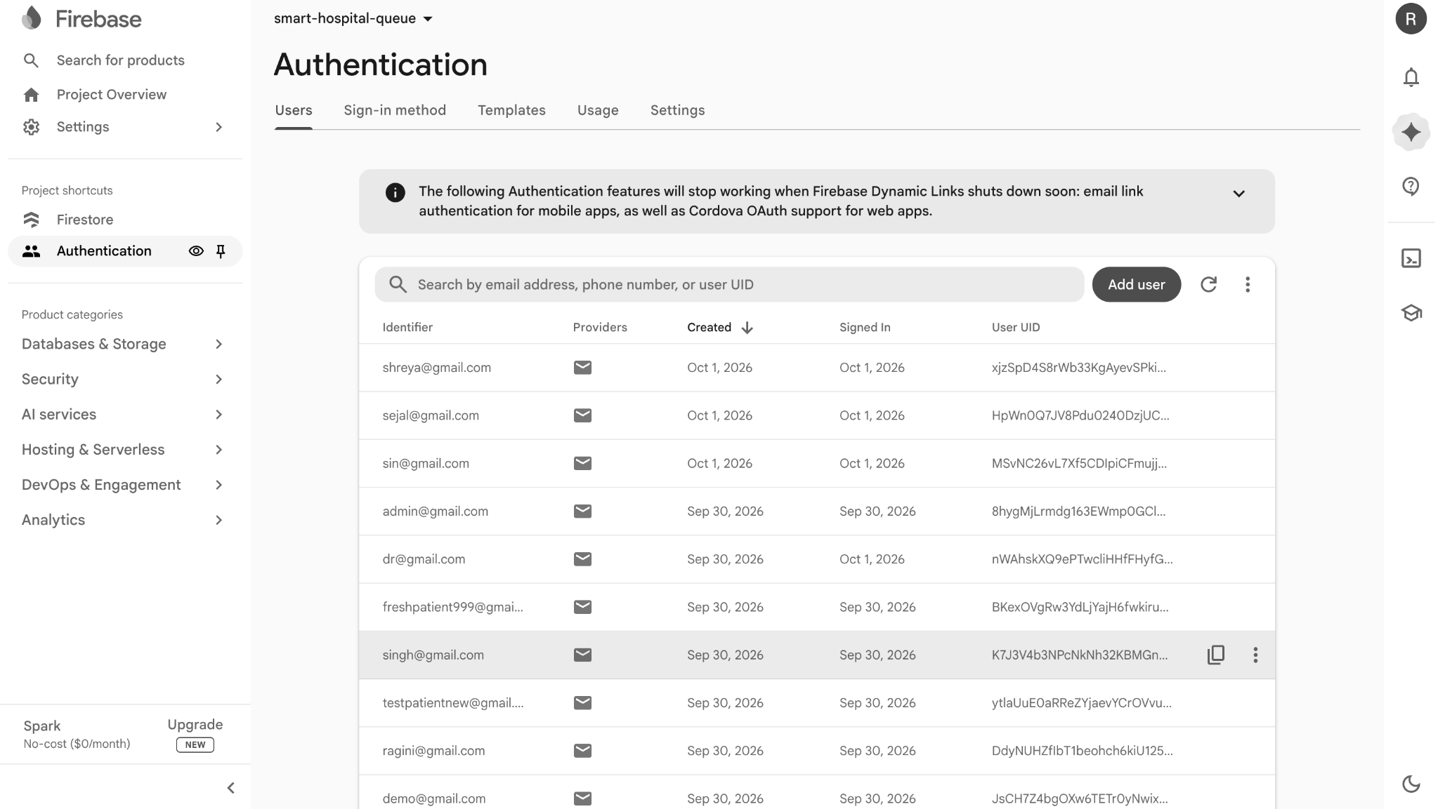

16. GitHub Repository
GitHub repository evidence for the final project source code.
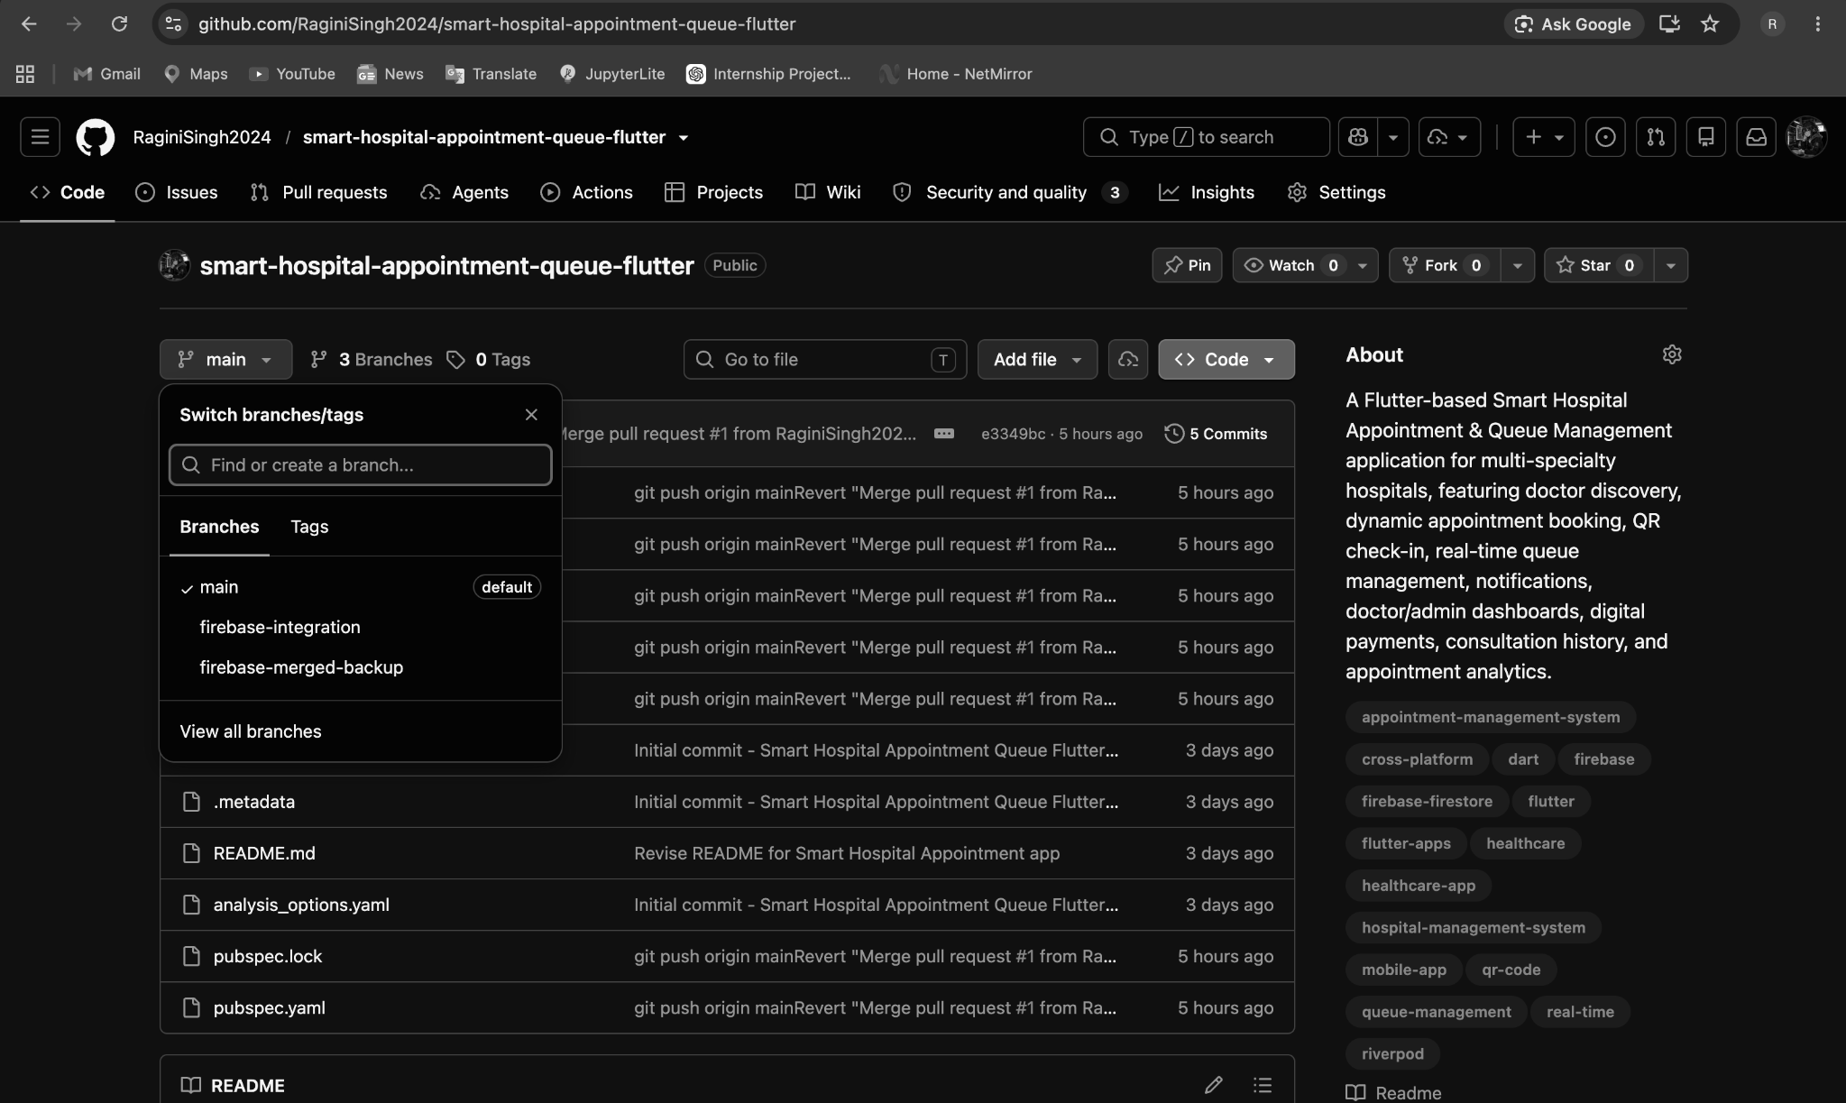

17. Patient Home Dashboard
Patient home screen showing quick actions and upcoming appointment state.

18. Notifications & Alerts
Notifications screen covering appointment, payment, queue and consultation updates.
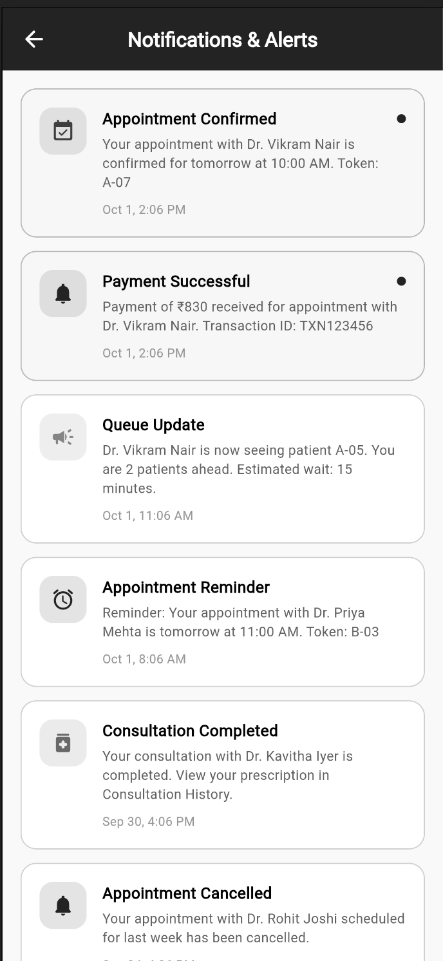

19. Patient Profile
Patient profile and health-ID screen with medical information and alert preferences.
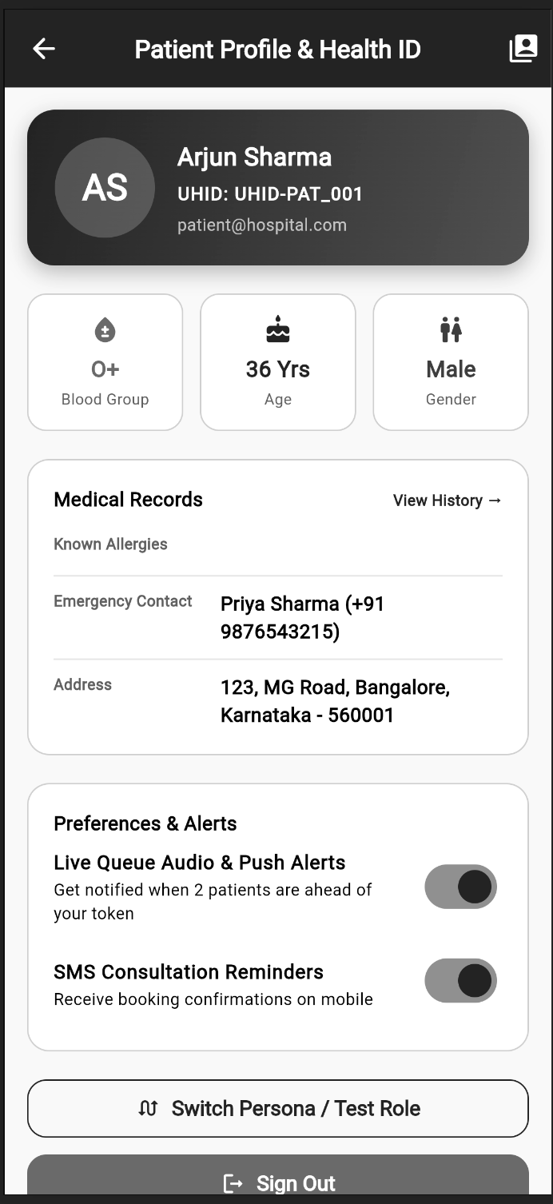

20. Doctor Patient List
Doctor-facing registered patient list for the doctor's assigned patients.
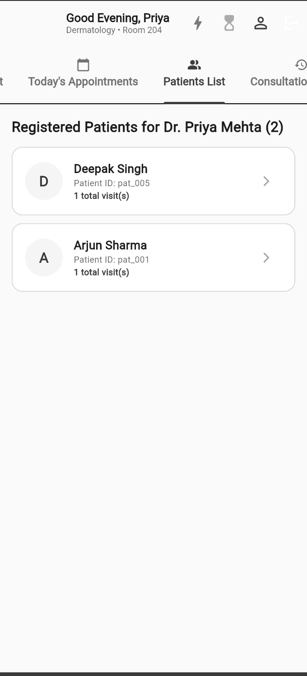

5. Documentation — Workflow & Features

End-to-End Patient Workflow
1. Register or sign in as a patient.
2. Open the patient dashboard and select Find Doctor.
3. Search or filter doctors by specialty and review availability/details.
4. Select a doctor and book an available appointment slot.
5. Receive booking confirmation with token and QR check-in information.
6. Use My Appointments to review appointment details, queue position and estimated waiting time.
7. Use QR Check-in and Live Queue functionality during the hospital visit.
8. Receive appointment, payment and queue notifications through Notifications & Alerts.

Doctor Workflow
1. Sign in through the doctor role.
2. Open the doctor dashboard to view queue and consultation information.
3. Review today's appointments and appointment status.
4. Open the patient list to review registered patients.
5. Use queue/consultation controls for active OPD flow.
6. Review and edit doctor profile details as required.

Admin Workflow
1. Sign in through the admin role.
2. Open the Hospital Operations Command dashboard.
3. Review OPD visits, active queue, registered doctors and average wait information.
4. Manage and review registered doctors and their availability.
5. Use administrative navigation for hospital-level monitoring.
6. Review administrator profile and system information.

Testing & Demonstration Evidence
The screenshot set demonstrates the main role-based journeys and project infrastructure. The final project repository and Firebase project evidence are included to support source-code and backend verification.

6. Project Links
Figma / UI Design: https://stitch.withgoogle.com/projects/6637076470176643694
GitHub Repository: https://github.com/RaginiSingh2024/smart-hospital-appointment-queue-flutter

7. Conclusion
MediQueue is a Flutter-based Smart Hospital Appointment & Queue Management application developed for PS 147. The project brings patient appointment booking, doctor discovery, digital queue/check-in workflows, doctor-side operations and administrator monitoring into a single role-based healthcare application. The included screenshots, project links and Firebase/GitHub evidence document the implemented solution for the Semester 5 Sprint 1 final project examination.

