**DATABASE AND WEB- PROJECT**

* **3RD Semester**

**Jaypee Institute of Information Technology, Sec 62**

**Report of Food Ordering System**

**Group Members:**

1. Paakhi Maheshwari 21103149
2. Anurag Sati 21103153
3. Ragini Mittal 21103160
4. Usman Mufti 21103165

**Submitted to:-**

Dr. Bhawna Saxena

**Objective of Project on Food Ordering System:**

The main objective of this project is to provide an interface for admin and staff to coordinate collecting and preparing orders. The project consists of three user interfaces- admin, chef, and waiter.

This will allow deleting, adding menu and menu items, and collecting orders, view sales, but will rely on the human connection of consumer input.

**Functionalities provided by Online Food Ordering System are as follows:**

* Admin will have the option to delete and create menu and menu items, managing staff, viewing the status of the orders, etc.
* Staff will have the option to view orders in addition to chef or waiter specific functionalities.
* Chef will have the option to view taken orders and prepare them accordingly. She can change the status and it will be displayed on the Admin side also.
* Waiter will have the option to create orders, which he will do by collecting it from the customer.
* Admin will also have the option to view sales and profits.
* It will have the login and authentication of staff and admin by accessing a database for all required fields.
* It also monitors status of staff and orders.
* You can also add a new menu altogether, in case the services are for more than one restaurant.
* Easily add, update, delete, and edit records.
* A single place for all placed orders for easier coordination.

**ER DIAGRAM**

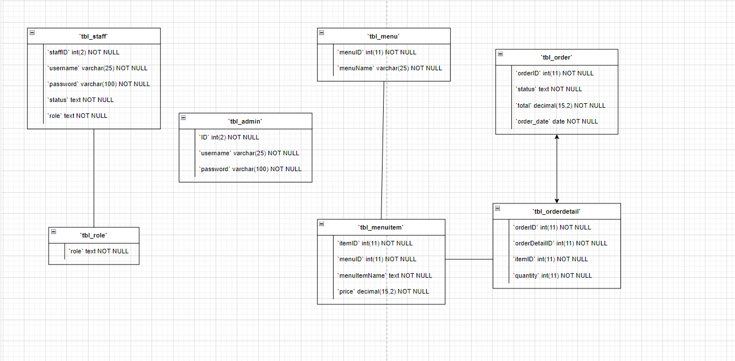

**PREVIEW OF SITE**

**This is the home page of our website and have two options for staff and admin login.**

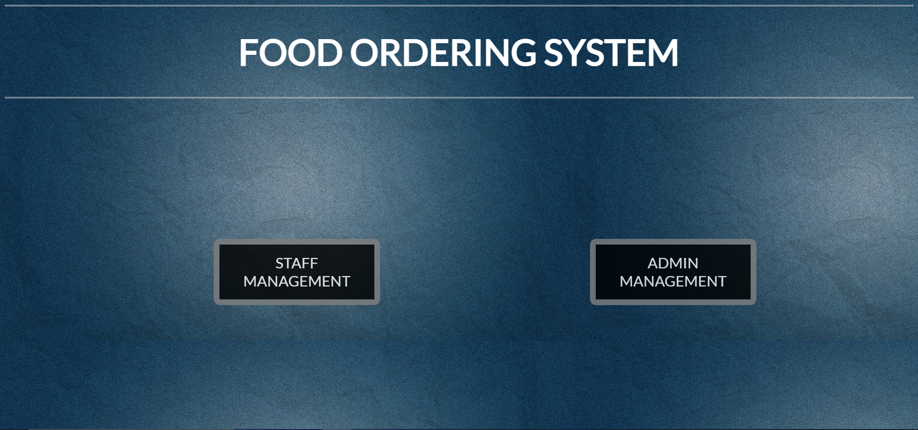

**In staff category there are two types either chef or waiter.**

**Anjali is waiter so he can take orders from customers**

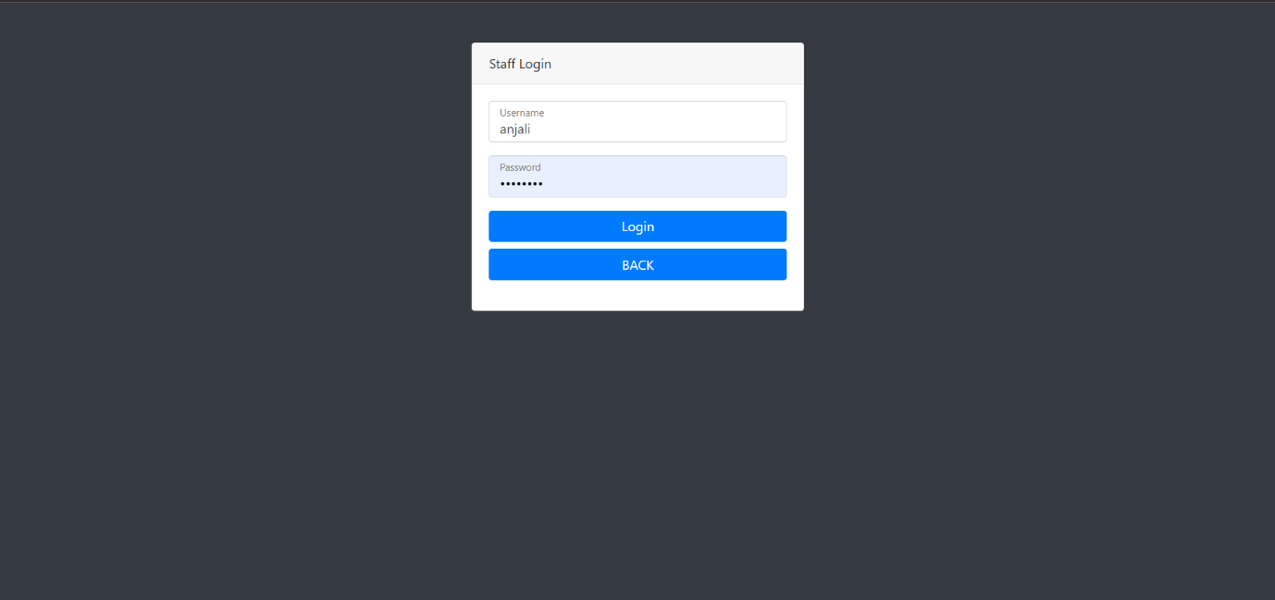

**In the dashboard section all ready to serve order are visible.**

**And staff members can mark themselves as offline or online by pressing on online icon.**

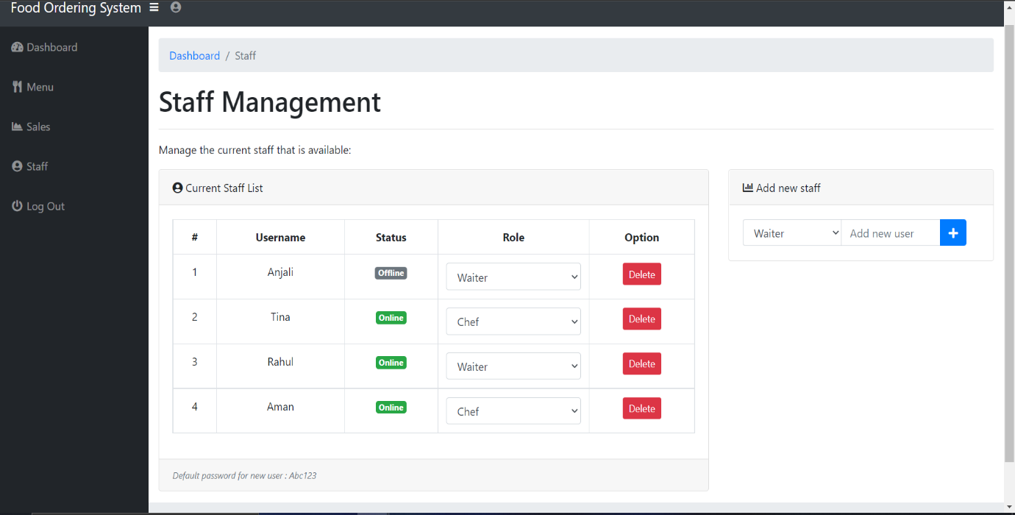

**Waiter can take orders from customers.**

**Logging out…**

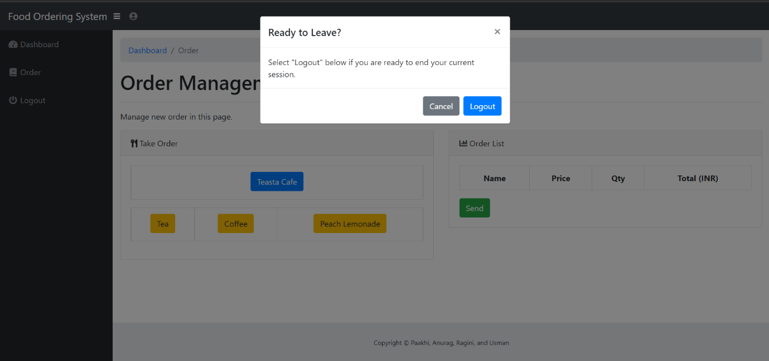

**Chef is a part of staff.**



**Chef can see all the orders which are ready to serve.**

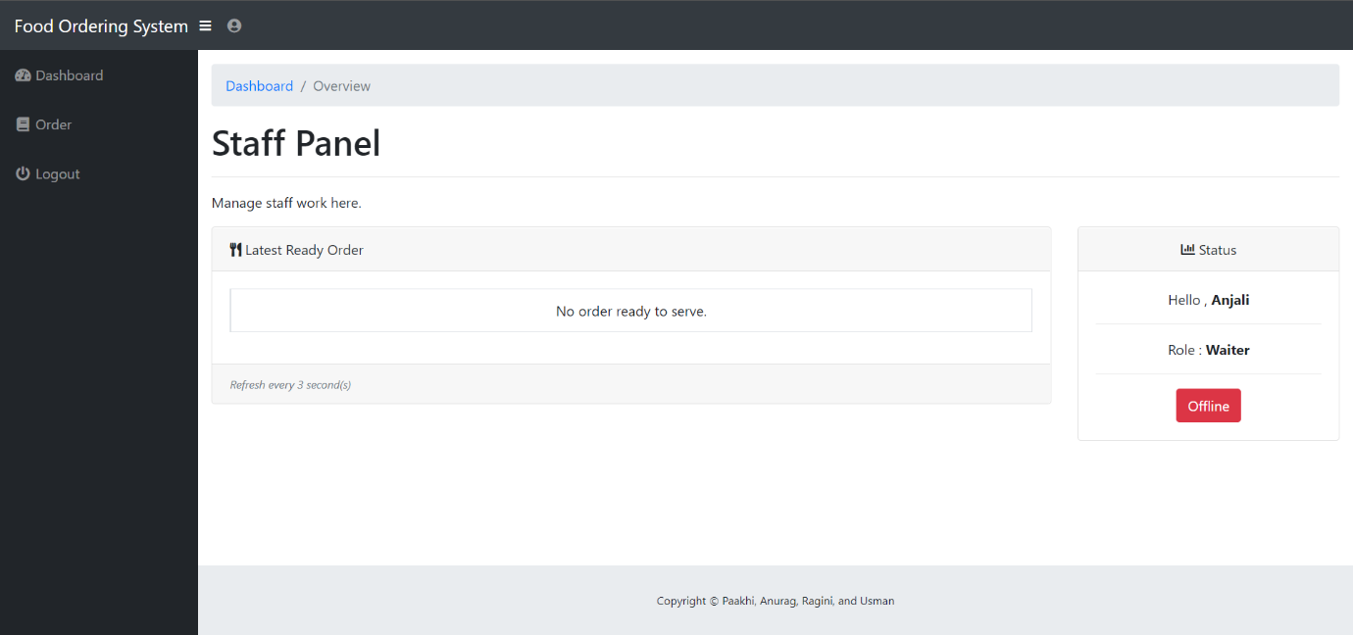

**Chef manages the current order list and can mark the as ready, preparing or can cancel the order.**

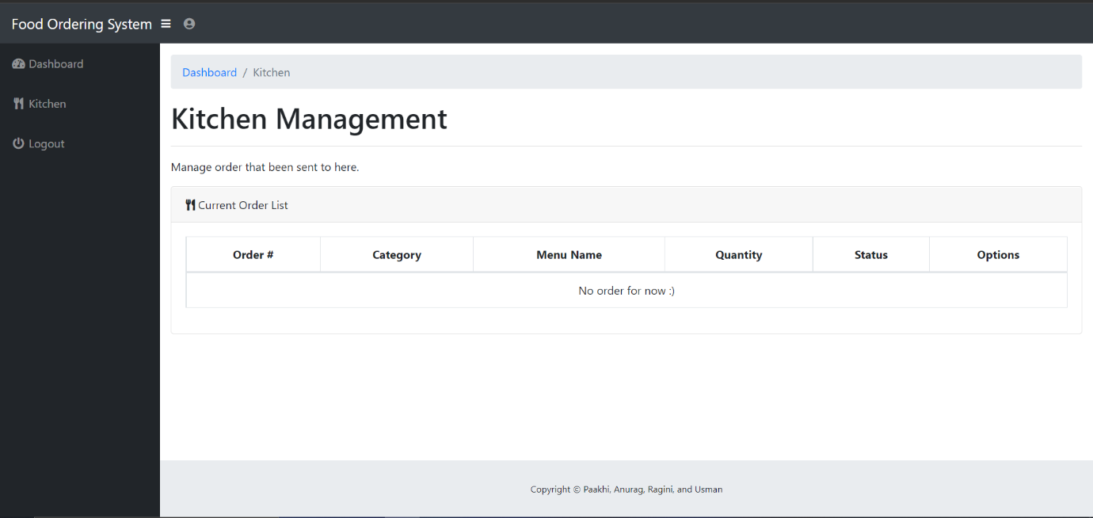

**Now, admin log in …**

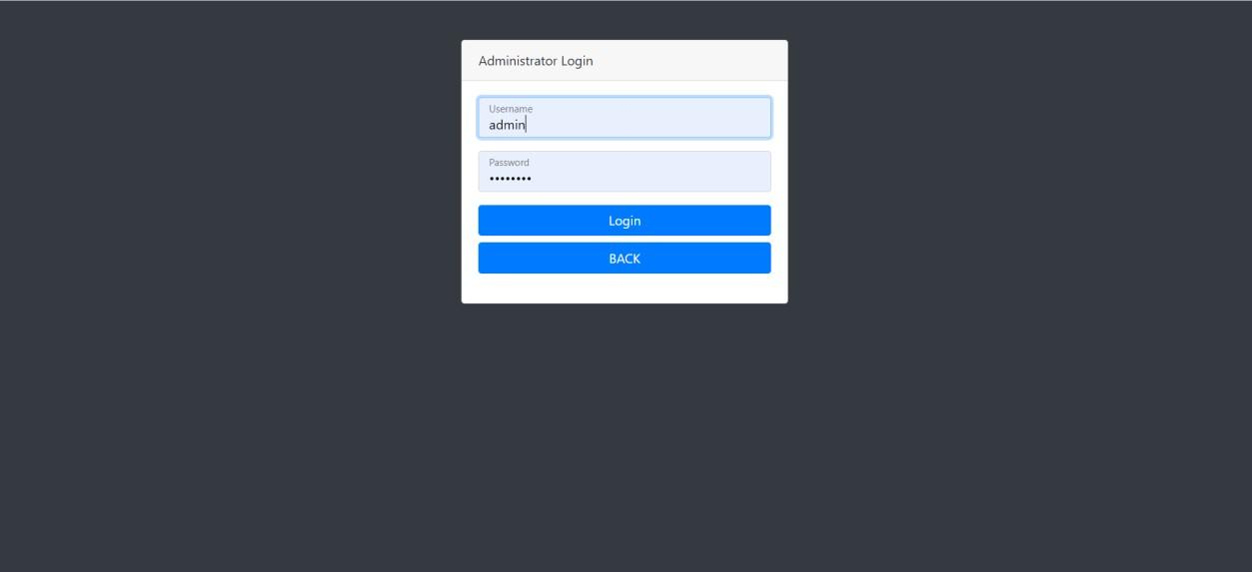

**Admin can see the all the order which are ready or under preparation.**

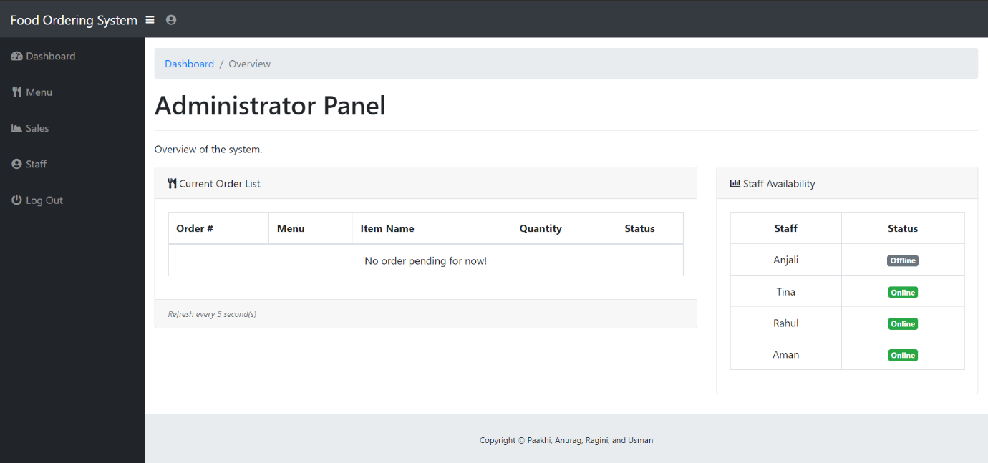

**Admin can add a new food category and add items under it.**

**And can edit any item and category present in the menu.**

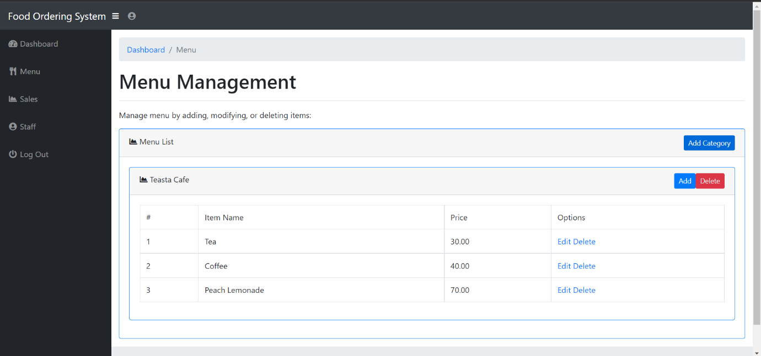

**Admin can see the sales as weekly, monthly, and totally.**

**Can see all the previous order status, bills and date of order placed.**

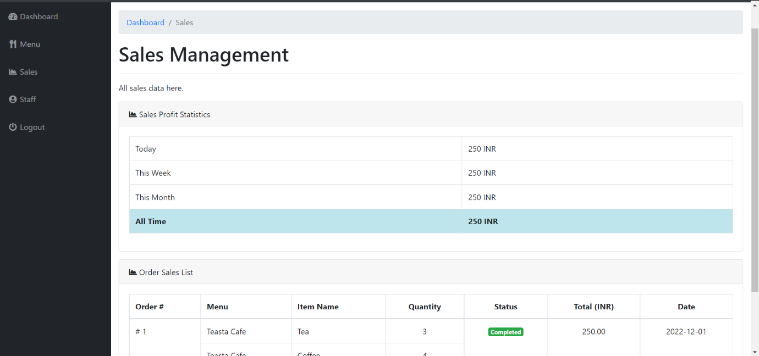

**Admin can add new staff as chef or waiter.**

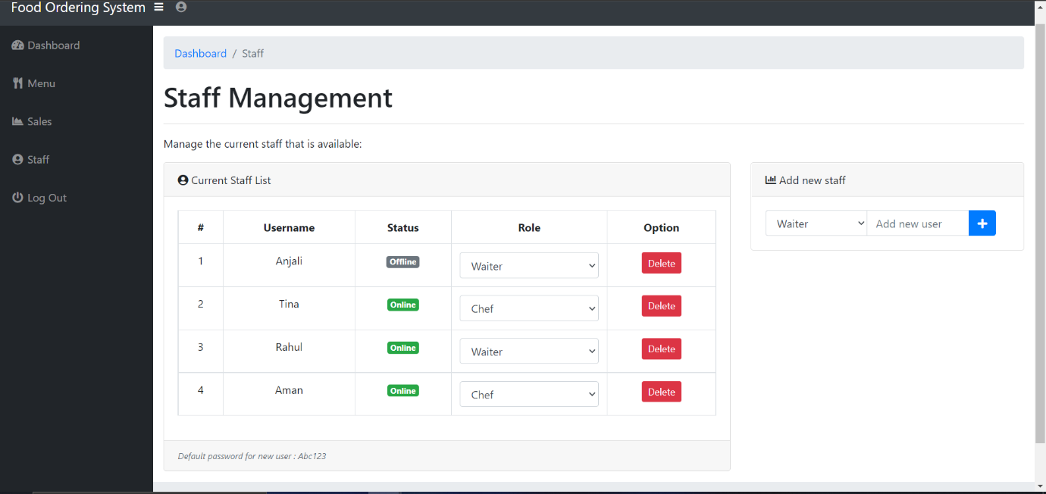

**LOGGING OUT….**

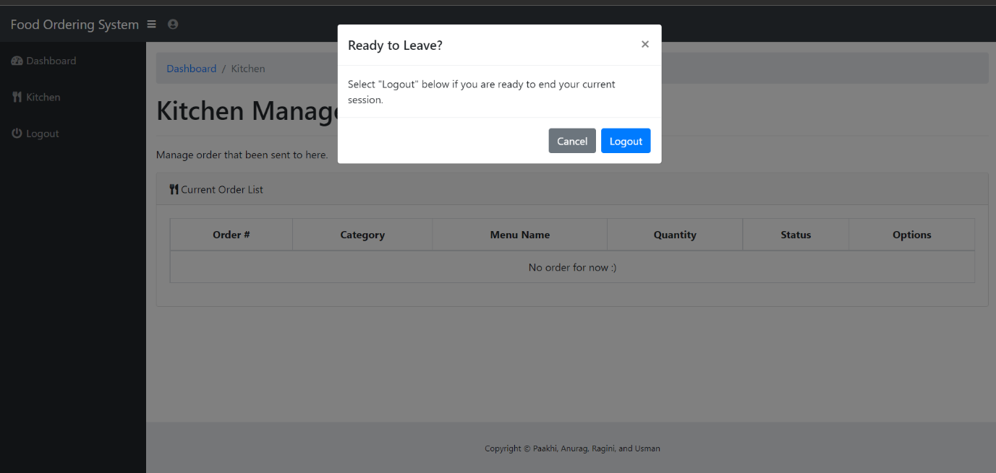

**CONCLUSION**

The Food Ordering System we have made is an interface of how the admin, chef, and waiters coordinate to successfully prepare, ready, and place orders from the customers using an easy and accessible database that provides all basic functionalities.

**References and Bibliography:**



* Google for problem solving
* https://www.w3schools.com/
* http://www.javaworld.com/javaworld/jw-01-1998/jw-01-Credentialreview.html
* https://www.tutorialspoint.com/java/
* http://www.javatpoint.com/java-tutorial
* https://docs.oracle.com/javase/tutorial/
* http://www.wampserver.com/en/
* http://www.tutorialspoint.com/mysql/